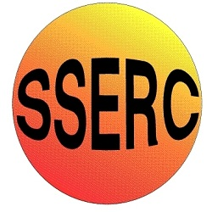

Chemical Demonstrations
Cannon Fire
This reaction can be applied to curriculum for excellence.
SCN 3-19a
Through experimentation, I can identify indicators of chemical reactions having occurred ...
SCN 4-19 a
…analyse experimental data on chemical reactions that result in an obvious change in energy.
CfE Higher – Chemical change and structure
Catalysts
CfE Advanced higher
Inorganic and Physical Chemistry
Catalysis by transition metals

Background
Cannon fire is an audio experiment that produces a series of crackles and bangs like gunfire. The noises are produced by hydrogen peroxide and potassium (VII) manganate reacting to produce oxygen.
These increase with the rate of burning of the ethanol
What you will need
- A large porcelain evaporating basin
- A bottle of 20 volume hydrogen peroxide [Harmful, Corrosive]
- A bottle of ethanol [Flammable]
- A 100 cm³ measuring cylinder
- A jar of a salt to use to colour the flame (e.g. LiCl is excellent)
- A spatula
- Pre weighed containers of 0.5 g of potassium permanganate (potassium manganate (VII)) (oxidising agent, harmful)
- Heat mat
- Bunsen
- Tripod
- Safety screen

What you do
- Measure out 30 cm³ of hydrogen peroxide and add it to the large evaporating basin.
- Measure out 20 cm³ of ethanol and place it in the large evaporating basin.
- Add a spatula of the salt to the mixture.
- Place the evaporating basin on the tripod stand so it is visible to the audience. Place the safety screen in front of the apparatus.
- Light the mixture and then carefully add the potassium permanganate slowly to the burning mixture. The reaction speed will increase and there will be a series of ‘cracks’ similar to cannon fire, as the potassium permanganate decomposes.
Do not add all the crystals at once-this will cause the burning mixture to spurt out of the evaporating basin.
Safety
Wear eye protection . Use a safety screen
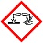
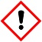
Care when using peroxide - Corrosive and harmful
Wear gloves

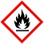
Care with ethanol– highly flammable

It is the responsibility of teachers doing this demonstration to carry out an appropriate risk assessment.

