
Chemical Demonstrations
Blue Bottle
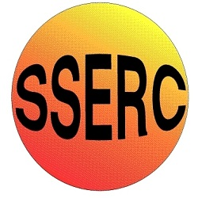
This reaction can be applied to curriculum for excellence.
SCN 3-19a
Through experimentation, I can identify indicators of chemical reactions having occurred ...
CfE Higher – Chemistry in Society
Oxidising or reducing agents

Background
This is a Redox reaction. The indicator can be oxidised many times by shaking.
Gently shaking the mixture produces one oxidised form with a different colour, while vigorous shaking will then turn this into a different oxidised form again, with yet another colour still.
As the mixture is allowed to stand, the dye reverts back to its reduced forms with the accompanying colours again becoming visible.

What you will need
- 250cm³ of 0.5M sodium hydroxide solution (corrosive)
- 7.5g of glucose powder
- 10cm³ of methylene blue indicator made up as below.
- 1 x 500 cm³ conical flask or large bottle (A 500cm³ coke or a vinegar bottle is fine)

What you do

Before the demonstration
Prepare the methylene blue dye by dissolving 0.1g of the powder in 100cm³ of distilled water.

The demonstration
- Place the sodium hydroxide, the glucose and the 10cm³ of the indigo carmine dye in a large conical flask or a bottle and stopper it tightly.

- Shake the mixture to dissolve the glucose.

- Allow the mixture to stand until it turns clear.

- Now shake vigorously – it turns goes blue again.

- Allow the contents to stand and watch them turn clear once more.
- Repeat again and again. The colour changes will tend to slow down as time goes on. The reaction can be refreshed by the addition of more glucose powder.

Safety
Wear eye protection. Wear gloves


Care with alkali – Corrosive

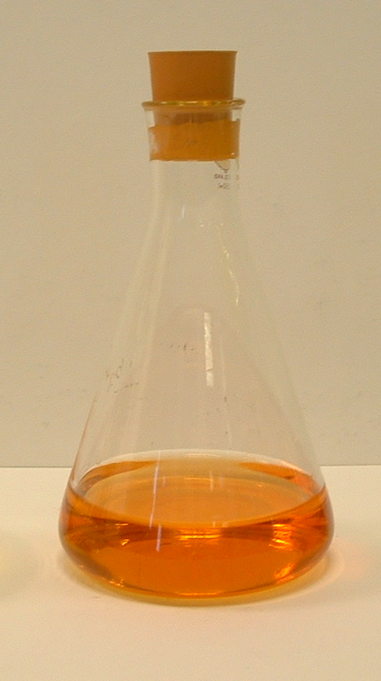
It is the responsibility of teachers doing this demonstration to carry out an appropriate risk assessment.

Using Safranin instead of methylene blue will give you a bottle that goes from Pink to clear.
Other redox dyes can also work.
See also – Traffic Lights

