

Chemical Demonstrations
Coca cola powered clock
This reaction can be applied to curriculum for excellence.
Through experimentation, I can identify indicators of chemical reactions having occurred ...
SCN 3-19a
. . . I can help to build simple chemical cells using readily-available materials which can be used to make an appliance work.
SCN 2-10a
I can help to design simple chemical cells . . .
SCN 3-10 a
N4 – Chemistry in Society
The properties of Metals and Alloys

What you will need
- A piece of magnesium ribbon about 15cm long (highly flammable)
- A piece of copper foil about 15cm long
- A piece of emery paper
- A wall clock with the battery removed and two crocodile leads soldered onto the battery connections
- A 100cm³ beaker
- An unopened can or 500ml bottle of coca cola

What you do
- Clean both pieces of metal with the emery then fold them in half.

- Fold the ends of the metal over the rim of the beaker to hold them upright and inside the beaker on opposite sides.

- Attach the metals to the crocodile leads.

- Open the can of coke and pour about 75cm³ into the beaker.

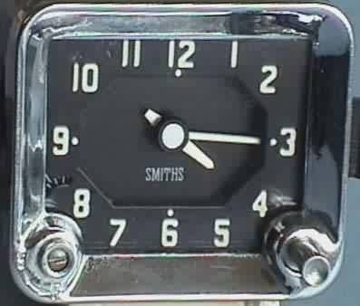
Piece of magnesium connected to negative battery terminal
Piece of copper connected to positive battery terminal
The clock should start and can go for up to 20 minutes.

It should look like this:

Small beaker of coke

This makes a simple battery.
It can be extended by trying different pairs of metals or by using fruit/vegetables as the electrolyte – the lemon clock for instance.
Safety
Wear eye protection.

It is the responsibility of teachers doing this demonstration to carry out an appropriate risk assessment.

