


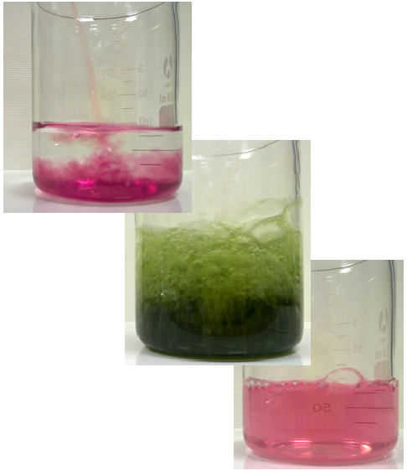
Chemical Demonstrations
A Catalyst at Work
This reaction can be applied to curriculum for excellence.
Through experimentation, I can identify indicators of chemical reactions having occurred ...
SCN 3-19a
CfE Higher – Chemical change and structure
Catalysts
CfE Advanced higher
Inorganic and Physical Chemistry
Catalysis by transition metals

Background

Hydrogen peroxide oxidises potassium sodium tartrate (Rochelle salt) to carbon dioxide. The reaction is catalysed by cobalt(II) chloride. When solutions of hydrogen peroxide and Rochelle salt are mixed, carbon dioxide is slowly evolved. The addition of cobalt(II) chloride causes the reaction to froth, indicating a large increase in the reaction rate. At the same time the colour of the cobalt(II) chloride turns from pink to green (an activated complex), returning to pink again within a few seconds as the reaction dies down. This indicates the catalysts actually take part in the reaction and are returned unchanged when the reaction is complete.

What you will need

- Bunsen burner, tripod, gauze and heat-proof mat.
- One 250cm³ beaker.
- One 0 – 100°C thermometer.
- One 25cm³ measuring cylinder.
- One dropping pipette.
- Access to visualiser (optional)
- 5 g of potassium sodium tartrate-4-water (Rochelle salt, potassium sodium 2,3-dihydroxybutanedioate, KNaC₄H₄O₆.4H₂O).

- 0.2 g of cobalt(II) chloride-6-water (CoCl₂.6H₂O) (harmful).
- 20 cm³ of 20 volume (ie approximately 6%) hydrogen peroxide
solution (H₂O₂(aq) (corrosive and irritant).
- 65 cm³ of deionised water.

What you do

before the demonstration:

- Make a solution of 0.2 g of cobalt chloride-6-water in 5cm³ of deionised water.

- Make a solution of 5 g of Rochelle salt in 60cm³ of deionised water in 250cm³ beaker.

The demonstration.

- Add 20cm³ of 20 volume hydrogen peroxide to the solution of Rochelle salt and
heat the mixture to about 75°C over a Bunsen burner.

- There will be a slow evolution of gas showing that the reaction is proceeding.

- Stirring the solution makes the evolution of gas more obvious.

- Now add the cobalt chloride solution to the mixture. Almost immediately the pink solution will turn green and after a few second vigorous evolution of gas starts and the froth will rise almost to the top of the beaker.

- Within about 30 seconds, the frothing subsides and the pink colour returns.

Visual Tips
Position and light the beaker carefully to make the evolution of gas before the addition of the catalyst more easily visible.

Extensions
Cobalt(II) bromide also catalyses the reaction and students could be asked to try other cobalt salts. The reaction is easy to time and could form the basis of an investigation into the factors affecting reaction rates.

Safety
Wear eye protection. Wear gloves


Care with peroxide - Irritant

It is the responsibility of teachers doing this demonstration to carry out an appropriate risk assessment.

