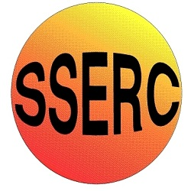


Chemical Demonstrations
A Cool Experiment
This reaction can be applied to curriculum for excellence.
Through experimentation, I can identify indicators of chemical reactions having occurred ...
SCN 3-19a

National 4 – Chemical Change & Structure
Energy changes of chemical reactions

National 5 – Chemical Change & Structure
Energy changes of chemical reactions

Stoichiometric quantities of solid barium hydroxide-8-water and solid ammonium thiocyanate are mixed in a conical flask. Reaction takes place to produce a liquid, and the temperature drops to below -25°C .

What you will need
- One 100cm³ conical flask
- Watch glass or piece of hardboard approximately 4 inches square
- Thermometer reading to –30C° or simply a glass stirring rod will do
- Access to a top pan balance
- Access to a fume cupboard (optional)
- A jar of barium hydroxide-8-water (Ba(OH)2.8H2O) (harmful)
- A jar of ammonium thiocyanate (NH4SCN) (harmful)

What you do
Before the demonstration:
Weigh out separately 20g of the barium hydroxide and 16 g of the ammonium thiocyanate. Avoid lumps as far as possible.
For a pupil demonstration, have these pre-weighed in tubs with screw top lids and label them ‘A’ and ‘B’.

The demonstration.
- Stand the conical flask on the watch glass or hardboard containing a few drops of water.

- Mix the two solids in the flask and stir with the thermometer. A liquid is formed –a colourless solution with ammonium thiocyanate.

- Observe the drop in temperature, which is confirmed by the fact that the beaker freezes to the watch glass.
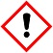
Safety
Wear eye protection Care with chemicals – harmful

Do not dispose of the chemicals down the sink. Add excess 0.2M Na₂SO₄ (aq) to precipitate barium ions. Filter and bag barium sulphate and dispose.

It is the responsibility of teachers doing this demonstration to carry out an appropriate risk assessment.

