

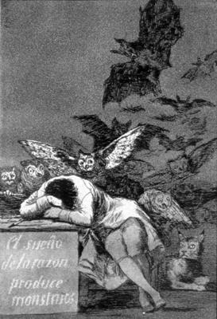
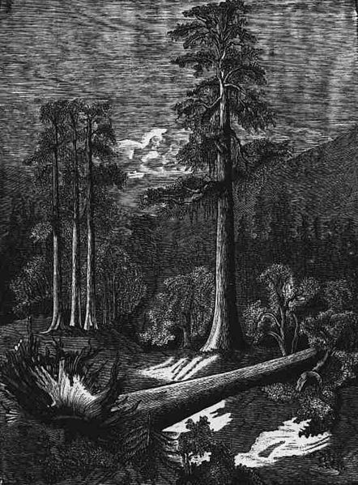
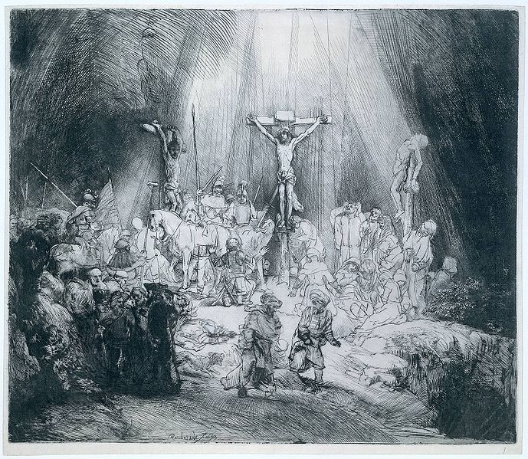
The three crosses - Rembrandt
Fallen tree – Carlos Alvarado Lang
The sleep of reason creates monsters – Francisco de Goya
Etch a Sketch
Degreasing Etch Plate
Instruction Sheet

What you apparatus you will need
Scissors
Insulating tape
Metal etch plate
Heatproof mat
1 cm³ Pasteur pipette x 4
Scourer x 3
Pair of tweezers
Plastic tub (Take away size)
Paper towels
Tea strainer

What chemicals you will need
Soy sauce (gluten/ wheat/ soy/ peanut/ nut/ sesame seeds allegories)
10 cm³ Washing up liquid
3 g calcium carbonate (no significant hazard)
10 cm³ vinegar (no significant hazard)
Access to tap water

What you will do
- Using the scissors, cut 4 strips of insulating tape that are longer than the sides of the etch plate.
- Take a strip and fold it over one side of the piece of the etch plate. Use the scissors to cut off any bits sticking out. Repeat this for the opposite side of the etch plate.
- Repeat step 2 for the 2 remaining sides of the etch plate.
- Using the scissors cut enough strips of the tape to completely cover the back of the etch plate. NOTE there should be no exposed metal on the back of the etch plate.
- Place the etch plate on a heat proof mat and using a Pasteur pipette add 5 drops of the Soya sauce to the exposed metal surface.
- Using a scourer, firmly rub the sauce into the metal surface.
- Using a pair of tweezers carefully place the etch plate into the plastic tub which is a quarter full with tap water and rinse off the sauce.
NOTE touching the exposed metal with your bare fingers will spoil the etching process to be carried out later.
- Using a paper towel, carefully dry off the etch plate.
- Again place the plate onto the heat proof mat and using another Pasteur pipette add a few drops of washing up liquid onto the metal surface.
- Using another scourer, rub the washing up liquid into the metal surface.
- Using a pair of tweezers carefully place the etch plate into the plastic tub and rinse off the liquid.
- Using a paper towel, carefully dry off the etch plate.
- Again place the etch plate onto the heat proof mat and using the tea strainer cover the metal surface with the calcium carbonate.
- Using another Pasteur pipette, add 1 cm³ of vinegar to the calcium carbonate-covered surface.
- Allow the mixture to fizz for a short while and using another scourer rub the mixture into the metal surface.
- Using a pair of tweezers carefully place the etch plate into the plastic tub and rinse off the mixture.
- Using a paper towel, carefully dry the etch plate.
- Using another Pasteur pipette, add a few drops of water to the exposed metal. The water drops should not run off the surface. If not repeat steps 5 to 17.
The etch plate has now been degreased and is ready for the etching process.
Ground Instruction Sheet
What you apparatus you will need
Plastic tub
Metal take-away tub
Access to kettle
Degreased etch plate
Pair of tweezers
Paper towels
Cocktail sticks

What chemicals you will need
Chopped tea light candles

What you will do
- Carefully half fill the plastic tub with boiling water.
- Place the chopped candle wax into the metal take away tub.
- Place the metal tub inside the plastic containing the boiling water.
- Once the wax has melted add the etch plate. NOTE it is best to try and get an even coat of wax on the exposed metal surface.
- Using the tweezers, carefully remove the plate and place it on the paper towel to cool.
- Once the wax has hardened, take a cocktail stick and carefully mark out your design. NOTE make sure the scratch is deep enough to expose the metal surface. If you make any mistakes, repeat steps 1 to 6.

Your teacher may ask you to keep the plastic tub for later.

Etching Instruction Sheet

What you apparatus you will need
Plastic etching tub
Large spatula
Etch plate
Timer
Stirring rod
Fine paint brush
Pair of tweezers
Plastic tub (take away size)
Paper towels
Scourer
Access to a kettle

What chemicals you will need
Etch solution (Harmful & Dangerous for the environment)

What you will do
- Raise one end of the plastic etching tub by placing it on top of a large spatula so that the tub is on a slope.
- Carefully pour the etch solution into the plastic tub.
- Place the etch plate with the exposed design facing upwards into the solution and start the timer.
- Use a stirring rod to hold down the plate and with a fine paint brush carefully brush the surface of the etch plate. Repeat this approximately every minute.
- When finished, use a pair of tweezers to remove the etch plate from the tub and place into a plastic tub a quarter full with boiling water.

- Using a pair of tweezers carefully remove the etch plate and place it on a paper towel. NOTE use a scourer to remove any black solids that may still be visible.
- Using a paper towel, carefully dry off the etch plate and then remove all the insulation tape.
The etch plate is now ready for the printing process
Printing Instruction Sheet

What you apparatus you will need
Bench cover
Plastic Petri dish
1 cm³ Pasteur pipette
Stirring rod
Filter paper
Etch plate
Dabber (sponge)
Cotton wool buds
Muslin cloth
Sellotape
Bed
Blanket
Rolling pin
Gloves (optional)

What chemicals you will need
5 x cm³ Thinners (flammable, harmful and dangerous for the environment)
10 cm³ Printing ink

What you will do
- Protect the bench by placing the bench cover on its surface.
- Place the printing ink into the plastic Petri dish.
- Using a Pasteur pipette and a stirring rod, mix enough drops of the ink and thinner to make it gloopy. NOTE too thick and it will not spread easily on the etch plate, too thin and the ink will not stay in the etched grooves.

- Take the filter paper and lightly spray it with water.
- Place the etch plate on top of the bench cover.
- In a circular motion, use the dabber to carefully spread the printing ink over the surface of the etch plate. You can also use the cotton wool buds to work in the ink into the grooves that have been etched out of the plate.
- Using the muslin cloth remove all the excess ink from the etch plate.
- Using the sellotape secure the etch plate into the surface of bed. NOTE if it moves the print will be smudged.
- Again using sellotape secure the damp filter paper on top of the etch plate. NOTE if it moves the print will be smudged.
- Now take the blanket and place it over the damp filter paper.
- Using the rolling pin, carefully roll it over the blanket backwards and forwards for a minute pressing down as hard as possible.
- Carefully remove the blanket and the filter paper from the press.
- Take the filter paper and leave to dry.
- For more prints repeat steps 4 to 13.

