
Name :
What’s the _{(end)} point?

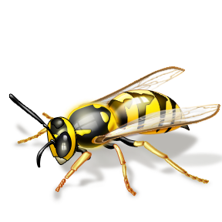
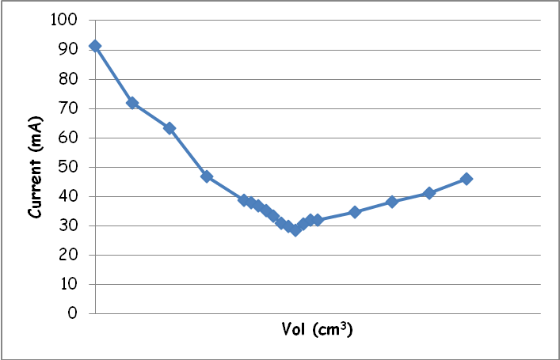


Instruction Sheet

The apparatus you will need
Low voltage AC power supply | multimeter
Leads and connectors | 50 cm³ conductivity flask
25 cm³ plastic syringe | 3 x 3 cm³ Pasteur pipette
3 x 1 cm³ Pasteur pipette

The chemicals you will need
0.1M Sodium hydroxide (irritant) | 0.1M Hydrochloric acid (irritant)
0.1M Sodium carbonate (irritant) | 0.1M Ethanoic acid
Bromothymol blue indicator solution
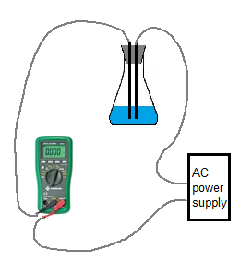

What you will do
- As shown by your teacher, set up a circuit containing a power pack, the conductivity flask and a multimeter. A circuit diagram is shown in figure 1.
Figure 1 Circuit Diagram for conductivity end point
- Have the circuit checked by your teacher.
A – strong acid v strong base
- Pour the hydrochloric acid into a 100 cm³ glass beaker and, using a syringe, carefully add 20 cm³ of the to the conductivity flask.
- Add 20 cm³ of hydrochloric acid and a few drops of the indicator to the conductivity flask.Set the power supply to 4V and turn it on,
- Switch on the multimeter and select the appropriate range.
- Wait for the reading to settle and record the current.
- Use a1cm³ pasteur pipette to take out 1 cm³ of sodium hydroxide. Add it to the flask. Give the contents a swirl and place back down.
- Let the reading settle and record the current again
- Repeat steps 7 and 8 until the total volume of sodium hydroxide added is 20 cm³.
- Empty the conductivity flask into the waste bottle and give it a quick rinse with the water bottle.

B – strong acid v weak base

Repeat steps 3 – 14 but this time you are carrying out the reaction between hydrochloric acid and sodium carbonate.

C – weak acid v strong base
Repeat again but this time put sodium hydroxide in the bottle and add ethanoic acid a bit at a time.

Experiment – acid/base conductivity

Vol added (cm³) | Conductivity (A)
 | Current (NaOH) | Current (Na₂CO₃) | Current (CH₃COOH)

