

-



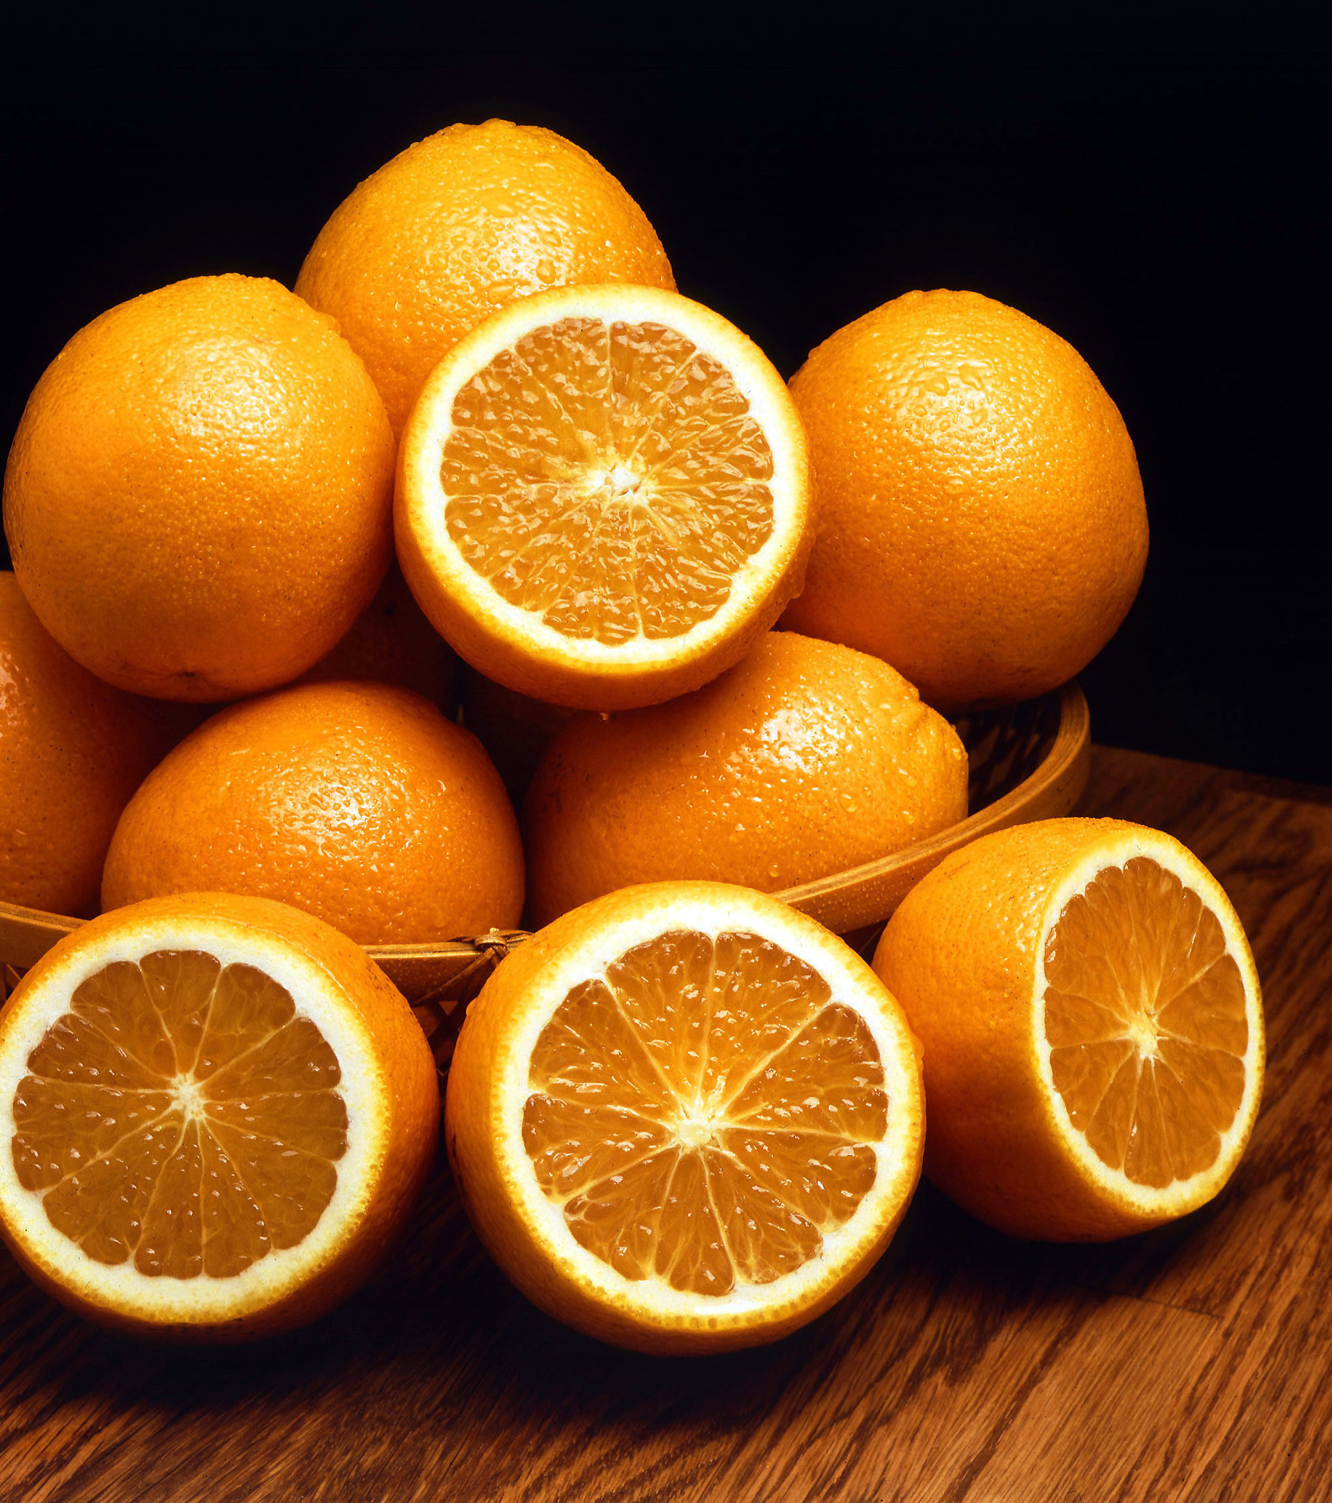
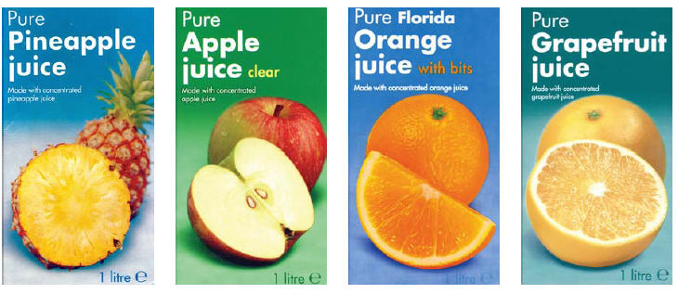
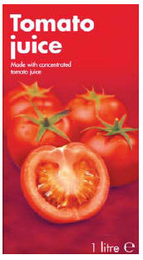
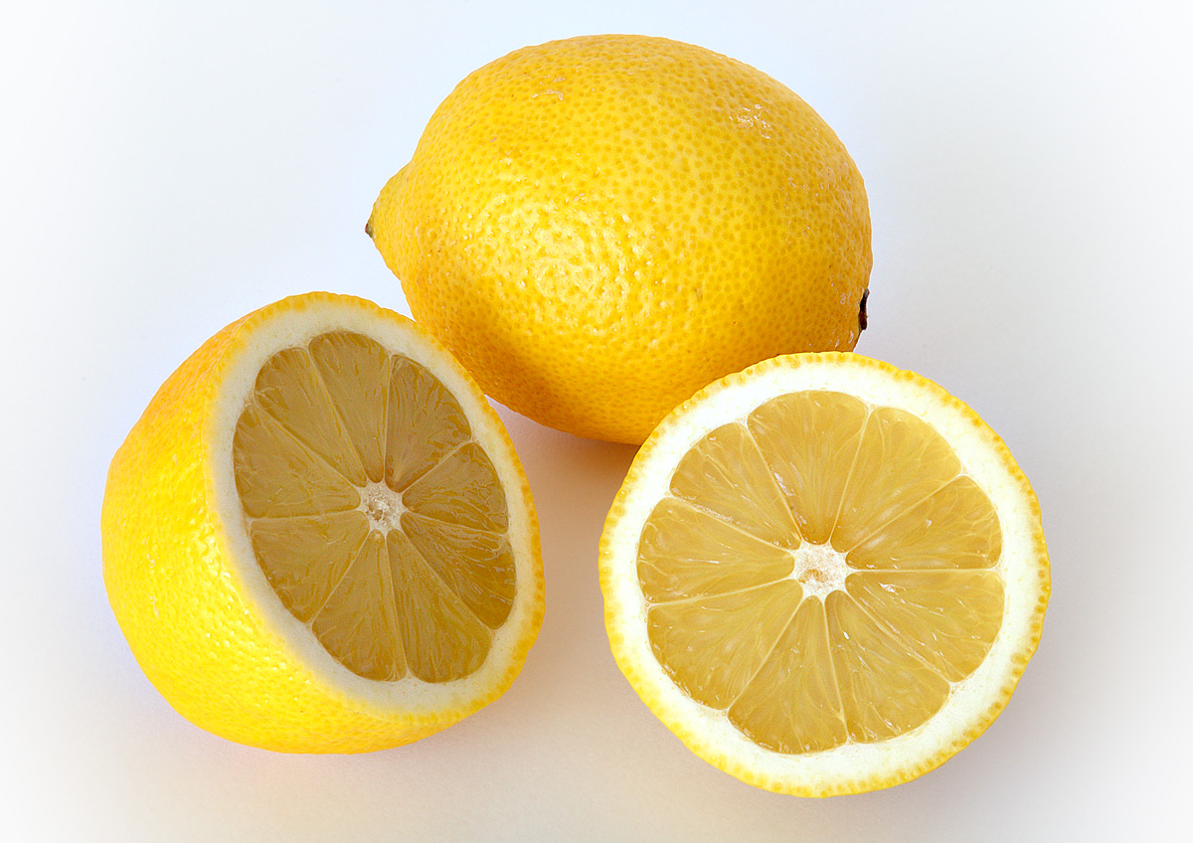
What you need

Iodine solution (care - will stain hands and clothing) | Starch solution
Distilled water | Fruit juices to test
Solution(s) of ascorbic acid
1 cm³disposable plastic droppers or plastic pipettes, one for each solution of fruit juice* | Test-tubes, a clean one for each test*
Test-tube rack | 10 cm x 10 cm piece of white paper or card for background
A 10 cm³ measuring cylinder | A 10 cm³ measuring cylinder

* As long as they are washed out between tests, it is possible to re-use pipettes and test tubes

What you do
Preparing your standards
If the solutions have already been prepared, then follow the instructions below.
If not, you have been provided with a solution containing 100mg/ml of ascorbic acid and you will need to make your own dilutions.
The dilutions we recommend are 60, 40, 30, 20, and 10 mg/ 100 cm³. Fill out the table below to work out the volumes of water and ascorbic acid you need to make 10 cm³of your dilute solutions.

Concentration (mg/100 cm³) | Volume of 100mg/100 cm³ ascorbic acid | Volume of distilled water
60 | 6
40 | 4
30 | 3
20 | 2
10 | 1
Making your standard curve
- Put 1 cm³ of starch solution in a test-tube.
- Add 5 cm³ of distilled water and mix by gently shaking the tube.
- Add 1 drop of iodine solution. A blue-black colour will appear.
- Hold a white piece of paper behind the test-tube. This helps see the colour change.
- Add drops of your most dilute solution from a pasteur pipette (5 mg/ 100 cm³) Shake the mixture after every drop. Keep adding until the blue-black colour of the solution disappears and there are no pieces of blue solid floating in the solution. COUNT THE DROPS.
- Record your answer, either use a new pipette or wash out the previous one in the beaker of water. (If you work from least to most concentrated, then washing out the same pipette will be perfectly OK)
- Repeat with the next dilution and continue until you have readings for the number of drops for all your standard solutions – including the 100 mg/ 100 cm³ solution you were given to start with.
- Plot your figures on the graph at the back of this booklet.

Preparing your fruit juices
A – Citrus Fruits
- Take the ½ fruit you have been given and use the squeezer to extract as much juice as you can.
- Pour it through a sieve into a test tube
- You have been divided into 2 groups. The five ‘pairs’ in group A each have a different citrus fruit. When you have tested the juice you prepared, swap with someone else in your group.
- The same applies to group B
B – Soft fruits
- Carefully place your fruit into the zip lock bag making sure there is little or no air trapped inside – or it will burst all over you!
- Carefully squidge the berries inside the bag with your fingers. A stirring rod may help to flatten the harder berries.
- Open the bag and pour the contents into a suitable container or alternatively simply dip a pipette in and draw up some of the juice.

C – Banana
- Put a piece of banana into a ziplock bag (as above) and squish it.
- Scrape your banana out into a universal (small jar)
- Add water up to the 20 cm³ line and shake vigorously
- Use this liquid to test for vitamin C

D – Vegetable juices
- Use a juicer to extract the juice. (At a push you can use a blender and let the juice drip out through a sieve/muslin)
- Use this liquid to test for vitamin C

Testing your fruit juices

- Add a fruit juice drop by drop.
- If you are not sure if all the blue-black colour has gone, try this: note the number of drops added, then add 1–5 more drops and see if the colour is any different after each drop added. If a new colour is made, add the extra drops to the original number of drops that you have noted. Then repeat – add more and see if the colour changes again. When the colour stops changing, this is the end point. Write down the total number of drops added in the results table.
- Now start again with a fresh test-tube.
- Make the blue-black colour as before (steps 1, 2 and 3).
- Repeat by adding the same fruit juice drop by drop until the colour is the same as that in the first test-tube, COUNTING THE DROPS as before. Check the final colour is the same.
- Repeat the whole experiment with all the different juices you have.

Safety - All the solutions are of low hazard so no special precautions are needed.

Results

Name of juice | Number of drops  to turn it colourless | Number of drops  to turn it colourless | Number of drops  to turn it colourless | Average number of drops

Questions

- Why does the juice solution have to be added drop by drop

- Which juice has the most vitamin C? Explain how you can tell.

- Look at the graph called “Estimating the Vitamin C in Fruit”.
Work out how much vitamin C (in mg/100 cm³) is present in each juice.

Name of juice | Concentration of Vitamin C  (mg/100 cm³)

- The 'RDA’ (recommended daily allowance) of vitamin C for a young person, (14-18 years old), is 75 mg for a male and 65 mg for a female.

Which juice(s) give the RDA for each in a 100 cm³ glass?

Boy:

Girl:

- The following table shows the RDA values for adults:

Adult (19 years and over) | Non-smoker  (mg) | Smoker  (mg))
Male | 90 | 125
Female | 75 | 110

Suggest why the RDAs for smokers are higher than for non smokers.

- Who else, apart from smokers, may need a higher RDA than that recommended for adults?

