

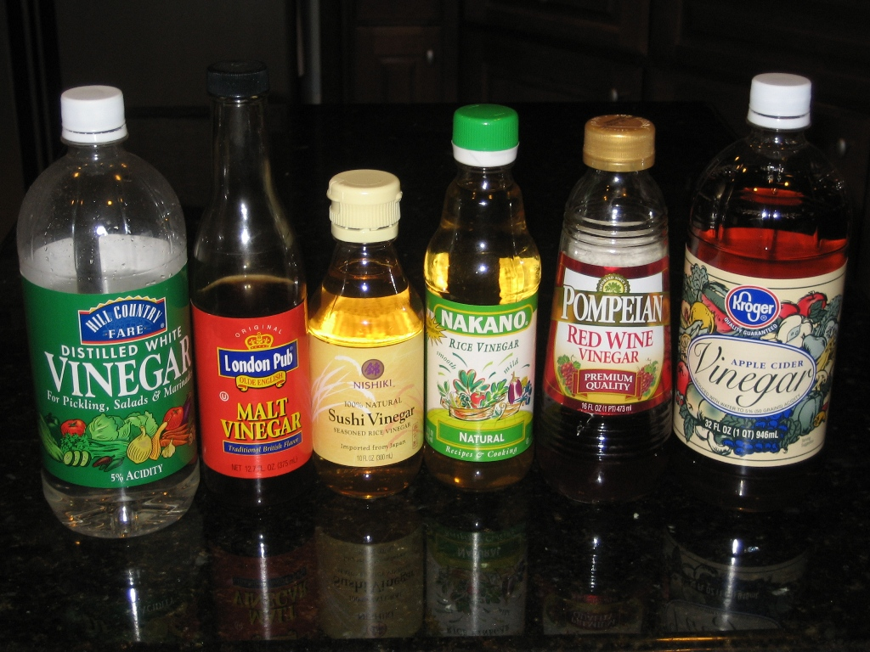

.
Alkali Experiment:

Required for pupils: Per Group

2 Plastic dropping pipettes
- Three (or 5) test tubes in a test tube rack (if 3 then pupils will need to wash out between tests, if 5 they can do all three repetitions then clean)
- 1x Dropper bottles of indicator solutions
- 1x bottle of dilute sodium hydroxide solution 0.4M (about 30 cm³) and a small beaker if the pipette will not reach into the bottle.
- 4x bottles of vinegar (will need about 5cm³ of each)
Supermarket
Burgers2Go
Just Chips
Fat Man’s Heaven

Prepare these as follows:

Supermarket vinegar: Undiluted

Burgers2Go vinegar: dilute supermarket stuff 1:1 (i.e. 50 cm³ vinegar + 50 cm³ distilled water)

Just Chips vinegar; Undiluted supermarket vinegar

Fat Man's Heaven vinegar: dilute supermarket vinegar 2:1 (i.e. make up each 120 cm³ with 80 cm³ vinegar + 40 cm³ distilled water)

Make these up using measuring cylinders.

Chalk Experiment:

Required for pupils: Per Group

1x 10 cm³ measuring cylinder

1x Small beaker

1x Stirring rods

1x Bottles of powdered chalk

1x spatula

1x weighing boat

Access to a balance able to read to 2 decimal places

1x Bottles of supermarket vinegar (will need 30cm³)

The experiment using the chalk and vinegar should be done using a two decimal place balance. This is because of the small mass losses in the experiments. They should be read to two decimal places for them to make any sense. Such balances can be purchased from the usual suppliers.

