

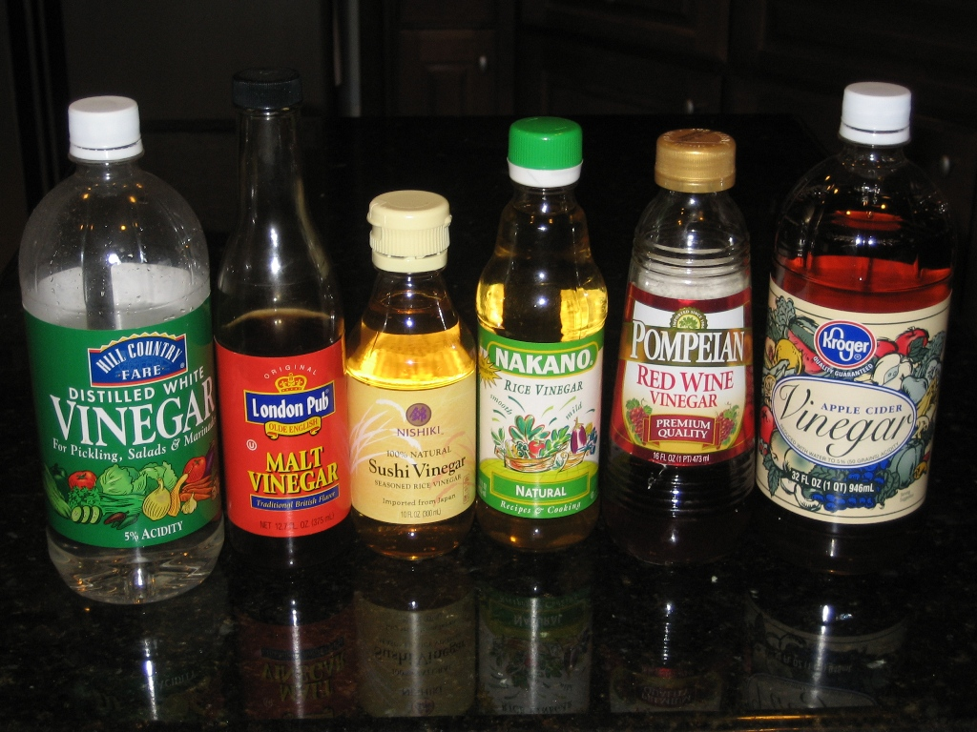

Introduction

This is a simple investigation into acidity and neutralisation.

We think it fits into CfE here:

Having taken part in practical activities to compare the properties of acids and bases, I have demonstrated ways of measuring and adjusting pH and can describe the significance of pH in everyday life.
SCN 3-18a

Through experimentation, I can identify indicators of chemical reactions having occurred. I can describe ways of controlling the rate of reactions and can relate my findings to the world around me.
SCN 3-19a

There are two parts to the experiment:

- Reacting the vinegar samples with dilute sodium hydroxide solution, using a suitable indicator – either one the pupils have prepared themselves from plant material or a normal laboratory one.

This can be done with a home made indicator (a method for preparing them is at the beginning of the pupil’s guide) or a normal laboratory indicator.

If this is done, it also addresses :

I can participate in practical activities to extract useful substances from natural resources.
SCN 3-17b

- Reacting the vinegar samples with calcium carbonate and following the reaction by seeing the loss of mass as the CO₂ is released.

Specimen answers:

- Vinegar/alkali:

Colours shown are from the vinegar (acid) to alkaline end point

Thymol blue Indicator: Yellow to blue

Vinegar | 1st Titre (drops) | 2nd Titre (drops) | 3rd Titre V(drops) | Ave Titre (drops)
Supermarket | 70 | 69 | 71 | 70
Burgers2Go | 35 | 34 | 38 | 36
Just Chips | 70 | 69 | 71 | 70
Fat Man’s Heaven | 46 | 47 | 49 | 47

You get very similar results (though very slightly higher) using phenolphthalein.

A good extension activity is to repeat using home made indicators. The values will be different but the rank order should be the same; with Burgers2go approximately half the titre from the Supermarket and Just Chips, and the Fat Man’s Heaven being about two thirds of the Supermarket value every time.

- Vinegar/chalk

A similar ratio of mass loss can be seen in the following results from the chalk experiment.

The mass loss is small so careful measurements will need to be made.

Vinegar/chalk

Vinegar Sample | Just Chips
Measurement | Expt. 1 |  | Expt. 2 |  | Expt. 3
Mass of chalk | 2. 2.00g |  | 2.00g |  | 2.00g
Mass of vinegar  + beaker | 53.76g |  | 53.94g |  | 60.54g
Total mass  at start | 55.76g |  | 55.94g |  | 62.54g
Total mass at  the finish | 55.50g |  | 55.74g |  | 62.32g
Mass loss | 0.26g |  | 0.20g |  | 0.22g
Average mass loss |  |  | 0.23g

Vinegar Sample | Burgers2Go
Measurement | Expt. 1 |  | Expt. 2 |  | Expt. 3
Mass of chalk | 2. 2.00g |  | 2.00g
Mass of vinegar  + beaker | 60.24g |  | 65.62g
Total mass  at start | 62.24g |  | 67.62g
Total mass at  the finish | 62.11g |  | 67.51g
Mass loss | 0.13g |  | 0.11g
Average mass loss |  |  | 0.12g

Vinegar Sample | Fat Man’s Heaven
Measurement | Expt. 1 |  | Expt. 2 |  | Expt. 3
Mass of chalk | 2. 2.00g |  | 2.00g
Mass of vinegar  + beaker | 64.94g |  | 59.46g
Total mass  at start | 66.94g |  | 61.46g
Total mass at  the finish | 66.79g |  | 61.36g
Mass loss | 0.15g |  | 0.14g
Average mass loss | 0.145g

The experiment using the chalk and vinegar should be done using a two decimal place balance. This is because of the smallmass losses in the experiments. They should be read to two decimal places for them to make any sense. Such balances can be purchased from the usual suppliers.

