
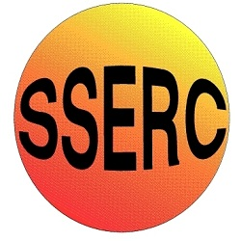

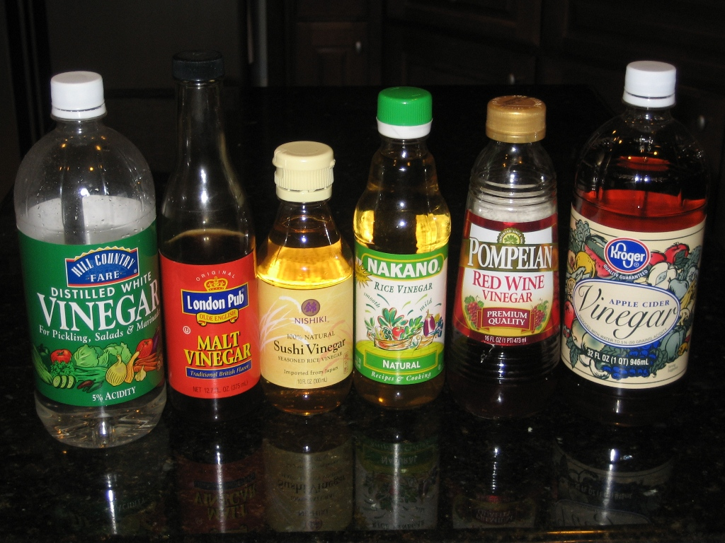

Definitely Correct

Could be Either

Definitely Incorrect

1. If you get an answer you don’t expect, it means you have done something wrong.

2. Vinegar is an acid
3. If you get an answer you don’t expect, you should repeat the experiment to check.

4. If you water down vinegar, it becomes less acid.

6. An indicator tells you a reaction is finished by changing colour.
7. All indicators change colour at the same pH.
8. If you repeat an experiment three times, you are more likely to get a reliable answer than doing it once.
5. Acids and alkalis neutralise each other.

9. If you water down vinegar, it will neutralise more alkali.

10. Vinegar tastes sour because it is an acid.
11. Chalk is magnesium carbonate.
12. When chalk and vinegar react, carbon dioxide is given off.

14. If you use watered down vinegar to react with chalk, more mass will be lost.
15. Counting the drops is an accurate way of measuring volume.
16. When carbon dioxide gas comes off, the reaction mixture gets heavier.
13. Wine vinegar or cider vinegar will give different results from the malt vinegar we normally put on chips.

17. The point at which an indicator changes is called the “colour point”.
18. The end point of a reaction is when the mixture becomes neutral (pH 7.0)
19. If there is a change in mass that means there has been a chemical reaction.
20. The loss of mass in the reaction is because carbon dioxide is heavier than air.

