Technician Guide
What’s the end point?

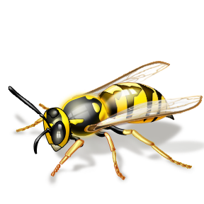
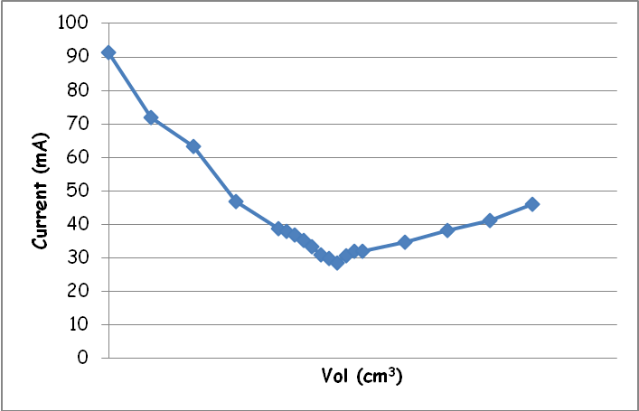
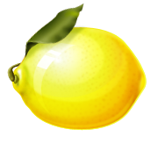

Technician’s Guide

*Assume 10 groups*

Experiment
Low voltage AC power supply
Multimeter or ammeter able to measure AC current
3 leads & 2 crocodile clips
50 cm³ conductivity flask
25 cm³ plastic syringe
3 cm³ Pasteur pipette x 3
1 cm³ Pasteur pipette x 3
100 cm³ glass beaker x 3
100 cm³ 0.1M hydrochloric acid (irritant)
50 cm³ 0.1M sodium hydroxide (irritant)
50 cm³ 0.1M sodium carbonate solution
50 cm³ 0.1M ethanoic acid solution
bromothymol blue indicator solution

Hydrochloric acid
Dilute according to the method on SSERC SafetyNet.
Take 1 litre of 0.1M acid and pour into 10 bottles.

Sodium hydroxide
Dilute according to the method on SSERC SafetyNet.
Take 500 cm³ of 0.1M acid and pour into 10 bottles.

Sodium carbonate solution
Dissollve 14.3g of sodium carbonate decahydrate in 500cm³ of distilled water.
Take 500cm³ of 0.1M sodium carbonate solution and pour into 10 bottles and label accordingly.

Ethanoic acid solution
Dilute according to the method on SSERC SafetyNet.
If you are out of glacial ethanoic acid, a rough solution can be made by taking 100cm³ of vinegar and making up to 500cm³ (most spirit vinegar is 5% ethanoic acid)
Take 500cm³ of 0.1M ethanoic acid solution and pour into 10 bottles and label accordingly.

Bromothymol blue indicator
Weigh 0.04g of indicator and add to 20 cm³ of ethanol in a 100 cm³ volumetric flask. Make up to the mark with distilled water.
Resources
All the chemicals can be found in school chemical stores.
If you already have conductivity flasks, which have been used in Standard Grade chemistry experiments and should therefore be accessible, then use those. (It is important however to check that the quantities of acid used will immerse the electrodes).
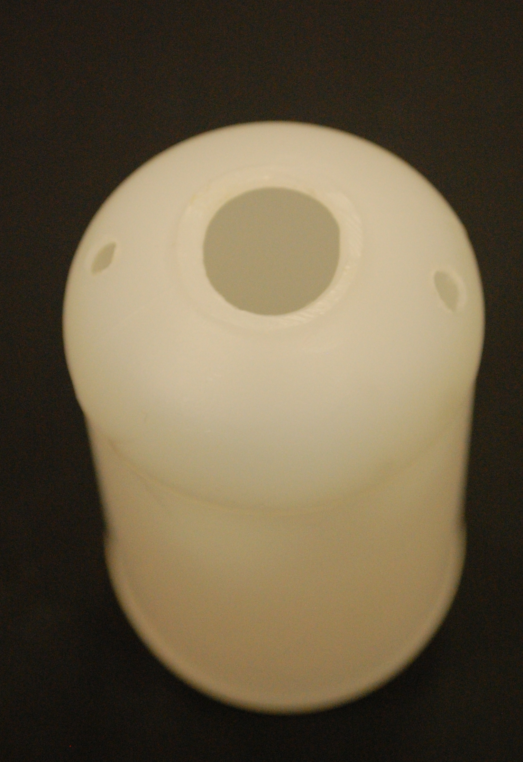
If you do not have conductivity flasks, it is possible to make a simple one with little trouble.
- Take a standard 100cm³ plastic bottle.
Use a hacksaw or sharp knife (or a hot knife) to cut off the neck of the bottle as shown.
Use a heated screwdriver or similar to make a couple of holes in the shoulders of the bottle – as shown.

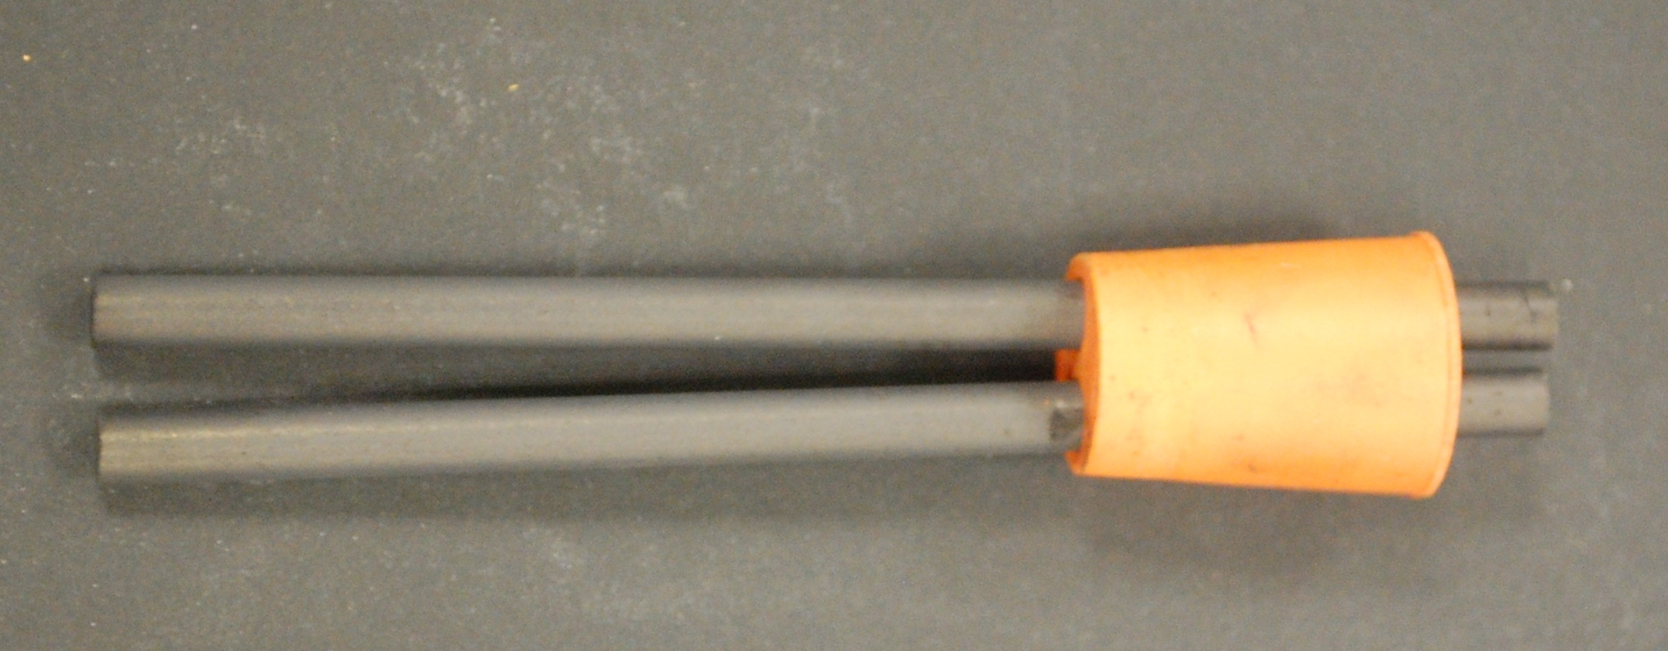
- Take a 2-holed bung that fits into the hole you now have in the top of your bottle.
Push 2 carbon rods through the bung, one through each hole, using petroleum jelly to help them go through.

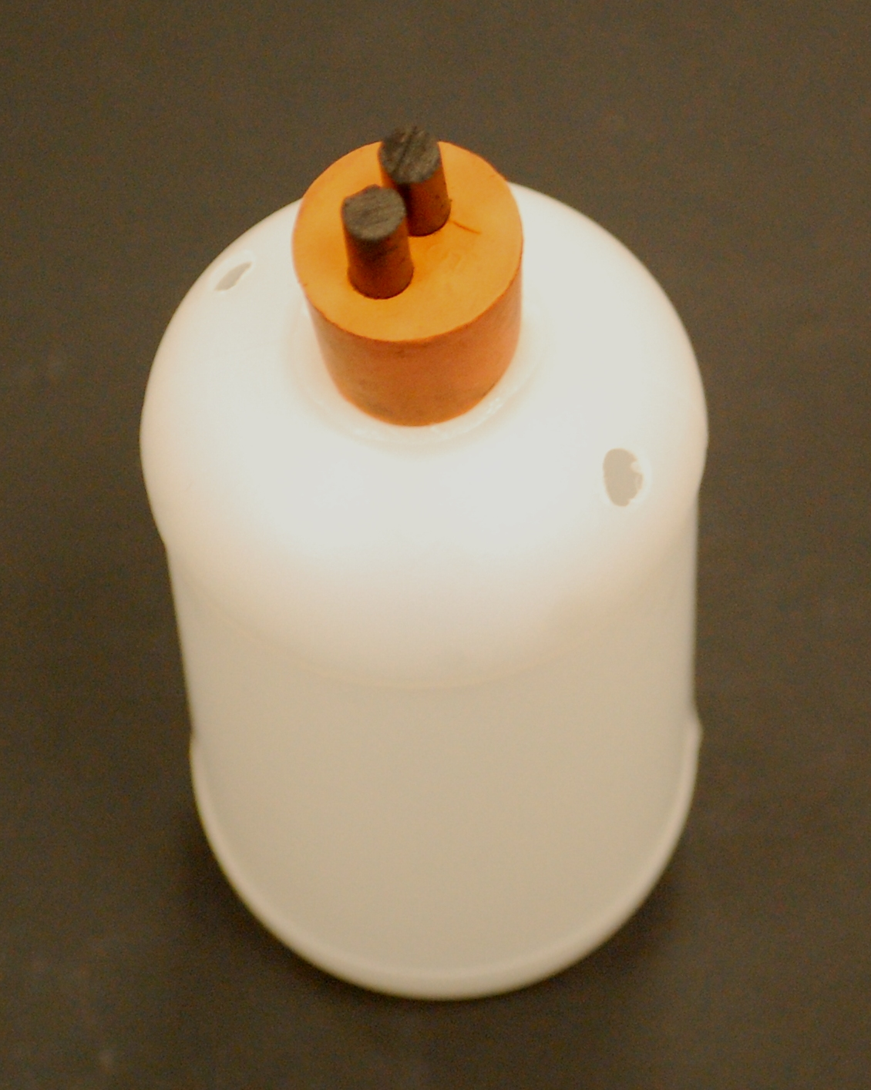
- Your conductivity flask is now made and should look like this.

Once it is connected up, you use the holes you made in the shoulder of the flask to add the reagent.

Ammeters

You might need to talk nicely to your physics colleagues to borrow suitable meters.

We have hade good results using multimeters but a lot of multimeters, especially the less expensive ones, do not measure AC current, only DC.

Trouble shooting
You need to take care to make sure that you do not short-circuit the set up by allowing the crocodile clips on the electrodes of the flask to touch. If this happens though, most power packs have a simple reset button.
You will find that different flasks will give different readings. This is normal in the circumstances. The bungs are not identical and so some have the electrodes closer than others. Also, there are slight variationsin the holes you cut so some will dip further into the solution than others.
Given the design, adding more electrolyte will lead to a greater current as there will be a larger area in contact with the solution as the height increases in the flask.
The weak acid/ base combination is likely to produce variable result that will not be accurate enough to determine the end point from the plotted conductivity curve.

