Teacher Guide
What’s the end point?

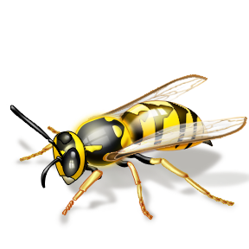
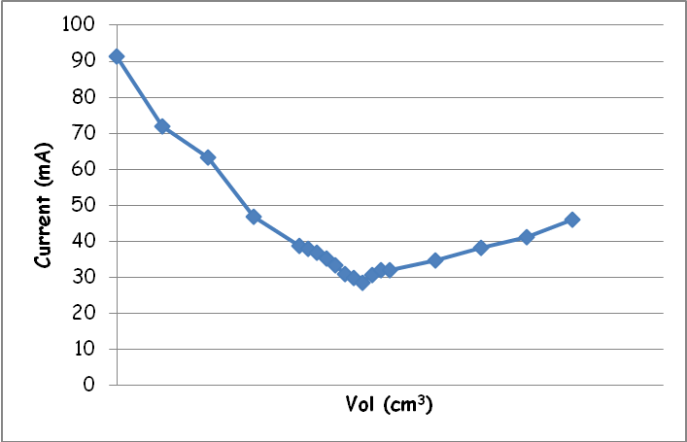
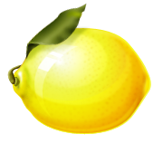

Teacher’s Guide

Overview
Students will have knowledge of what acids and bases (neutralisers) are and where they may come from in everyday lives. However many confuse concentration with strength. This practical helps to highlight that with acids having the same concentration their “strengths” are different. In this case each reaction will reach its end point but the conductivities at the beginning and the end will be different according the strength of the acid or base being used.
This resource can be linked to the following outcomes
National 4 Chemistry
Chemical changes & structure
Acids & alkalis
Neutralisation reactions
National 5 Chemistry
Chemical Change & Structure
Acids & bases – neutralisation

Introduction
The concentration of a solution is determined by the quantity of material dissolved in it. When the students have too much orange juice concentrate in their glass they can very clearly taste the orange.
However, the strength of an acid or base depends upon how well the ions dissociate into their positive and negative ions when dissolved in water. The reason why many students can put vinegar on their chips is because the ethanoic acid is weak enough so that it is not harmful to your mouth. Remember though if taken in large enough quantities it can still cause harm.
For this practical all the acids and bases are equi-molar. This means that the same molar quantities of solutes have been dissolved into the same volumes of water.
When a strong acid/ base conductivity curve is compared to that of a strong acid/ weak base curve the stationary points will be similar but the gradients will be different.
From a conductivity curve it can be seen that the drop in conductivity is due to the loss of the very mobile hydrogen ions. The stationary point of the curve is when all of the hydrogen ions have been removed. The conductivity then starts to rise again but at much lower rate due to the increasing presence of the less mobile hydroxyl ions.
The differences of the gradients of the conductivity of the strong and weak bases are due to their differences in their mobilities. The strong base being fully dissociated and thus have more mobile ions than that of the weak base.

Ion mobility

Movement of an ion through a solution under the influence of a potential gradient (electric field) is the result of the acceleration of the charged particle in the field and the opposing forces of assymetry and the electrophoretic effect. Thus the ion moves at a constant rate determined by a balance of these forces.
Ion | u⁰(m² s⁻¹V⁻¹) | Ion | u⁰(m² s⁻¹V⁻¹)
H₃O⁺ | 36.3 x 10-8 | Mg²⁺ | 5.5 x 10-8
OH⁻ | 20.5 x 10-8 | Zn²⁺ | 5.5 x 10-8
Li⁺ | 4.0 x 10-8 | Cl⁻ | 7.9 x 10-8
Na⁺ | 5.2 x 10-8 | Br⁻ | 8.1 x 10-8
K⁺ | 7.6 x 10-8 | NO₃⁻ | 7.4 x 10-8
Ag⁺ | 6.4 x 10-8 | SO₄²⁻ | 8.3 x 10-8

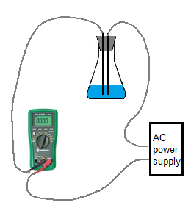
What to do
Figure 1 Circuit Diagram for conductivity end point
Set up the apparatus as shown in figure 1 to ensure the students know how to connect the pieces of equipment. It would be good practice to show them the colour change of the indicator from acid to neutral to alkali as they may not have used bromothymol blue before.
The power supply should have an AC outlet and depending on the rest of the apparatus a 4 – 6v output should be fine.
Allow the students to follow the instructions and record the volume added and the current.
Allow the students to complete their results sheet and the accompanying spreadsheet. This will work out the current and plot the subsequent conductivity curve.
Allow the students to repeat the whole process but instead to use a different combination of acid/ base strengths.
These curves can be printed and used by the students as a discussion activity.

Sample results

Strong acid (hydrochloric) / Strong Base (sodium hydroxide)

Cm³ | 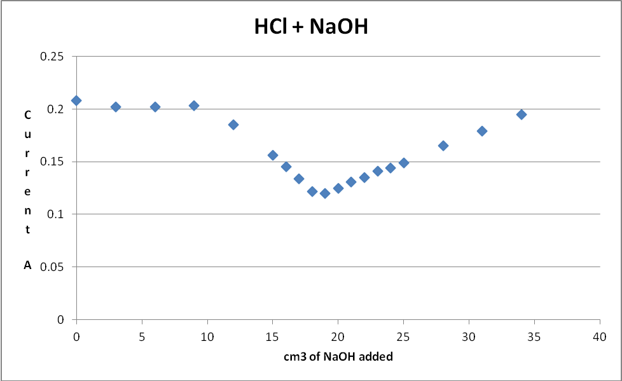  A
0 | 0.208
3 | 0.202
6 | 0.202
9 | 0.203
12 | 0.185
15 | 0.156
16 | 0.145
17 | 0.134
18 | 0.122
19 | 0.12
20 | 0.125
21 | 0.131
22 | 0.135
23 | 0.141
24 | 0.144
25 | 0.149
28 | 0.165
31 | 0.179
34 | 0.195

Strong Acid (hydrochloric)/ weak base (sodium carbonate solution)
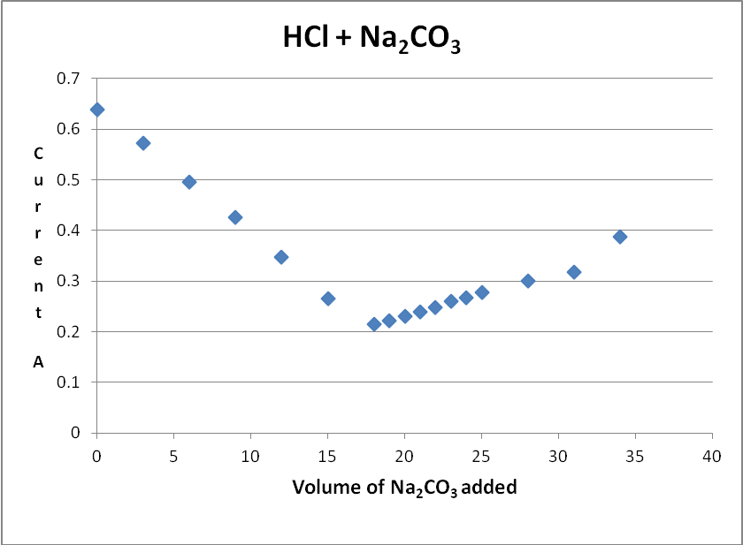
Vol | HCl + CO3
0 | 0.638
3 | 0.573
6 | 0.496
9 | 0.425
12 | 0.347
15 | 0.266
18 | 0.214
19 | 0.221
20 | 0.23
21 | 0.24
22 | 0.248
23 | 0.26
24 | 0.267
25 | 0.277
28 | 0.3
31 | 0.318
34 | 0.388

Strong base (sodium hydroxide)/ weak acid (ethanoic acid)
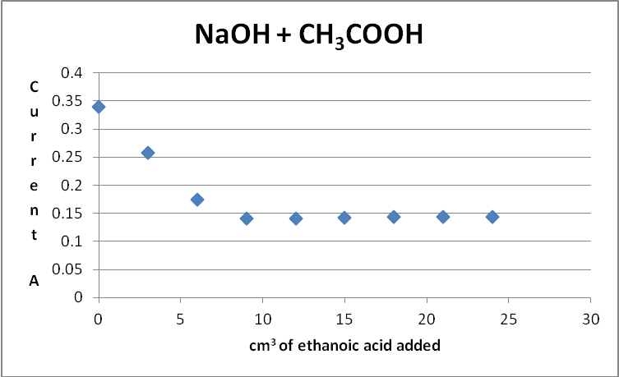
Vol | NaOH + CH₃COOH
0 | 0.34
3 | 0.258
6 | 0.174
9 | 0.14
12 | 0.141
15 | 0.142
18 | 0.144
21 | 0.143
24 | 0.143

Resources
All the chemicals can be found in school chemical stores.
If you already have conductivity flasks, which have been used in Standard Grade chemistry experiments and should therefore be accessible, then use those. (It is important however to check that the quantities of acid used will immerse the electrodes).
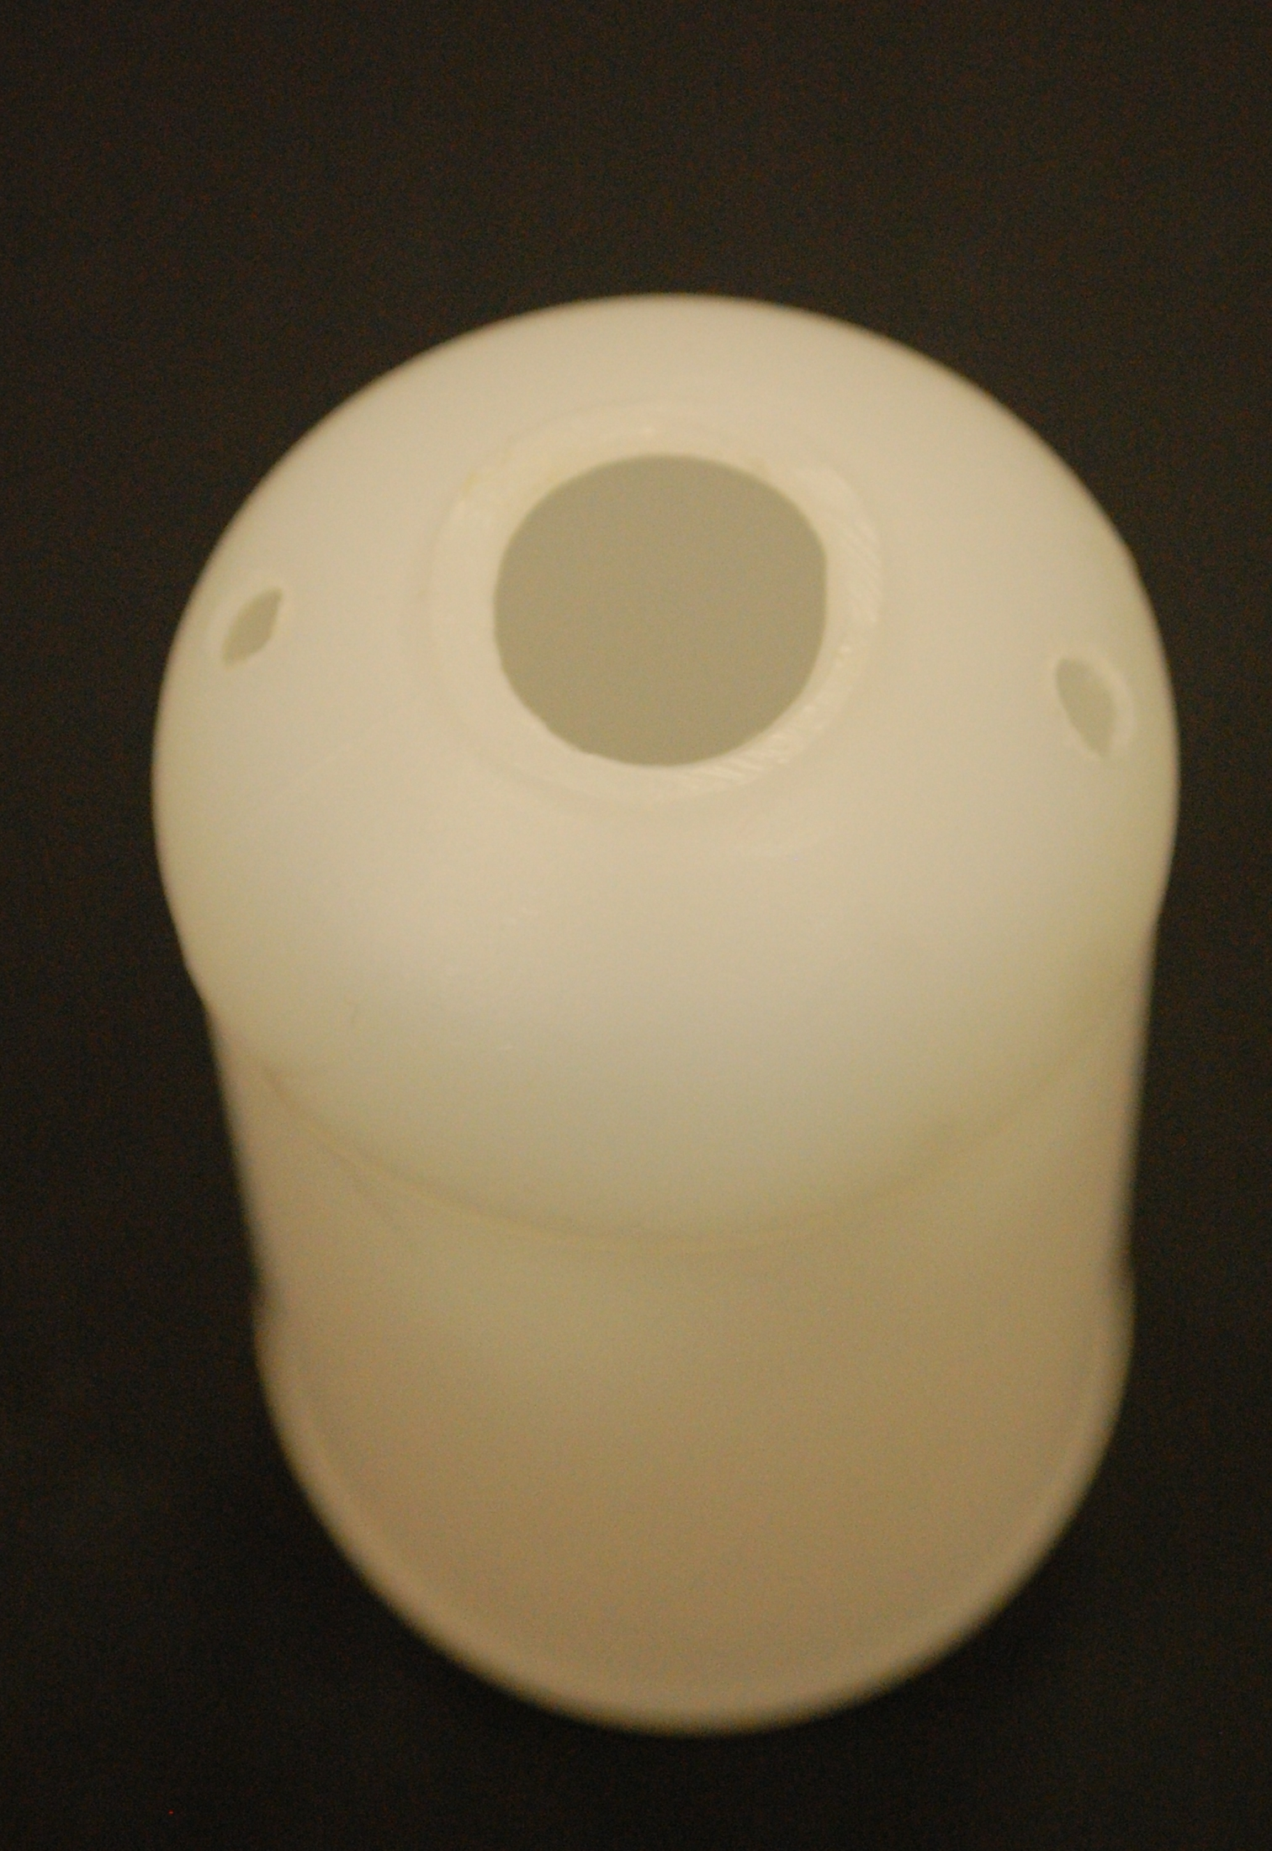
If you do not have conductivity flasks, it is possible to make a simple one with little trouble.
- Take a standard 100cm³ plastic bottle.
Use a hacksaw or sharp knife (or a hot knife) to cut off the neck of the bottle as shown.
Use a heated screwdriver or similar to make a couple of holes in the shoulders of the bottle – as shown.

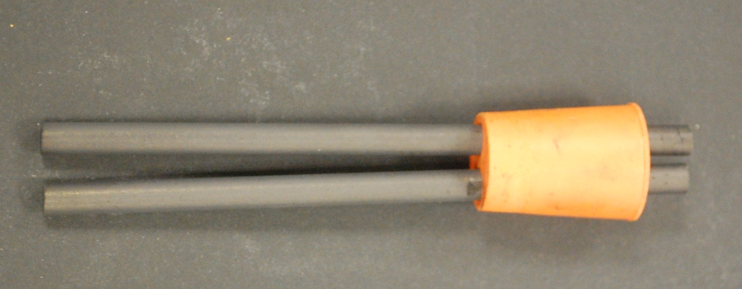
- Take a 2-holed bung that fits into the hole you now have in the top of your bottle.
Push 2 carbon rods through the bung, one through each hole, using petroleum jelly to help them go through.
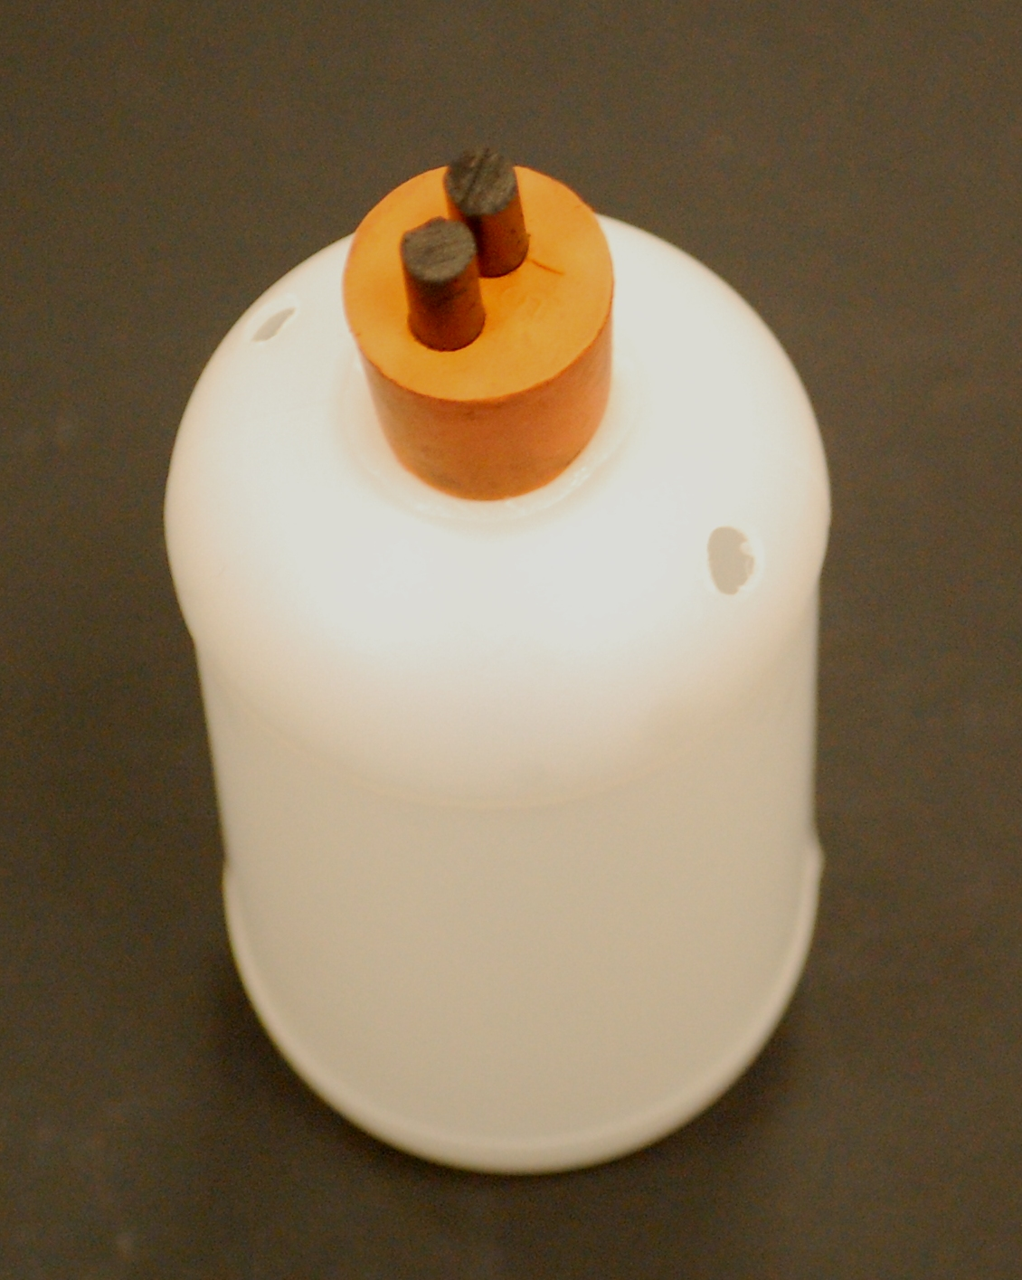
- Your conductivity flask is now made and should look like this.

Once it is connected up, you use the holes you made in the shoulder of the flask to add the reagent.

Ammeters

You might need to talk nicely to your physics colleagues to borrow suitable meters.

We have hade good results using multimeters but a lot of multimeters, especially the less expensive ones, do not measure AC current, only DC.

Trouble shooting
You need to take care to make sure that you do not short-circuit the set up by allowing the crocodile clips on the electrodes of the flask to touch. If this happens though, most power packs have a simple reset button.
You will find that different flasks will give different readings. This is normal in the circumstances. The bungs are not identical and so some have the electrodes closer than others. Also, there are slight variationsin the holes you cut so some will dip further into the solution than others.
Given the design, adding more electrolyte will lead to a greater current as there will be a larger area in contact with the solution as the height increases in the flask.
The weak acid/ base combination is likely to produce variable result that will not be accurate enough to determine the end point from the plotted conductivity curve.

