
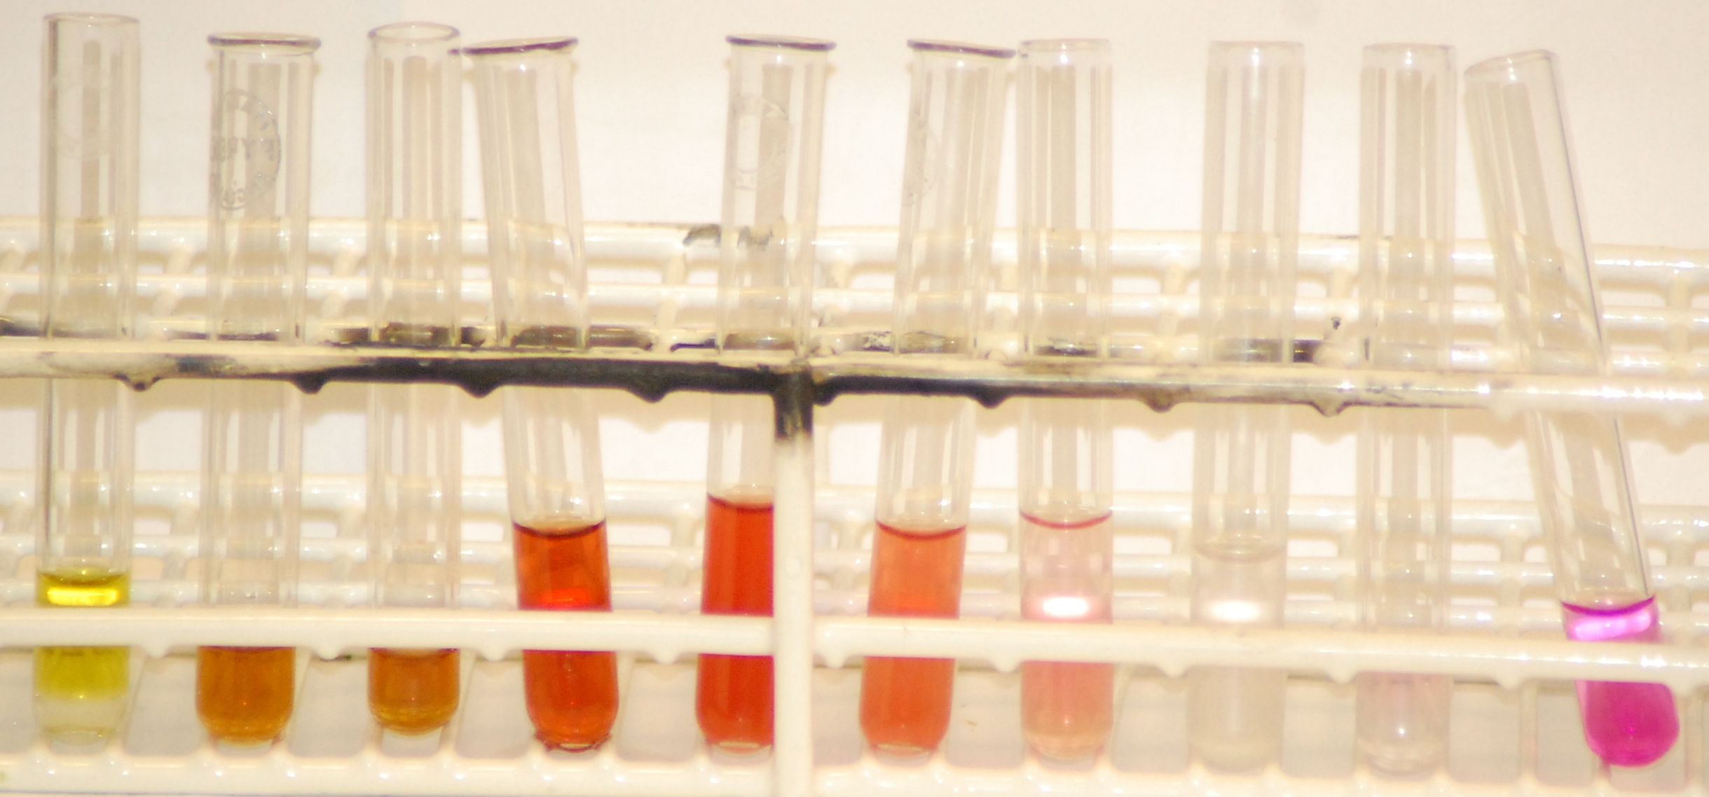
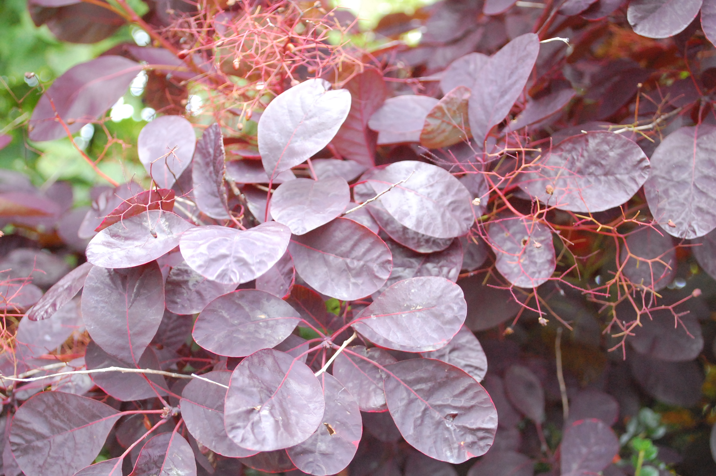
Flash Chromatography
Son of
Syringe Flash Chromatography

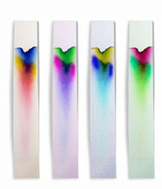
Introduction
If you look at a bottle of black food dye you can a list of three E numbers:- E102, E122 and E143. This indicates it is a mixture of three dyes.
This workshop will show you a way of separating this mixture – and others
All forms of chromatography work by exploiting different interactions between the dyes and the two components of the chromatography setup.
The stationary phase – this does not move and the liquids pass through it. (In ordinary paper chromatography, the paper is the stationary phase.)
The mobile phase – this is the liquid that moves through the stationary phase (like the water through filter paper)
Paper chromatography is a familiar technique in schools. A mixture of dyes (often an ink) is place on some filter paper and a solvent is allowed to run up/along the paper carrying the different dyes different distances.
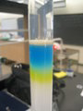
Column chromatography works on the same principle. The ‘ink’ is washed down a column filled with a permeable solid. The different dyes move at different speeds and so come out of the bottom at different times. The advantage of this is that you can get samples of your separated dyes to do further work on.
The problem in school is that column chromatography is slow – taking several hours. It can be speeded up by applying pressure to force the liquid through – a technique called Flash Chromatography.
Traditional versions of this use a glass tube filled with a starch slurry. This is then linked by rubber tubing to a syringe to apply the pressure.
In this method
  - the syringe itself is used as the column.
  - the stationary phase is either talc or cornflour
  - the packing is done dry (much easier)

Equipment required:
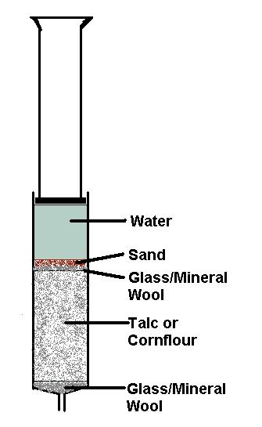
syringe 10 cm³
spatula
beaker, 100 cm³
Test tubes x 5
pasteur pipettes, 1x1 cm³, 1x3 cm³
stirring rod
Mineral wool

Chemicals required:

For packing the column
Talc (baby powder is fine) and/or cornflour
dry fine sand

For the elution
Colour mixture
Food colouring (ensure there is a mixture of colours in it as indicated by different E numbers) Black and green work best. Be aware though that more and more companies are changing their recipes and going to single dyes now.
Sweets - M&Ms, Skittles or similar. (Smarties now use natural dyes and are not mixtures.
Plant material – grass is a good source of photosynthetic pigments. Flowers, ‘red’ leaves etc can be used as sources of anthocyanins.
Solvent
For the food colouring, distilled water is fine.
For the plant materials:
- photosynthetics – extract in propanone and run using propanone or a less polar solvent – white spirit will work.
- Anthocyanins – extract in acidified ethanol/methanol. Run in a non-polar solvent first (such as white spirit) and then use a more polar one such as ethanol to extract the remaining anthocyanins.
Experiment 1 - Black food colouring.

Instructions
- Prepare the syringe as described in the experimental sheet.
- Get 5 cuvettes ready to collect the samples.
- Dot about 0.5cm³ of black food colour on the top of the mineral wool
- Sprinkle with sand.
- Put distilled water in the syringe and apply pressure.

You will see the colours starting to separate as you push the plunger in.

Hints
The first dye is only just separated from the second so your first sample should contain only 1 drop – or possibly 2. (You can add a small amount of water to get a sample that is easier to see if you want)
The second sample will be a mixture of 2 dyes, when you think you are getting a pure colour rather than a mixture, move on to the next tube/cuvette.
Carry on until you have samples of all 3 dyes.

Results
 | Sample | Colour
Tube 1 | Dye 1 | …………………………………………………
Tube 2 | Dyes 1 & 2 | …………………………………………………
Tube 3 | Dye 2 | …………………………………………………
Tube 4 | Dyes 2& 3 | …………………………………………………
Tube 5 | Dye 3 | …………………………………………………
Experiment 2 - Sweets

Instructions
- Prepare the syringe as described in the experimental sheet.
- Get 5 cuvettes/small test tubes ready to collect the samples.
- Put your chosen sweet (you are getting a brown M&M) in a test tube and just cover it with distilled water from the wash bottle.
- Leave for a couple of minutes then use a Pasteur pipette to pick up about 0.5 - 1cm³ of the colour and dot it on the top of the mineral wool.
- Sprinkle with sand.
- Put distilled water in the syringe and apply pressure.

If you have chosen the right colour sweet, you will see the colours starting to separate as you push the plunger in.

Hints
Try to use the minimum amount of water to make sure your solution is as concentrated as possible.

Results
 | Sample | Colour
Tube 1 | Dye 1 | …………………………………………………
Tube 2 | Dyes 1 & 2 | …………………………………………………
Tube 3 | Dye 2 | …………………………………………………
Tube 4 | Dyes 2& 3 | …………………………………………………
Tube 5 | Dye 3 | …………………………………………………
Experiment 3 – Photosynthetic pigments from grass

Instructions
- Prepare the syringe as described in the experimental sheet.
- Get 5 small test tubes ready to collect the samples. NOT CUVETTES
- Take a small sample of grass, chop it into the mortar with scissors, add some sand and grind it to a pulp.
- Add about 5 cm³ of propanone and mix again.
- Leave for a minute or so to settle then use a Pasteur pipette to pick up about 0.5 – 1 cm³ of the colour and dot it on the top of the mineral wool.
- Sprinkle with sand.
- Put propanone in the syringe and apply pressure.

Hints
As for the black food colouring, there is little separation between the first 2 pigments so the first sample should only be 2 or 3 drops.

Results
 | Sample | Colour
Tube 1 | Dye 1 | …………………………………………………
Tube 2 | Dyes 1 & 2 | …………………………………………………
Tube 3 | Dye 2 | …………………………………………………
Tube 4 | Dyes 2& 3 | …………………………………………………
Tube 5 | Dye 3 | …………………………………………………

Experiment 4 – Anthocyanins from Cotinus leaves

Instructions
- Prepare the syringe as described in the experimental sheet.
- Get 5 small test tubes ready to collect the samples.
- Take a small sample of the leaves, chop into the mortar with scissors, add some sand and grind it to a pulp.
- Add about 5 cm³ of acidified ethanol and mix again.
- Leave for a minute or so to settle then use a Pasteur pipette to pick up about 0.5 – 1 cm³ of the colour and dot it on the top of the mineral wool.
- Sprinkle with sand.
- Put cyclohexane (or another polar solvent) in the syringe and apply pressure.
- It will probably take 2 syringes full to get most of the green/yellow photosynthetic pigments through, (1 refill).
- Then switch to propanone. This should get the first of the anthocyanins through and will flush out the cyclohexane.
- When most of this colour is through, switch to ethanol for the final anthocyanin. You should manage to get 2 colours, very close together, a blue and a pink but only a drop or two of each.

Hints
The separation of photosynthetic pigments is not as good here but you may manage to see a separate green and yellow.
Don’t forget that there will be overlaps where the colours are mixed, you can just collect all these together in a waster bottle/tube if you want.

Results
(over the page)

 | Sample | Colour
Tube 1 | Dye 1 | …………………………………………………
Tube 2 | Dye 2 | …………………………………………………
Tube 3 | Dye 3 | …………………………………………………
Tube 4 | Dye 4 | …………………………………………………
Tube 5 | Dye 5 | …………………………………………………

Extensions / alternatives
Other stationary phases may give different results – using cornflour for the black food dye extracts the colours in a different order.
There is more experimantation to be done here on the separation of plant pigments, particularly regarding the selection of the plant and the solvents.
If you have enough small tubes then a good technique is to let equal numbers of drops fall into each tube. That way you get something like this
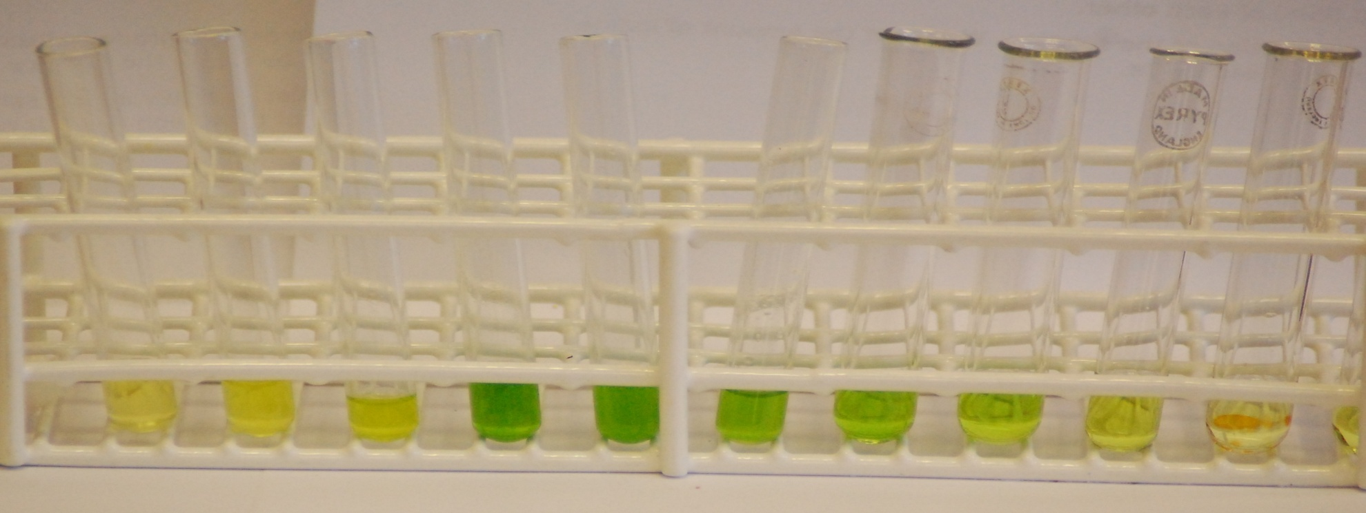
Photosynthetic pigments in grass

