
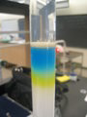
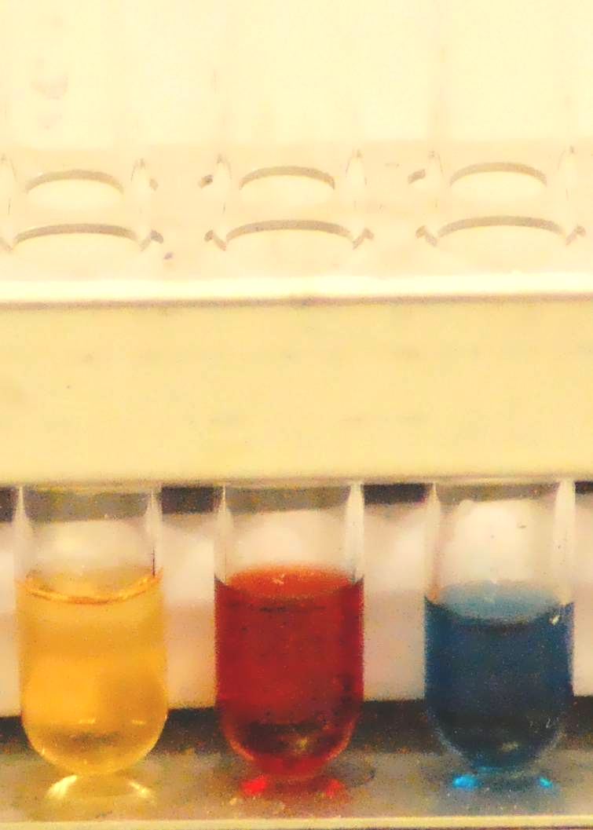
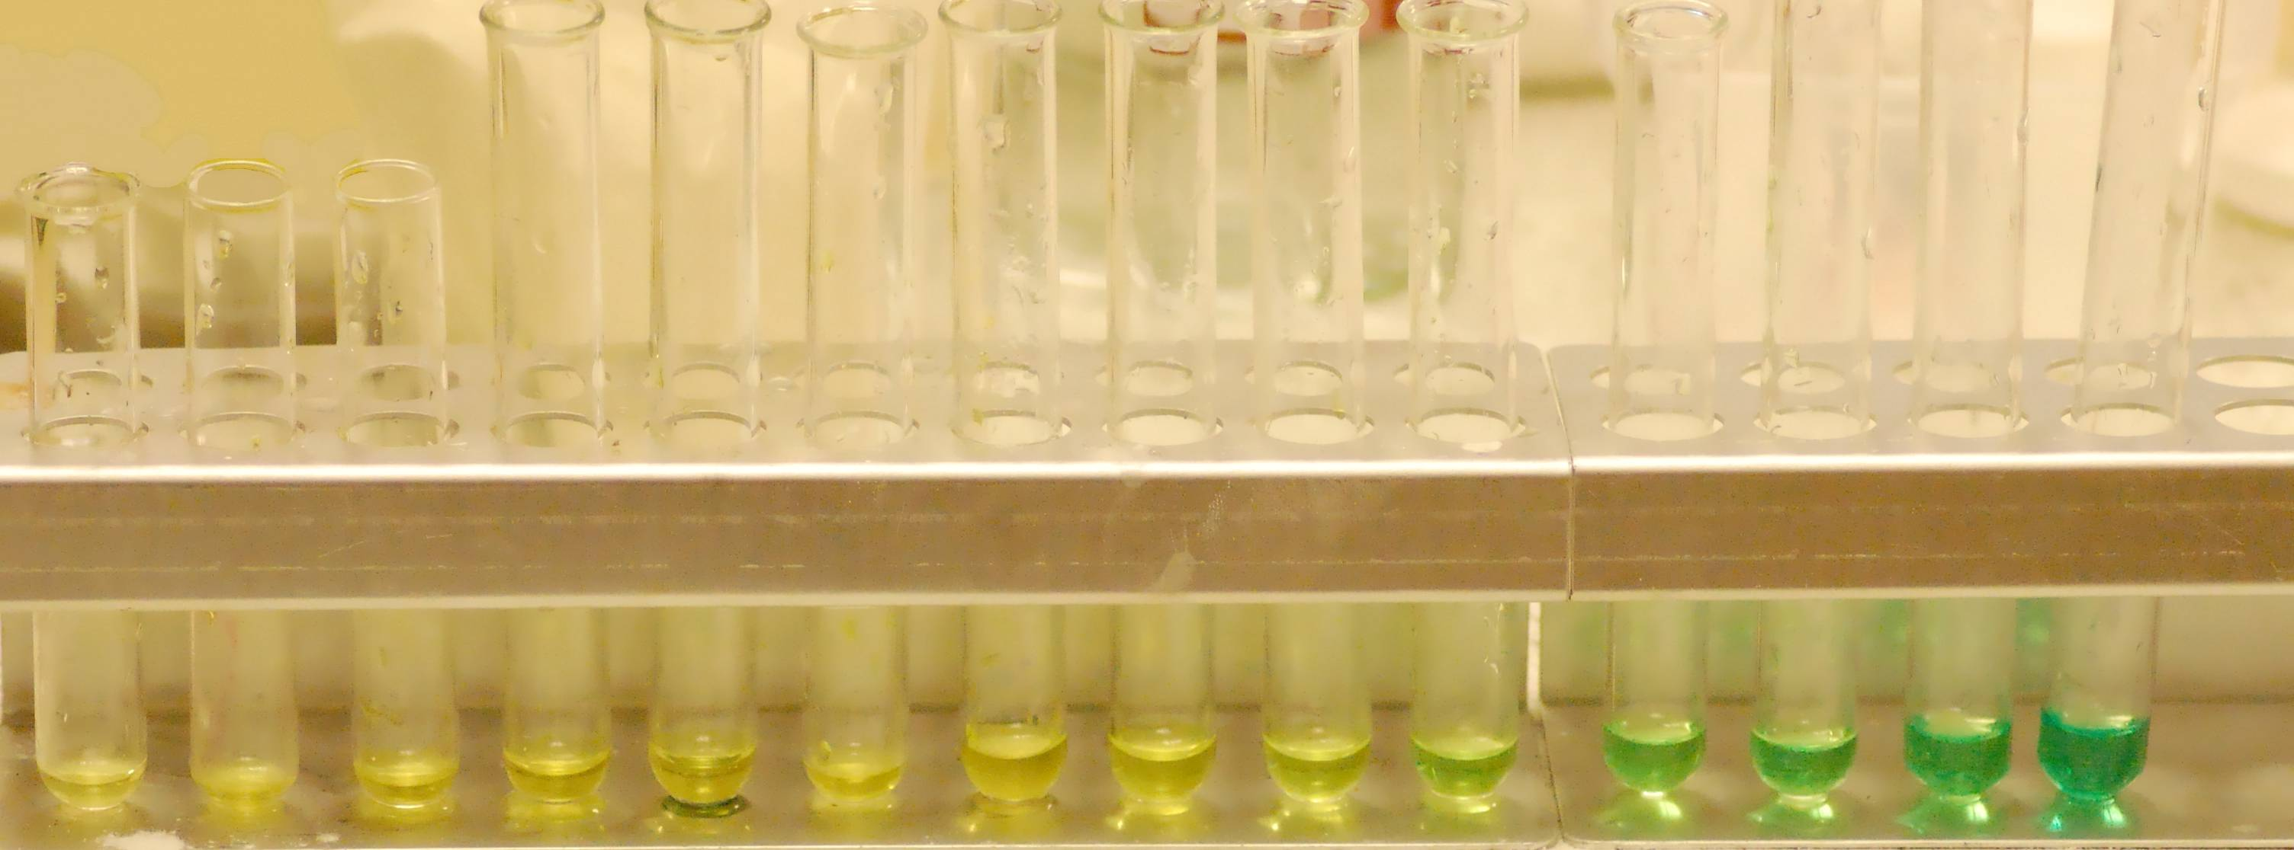
Son of . . .
Flash Chromatography
Teacher’s / Technician’s Guide


Syringe Flash Chromatography

Introduction
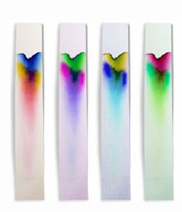
If you look at a bottle of black food dye you can see it is a mixture of three E numbers:- E102, E122 and E143. This indicates it is a mixture of three dyes.
This workshop will show you a way of separating this mixture – and more
This technique could be used to support learning outcome SCN 3-16a - I can differentiate between pure substances and mixtures in common use and can select appropriate physical methods for separating mixtures into their components.
All forms of chromatography work by exploiting different interactions between the dyes and the two components of the chromatography setup.
The stationary phase – this does not move and the liquids pass through it. (In ordinary paper chromatography, the paper is the stationary phase.)
The mobile phase – this is the fluid that moves through the stationary phase (like the water through filter paper)
Paper chromatography is a familiar technique in schools. A mixture of dyes (often an ink) is place on some filter paper and a solvent is allowed to run up/along the paper carrying the different dyes different distances.
Column chromatography works on the same principle. The ‘ink’ is washed down a column filled with a permeable solid. The different dyes move through the column at different speeds and so come out of the bottom at different times. The advantage of this is that you can get samples of your separated dyes to do further work on.
The ability to show separate dyes in separate containers can show how this technique can recover the constituent parts – a task which is a little more difficult with paper chromatography.
The problem in school is that column chromatography is slow – taking several hours. It can be speeded up by applying pressure to force the liquid through – a technique called Flash Chromatography.
Traditional versions of this use a glass tube filled with a starch slurry. This is then linked by rubber tubing to a syringe to apply the pressure.
Unfortunately, this method is rather fiddly – stirring of the slurry is critical and the tube tends to pop off when pressure is applied.
In this new method
  - the syringe itself is used as the column.
  - the stationary phase is either talc or cornflour
  - the packing is done dry (much easier)

Equipment required:
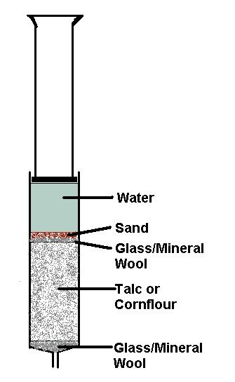
syringe 10 cm³
spatula
beaker, 100 cm³
Test tubes x 5
pasteur pipettes, 1x1 cm³, 1x3 cm³
stirring rod
Mineral wool

Chemicals required:

For packing the column
Talc (baby powder is fine) and/or cornflour
dry fine sand

For the elution
Colour mixture
Food colouring (ensure there is a mixture of colours in it as indicated by different E numbers) Black and green work best.
Sweets M&Ms, Skittles or similar. (Smarties now use natural dyes and are not mixtures).
Plant material – grass is a good source of photosynthetic pigments. Flowers, ‘red’ leaves etc can be used as sources of anthocyanins.

Solvent
For the food colouring, distilled water is fine.
For the plant materials:
- photosynthetics – extract in propanone and run using propanone or a less polar solvent – white spirit will work.
- Anthocyanins – extract in acidified ethanol/methanol. Run in a non-polar solvent first (such as white spirit) and then use a more polar one such as ethanol to extract the remaining anthocyanins.

Hints and Tips

Syringe size – You seem to get the best separation using a narrow bore such as a 1cm³ syringe but they are very fiddly to pack. Most of the time I just use what is available – I have generally used 5 cm³ or 10 cm³ syringes (It is a good use for old syringes with the markings worn off).
Packing - It is possible to run the column dry – ie without running the solvent through first. This way does give slightly better packing and more consistent results so if time is not an issue, it is preferable to do so.
Pressure – It can get a bit tiring holding the plunger but it seems not to cause problems to the separation if you release the pressure for a bit, to rest or change hands
Stationary Phase – I have had most success with starch and, especially, talc (using simple cornflour and talcum powder) but you can try anything. You can see interesting effects by trying different materials. Colours will sometimes come out in a different order.
Eluent volume – I have had no problems with simply pulling out the plunger when all the solvent has gone into the column (carefully) re filling the barrel of the syringe and carrying on – sometimes the plug of talc/starch gests pulled up the tube, sometimes it breaks and part of it does but pushing back down and carrying on seems to have little deleterious effect.
Mobile Phase – you can try any solvent as long as it is not going to dissolve the syringe.
Plant Materials – For this technique, there is, as yet, no body of information about which plants work best with which solvents / solids. We have given a couple of ideas for initial experiments on the pages that follow but please try anything . . . and pass on any interesting results!
How to prepare and run the column

- Preparing the column

- Insert a loose plug of mineral wool into the syringe and tamp down with the stirring rod.
- a. Talc – use the spatula to put talc in up to roughly the 8 cm³ line
b. Cornflour – Use the spatula to put cornflour in up to roughly the 5 cm³ line
- Insert another plug of mineral wool and tamp it down with the glass rod again – quite firmly.
- Put 2 or 3 cm³ of distilled water on the top (using either a wash bottle or a pasteur pipette.
- Insert the plunger and press to force the water through. Push hard and keep going until the plunger is pressed firmly against the talc/starch and has compressed it as far as possible.
- Pull out the plunger. The plug of talc/starch may well be pulled up the barrel of the syringe by the suction. But you can just push it back down carefully – using the stirring rod or the bulb end of a pasteur pipette.
It is possible to run the column dry – ie without running the solvent through first. This way does give slightly better packing and more consistent results so if time is not an issue, it is preferable
- Running the column
- Take the 1 cm³ pasteur pipette and use it to pick up between 0.25 and 0.5 cm³ of the food colouring. Carefully dot this over the mineral wool in the barrel of the syringe (try not to get any on the sides)
- Put a layer of silver sand on the top, a few mm thick, then carefully add distilled water again trying not to disturb the sand too much so you keep the water clean. Fill up to the 10 cm³ line (or a bit more)
- Insert the plunger and apply pressure. To start with let the liquid drip into the beaker. Watch very carefully for the first signs of colour.
- When you see the first hint of colour, move the syringe so it is over the first test tube and keep pressing. (If it is black food colouring, the first colour will be literally one or two drops.
- When you see the colour changing, move to the next tube and keep pressing until you think it is a new colour then move to the third test tube and get a sample of that colour. If there is a third colour then repeat the process with the 4th tube for the mixture and the 5th for the next pure colour.
- If your syringe runs dry, pull out the plunger, push back the plug that will probably have been pulled up by the suction, put more water in, replace the plunger and carry on.

Hints and Tips
Syringe size – You seem to get the best separation using a narrow bore such as a 1ml syringe but they are very fiddly to pack. Most of the time I just use what is available – I have generally used 5ml or 10ml syringes (It is a good use for old syringes with the markings worn off).
Pressure – It can get a bit tiring holding the plunger but it seems not to cause problems if you release the pressure for a bit, to rest or change hands
Medium – I have had most success with starch and, especially, talc (using simple cornflour and talcum powder) but feel free to try any. You can see interesting effects by trying different materials. Colours will sometimes come out in a different order.
Eluent volume – I have had no problems with simply pulling out the plunger when all the solvent has gone into the column (carefully) re filling the barrel of the syringe and carrying on – sometimes the plug of talc/starch gests pulled up the tube, sometimes it breaks and part of it does but pushing back down and carrying on seems to have little deleterious effect.
Solvent – you can try any solvent as long as it is not going to dissolve the syringe
Experiments
  - Food colouring – green and black food colours seem to be the only ones containing more than one dye (and not all of those) so check first. With the black one (using talc) the yellow dye is only one or two drops so care is needed when the colour first comes through.
(Here is a photo of the colours obtained from black food colouring (using a 1ml syringe)
You do not usually get a clear separation between tubes – the colours tend to run into each other. The diagram below shows the results using a green food colouring allowing 10 drops to fall into each tube before moving on

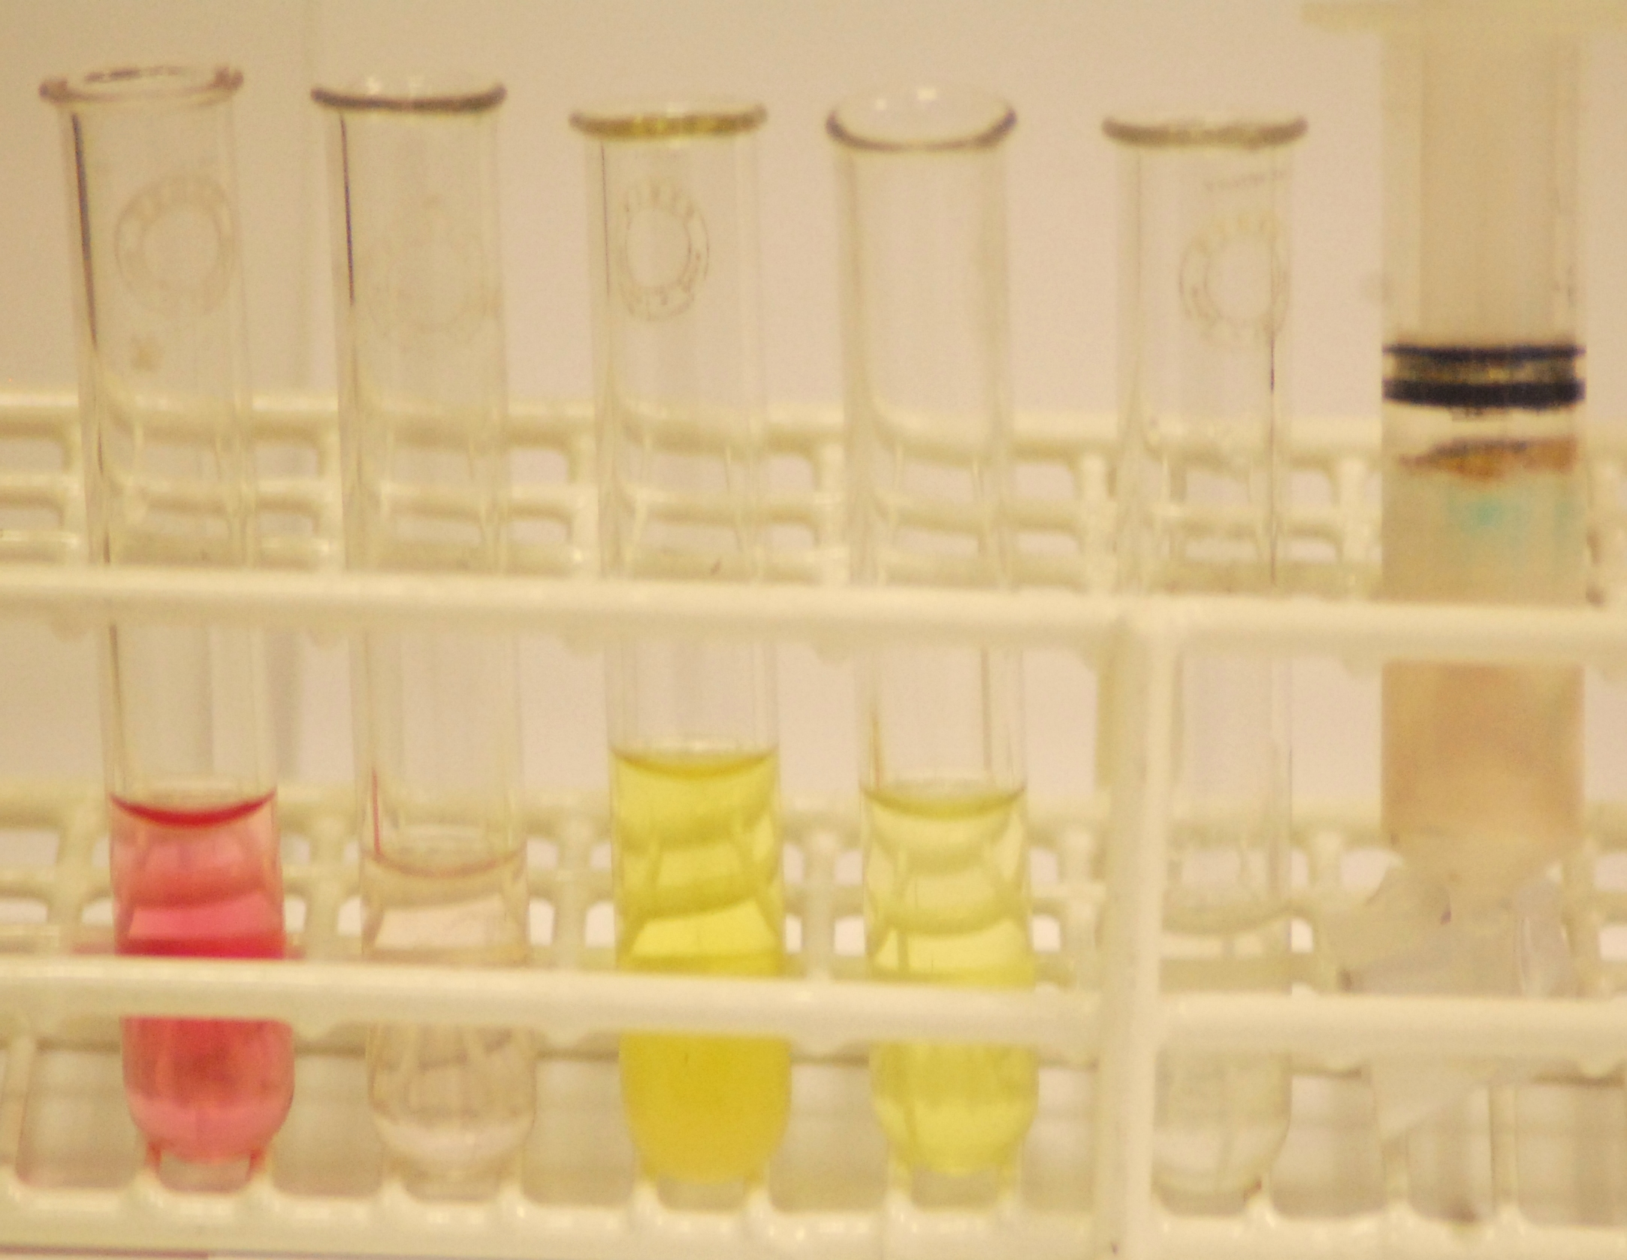
  - Sweets – the colours of sweets can be extracted by putting one or two in a test tube with just enough water to cover them. There are not many sweets that seem to have different dyes – try the brighter ones like skittles and M&Ms.
The picture here shows a brown M&M using talc – you can see the red and yellow have come out well enough but the blue remains in the column (you can see it at the top). If you change the solvent at this stage then it is usually possible to elute otherwise stubborn colours.
  - Plant Extracts
    - Chlorophylls – It is possible, with care to separate out at least some of the different leaf pigments. Although spinach is normally used, I have found that grass is better (I think the water content of the spinach leaves is to blame). A method I have used successfully is to
- Grind up a few g of chopped grass with some silver sand and extract with propanone.
- Load it onto the ‘column’ and elute using white spirit.
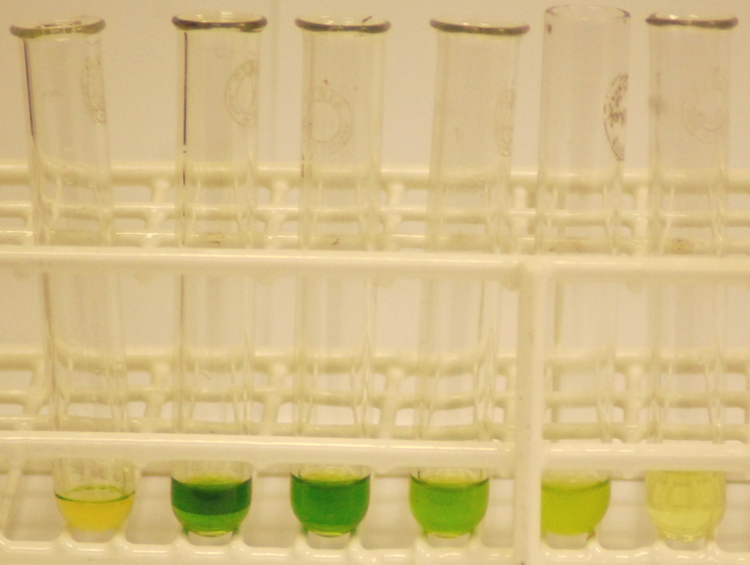
As white spirit is a non-polar solvent, the constituents come out in reverse order of polarity.
The photo here shows the results of such a run. I think the left hand yellow tube contains Xanthophyll (possibly some carotene)
Then comes the green chlorophyll a
And then the yellow/green chlorophyll b
    - Anthocyanins – If you choose a red-leafed plant, it is possible to separate out the pigments that give it the red colour as well. These need extracting in acidified methanol/ethanol (1cm³ HCl_{(c)} in 100cm³ alcohol)
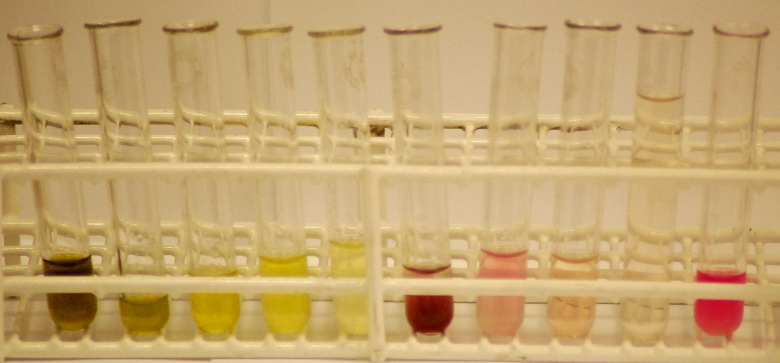
The picture below shows Cotinus (a common ornamental shrub) leaves extracted in acidified ethanol and then eluted with white spirit. You can see the dark green chlorophyll a on the right followed by the yellower chlorophyll b and then a red anthocyanin. The bright pink colour (another anthocyanin) remains resolutely in the talc medium until you add a more polar solvent, in this case ethanol, to extract it.

Each group will need

For all the experiments.
1 or more syringes – 5 or 10 cm³ are best*
spatula
pasteur pipettes, 1x1 cm³, 1x3 cm³
stirring rod
Mineral wool
Test tubes x 5 (or cuvettes – just containers to collect small amounts of the eluted solvent)
Test tube rack (if test tubes are being used above)
Talc (baby powder is fine) and/or cornflour
Small beaker (with water in for rinsing out Pasteur pipette)
distilled water
dry fine sand
* It is quite possible to wash out a syringe, dry the inside with paper towel and then re-use the same one if there is a shortage.

Specific Experiments

- Food colouring (ensure there is a mixture of colours in it as indicated by different E numbers) Black and green work best.
  - Check the food colouring first (a look at the label should be enough) not all are mixtures.

- Sweets
  - Choose brightly coloured sweets – M&Ms or skittles work (some colours at least.
  - In addition to the above, each group will need
    - a test tube (one per sweet colour)
    - test-tube rack.
- Plants
  - For photosynthetic pigments, grass works well. In addition to the above, each group will need
    - A pestle and mortar
    - A pair of scissors (to chop the plant material prior to grinding)
    - Propanone for the extraction. (approximately 5 cm³)
    - Propanone or another polar solvent such as ethanol (IMS is fine) – you can also try less polar solvents such as white spirit.

  - For anthocyanins, try anything coloured and see what happens.
    - A pestle and mortar
    - A pair of scissors (to chop the plant material prior to grinding)
    - Acidified ethanol/methanol** for the extraction. (approximately 5 cm³)
    - White spirit (or another non-polar solvent such as petroleum ether or cycloxexane) and then a polar solvent such as ethanol (IMS is fine)

** The acidified alcohol is prepared by adding 1cm³ of concentrated HCl (corrosive) to 100cm³ of the alcohol.

