
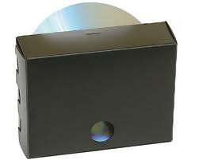
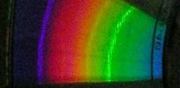
The Construction of the
periscope-type DVD spectroscope

This spectroscope must be made using a sheet of card which is impenetrable to light as it is desirable that the inside of the spectroscope is black.

The full-size paper pattern of the periscope-type DVD spectroscope is attached on the pdf file “Spectroscope plan” in the folder. The length indicated by the arrow should be 50 mm. Check it is and if not, rescale.

Any mirror sheet of 2mm thickness or less will do.

As a DVD, you can use single-sided (4.7GB) or double-sided (9.4 GB)
single-layer-type DVD-ROM or DVD±R/RW (2). A double-layer-type DVD cannot be used because it does not act as a simple grating. A DVD-RAM cannot be used because its line pitch is as half as that of other DVDs. The DVD has to be cut to eighth parts with scissors or a cutter for plastics. A higher-speed band-saw for woodworking is also applicable. Please be cautious not to be injured by the debris of the DVD when you cut the DVD. You should wear safety glasses to protect your eyes. Sometimes, it is difficult to cut DVD properly.

The slit should be cut narrowly and sharply: the slit width of ca. 0.5 mm is sufficient to resolve two yellow lines of mercury at 577 and 579 nm. However, narrower and sharper slit are required to obtain high resolution enough to resolve Na D lines.

If you want to take photographs of the observed spectra, it is recommended that a round viewing window of diameter slightly less than the lens body be cut (See page 3 of the “Spectroscope plans” pdf document). The lens body is inserted to the window and the spectroscope can be supported by the tension of the card stock. In this design, the diameter of the lens body that can be inserted is restricted to less than 30 mm.

To construct a spectroscope you will need:

A full-size paper pattern
Black card to copy the pattern onto
A piece of thin mirror sheet ca. 2mm thick and 15 mm X 15 mm square
A piece cut from a DVD. This is a one eighth (1/8) segment
A black felt tip pen able to write on plastic

You will also need

Scissors or blade
Tube of paper glue
Double sided sticky tape
A ruler or straight edge

Suitable mirror sheet can be purchased from MUTR. http://www.mutr.co.uk/
Mirror Card GS6-007A – A4 size - £1.01 ex VAT

