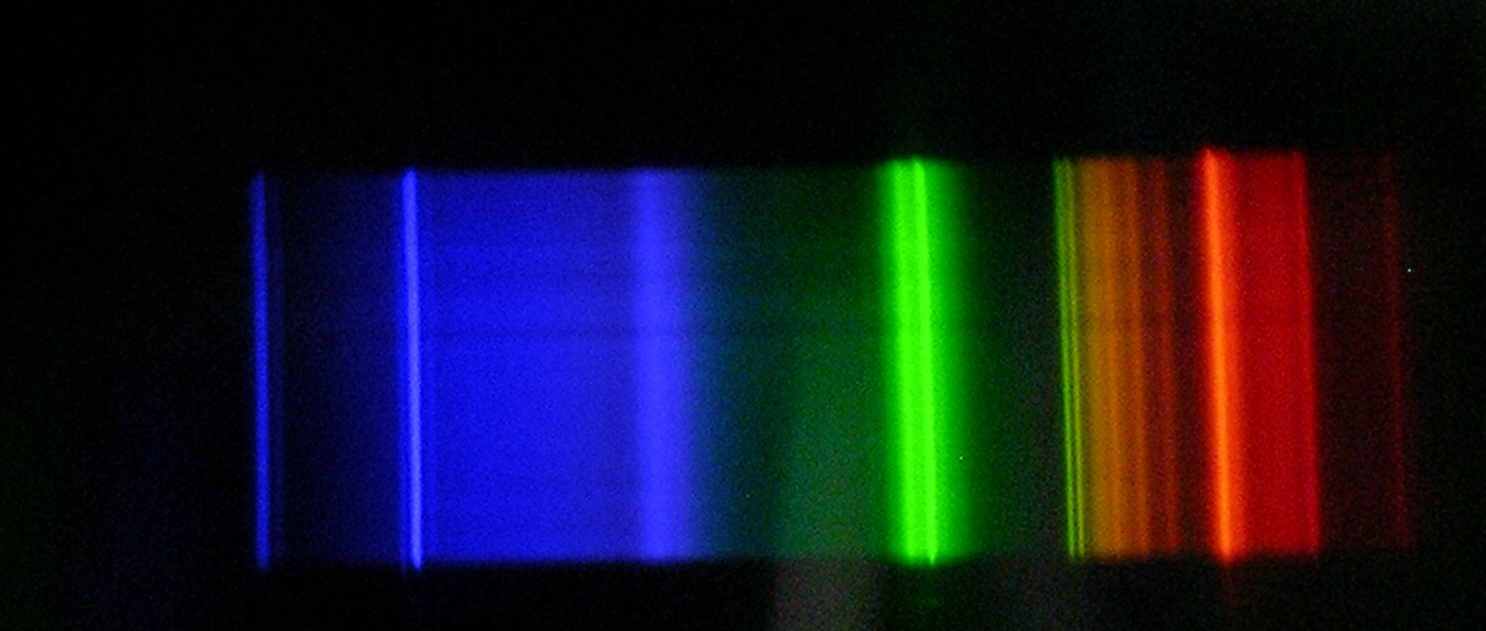
Analysing Emission Spectra using Tracker


Spectrum Analysis Using tracker.jar

This guide assumes that you have taken a digital photo of a spectrum in jpeg format. The photo should have been transferred to your computer.

Starting Tracker

When you start tracker.jar you will see the following screen:

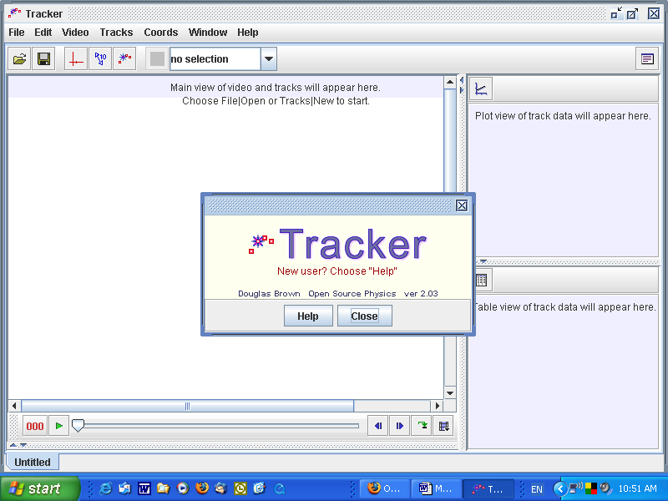

Click Close, which closes the window that offers help, not the application.

The first thing you must do is to import a photo of a spectrum into tracker.jar. Choose Import… from the Video menu.

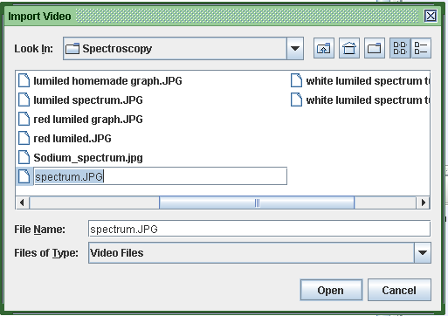

Find the file you want to open, click on it then click Open.

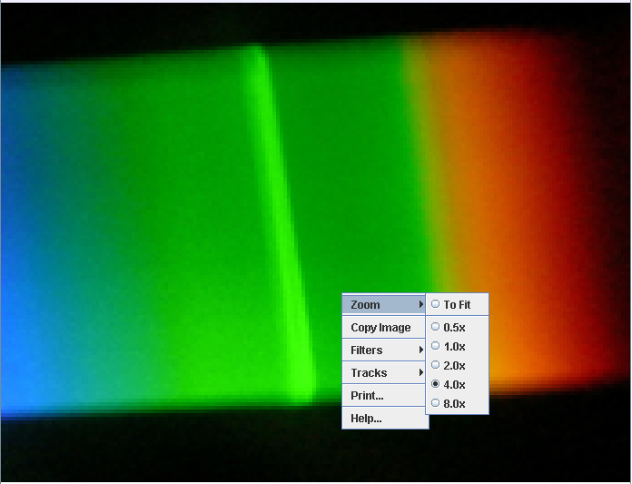

If your spectrum is too small or if only part of it is visible, right click on it, go to Zoom and choose a suitable setting.

Another way of getting a spectrum into tracker

Open your picture using Microsoft Paint, a program that is found on most Windows computers under Accessories.

Use the selection tool (circled in red below) to drag over the part of the photograph that you want to analyse.

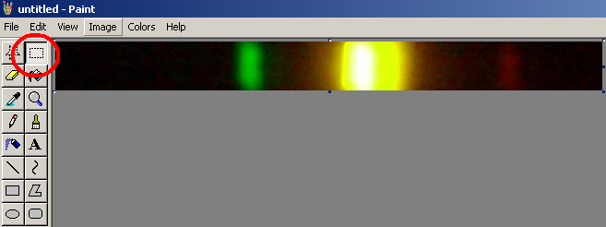

Go to Edit. Choose Copy.

Switch to tracker. Go to Video and choose Paste Image.

If you already have an image in tracker, choose Replace Video.

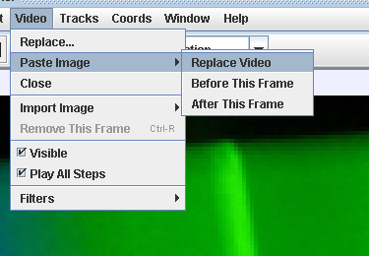

Again, you can use the zoom tool to make the spectrum the size you want it to be.

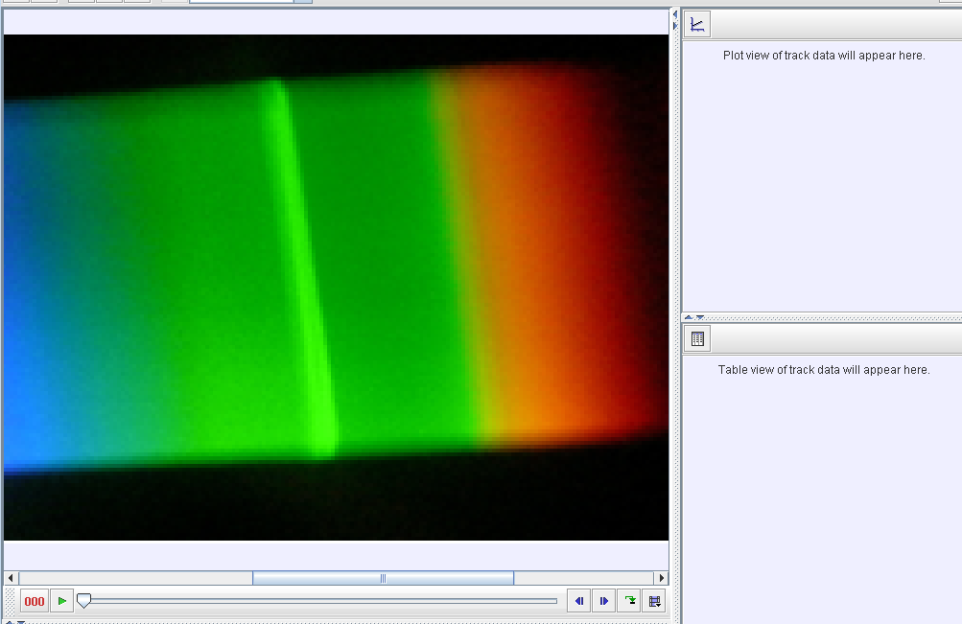

Scroll bar

The scroll bars can be used to position your spectrum.

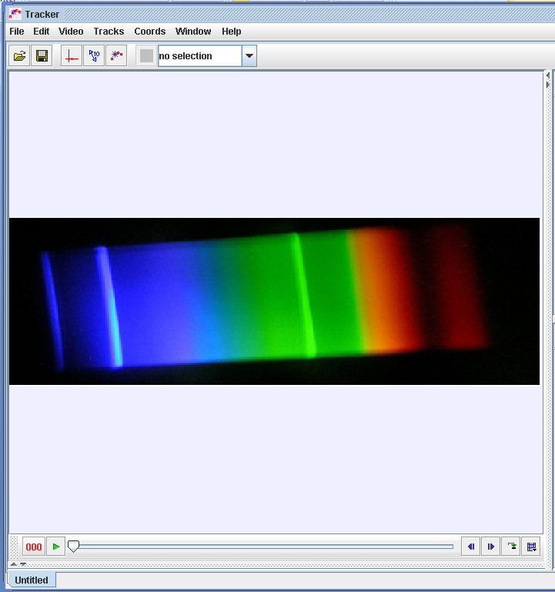
By zooming and using the scroll bars, you should be able to get your spectrum filling the tracker screen.

We will now use a tool called a line profile to analyse the pixel brightness of each part of the spectrum.

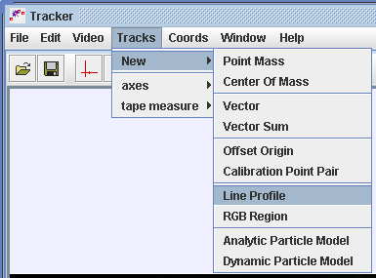
Go to Tracks.

Choose New.

Select Line Profile.

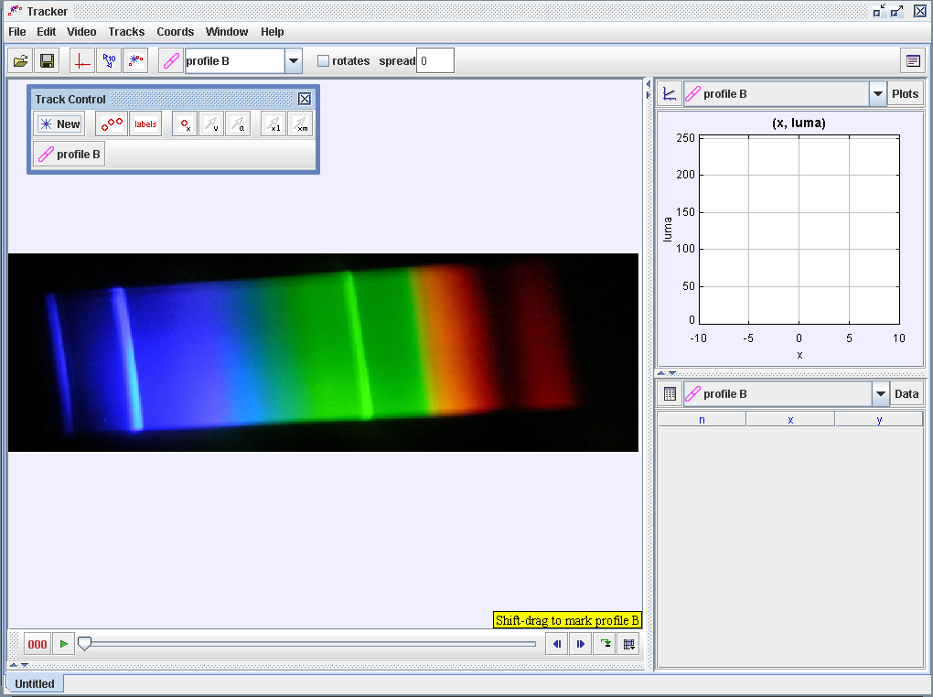

Down at the bottom right of the tracker screen, you should see a message that tells you to shift-drag to mark the line profile.

Move your mouse to the left of the spectrum, about half way down.

Hold down Shift.

Drag with your mouse. (If this doesn’t work first time, try again).

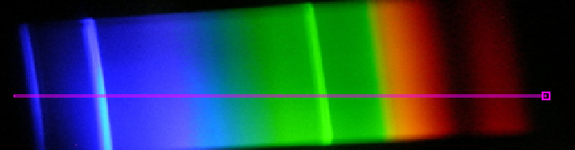

Drag right across the spectrum, as shown above.

At the top right of your screen, a graph like the one below should appear.

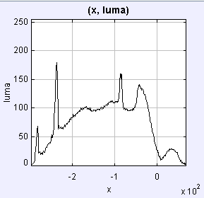

This is a spectrograph. The peaks correspond to the brightest parts of the spectrum. You can make it larger by double-clicking it.

A commercial spectrograph (see below) would have wavelength on the x-axis.

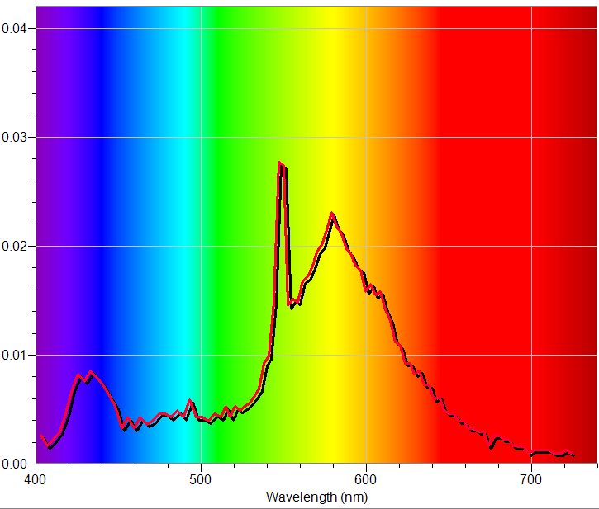
Calibrating

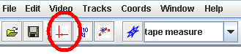 | Import a picture of a full spectrum into tracker.jar. (The file Lumiled homemade2 is suitable)  Click the axes tool
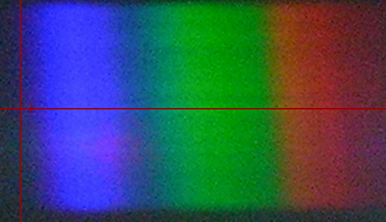 | Use your mouse to position your axes so that the origin is at the leftmost edge of the blue end of the spectrum.  The vertical position does not matter.
The human eye responds to wavelengths between 380 nm and 750 nm (approximately).

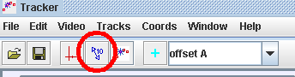 | Click the ruler tool.  Drag the ends of the ruler so that one is at the blue extreme of the spectrum and the other is at the red extreme.
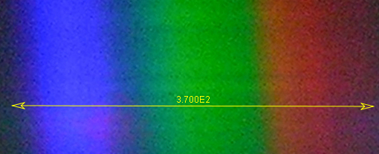 | Double click on the number.  Change it to 370 (i.e. 750-380)  Tracker will turn this into scientific notation.
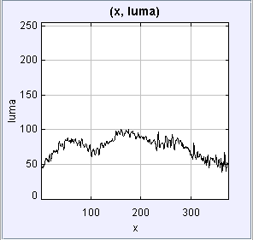 | Set up a line profile as shown earlier.  Click the x below the x-axis of the graph.  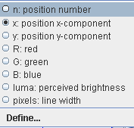  Select Define from the pop-up that appears.

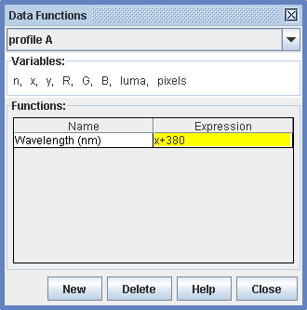 | Click New and enter Wavelength (nm) as the name of your variable.  Enter x+380 as the expression.  What you are doing here is defining a variable called wavelength (nm) that will be equal to the x value of your graph plus 380.  Click Close.
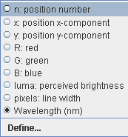 | Click the x below the x-axis again. Select wavelength (nm).  Your spectrograph should now be calibrated in nm along the x-axis.
Here’s how it happened:

- We moved the origin to the blue end of the spectrum.

- We used the ruler to define the spectrum as covering a range of 370 nm.

- We defined a variable wavelength which was equal to the x value + 380, so that the blue end of the spectrum (x value 0) became 380 nm and the extreme of the red end (x value 370) became 370 + 380 = 750 nm.

Finally, we can right click on “luma” on the y – axis and choose Autoscale from the list that pops up.

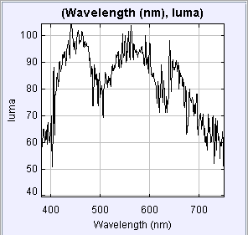 | 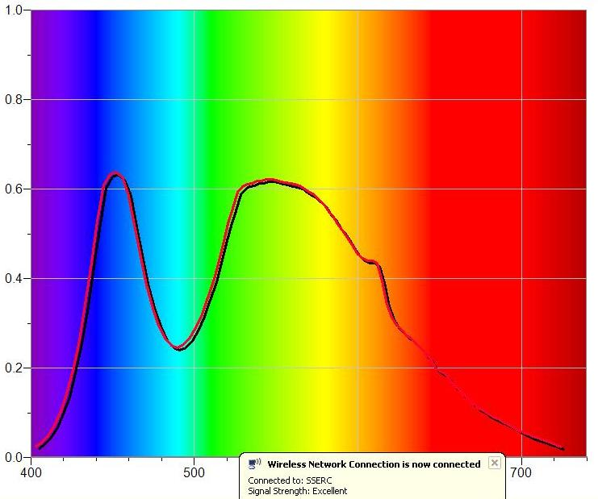
It is interesting to compare your home-made spectrographs with those made using a commercial spectrophotometer.

How might you use this technique to find, say, the wavelength of the sodium yellow line?

