
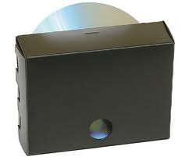
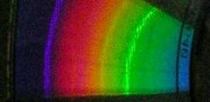

The Construction of the
periscope-type DVD spectroscope

To make your own spectroscope, you will need:

Black card with the spectroscope pattern copied onto it
A piece of thin mirror sheet ca. 2mm thick and 15 mm X 15 mm square
A piece cut from a DVD. This is a one eighth (1/8) segment
Scissors or blade
Tube of paper glue.
Double sided sticky tape.
A black felt tip pen which will write on plastic
A ruler or straight edge

- Check you can see the outline for cutting and the dotted lines for folds are visible on the black card.

- Cut around the outside solid lines and use a pair of scissors or a blade to carefully score (but not cut) along the dotted lines. See the paper pattern on the back of this sheet if unsure.

- Cut out the viewing window and the slit for the light to enter.

- Use double sided sticky tape to fix the square of mirror onto the black Spectroscope template at the position indicated (position 2). See the paper pattern on the back of this sheet if unsure.

- Check the piece of DVD. The clear plastic outer and inside rims can reflect light so need to be blacked out with the felt tip pen. If need be, do this now.

- Use double sided sticky to tape the piece of DVD with the recording surface upper most onto the black Spectroscope template at the position indicated on the paper pattern (position 3). See the paper pattern on the back of this sheet if unsure.

- Fold up each of the sides and the flaps and ensure the spectroscope fits together and you understand what needs to be glued.

- Now glue each of the flaps to form the spectroscope (note that some will have to be glued on the reverse). Ensure the side with the viewing window is folded in last.

The template for the construction of this spectroscope was devised by

Fumitaka Wakabayashi
Department of Science and Engineering, National Museum of Nature and Science,
3-23-1 Hyakunin-cho, Shinjuku-ku, Tokyo 169-0073, Japan; f-waka@kahaku.go.jp
This is NOT drawn to size and should not be used to construct the spectroscope.
For the full sized pattern to use, see the pdf document ‘Spectroscope plan’ (page 3).
This page will also give instructions on how to take a photograph of a spectrum using the spectroscope.

