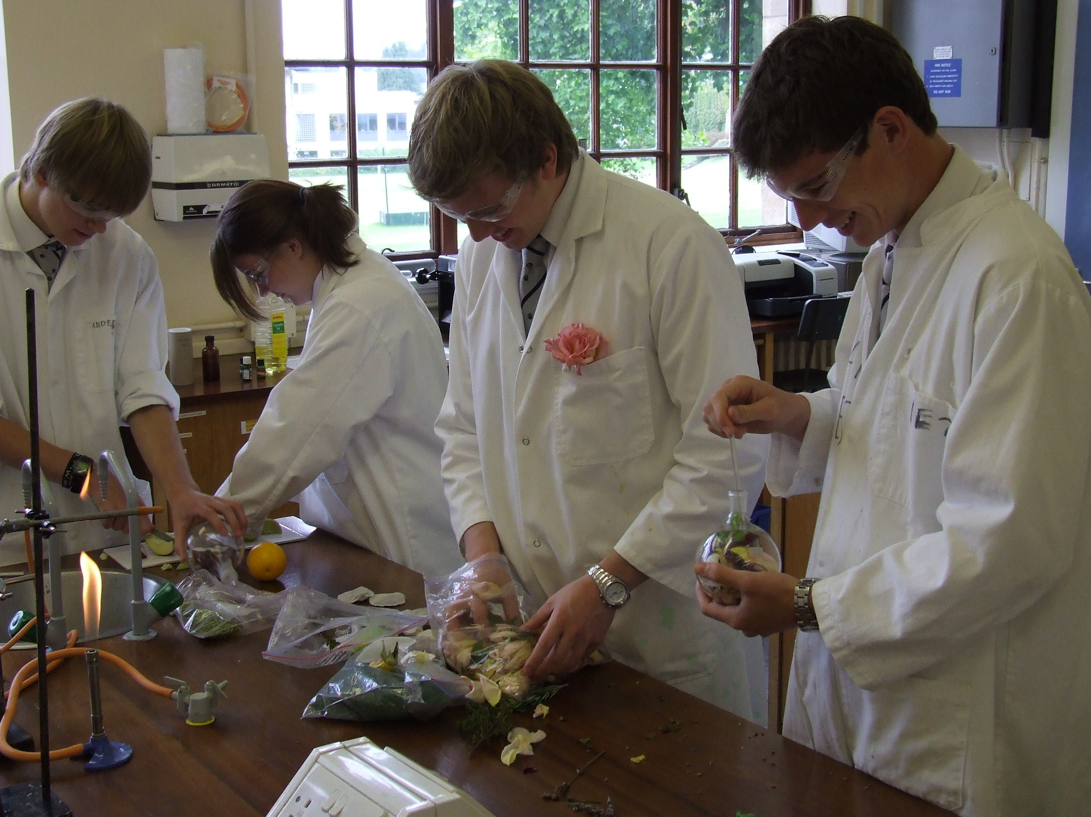



Shampoo Making -Technician’s Guide

Each group will need

A. Steam Distillation (full version)
- 500 cm³ Conical flask for use as steam generator
- 500 cm³ round bottom flask
- Still head
- condenser
- appropriate tubing (see diagram below)
- receiver (bend)
- 100 cm³ flask or 100 cm³ beaker (to collect distillate)
- two Bunsen burners
- tripod
- ice
- plant material
- plastic tub
- anti-bumping granules

Apparatus

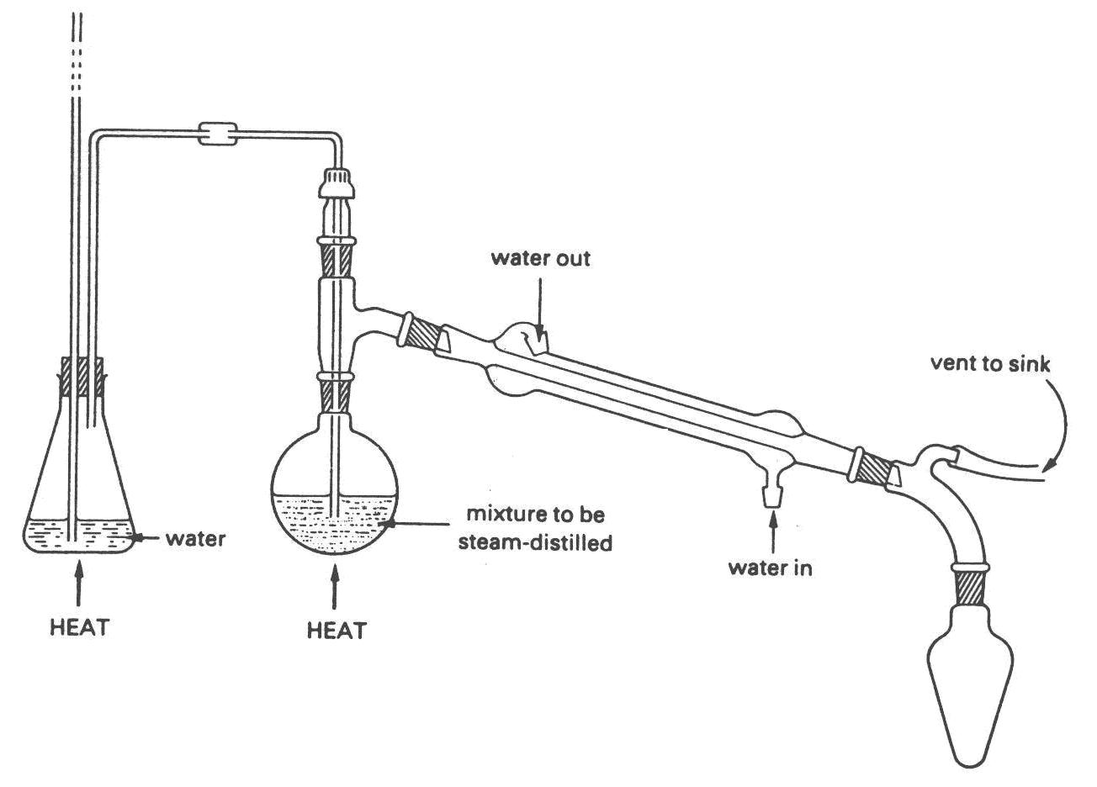
ice cold water
plant material

Steam Distillation (Simple version)
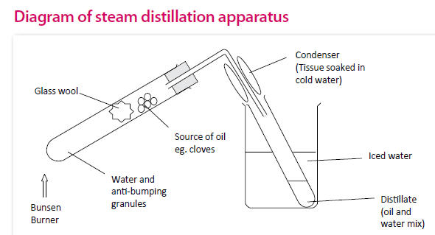

Boiling tube | Glass wool
appropriate tubing (see diagram above) | receiver (bend)
test tube (to collect distillate) | Bunsen burner
Clamp and stand | ice
plant material | plastic tub
anti-bumping granules

Herbal Infusion

- 2 x 250 cm³ beakers
- Tripod
- Bunsen burner
- fresh or dried herbs
- tea strainer or filter funnel and paper
- 150 cm³ of boiled water from kettle

Making Shampoo

- 30 cm³ sodium lauryl sulfate (Irritant)
- 10 cm³ coco betaine (Irritant)
- 2 cm³ polysorbate-20 (Irritant)
- Distilled or sterile water
- Glass rod
- 250 cm³ beaker
- 10 cm³ , 50 cm³ and 100 cm³ measuring cylinders
- Disposable droppers
- 2 x 60ml plastic dropper bottles
- A range of essential oils

Testing Shampoos

Samples of 3 commercial shampoos

1 test tube rack | 4 Test tubes
4 petri dishes | 1 10ml measuring cylinder
1 250ml measuring cylinder | 4 large test tubes (with stoppers)
2 1ml Pasteur pipettes | Universal indicator
Cooking oil | India ink
Distilled water

Sourcing Materials for Practical Work

The latest version of this project (which is rather more affordable than the original uses the following products

Prices from Phoenix Products Ltd
Unit A4
Bridge Road Industrial Estate
Southall
Middlesex
UB2 4AB 0845 230 1982

www.phoenixproducts.co.uk

Orders to :- info@phoenixproducts.co.uk

Prices correct as of 28 / 07 / 2014

Cocobetaine | 1kg | £6.96
Ammonium Laureth Sulphate (28%)* | 500g | £2.76
Sodium Lauryl Ether Sulphate (28%)* | 500g | £2.76
Polysorbate 20 | 500g | £4.10
Carriage | Up to 20kg | £8.00

* You only need one of these. As far as we can tell, it makes no difference which you use.

The Original Recipe used the following:

Chemical | Supplier | Quantity | Cost | Order code
Ammonium Lauryl Sulphate | Fluka | 250 ml | £11.70 | 09887
 |  | 1 litre | £30.10 | 09887
Poly sorbate -20 | Alfa Aesar | 100 ml | £6.40 | L15029
Lauryl Betaine | Linosa Ltd,  ICG House  Station Approach  Oldfield Lane North  Greenford  Middlesex, UB6 OAL  Tel: 0208 575 7070  Fax: 0208 566 6441 | 1 litre | £16.42

