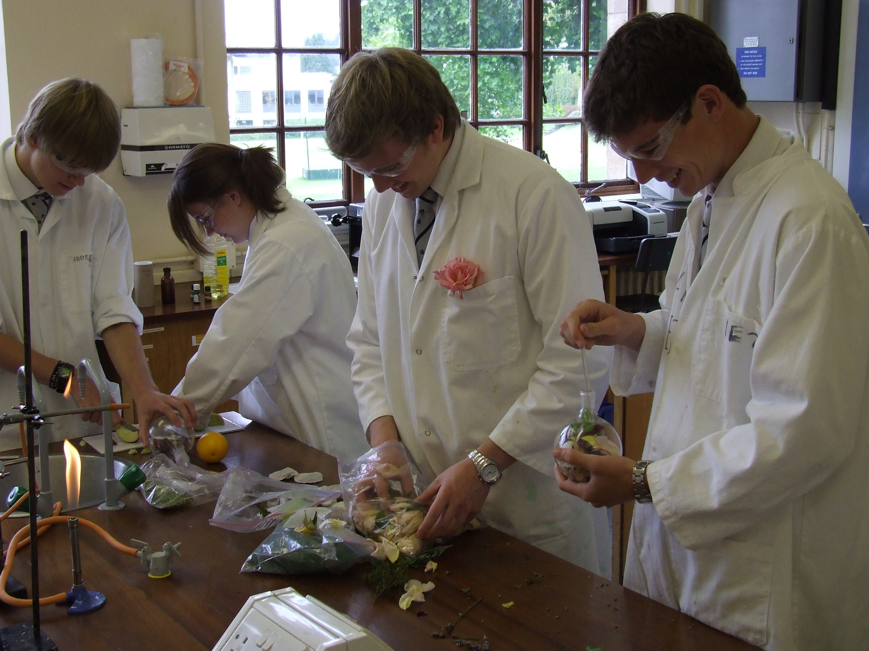


Making and Testing Shampoos



Introduction

In this workshop pupils will design and prepare your own herbal shampoo. There will be three stages in the preparation of your product.

Extracting scent from natural products
Blending a shampoo
Testing your shampoo

The practical activities can be adapted for use with pupils at every level from S1 to Advanced Higher and can be used to deliver a wide range of subject content. Experimental work on developing a cosmetic product also provides a large number of opportunities for cross-curricular projects including; investigating packaging design, marketing, brand identity and the ethical issues behind animal testing.

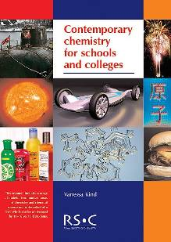

The experimental procedures in this workshop are all based upon materials produced and distributed free of charge to all schools and colleges by the Royal Society of Chemistry.
Links to Curriculum for Excellence

Topical science Having selected scientific themes of topical interest, I can critically analyse the issues, and use relevant information to develop an informed argument.

SCN 4-20b
Materials
Properties and uses of substances
I can differentiate between pure substances and mixtures in common use and can select appropriate physical methods for separating mixtures into their components.
SCN 3-16a

Level 3
Materials
Earth’s materials
I can participate in practical activities to extract useful substances from natural resources.

SCN 3-17b
Level 3
Level 4
Topical science Through research and discussion, I have contributed to evaluations of media items with regard to scientific content and ethical implications.

SCN 3-20b

Level 3

Scent Sells- Extracting Scents from Natural Products
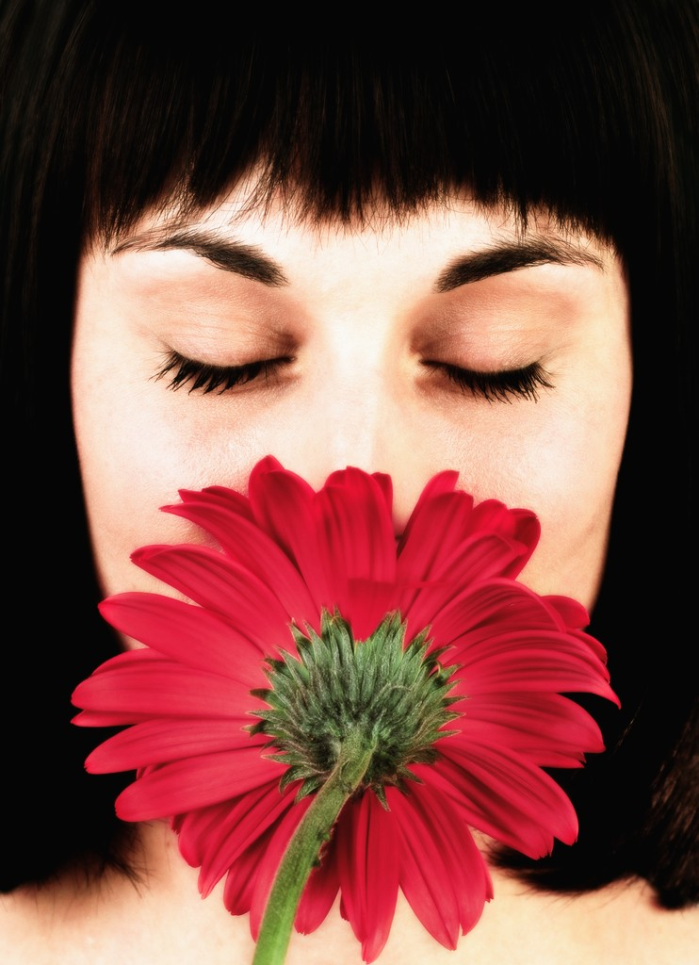

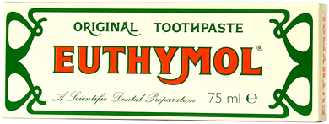
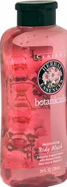
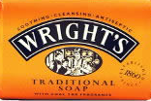
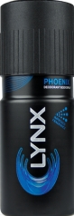
Whether a product makes millions or proves a complete flop can depend on its scent.

Your shampoo will be delicately perfumed using scents extracted from fresh herbs and fruit. You will need to blend carefully if you are to create a perfume that is appropriate for the target market you are after.

The first stage of the production of your new brand will be to extract the scent molecules from their plant sources.

Fresh
Invigorating

Natural

Masculine

Sexy
Clean

The table below shows common blends used in shampoos.

Steam Distillation- extracting your choice of floral or fruit scents

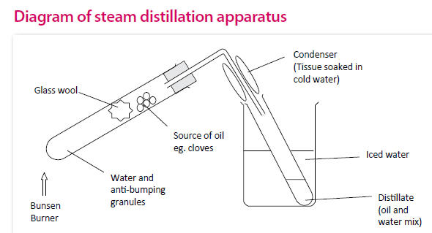
Many of the molecules responsible for floral or fruit type scents hydrolyse or are easily degraded at high temperatures. This makes conventional distillation completely unsuitable for extracting essential oils. A technique called “steam distillation” is often used. In this technique steam passed into the plant matter has the effect of depressing the boiling point of the scented compounds. These valuable substances then volatilize and are carried to the condenser in the flow of steam.
Version 1 - Simple

Steam Distillation
You will need:
- Boiling tube | - Glass wool
- appropriate tubing (see diagram above) | - receiver (bend)
- test tube (to collect distillate) | - Bunsen burner
- Clamp and stand | - ice
- plant material | - plastic tub
- anti-bumping granules

Health and safety
- Wear eye protection- goggles.

Preparing for the Distillation

- Prepare the plant material for distillation by cutting into small pieces. In the case of citrus fruits, using a ‘zester’ ensures the most scent
- Place a few anti-bumping granules into the water in the boiling tube
- Place a plug of glass wool in the boiling tube
- Load the plant material into the boiling tube on top of the glass wool (the finer it is chopped, the more you will be able to get in).
- Assemble the apparatus as shown in the diagram.
- Wrap some wet paper towel around the delivery tube as shown
- Fill the plastic tub/beaker with ice and water and move it into position around the test tube being used to collect the distillate.

Carrying out the Distillation

- Gently heat the boiling tube until the water until it starts to boil.
- As steam begins to pass up through the plant matter it will carry the essential oils with it.
- Carry on heating until approximately half the water in the boiling tube has evaporated and you have about 1cm of liquid in the test tube.
- Move the clamp so the tube is not dipping in the liquid – to avoid suckback – and stop heating
- Remove the test tube containing the distillate and smell carefully.

Version 2 – a more complex method
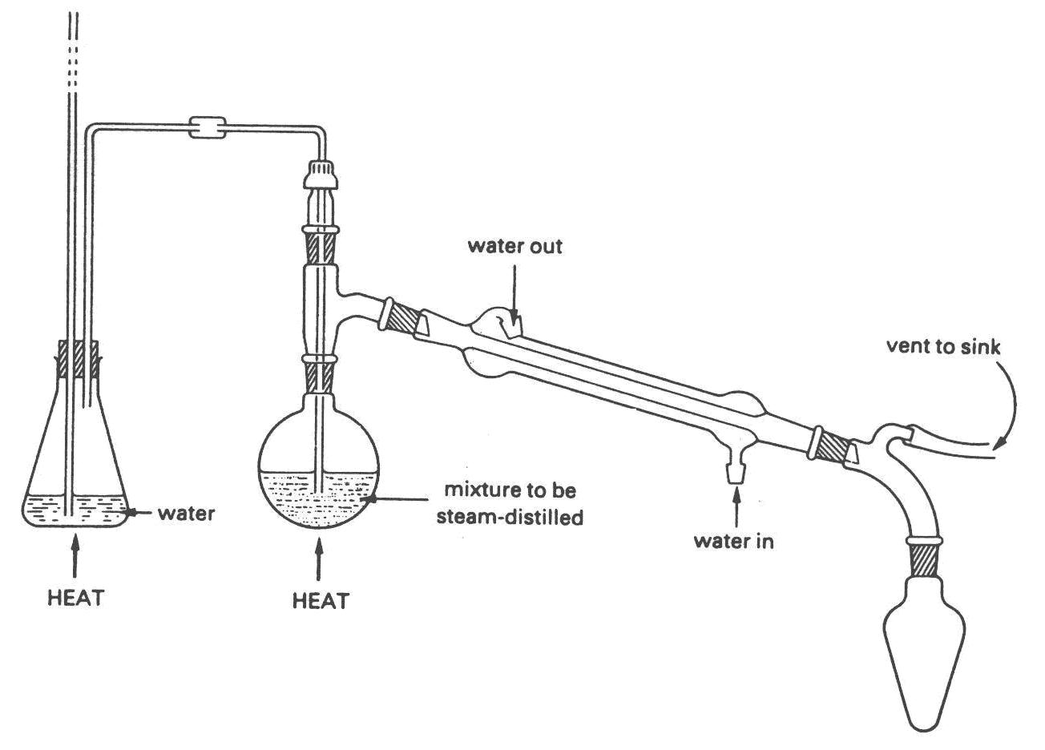
ice cold water
plant material

Steam Distillation
You will need:
500 cm³ Conical flask for use as steam generator | 500 cm³ round bottom flask
Still head | condenser
appropriate tubing (see diagram above) | receiver (bend)
100 cm³ flask or 100 cm³ beaker (to collect distillate) | two Bunsen burners
tripod | ice
plant material | plastic tub
anti-bumping granules

Health and safety
- Wear eye protection- goggles.
- Ensure that the vertical tube coming from the conical flask used as a steam generator is unobstructed. In the event of any blockage in the distillation apparatus, water will rise up this tube to relive the build up of steam pressure. In the event that water is rising close to the top of the glass tube, reduce the heat under the flask and inspect for blockages.
- Do not stand close to the steam generator flask whilst the distillation process is under way. Hot water may emerge from the vertical relief pipe.

Preparing for the Distillation

- Prepare the plant material for distillation by cutting into small pieces.
- Load the plant material into the 500 cm³ round bottom flask.
- Place a few anti-bumping granules into the water in the conical flask.
- Assemble the apparatus as shown in the diagram.
- Check to make sure that the steam generator flask is as shown in the diagram with the mouth of vertical pressure relief tube below the water level and the steam connection to the distillation apparatus well above the water level.
- Check that the steam pipe passes close to the bottom of the round bottom flask so that the steam will rise through the plant material. It is important that this tube is not blocked.
- Fill the plastic tub with ice and water and move it into position around the flask or beaker being used to collect the distillate.
- Connect and turn on the condenser.

Carrying out the Distillation

- Gently hear the conical flask until the water until it starts to boil.
- As steam begins to pass into the round bottom flask containing the plant matter, water will start to consense. Use a second Bunsen burner to gently warm this flask without charring the plant material.
- You make gently increase the level of heating to the conical flask to achieve a steady trickle of drops through the condenser.
- When you have collected around 30 to 50 cm³ of distillate switch off both bunsens
- When no further drops of liquid come out of the condenser you should remove the flask or beaker containing the distillate and smell carefully.

Herbal Infusion- extracting your choice of herb based scent
The scent molecules found in some cooking herbs are sufficiently water soluble and stable to allow them to be extracted from the plant material by simply soaking in boiling water.

Herbal Infusion
The scent molecules found in some cooking herbs are sufficiently water soluble and stable to allow them to be extracted from the plant material by simply soaking in boiling water.

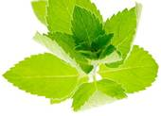
You will need:

  - 1 x 100 cm3 beaker
  - 1x boiling tube
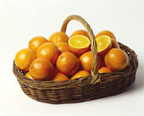
  - Clamp and stand
  - Bunsen burner
  - fresh or dried herbs
  - tea strainer or filter funnel and paper
  - boiling water from kettle

Health and safety
- Wear eye protection- goggles.
- Boiling water is used in this experiment.

Carrying out the infusion

- Place a few anti-bump granules in the bottom of a boiling tube
- Place either a teaspoon or two of herbs/spices into a boiling tube.
- Half fill the boiling tube with the hot water.
- Bring it back to the boil and boil gently for about 10 minutes.
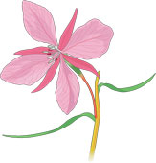
- Leave to cool.
- Empty the rest of the water in your beaker down the sink
- Strain or filter your infusion into the beaker.

The Winning Formula- Blending your shampoo

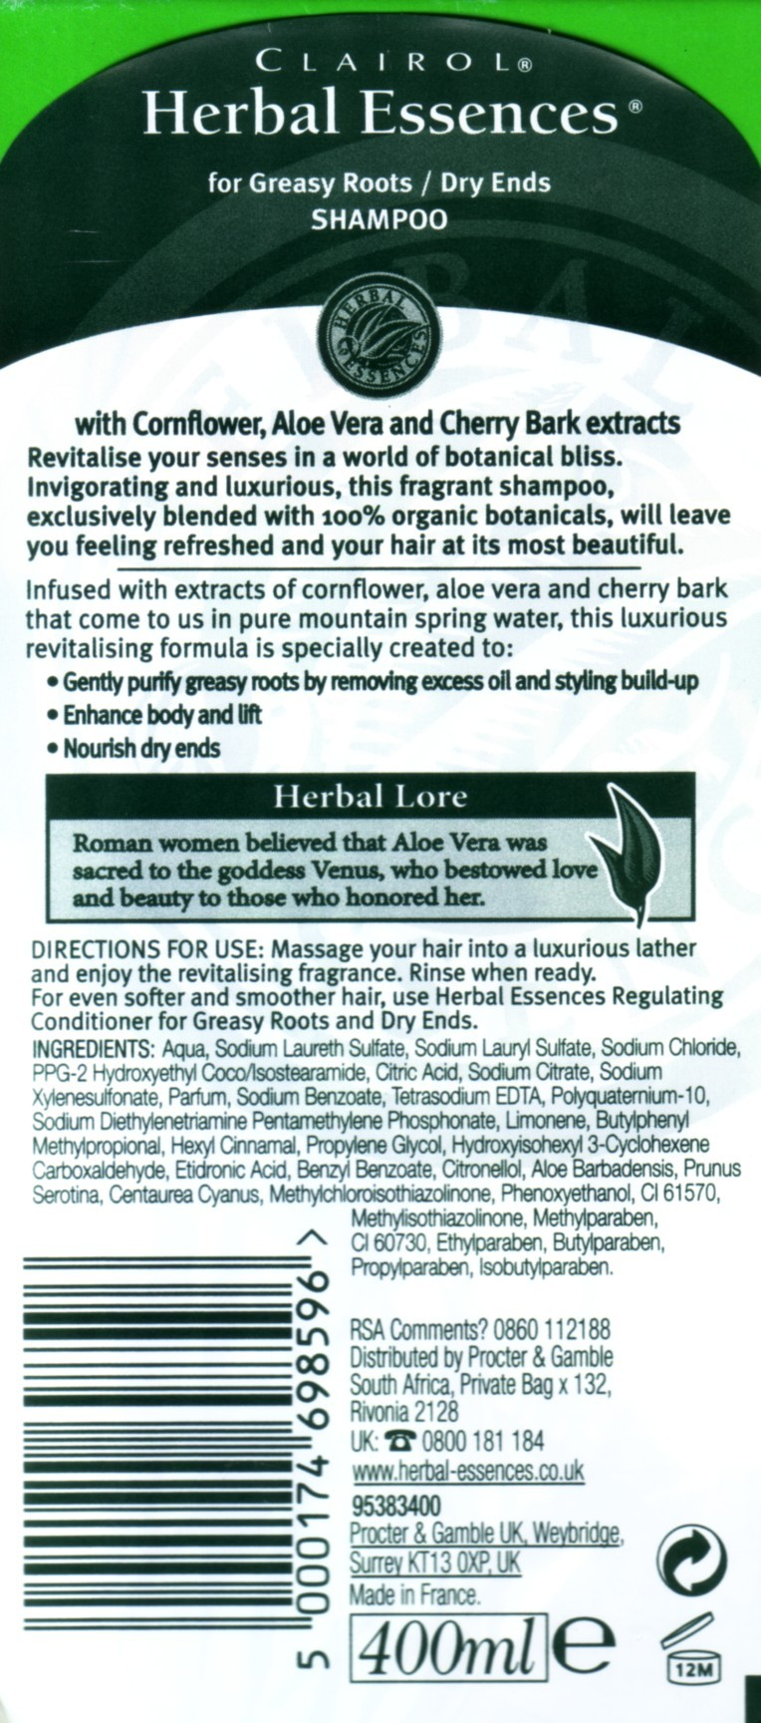
Shampoos represent the result of thousands of hours of careful research by expert chemists. Many different parameters must be carefully controlled including the viscosity, colour, quantity of lather produced, behaviour in hard and soft water areas, perfume, effect on hair structure and scalp.

The ingredients list for a shampoos provides the opportunity to explore many areas of chemistry.

The appendix at the back of this booklet contains an extensive list of the chemicals to be found on shampoo bottles with an explanation of what each ingredient does. Some examples are shown below.
Sodium Laureth Sulphate
Water softener, Surfactant, Skin cleanser

Aloe Barbadensis
Softens skin, soothes burns and injuries.

Parabens (Preservatives)
Most commonly used ingredient other than water. Used in low concentrations so will be found at the ends of ingredients lists. These compounds stop bacteria growing in the product and are not irritating or toxic.

Our shampoo formulation will contain five ingredients.

INGERDIENTS: Aqua, ammonium lauryl sulphate, lauryl betaine, polysorbate-20, parfum

Aqua
This is the name used in European cosmetic products for water. Water is the main ingredient of many cosmetic products so is found first in the ingredients list. Sterile water must be used - this means the water must be boiled to ensure no bacteria or other microorganisms are present.

ammonium lauryl sulphate (surfactant)
Compound made from coconut oils. Good at breaking up oils and soil, so effective in shampoos. Good cleansing agent and foam maker.

lauryl betaine
Compound used in shampoos to lower the irritation potential of surfactants. No known toxicity.

polysorbate-20 (emulsifier)
Substance which is added to help make an emulsion. An emulsion is the mixture of two liquids which do not usually mix together, such as oil and water. The emulsifier helps to keep the two liquids mixed, stopping layers forming.

Parfum
This is the general name given to 'fragrance'. This could mean one or more compounds added to give the product an attractive smell. Exactly what there compounds are is us to you.

Making Your Shampoo
The time has now come for you to mix the ingredients to make your shampoo

You will need:
- 30 cm³ ammonium lauryl sulfate (Irritant)
- 10 cm³ lauryl betaine (Irritant)
- 2 cm³ polysorbate-20 (Irritant)
- Distilled or sterile water
- Glass rod
- 250 cm³ beaker
- 10 cm³ , 50 cm³ and 100 cm³ measuring cylinders
- Disposable droppers
- 2 x 60ml plastic dropper bottles
- Your steam distillate and/or herbal infusions
- A range of essential oils

Health and safety
- The greatest risk during this preparation is that the shampoo produced is contaminated by chemicals left on dirty glassware. Make sure the equipment used to prepare the shampoo is scrupulously clean.
- ammonium lauryl sulfate is a mild irritant. Avoid prolonged contact of the undiluted liquid with the skin.
- 10 cm³ lauryl betaine can be a mild irritant. Avoid prolonged contact of the undiluted liquid with the skin.
- 2 cm³ polysorbate-20 can be a mild irritant. Avoid prolonged contact of the undiluted liquid with the skin.

Blending your shampoo

- Place the distillate from your steam distillation into the 250 cm³ beaker. (If haven’t carried out a steam distillation add 10 cm³ of distilled water instead.)
- Add 5 cm³ of your herbal infusion to the beaker. (If you haven’t prepared a herbal infusion add 5 cm³ of distilled water instead.)
- Add 30 cm³ of ammonium lauryl sulphate and stir well.
- Add 10 cm³ of lauryl betaine and stir.
- Add 2 cm³ of polysorbate-20 and stir.
- You can now add up to 0.5 cm³ of essential oils to complete your fragrance.
- Stir well before dividing between the two clean 60 cm³ plastic dropper bottles.
- Like any other manufacturer, your shampoo bottles must be labelled. Attach a sticker to each bottle of shampoo you have made.

INGERDIENTS: Aqua, ammonium lauryl sulphate, lauryl betaine, polysorbate-20, parfum
Use before:

Quality Control- Testing your shampoo
Cosmetic products must go through exhaustive testing prior to launch to ensure that they are effective and safe to use. Manufacturers employ extremely exacting on-going testing to ensure that every bottle of shampoo produced meets the product specification exactly.

Having produced a shampoo, it is now time to test your product against its competitors. You are getting 3 commercial shampoos to compare: a cheap one, a mid-price one and an expensive one

Preparation:
Procedure: Prepare a 1% solution of your shampoo. Mix 2cm³ of shampoo with 200 ml of distilled water. Put the shampoo in the beaker first and add the water slowly. Swirl the beaker to mix the shampoo and water. Don’t shake it. You don’t want to create foam.

You will need

1 test tube rack | 4 Test tubes
4 petri dishes | 1 10ml measuring cylinder
1 250ml measuring cylinder | 4 large test tubes (with stoppers)
2 1ml Pasteur pipettes | Universal indicator
Cooking oil | India ink
Distilled water

Test A - Determination of pH:

- Put one drop of the shampoo in a test-tube.
- Fill the tube 3/4 full with distilled water.
- Add two drops of Universal Indicator solution.
- Find the pH value of the shampoo solution.
- Record your results in the table.

Health and Safety
- Avoid any skin contact with the Universal indicator.
- Immediately wash any Universal indicator off exposed skin.

Information: Most shampoos are neutral or slightly acidic. Acidic solutions cause the cuticle (outer layer) of the hair to shrink and lay flatter on the shaft of the hair. Basic solutions cause the cuticle to swell and open up. Acidic solutions make the hair seem smoother. Basic solutions make hair seem frizzier.
Test B - Oil Test:

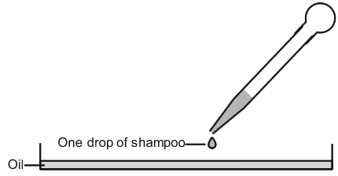
- Pour cooking oil into a petri dish to make a thin film over the base.
- Place the dish on the dark paper.
- Use a dropping pipette to drip one drop of shampoo onto the oil film (see diagram).
- Wait until the drop has stopped spreading out, then measure the diameter of the faint iridescent halo formed around the shampoo drop. This will probably be between 3 and 6 cm in diameter. Write this down in the 'oil test' column of the table.

Test C and Test D are done together make sure you read Test D before you start.

Test C Shake Test - Determination of Foam Formation:

- Put approx 50 ml of the 1% shampoo solution into a 250ml graduated cylinder and record the volume.
- Cover the cylinder with your hand and shake 10 times.
- Record the total volume of the contents after shaking
- Calculate the volume of the foam only and record your answer
- Record the size of the bubbles (as small, medium, or large)

Information: A good shampoo should have a foam volume of 100 ml or more in the shake test. Bubbles should be small. The smaller the bubbles the longer the foam will persist.

Test D Foam Quality and Retention:

- Immediately after the Shake Test (Test C), Begin timing.
- Record the volume of foam at 1-minute intervals for 5 minutes in the table.

Information: In a good shampoo, foam retention should remain stable for at least 5 minutes.

Test F Dirt Dispersion:

- Put two drops of shampoo in a large test tube
- Add 10 ml of distilled water
- Add 1 drop of India Ink
- Stopper the test tube and shake it ten times.
- Estimate the amount of ink in the foam (as None, Light, Moderate, or Heavy) and record

Information: Shampoos that cause the ink to concentrate in the foam are considered poor quality. The dirt should stay in the water portion. Dirt that stays in the foam will be difficult to rinse away. It will redeposit on the hair.

What do we do with the shampoo now?

“This is a very pleasing activity. The quality of the shampoo product is very good, provided instructions are followed as stated. It is important to measure the amounts accurately. The essential oil is optional - but it adds a good perfume. These oils are very concentrated so only the small amount shown is needed. The herb extract lends a 'natural' quality to the product and some individuality. Students could prepare this at home (it is no more complicated than boiling up vegetables or cooking pasta) to bring in for the shampoo-making lesson.
The main challenge is sourcing the ingredients. They are available from Neal's Yard Remedies (please see notes below) whose help is acknowledged in the preparation of this exercise. However, they are easily obtainable through the many websites for home soap and shampoo makers. A suitable container would be a sterile 100 cm³ bottle with screw cap, which will probably cost more than the reagents.
A second point is what to do with the shampoo. It seems a great pity to throw it away just as it has been made in school and therefore has some (unspecified) 'risk' attached. I have never heard of anyone not eating a cake or trifle just because it was made in school. If the solutions and components have come from a source intended for shampoo making and if the measuring equipment and area used in preparation are scrupulously clean and the bottle sterile, then commonsense should prevail - this product is no more 'dangerous' than any other and is probably a lot gentler on the skin and hair than most! However, bear in mind that no preservative has been added product should not be kept longer than three weeks and anyone suffering from skin complaints such as eczema should NOT use the product. Do NOT be tempted to use ordinary laboratory - reagents which may be contaminated.”
Vanessa Kind, Royal Society of Chemistry

