


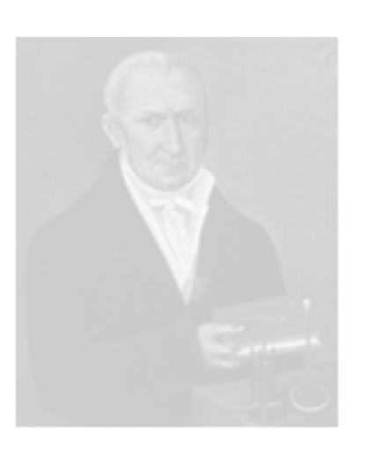

Teacher’s Technician’s Guide

Teacher Guide
This activity can be used to help teach the E.O. s
“I can help to design simple chemical cells and use them to investigate the factors which affect the voltage produced. SCN 3-10a”
and
“Using experimental evidence, I can place metals in an electrochemical series and can use this information to make predictions about their use in chemical cells. SCN 4-10a”
It uses plastic cuvettes normally used for colorimetry to produce cells. You do not have to use the worksheets supplied. The idea is to use the cuvettes. The recording /discussion of the work can be done any way the teacher wishes.
The electrolyte is a mixture of diluted lemon juice and salt water. The dilution of the juice and then the addition of the salt water lowers the internal resistance of the cell.
The clamp stand, boss head and clamp can be used to stabilize the cells and allow the pupils to work hands free on the apparatus.
Ensure the metals are cleaned before the experiment using steel wool or fine sandpaper.
It is helpful if the metals are bent over the edge of the cuvette to keep them upright and able to be connected to the crocodile clips.
Ensure the metals and any crocodile clips do not touch and short out the cell.
The electrolyte will froth as the cell works. It will become used up. Ensure only a maximum of 3 cm³ of the electrolyte is used in the cells and the metals are in place before the electrolyte is introduced.
The following specimen voltages were produced when the cells were tested using copper as the standard:
Metal connected | Nerve Juice 1 Voltage | Nerve Juice 2 Voltage  Feel free to  use different metals.
Magnesium | 1.85 | 1.93
Zinc | 0.92 | 1.00
Tin | 0.36 | 0.44
Lead | 0.33 | 0.40
Copper | 0.00 | 0.00
The voltage from a single cell is affected by the electrolyte used and the metals connected (farther apart metals give a greater voltage when connected).
First Challenge: With the electrolytes supplied, only the Mg/Cu cell with “Nerve Juice 1” should produce enough power to turn a solar motor.
No other cell should turn the motor. This can lead to a discussion on the magnitude of the voltage produced between the two metals connected up.

The second challenge set is to produce an arrangement which will light 5 L.E.D.s which are connected in series.
Using “Nerve Juice 1” again, it needs five or six Mg/Cu cells connected in series to light the five (5) L.E.D.s, although other cells may power a smaller number of L.E.D.s. No other arrangement should light 5 L.E.D.s.
The individual cells can be connected up in series using the crocodile clips to connect the copper of one cell to the magnesium of the adjoining one. The elastic band can be used to hold all six cells together.
Once again, the cells can be clamped together in the clamp stand to enable hands free working on the cells. Ensure none of the crocodile clips touch.

Extension work:
Either as a demonstration or in groups, batteries can be set up with two multimeters connected in the circuit, one to measure the voltage and the other the current. Show the drop in a reading when the battery is put under a load. This can lead to a discussion on why only the Mg/Cu cell powers the motor and lights the L.E.D.s.
Discuss connecting the cells in parallel. Then try it to see what happens to the voltage and current.
Try different combinations of lemon juice at different concentrations with different concentrations of salt water to see if these produce differences in the voltage and current produced. e.g. lemon juice at 100% (undiluted bottled juice), or 75%, or 50%, or 20% could be mixed with NaCl at either 1M, 0.5M, 0.25M or 0.1M concentration and the voltage and current delivered by the cell/battery measured. Will varying the electrolyte mixture affect the internal resistance of the cell?
Also try varying the relative proportions of juice to salt water mixed together. e.g. try 1:0 or 1:1 or 3:1 mixes, to see if these affect the voltage.
Technician Guide

Apparatus Required for the workshop and two Challenges:

Bottles labeled “Nerve Juice”. 1 per group
Plastic disposable droppers. (3 cm³ size). 1 per group
Some plastic cuvettes . 7 per group
Multimeters. 1 per group
Some connecting leads. 4 per group
Some crocodile clips. 9 per group
Strips of different metals (e.g. magnesium, zinc, tin, lead, copper etc.)
6 of each per group. These strips should be approximately 4.5 cm long and 0.4 cm wide (use Mg ribbon as supplied).
Some fine sandpaper or steel wool. 1 piece per group
Elastic bands. 1 per group.
Foam cuvette holder. 1 per group.
Solar motors each fitted with a propeller. 1 per group
Boards with five (5) red L.E.D.s connected in series. The L.E.D.s must be red ones.
Extension work
1 extra multimeter per group
1 extra connecting lead per group
lemon juice at 100% (undiluted bottled juice), 75%, 50%, 20% . 100 cm³ each
NaCl at 1M, 0.5M, 0.25M, 0.1M. 1000 cm³ each

The L.E.D.s and the resistor are connected as shown:
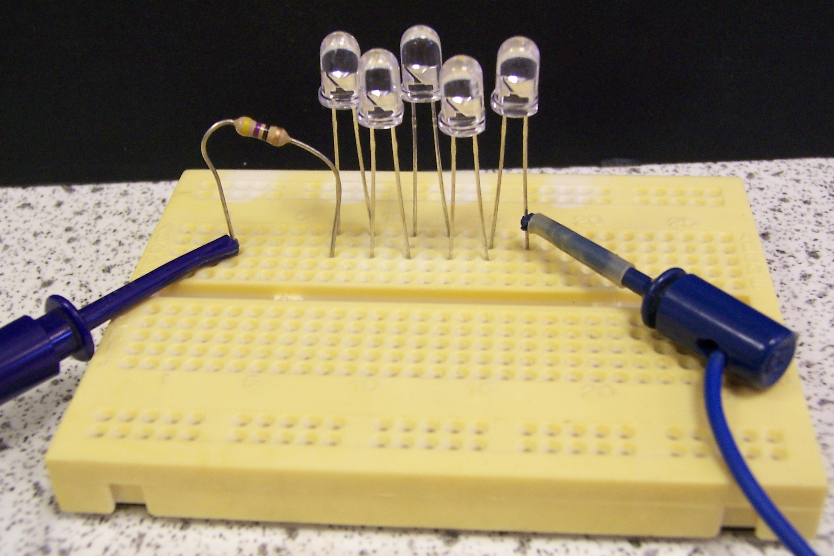

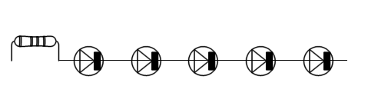
The resistor is rated at 47 Ω and 0.25W. Each of the red L.E.D.s is connected with their long +ve leg towards the resistor. i.e.
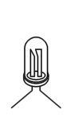
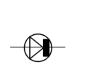
47Ω/
0.25W

K
A
_
+

+ve -ve

The set up shown can be supplied 1 per group or allow groups to access one as required. (latter policy will mean only 2-3 boards needed per class)
One “nerve juice” (Nerve Juice 1) is prepared from Supermarket bottles of lemon juice and 0.5 mol l⁻¹ Sodium chloride solution
Dilute the bottled lemon juice to 50% concentration by mixing with an equal volume of distilled water. Then mix this 50% lemon juice in a 2:1 ratio of juice : salt water to prepare the “ nerve juice”.
90 cm³ of any “nerve juice” should be more than sufficient for each group to complete the workshop and the two challenges.
However, allow a “teacher reserve” of the electrolyte for initial failures in one or more of the two challenges (say 120 cm³).
i.e. a total volume of 210 cm³ of the 2:1 mixture will require 70 cm³ bottle juice + 70 cm³ distilled water (giving a 50% solution) + 70 cm³ of 0.5 mol/l⁻¹ sodium chloride solution all mixed together.
The other “nerve juice” (Nerve Juice 2) is supermarket orange juice from a carton.
Foam Cuvette holders

Requirements;
Foam camping mat (Argos ~£4.99/roll – enough to give oodles of holders)
Scissors/sharp knife
Pen
Ruler

Method
Measure a strip 12cm wide and cut away from mat.
Using the strip you have just cut, measure 10cms, mark and cut. It should be possible to get 5 pieces out of one width of the mat
Mark the centre of the piece of foam by using its diagonals
Around this mark measure a slot to be cut of 7cms by 1cm along the 12 cm side,
Cut the slot out using a sharp knife
Cut a strip from the mat approximately 3cms wide and again cut into 10cms strips (5 pieces from a width)
Mark the same size of slot as before (7 x 1cms) in the centre of the piece along the 10 cm length i.e.

7 cm
3 cm
10cm
10 cm
1 cm

12 cm

Glue, using bostik or similar, the 2 pieces together, aligning the slots and leave to dry.

This will hold up to 6 cuvettes and can be adjusted if more are required

