



Luigi Galvani (1737-98) was an Italian trained in medicine and interested in physics. He lectured in anatomy in Bologna in Italy. His interest in anatomy and physics led him to look at the effect of electricity on the muscles of animals, particularly frogs.
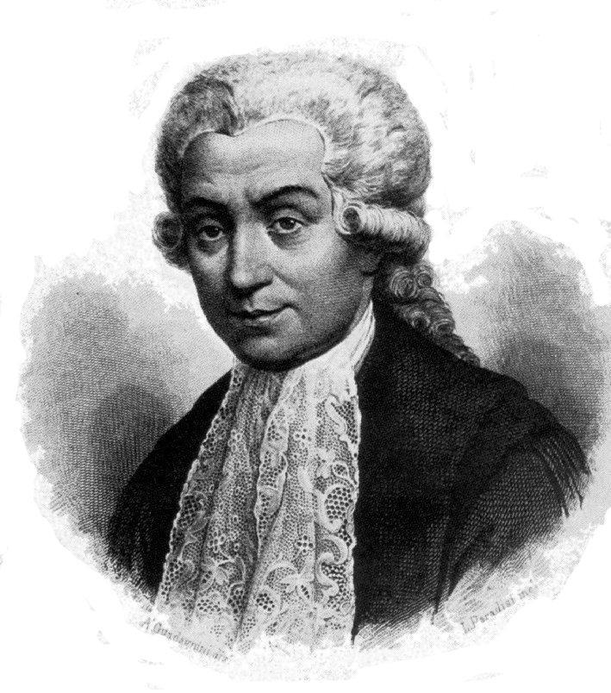
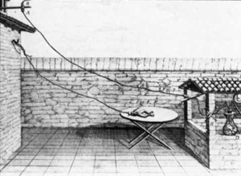
To do this he sometimes used electricity from thunderstorms and attached the frog’s legs to iron fences and other large metal objects! He also found out that simply by connecting two different metals into the frog’s legs, the muscles contractions occurred without any apparent source of electricity. He thought the electricity was in the nerve juices in the muscles.
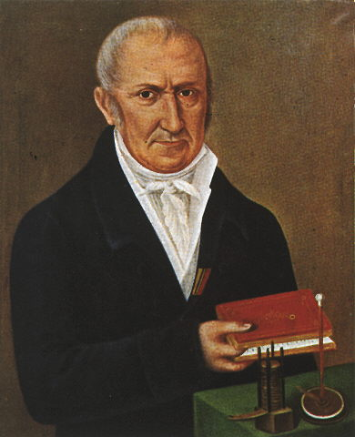

Another Italian called Alessandro Volta realized that it was the two metals themselves which were generating the electricity to cause the nerve contractions in the muscles.

This is a similar experiment to the one Galvani did using two different “Nerve Juices” and combinations of different metals (but not frogs legs!).
cuvette
nerve juice
leads
copper metal
one of the
other metals
multimeter
0.00

What you need:
Bottles of different “Nerve Juice”
A plastic disposable dropper (3 cm³ size)
Some plastic cuvettes (small containers)
A Foam Cuvette Holder
A multimeter
Some connecting leads
Some crocodile clips
Strips of different metals (e.g. magnesium, zinc, tin, lead, copper etc)
Some fine sandpaper or steel wool

What you do:
- Clean the surface of the metals with the sandpaper or steel wool
- Always use copper as one of the two metals
- Always have the metals in the cuvette before you add any “nerve juice”
- Set up the apparatus like this:
cuvette
nerve juice
leads
copper metal
one of the
other metals
multimeter
0.00
You may find it helpful to place the cuvette in the Foam Cuvette Holder provided so the bottom of the cuvette rests on the base of the holder. This will keep the cuvette from falling over and allow both your hands free.

- You may find it easier to bend the metal over the rim of the cuvette to hold it in position
- Make sure the two metals do not touch
- Connect the copper strip to the multimeter socket marked “V”
- Connect the other metal to the multimeter socket marked “COM”
- Make sure the crocodile clips do not touch
- Turn the dial so the pointer is on the “V ” scale and set at 20
- Use the plastic dropper to put 3 cm³ of a “nerve juice” in the cuvette
- Record the reading on the multimeter scale
- Empty out the cuvette and rinse it with water
- Set up new cuvettes and repeat the experiment with each of the other metals connected to a copper strip
- Repeat with the other type of “nerve juice” as before

What you need:
Bottles of “Nerve Juice”
A plastic disposable dropper (3 cm³ size)
Some plastic cuvettes (small containers)
Some connecting leads
Some crocodile clips
Strips of different metals (magnesium, zinc, tin, lead, copper etc)
An elastic band
Some fine sandpaper or steel wool
A solar motor with a propeller fitted
Access to a board with five (5) red L.E.D.s connected in series. It should look something like this:
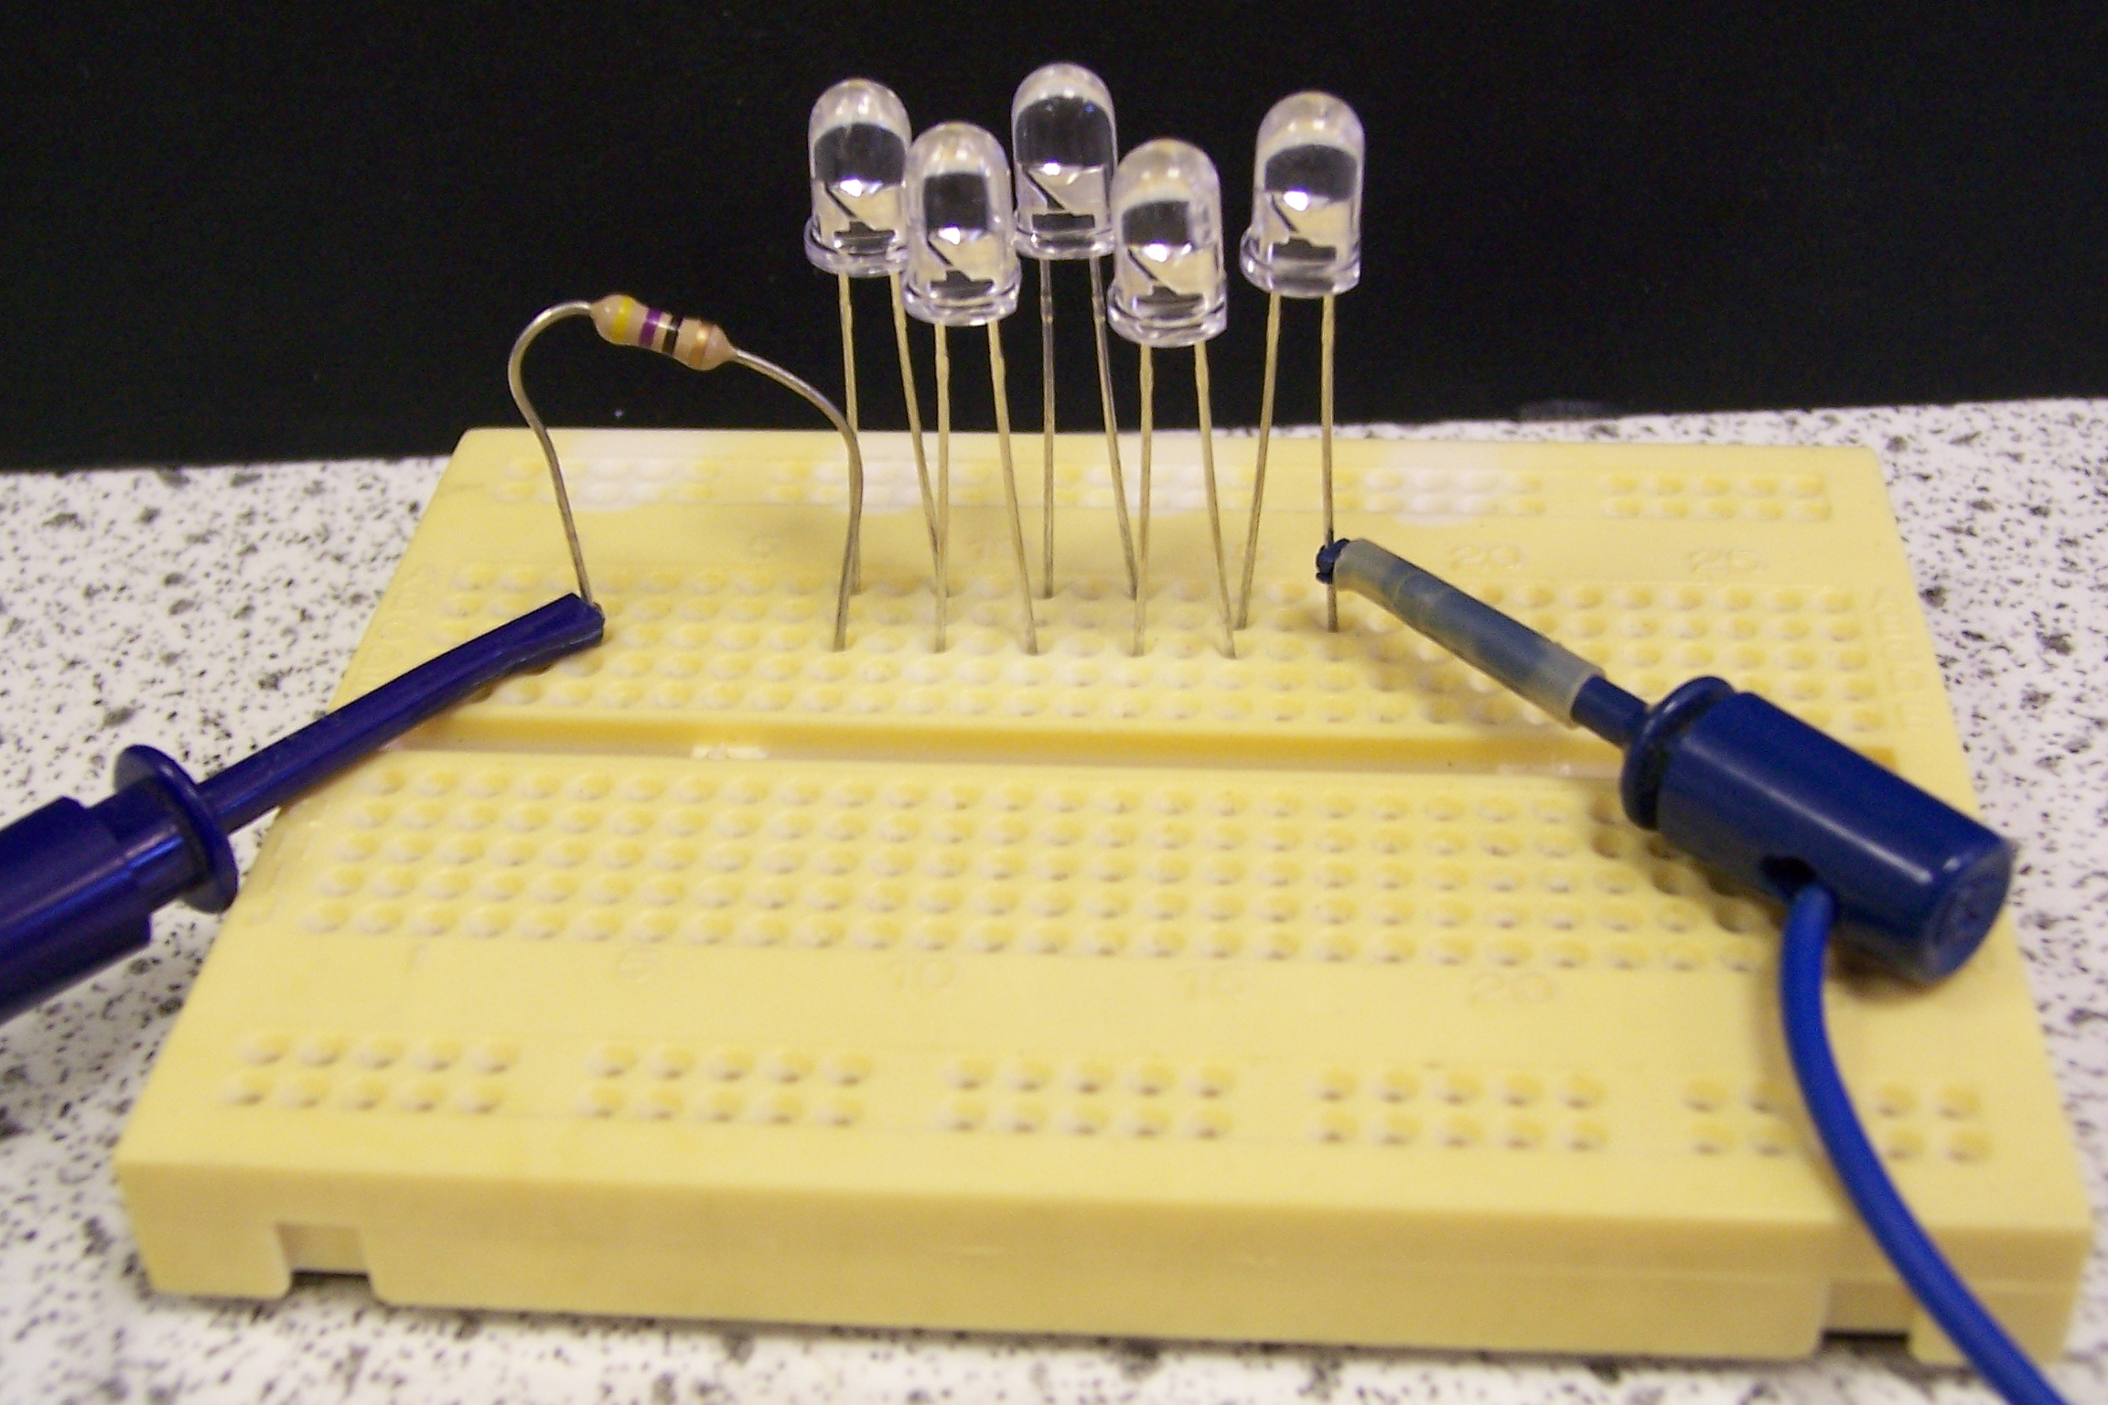

Note how the leads are connected to the resistor and the last bulb in the line.
Always connect the copper strip to the resistor and the other metal to the L.E.D.

Can you get one of your cells to power your motor?

Which one will you choose? How long does your cell power the motor for?

Can you get all five L.E.D.s to light up together?

Will one cell make them all light up or will you need more?

For both challenges:
You can only use a maximum of 3 cm³ of “nerve juice” in a cell.
You will need to think about which of the two metals you are going to use.
You can use a Foam Cuvette Holder as before to keep your apparatus from falling over.
Results:

Metals connected  to Copper | Voltage seen  in Nerve Juice 1 | Voltage seen  in Nerve Juice 2

When you connect two different metals in a solution which conducts electricity, electrons flow round the wires connecting them, from one metal to the other.
When two different metals are connected like this to produce electricity, we say we have made an electrochemical cell, sometimes just called a cell.

Two cells were set up and it was found they produced different voltages. Can you think of two ways the cells might be different?

Now list the metals in order of the size of the voltage you saw when they were connected to copper. The one which gave the biggest voltage when connected should be at the top of the list, gradually going down to the one which gave the smallest voltage.
- ……………………………………………….. This one gave the largest voltage

2. ………………………………………………..

3. ………………………………………………..

4. ………………………………………………..

5. ………………………………………………..

6. ……………………………………………….. This one gave the lowest voltage

The electricity is produced when the metal loses some of its electrons. This will happen when a metal is placed in some solutions. Chemists made up a list of metals showing how good they are at giving away electrons.
They called this list The Electrochemical Series. Metals at the top of the list lose electrons more easily than metals near the bottom of the list.
When you connect two different metals in a solution which conducts electricity, electrons flow round the wires connecting them, from the metal nearest the top of the list to the metal nearer the bottom of the list.
The solution used in the cell is given a special name. It is called an electrolyte.
You are given two cells containing the same electrolyte. Can you think of one way of increasing the voltage produced from one of the cells?

Metals chosen: ……………………………… and ………………………………………

Solution chosen: ……………………………………………………………….

Did you manage to get
Aye! |  | Naw!
a cell to power the motor?
(Put a tick in a box)
If your answer was a resounding , ask your teacher for some hints before trying the experiment again.

If it worked, how long did the motor run for? ………………………

Did you make all 5 L.E.D.s light up together? If you managed it, draw the apparatus in the space below and show it connected to the L.E.D.s.

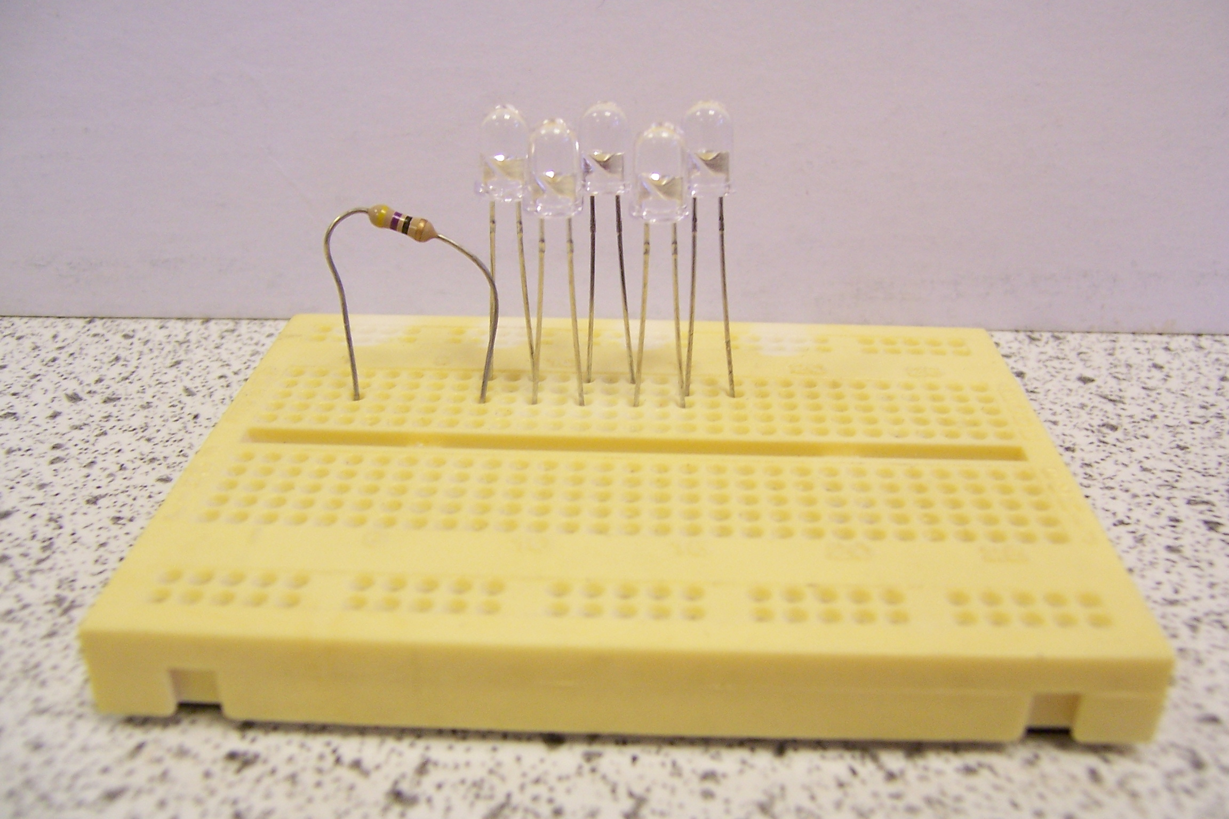

When cells are arranged like this, a battery has been made.

