Technician Guide
Rock to Riches

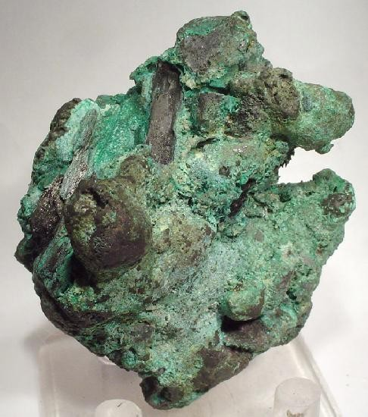
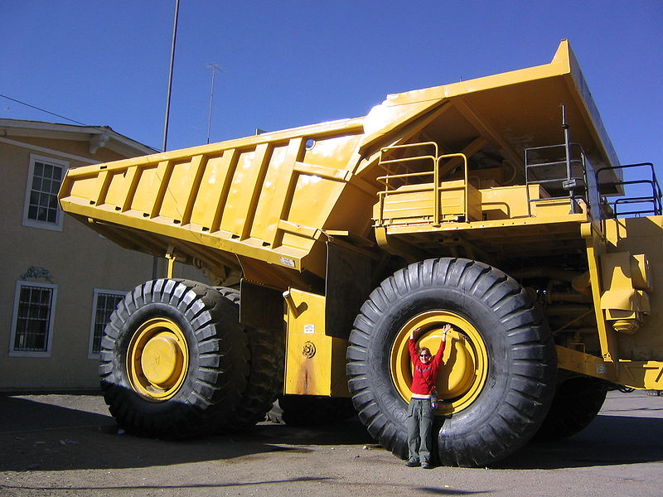
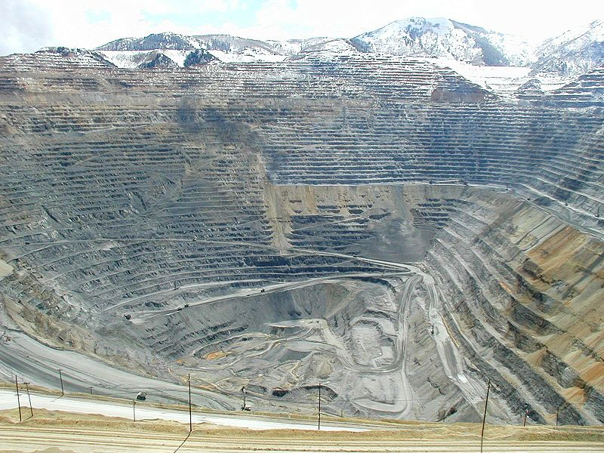
Rocks to Riches, Technician Sheet

*The following recipe assumes 10 pairs per class of 20 pupils*

Comparison solutions apparatus
Eye protection – indirect vent goggles BS EN 166 3
Solution 1 x 30 cm³
distilled water x 40 cm³
plastic cups x 2
10 cm³ syringe x 2
Test tube rack x 1
Test tubes (long neck and be able to hold 10 cm³ samples) x 5
Sheet of white paper

Percentage of metal in ore apparatus
Eye protection – indirect vent goggles BS EN 166 3
250 cm³ glass beakers x 1
Plastic cup x 1
100 cm³ measuring cylinder x 1
Plastic sample bottles x 3
Solution 2 x 225 cm³
Ore Samples A, B & C
10 cm³ syringe x 2
Stirring rod x 1
Filter paper as required
Filter funnel x 3
Test tube (long neck and be able to hold 10 cm³ samples) x 3
Distilled water as required

Electro-winning apparatus
Eye protection – indirect vent goggles BSN 16 63
Low voltage power supply
Wires x 3
Crocodile clips x 2
(Ammeter – if power pack does not have one built in)
Square of emery paper
Nickel spatula (cut in half)
Copper strip 8 cm long x 8 cm high (the height must be enough for the top edge of the plate to be above the lip of the beakers being used)
1M sulphuric acid x 5 cm³ (use left-overs from previous activity)
10 cm³ syringe
Timer
Hair dryer x 5 (per set of 20) optional
Each class set must have access to a top pan balance with 2 decimal places.

Apparatus
Top pan balance to 2 decimal places x 1
Figure 1 highlights the correct diameter for the conical flasks being used.

Preparation of copper sulphate solution (solution 1)
Dissolve 124.84 g of copper sulphate into 400 cm³ of distilled water and make up to 500 cm³.
Place 30 cm³ into 10 bottles with screw caps and label as solution 1 with harmful and dangerous to the environment pictograms.

Preparation of sulphuric acid (solution 2)
Place 2.25 litres of 1 M sulphuric acid into 10 bottles with screw caps and label as solution 2 with irritant pictograms.

Preparation of ores
Weigh out 200 g of activated charcoal and divide it up as required for each ore given below.
Ore A - Weigh out 1 g of the copper carbonate and 9 g of the activated charcoal. Place them into a mortar and pestle and mix them together. Then place into a sample jar labeled as Ore A. This needs to be repeated for the other groups.
Ore B - Weigh out 3 g of the copper carbonate and 7 g of the dried sand. Place them into a mortar and pestle and mix them together. Then place into a sample jar labeled as Ore B. This needs to be repeated for the other groups.
Ore C - Weigh out 9 g of the copper carbonate and 18 g of the dried sand. Place them into a mortar and pestle and mix them together. Then place into a sample jar labeled as Ore C. This needs to be repeated for the other groups.
NOTE
If this is done in large batches and then divided up there will be no guarantee that each ore sample will have the correct percentages of copper for the practical to be successful.

Preparation of the electrodes
Careful selection of the type of spatula used is needed. They must be nickel as others can contain chromium which is used in stainless steel and will produce chromium salts in the leachate.
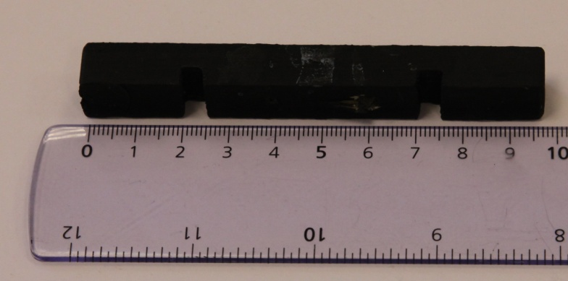
To help maintain the position of the electrodes in a 100 cm³ beaker figure 2 shows a simple model that can be used.
Figure 3

Figure 2
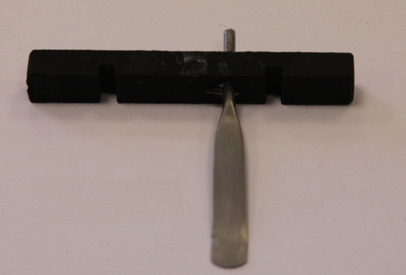
Ensure the diameter of the hole is large enough for a snug fit of the nickel spatula. This can be seen in figure 3.

Figure 3

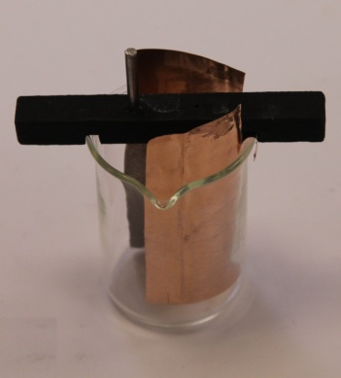
To maximise the plating area of the copper electrode the dimensions given fit 100 cm³ beakers. If you are using different sizes then ensure when cutting out the thin copper foil that the height is sufficient to have it sticking out above the lip of the beakers being used. Ensure the copper plate has a wide enough strip cut out of the top side for a snug fit of the electrode holder. This can be seen in figure 4.
Figure 3

Figure 4

Costings
These were correct as of 22/02/11. Note these items can be purchased from usual school suppliers.
Item | Order No | Quantity | Price | Quantity used per group | Number of class sets per pack if only used for this experiment | Cost per class set (10 groups) | Total Cost | Total Cost per class set
Charcoal, activated | CH005 | 500g | £6.20 | 200g | 2.5 | £2.48 | £6.20 | £2.48
Copper (II) carbonate | CO075 | 250g | £4.00 | 130g | 1.9 | £2.10
 | CO080 | 500g | £6.85 | 130g | 3.8 | £1.80 | £6.85 | £1.80
Copper Sulphate | CO120 | 500g | £3.60 | 125g | 4 | £0.90
 | CO125 | 1kg | £6.35 | 125g | 8 | £0.79 | £6.35 | £0.79
Sulphuric Acid | SU045/1 | 1l | £5.85 | 122cm³ | 8.1 | £0.72
 | SU045 | 2.5l | £13.90 | 122cm³ | 20.4 | £0.68 | £13.90 | £0.68
 |  |  |  |  |  |  | £33.30 | £5.75
Copper,foil | CO055 | 250g | £8.70 | 7.5cm² | 20 approx | £4.35
Nickel Spatulas | SPA030030 | Pack of 5 | £23.75 |  |  | £23.75
Syringes | SYR200040 | Pack of 100 | £14.85 |  |  | £14.85

