Teacher’ Guide
Rocks & Minerals

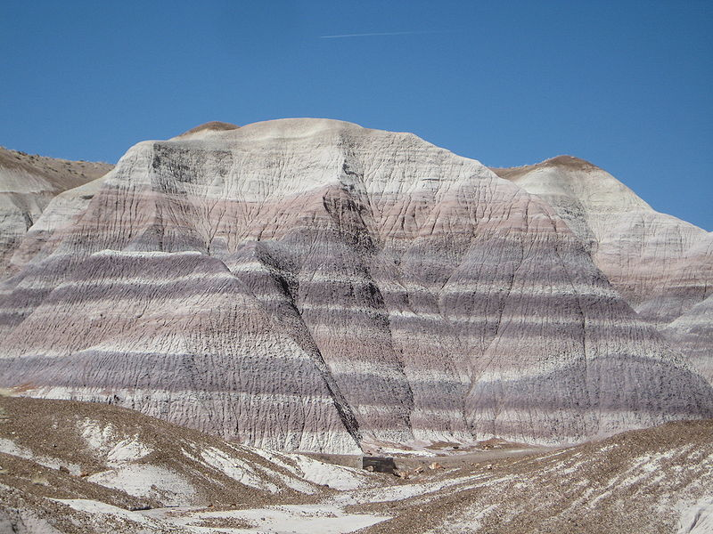
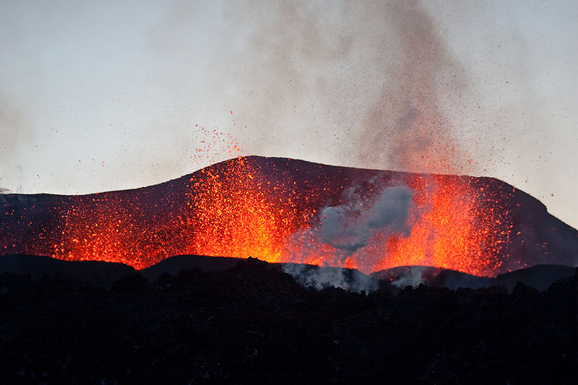
Rocks & Minerals, Teacher’s Guide

Overview
Naturally occurring elements and compounds are called minerals. These are naturally produced in localised concentrations found in the Earth’s crust. At present there are over 3000 minerals of which 300 are common enough to have sufficient economic value.
Many pupils are unaware of where materials come from, in particular minerals and metals.
Using simple, cheap everyday materials they can follow a recipe that allows them to produce their own rocks.
These practical activities can be linked to the following experiences and outcome SCN 3-17a through evaluation of a range of data, I can describe the formation, characteristics and uses of soils, minerals and basic types of rocks.

Introduction
Starting with a light bulb, pupils are introduced to the type of materials needed in the manufacturing of the bulbs and where they originate from. The pupils are given the opportunity to produce their own “rocks” in a fun manner using cheap, everyday materials. This leads into the 3 basic rock types and how they are all part of the rock cycle. There is also the opportunity for the pupils to see that certain metals come from certain minerals. Throughout the practical activities there some active talk strategies that cam enhance and consolidate the learning and teaching.

What to do
The following sequence can be split over 3 lessons or can be tailored to individual needs.
Use the Rocks and Minerals power point as a starter.
For the back to back (B2B) active talk strategy divide the class into pairs and issue one with a copy of the light bulb and the other with a piece of paper and pencil. To save resources these can be laminated and pupils issued with water soluble pens so that the drawings can be washed off afterwards. Allow the pupil with the picture to describe it without naming any parts. Once the other pupil has finished drawing it allow them to compare the picture with the drawing. It should represent the light bulb. Now ask the pupils where the materials to make it have come from. A pupil should be able to give the answer from the Earth. This can lead into rocks and the practical on how to make them. Be aware that the instruction cards are not labelled as to which rock they represent as the pupils are to work out which one is which.
Allow the pupils to follow the Rock 1 (sedimentary) instruction sheet. Pay particular attention to the slurry or paste the pupils make. Over flowing the paper cup with the sediment solution will mean more mess to clear up. As these need to be oven baked it would be best to leave the observations and explanations on the pupil result sheets for the next session. Set the oven to approximately 80ºC. Using the 150 x 150 mm heat proof mats the pupils will be able to place 4 paper cups on 1 mat and leave for 90 minutes to dry completely.
Now allow the pupils to follow the instruction sheet for Rock 2 (metamorphic) and to complete their result sheets. Access to a kettle will make it easier for collection of the boiling water. Ensure the zip bag remains closed to avoid any melted wax from landing on skin, etc. Stress to the pupils that too much pressure from the stirring rods will split the zip bag, making it difficult to retrieve the “new” rock formation.

For the next lesson recap on the formation of rocks 1 & 2 and allow the pupils to the complete their result sheets. Now allow the pupils to follow the instruction sheets for the Rock 3 (igneous) and allow them to complete their result sheets. Stress to the pupils that the open end of the test tubes must be pointing away from pupils whilst heating and that care must be taken when pouring the molten acid into the water and paper cup. Access to a torch would allow the pupils to see the small crystals formed through the slow cooling process to glisten.
For the next lesson recap on the formation of the 3 types of rock and allow them to complete their result sheets.
Now get the pupils to think about these 3 types of rock can be linked together in some sort of cycle. The rock cycle has evolved over 4 billion years and is a constant recycling circle. This URL shows a great animation of how it works. http://www.classzone.com/books/earth_science/terc/content/investigations/es0602/es0602page02.cfm or you can use the Rocks & Minerals PowerPoint to explain the formation of the 3 rock types. Now split the pupils into pairs, allowing them complete the rock formation cards. Note for each card the reverse side has a picture of that rock type. This will help the pupils to sort out the cards into the 3 desired piles and which then can be arranged by statement sorting. Each pair can then check theirs against other groups.
Card Number | Rock formation
1-6 | Sedimentary rocks
7-11 | Igneous rocks
12-16 | Metamorphic rocks
Now allow the pupils to complete their result sheets (Which one? You Decide) and compare their answers.
Now that the pupils will have some idea of how the types of rock are made this URL is helpful to show what types of rocks might be present in their local environment.
http://www.nhm.ac.uk/nature-online/earth/rock-minerals/index.htm
By using the Rocks and Minerals PowerPoint pupils can be shown the picture of the light bulb and asked to think about where the materials used to make it come from. Names/ uses of common minerals can be found using this URL http://lirary.thinkquest.org/05aug/00461
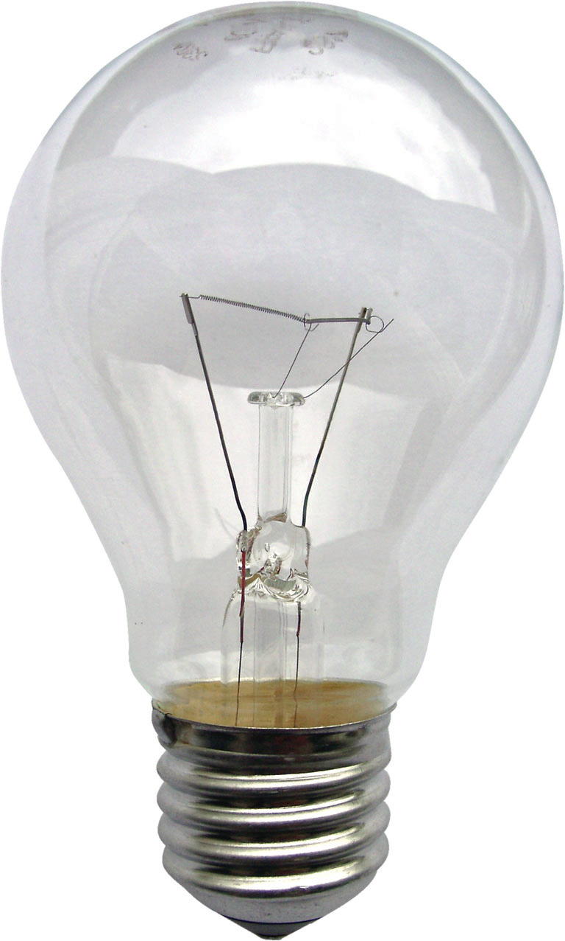
Metal | Mineral/ Ore
Tin | Cassiterite (SnO₂)
Lead | Galena (PbS)
Aluminium | Bauxite (Al₂O₃.2H₂O)
Molybdenum | Molybdenite (MoS₂)
Tungsten | Wolframite (FeWO₄)
Iron | Haematite (Fe₂O₃)
Copper | Chalcopyrite (CuFeS₂)

To consolidate all the learning and teaching the cluster buster active talk strategy can be used. Issue each pupil with a card and allow them to read the card to make sure they understand what it means. The pupils then compare their cards and if they decide there is a link they form a cluster.
Card Number | Cluster
1-4 | Sedimentary rocks
5-9 | Igneous rocks
10-12 | Metamorphic rocks
13-15 | Rock cycle
16-20 | Minerals and ores

What to record
Sedimentary rocks are made when igneous and metamorphic rocks are eroded by the weather. The sediment flows and the settles on the ocean floor. The water either evaporates or is squeezed out allowing the salts to bind the sediment into rock layers. These can contain fossils and enough minerals to be economic as a raw material.
The Rock 1 (sedimentary) instruction sheet allows the pupils to simulate a similar process of the formation of these rocks. The resulting sediment formation of the Epsom salts and silver sand will be brittle/ flake like. The Epsom salts (binding solution) have cemented the sand together and the water has been squeezed out and evaporated. This is typical of sedimentary rock like sandstone. The oven represents the drying effect of sea beds by the Sun.
Metamorphic rocks are made from either or both igneous and sedimentary rocks being subject to extreme heat and pressure from the Earth’s crust and being changed into a new rock formation like marble and slate. These rocks rarely produce mineral concentrations of economic importance.
The Rock 2 (metamorphic) instruction sheet allows the pupils to simulate a similar process of the formation of these rocks. The candle wax and soft diary fudge represent sediment layers that change into a new formation with streaks of the fudge throughout the candle wax. This is typical of metaphoric rocks like marble. The hot water represents the heat from the Earth whilst the pushing of the stirring rod shows the pressure of the tectonic plate movements of the Earth’s continents. Allow the pupils to complete their result sheets.
Igneous rocks are made when lava is allowed to cool. Quick cooling results in extrusive igneous rocks like pumice stone being formed and slow cooling results in intrusive igneous rocks like granite being formed. Few of these rocks have economic importance as raw materials.
The Rock 3 (igneous) instruction sheet allows the pupils to simulate a similar process of the formation of these rocks. The molten stearic acid that is cooled quickly in the cold water will show none or little quantities of crystals and there may even be some evidence of “air bubbles” being trapped and released. This is typical of intrusive igneous rocks like pumice stone.
The molten stearic acid that is cooled slowly in the cup placed in the sand there will be crystals that will glisten when shown under lighting. This is typical of extrusive igneous rocks like granite. Allow the pupils to complete their result sheets.

Trouble shooting & alternatives
When making rock 1 (sedimentary) ensure the pupils add small quantities of the rock solution at a time as too runny or too thick a paste will hinder the drying process.
When making rock 2 (metamorphic) be aware of pupils over filling the 250 cm³ beakers with boiling water and crushed iced as too much will result in water displacement by the zip lock bag.
When making rock 3 (igneous) be aware of the melted acid being poured into the paper cup and water. Emphasise care when using test tube tongs to avoid any accidental spillages.
The making of igneous rocks can also be done by melting cooking chocolate and allowing it to cool. For metamorphoric rocks, melted chocolate with added cornflakes, raisins, rice and allowed to cool can be used. Sedimentary rocks can be simply done by mixing different grades (sizes) of sand in a beaker, allowed to settle and then dry out.

Resources
The Epsom salts, silver sand and stearic acid are common laboratory supplies. The small (petite) baking cups, soft fudge and tea lite candles can be purchased from most supermarkets.

Other resources
http://lirary.thinkquest.org/05aug/00461
Provides information about the 3 basic rock types, examples of these and minerals that are found in the Earth’s crust.
http://www.nhm.ac.uk/nature-online/earth/rock-minerals/index.htm
Enter the Earth-lab datasite followed by rock type and then location. To view the data selected use the view selected button. This will show the rock type for the selected area.
http://www.classzone.com/books/earth_science/terc/content/investigations/es0602/es0602page02.cfm
An interactive web resource that animates the different stages of the rock cycle. Follow the instructions at each stage for more detailed descriptions and examples.

