Name : Reg:
Rocks & Minerals

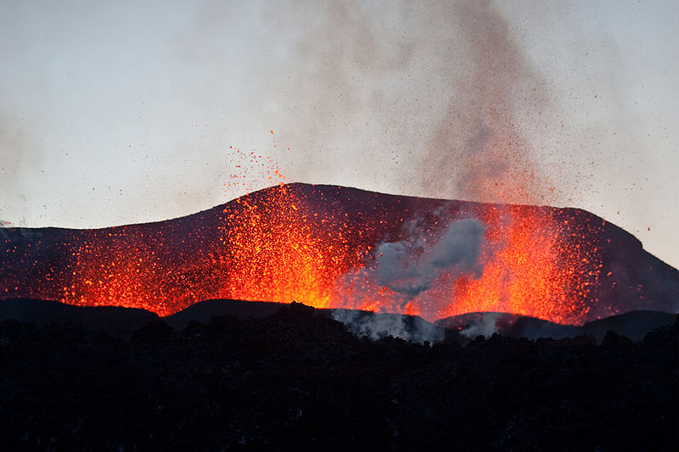
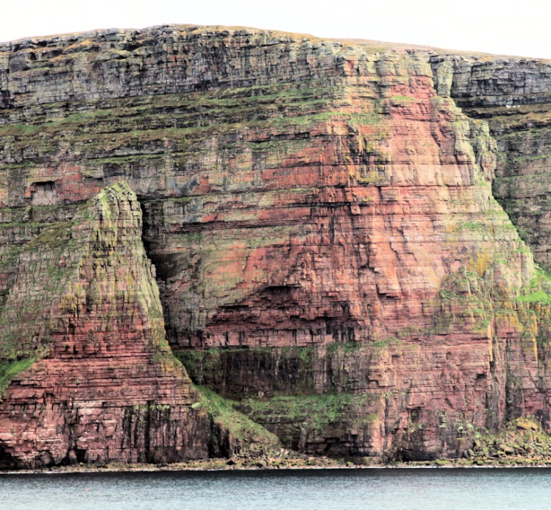
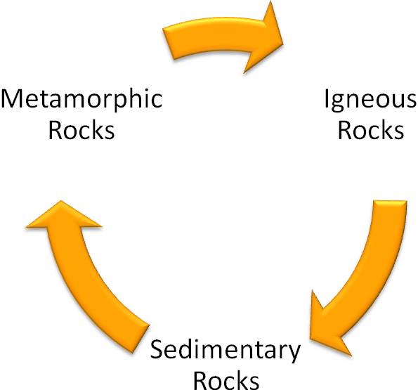
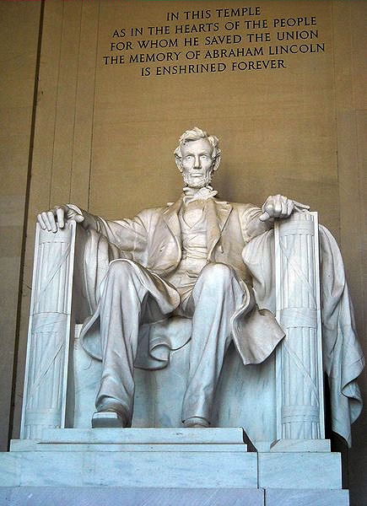

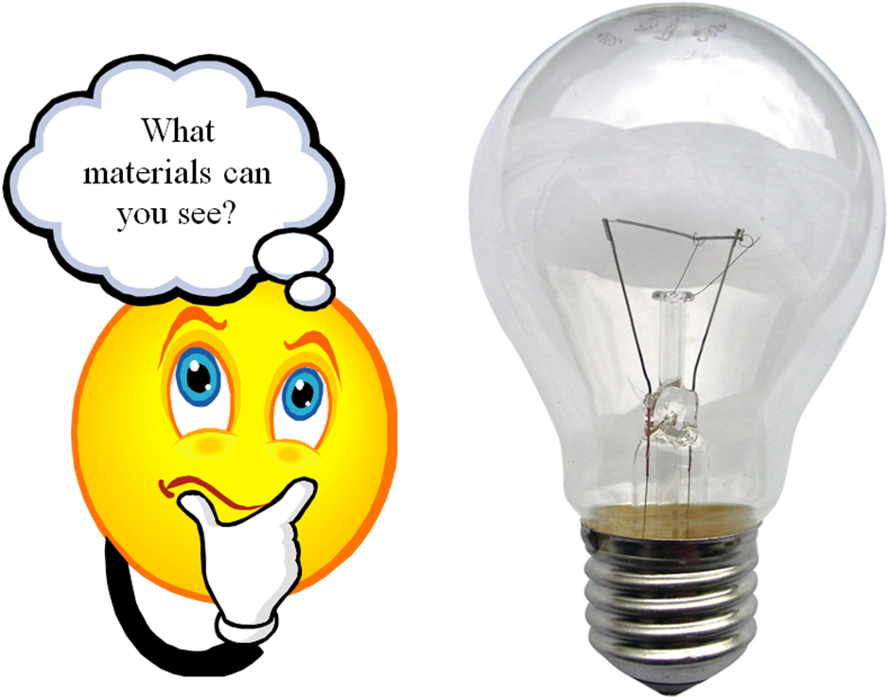

Make a list
Pupil Instruction Sheet Rock 1

Apparatus you will need
Goggles
Stirring rod
Heat proof mat
Pasteur pipettes – disposable 3 cm³
Tongs
Scissors
Small baking paper cups

Chemicals you will use
Silver sand
Sediment solution

What you will do
- Add enough sand to the paper cup to make it half full.
- Using a Pasteur pipette add 2 cm³ of sediment solution to the layer of sand in the cup. Or enough to make a thick paste.
- With a stirring rod carefully mix the sand and solution into a paste mixture without tearing the cup.
- Place the cup on a small heat proof mat and put into an oven set at 80 ºC for 90 minutes.
- Remove the cup and using a pair of scissors carefully cut off the sides of the cup and look at the new rock formation.
Pupil Instruction Sheet Rock 2

Apparatus you will need
250 cm³ plastic beaker x 2
250 cm³ glass beaker x 2
Plastic zip bag (95 mm x 150 mm) x 2
Scissors

Chemicals you will use
Candle wax x 8 pieces
Soft fudge x 8 pieces
Crushed ice

What you will do
- Stack the candle wax and fudge on top of each other in layers.
- Place the layer arrangement into the plastic zip bag and seal it.
- From a kettle add 150 cm³ of boiling water into a 250 cm³ plastic beaker.
- Carefully place the bag into the beaker of water and allow the wax to melt.
- Using a stirring rod carefully apply pressure on the bag without breaking it to mix up the layers.
- Carefully place the bag into another 250 cm³ glass beaker containing crushed ice and water.
- Allow all of the mixture to become solid and then remove the bag.
- Using a pair of scissors carefully cut a corner off the bag and look at the new rock formation.
Pupil Instruction Sheet Rock 3

Apparatus you will need
250 cm³ glass beaker
Bunsen burner, heat proof mat, tripod
Test tubes x 2
Test tube rack
Test tube tongs
Tongs
Large spatula
Crystallising dish
Paper towels
Small baking paper cups x 2

Chemicals you will use
Stearic acid (irritant)
Sand

What you will do
- Using a large spatula add the solid stearic acid into 2 test tubes to a depth of 2 cm in each and place them into the test tube rack.
- Add 150 cm³ of water to a 250 cm³ glass beaker and place the 2 test tubes inside it.
- Using a Bunsen burner heat up the beaker until all the acid has melted. Remember to point the open ends away from other pupils.
- Fill a crystallising dish half full with sand and place the paper cup on top of the sand.
- Using the test tube tongs carefully pour the melted acid from one test tube to the paper cup and leave to cool.
- Add 100 cm³ of cold water to another 250 cm³ glass beaker.
- Using the test tube tongs carefully pour the melted acid from the 2nd test tube into the water.
- Using tongs, carefully remove the solid from the cold water and place onto a paper towel to dry.
- Once the solid has formed in the paper cup remove the cup from the sand and tip out the contents onto the paper towel.
- Shine a light on the samples and record any differences.
Note
This method is only a physical change NOT a chemical one but it does show how rocks can be melted and cooled to make new ones.
Rocks & Minerals Pupil Result Sheet


Rock 1
Does the rock made with the rock solution feel rough or smooth? Does it break easily?
___________________________________________________________
___________________________________________________________
___________________________________________________________
What does the rock solution do to the gains of sand?
___________________________________________________________
___________________________________________________________
___________________________________________________________

Rock 2
What helped the candle wax and soft fudge to melt?
___________________________________________________________
___________________________________________________________
What helped to push the layers together?
___________________________________________________________
___________________________________________________________
Which 2 words would you use to describe what helps to make this type of rock?
___________________________________________________________

Rock 3
Which cooling process made the small, fine crystals? Which process made the larger, coarser crystals? The level of “sparkle” under the light might help you decide?
Write or draw what you have seen in the beaker and paper cup.
Quick Cooling (water) | Slow Cooling (sand)

Which one? You Decide
Having made all 3 types of rock and sorted out the rock formation cards work out which rock number was which rock type?
Rock Number | Type of rock
1
2
3
Now check your findings with another group.
Did they get the same as you?

