Teacher’s Guide
Ocean Acidification

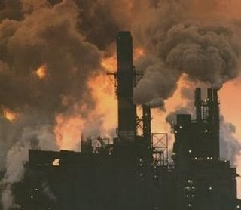
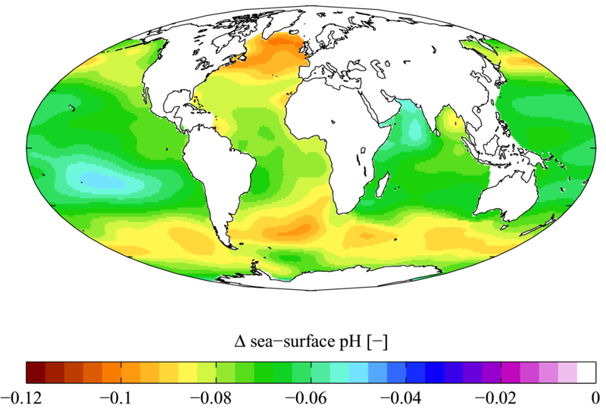
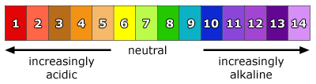
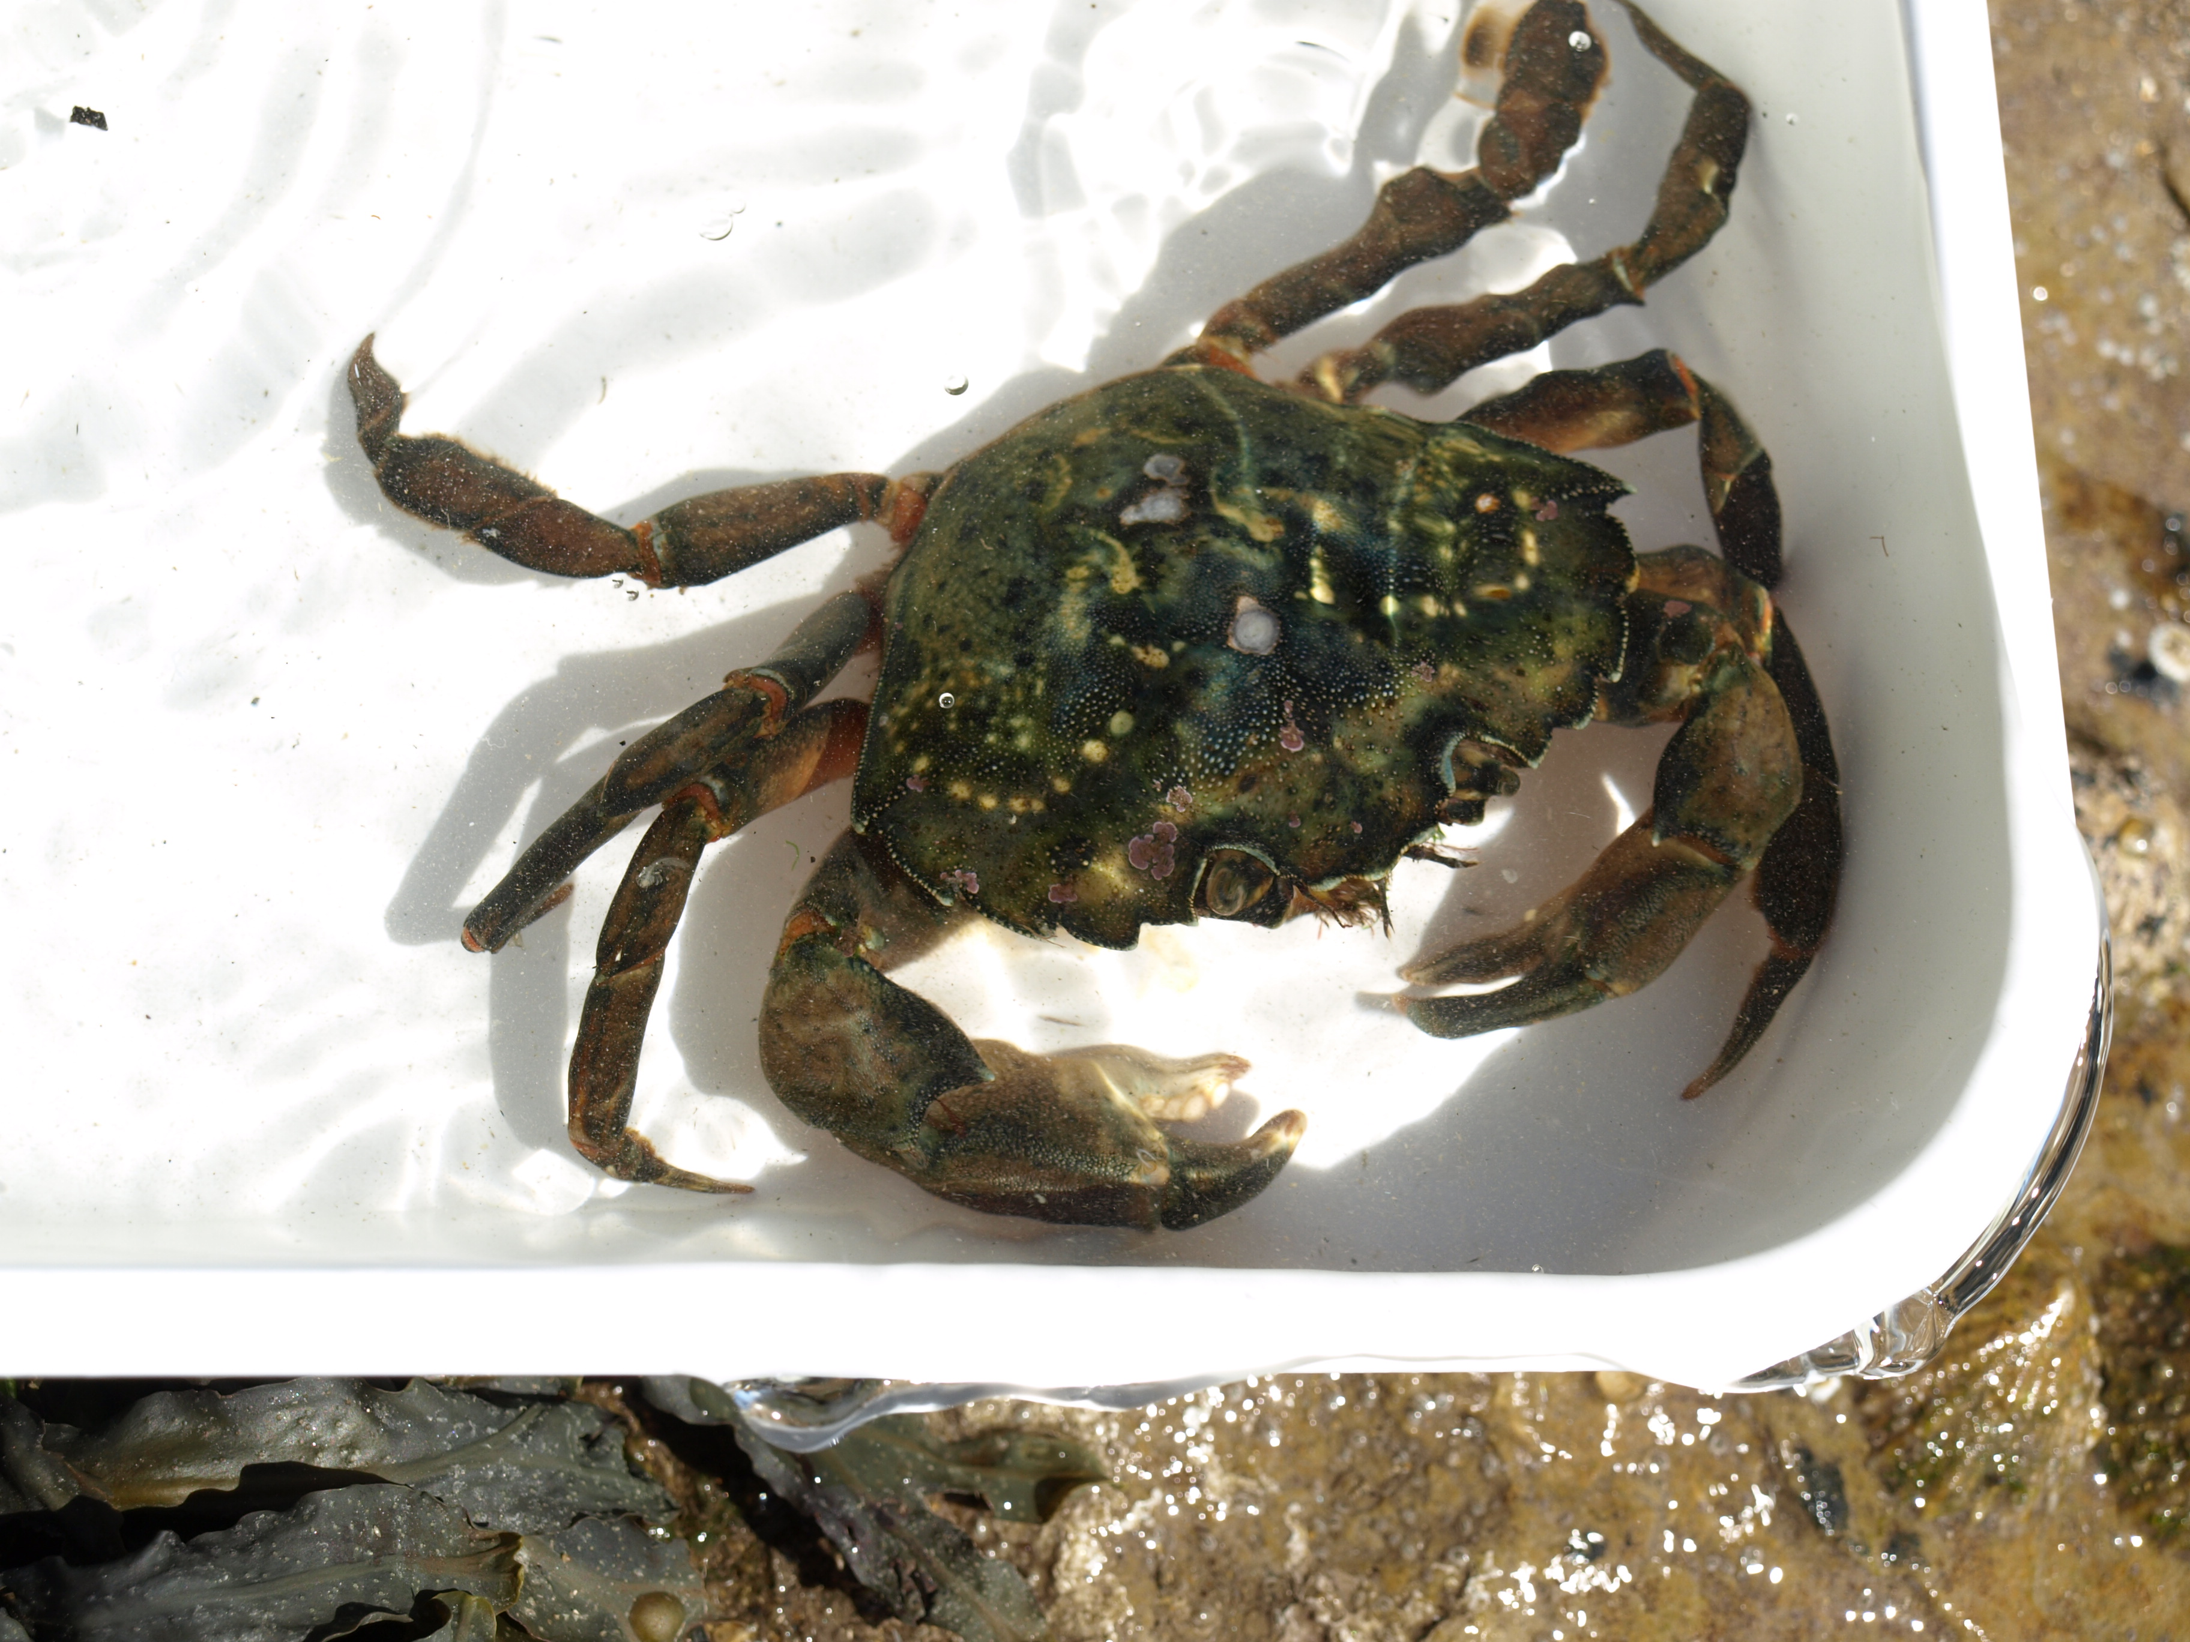
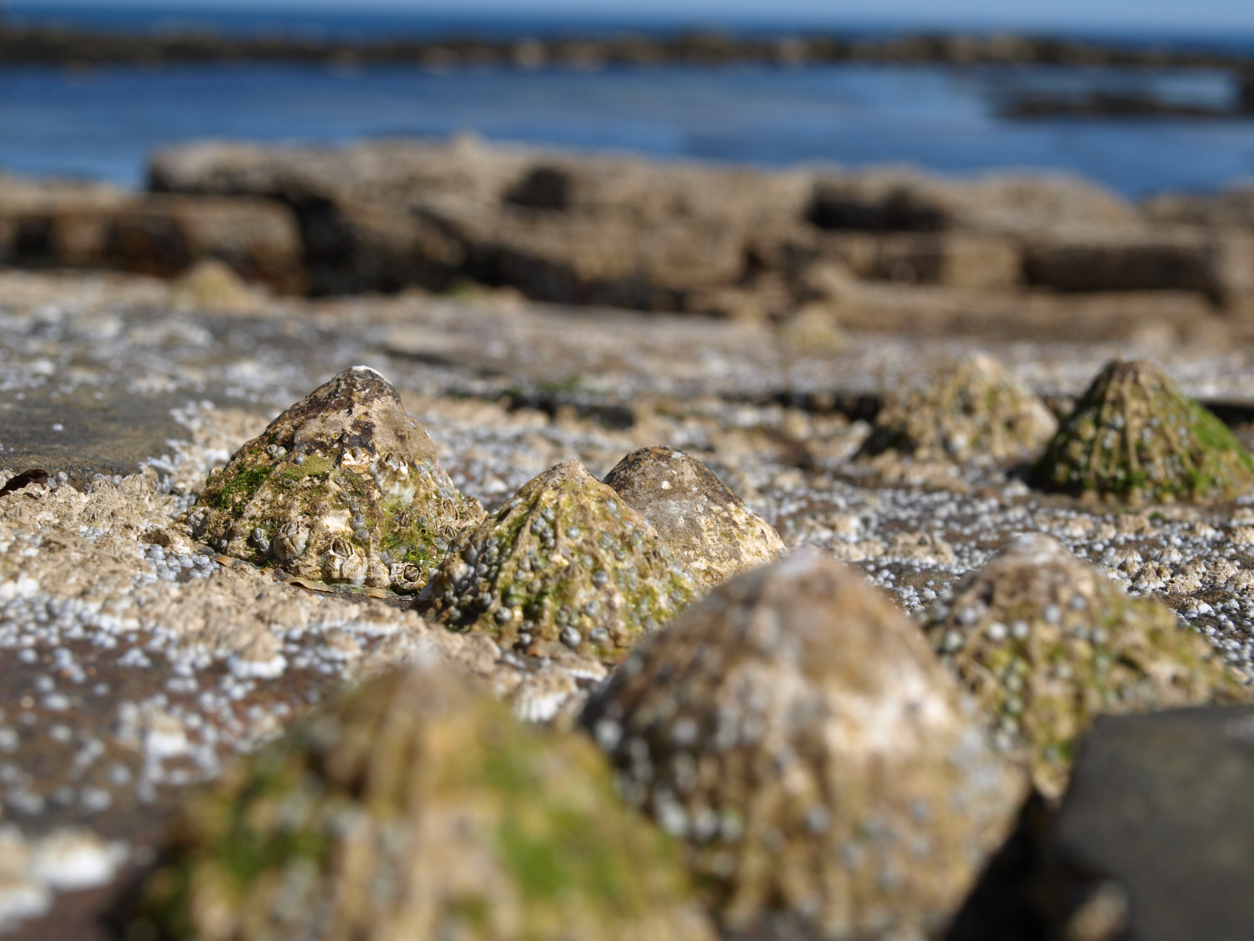
Teacher’s Guide

Overview
The Earth’s oceans are huge carbon “sinks” and play a major role in the carbon cycle. It is a very complex process but in general terms they absorb more carbon dioxide than they release into the atmosphere.
The balance of this process is dependent upon the oceans pH’s, temperatures and alkalinities. Any changes in these variables will affect the seawater carbonate chemistry and may have a devastating effect on many shell-forming organisms. [1]
Ocean Acidification is a process by which the oceans have absorbed the carbon dioxide to give a measurable change in the pH, bicarbonate (HCO₃) and carbonate (CO₃) concentrations found in the oceans. It has been estimated that they have taken in approximately 30% of anthropogenic (man-made) carbon in the form of carbon dioxide emissions from activities like transport and electricity generation. [2]
Bodies like the European Project on Ocean Acidification (EPOCA) have estimated the mean surface ocean pH has dropped 0.1 pH units since the beginning of the industrial revolution producing a 30% increase in the hydrogen ion concentration. [3]
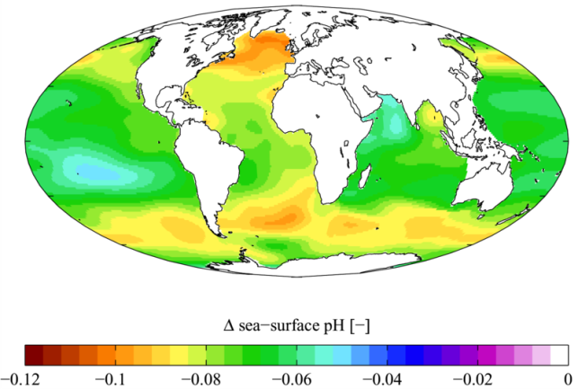
The highest levels of change have been found in the in the top 500 metres of the oceans, the layer closest to the atmosphere, and Northern Atlantic (nearest to population centres with high energy requirements) and Antarctica (coldest and most dense waters).
From burning candles to photosynthesis [4], solubility of carbon dioxide [5] to the buffering effect of seawater [6] this resource can be linked to the following experiences and outcomes :
SCN 3-02a, I have collaborated on investigations into the process of photosynthesis and can demonstrate my understanding of why plants are vital to sustaining life on Earth,
SCN 3-05b, I can explain some of the processes which contribute to climate change and discuss the possible impact of atmospheric change on survival of living things,
SCN 3-18a, having taken part in practical activities to compare the properties of acids and bases, I have demonstrated ways of measuring and adjusting pH and can describe the significance of pH in everyday life,
SCN 4-05b, through exploring the carbon cycle, I can describe the processes involved in maintaining the balance of gases in the air, considering causes and implications of changes in the balance,
SCN 4-18a, I can monitor the environment by collecting and analysing samples, I can interpret the results to inform others about levels of pollution and express a considered opinion on how science can help to protect our environment,

Introduction
Ocean acidification is the measurable change of hydrogen, bicarbonate and carbonate ion concentrations. As more CO₂ is absorbed by the oceans the hydrogen and bicarbonate ion concentrations increase and the carbonate ion concentration decreases. This is of scientific interest as calcifiers (shell-forming organisms) need the carbonate ion to make their shells and a drop in this value could lead to their extinction with significant impacts on other food chains found the in oceans.

Carbonic Acid
Initially carbon dioxide dissolves in water as shown in (I)
CO_{2(g)}⬄ CO_{2(a,q)} (I)
Once the CO₂ has dissolved in the water it reacts to from carbonic acid. This can take a little as a few seconds to a few minutes (II)
CO_{2(a,q)} + H₂O _{(l)} ⬄ H₂CO_{3(a,q)} (II)
However carbonic acid rapidly dissociates to form first the bicarbonate ion (III) and then the carbonate ion. (IV)
H₂CO_{3(a,q)} ⬄ HCO₃⁻_{(a,q)} + H⁺_{(a,q)} (III)
HCO₃⁻_{(a,q)} ⬄ CO₂⁻²_{(a,q)} + H⁺_{(a,q)} (IV)
As can be seen the reactions eventually end with the production of the hydrogen ion subsequent drop in pH.

Combustion
Fossil fuels like coal, oil and natural gas burn in oxygen in an exothermic reaction called combustion. What is of importance is the production of CO₂ as this reaction is considered to be one of the main sources of anthropogenic carbon absorbed by the oceans. (I) It has been estimated that there is 3,000 gigatonnes of CO₂ in the atmosphere.
CH_{4 (g)} + O_{2(g)} → H₂O_{(g)} + CO_{2 (g)} (I)

Solubility of carbon dioxide
The ability of the ocean to dissolve CO₂ is also dependent upon its surface temperature. From the reactions given for the formation of carbonic acid when the temperature is high the equilibrium adjusts even more so to the left. (the solubility decreases)

Alkalinity
This is the ability of the seawater’s negative ions to react with the positive hydrogen ion. In the oceans the hydrogen carbonate and carbonate ions react with the hydrogen ions to buffer/ resist changes in the pH. Most of the oceans have a narrow pH range with an average of approximately 8.2.

Photosynthesis
Photosynthesis has been most probable one the most vital reactions to evolve on our planet. Over the last 3000 million years it has been responsible for creating the right conditions to support life and maintain the balance of gases in the atmosphere. [7]
Plants and in particular the chloroplasts trap the energy from the sun and use it to split water molecules into hydrogen and oxygen molecules. (I) This primary reaction is known as photolysis and can only happen in the presence of light.
H₂O _{(l)} → H₂ _{(g)} + O₂ _{(g)} (I)
The oxygen is released into the atmosphere and the hydrogen carried by the stroma to reduce the carbon dioxide into glucose (II) that is either used by the plants during their own respiration or as building blocks to make polysaccharides like cellulose or starch (III).
CO_{2(g)} + H₂ _{(g)} →C₆H₁₂O₆ (II)
nC₆H₁₂O₆ → (C₆H₁₀O₅)_{n} (III)
This shows that photosynthesis can help to maintain the pH of the oceans by removing any carbon dioxide dissolved in the oceans.

What to do
Students are required to know that exhaled breath contains more carbon dioxide than inhaled breath and that combustion of fossil fuels produces carbon dioxide.
If there are available resources to make your own solid carbon dioxide [8] you can show how it is denser than air, turns limewater from clear to cloudy, etc. If you are unable to do this carbon dioxide pellets can be bought from common suppliers.

In today’s high media coverage it is more than likely the students will know about global warming and where the carbon dioxide is coming from. You could choose to make this a discussion activity.
Allow the students to follow the Ocean Acidification Instruction Sheet. Ensure that they are aware of possible burns and that the 250 cm³ glass beaker needs to be kept if they are to complete the other experiments.
Allow the students to record their observations and results.
In general terms the carbon dioxide dissolves into the water and so the pH drops. This is seen be the colour change of the bicarbonate indicator.
Allow the students to follow the Solubility of Carbon Dioxide Instruction Sheet. Remind them that fresh straws must be used each time for hygiene reasons. Although everyone has a different lung capacity and indeed respiration rate so long as the same student does the breathing and at a steady rate it can be assumed that the each breath contains the same volume of CO₂.
Allow the students to record their observations and results.
In general terms as the temperature increases the solubility decreases. (number of breaths decreases)
There is also an opportunity to carry out a plot of temperature against number of times exhaled. (quantity of carbon dioxide)
As the students may not have come across phenol red indicator it is good practice to demonstrate the colour changes of red to yellow and back to violet/ pink. This can be done be taking a sample of water, adding the phenol red, then the vinegar and finally the sodium hydroxide. Quantities are not important. Allow them to follow the Resisting Acidification Instruction Sheet.
In general terms the more the type of water can resist the pH change (buffer) the less number of drops are needed to bring the pH back to where it started.
There is also an opportunity to carry out a plot of types of water against number of drops.
Allow the students to follow the Are Plants the Answer? Instruction sheet. If they have kept the bicarbonate indicator from the combustion of fossil fuels activity they carry out the photosynthesis directly. As they may not have used bicarbonate indicator or the strip before it is good practice to ensure they students understand what colours on the strip show which pH.
Allow the students to record their observations and results.

What to record
These results are specimen answers. You may need to carry out rough estimates to account for local differences like ion concentration etc.

Ocean Acidification
 | Start | End
Colour | Red | Yellow
pH | 8.2 | 7.2

Solubility of Carbon Dioxide
As the temperature increased the number of times exhaled decreased.
Countries are trying to reduce their levels of CO₂ production because if the temperature of the ocean increases they will be able to absorb less CO₂ and the rate of global warming will increase.

Resisting Acidification
The seawater is the best type of water to resist the acidification.
Seawater was able to resist the acidification because there must have been other chemicals in it to mop up the extra acid present. For example the bicarbonate and carbonate ions that are present in seawater but not in distilled water.

Are Plants the Answer?
 | 10 minutes | 20 minutes
pH | 7.8 | 8.0
The pH of the water is becoming more alkaline, moving away from 7.
The Cabomba is helping to change the pH of the water.

Troubleshooting
If the burn time is more than 60 seconds it will take a considerable length of time for the Cabomba to carry out photosynthesis and show a colour change with the bicarbonate indicator.
If there is no significant difference in the distilled water and seawater, check the pH of the distilled water. Adjust it accordingly by using a weak base like ammonia solution so that its pH is of similar value to the seawater. (8.2)
If the photosynthesis is taking too long then replace with fresh Cabomba with as many fronds on each strand as possible. Or if the output from the lamp is not sufficient leave the beaker in strong sunshine until next lesson.

References & Acknowledgements
1 = S.C.Doney and R.A.Feely, Ocean Acidification, Education in Chemistry, November 2009
2 = Turley, Findlay, Mangi, Ridgwell and Schmidt, Marine Climate Change Impacts Patnership (MCCIP) Ecosystem Linkages Report Card 2009 CO₂ and ocean acidification
3 = EPOCA, Making it clear, http://www.epoca-project.eu (Ocean acidification – questions answered)
4 = SSERC, Climate change, are plants the answer?
http://www.science3-18.org/sserc/images/Bulletins/235/5-7_Climate_change.pdf, 2011
9 = Nuffield Foundation, RSC, The reaction between carbon dioxide and water, http://www.practicalchemistry.org/experiments/the-reaction-between-carbon-dioxide-and-water,298,EX.html
6 = Ocean Carbon & BioChemistry Program, Ocean acidification lab, http://www.nrdc.org/oceans/acidification/files/labkit.pdf, 2009
7 = D Eldrige, Photosynthesis – A survival guide,
8 = Nuffield Foundation, IOP, Solid carbon dioxide turning into a gas, http://www.practicalphysics.org/go/Experiment_185.html

