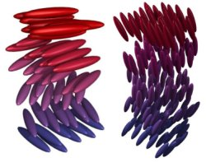
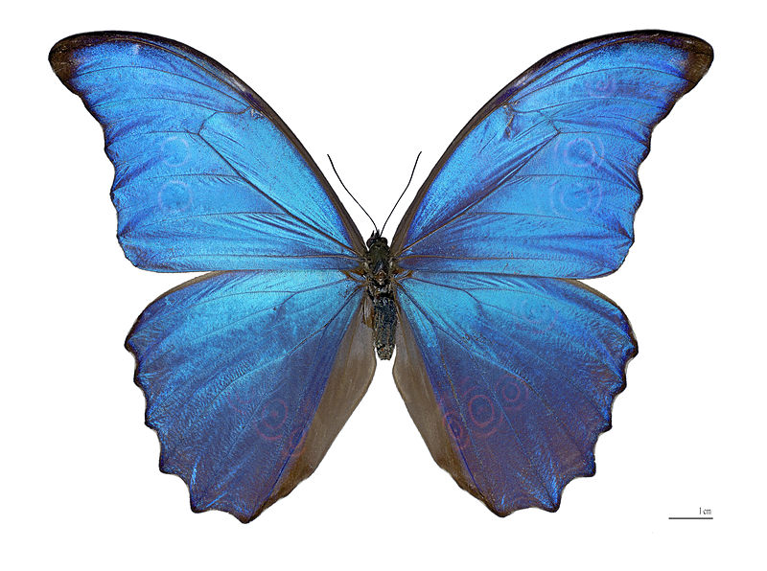
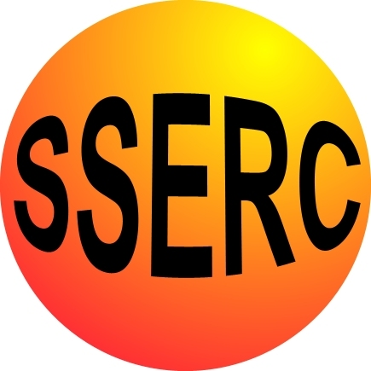
Technicians’ Guide

Making Liquid Crystals
Each group will need access to:
A balance (2 d.p.)
An oven (set at 150⁰C)
A permanent felt tip marker pen
Cholesteryl oleyl carbonate
Cholesteryl Pelargonate
Cholesteryl Benzoate

Each Group will also need:

- Weighing boats (3)
- Spatulas (3)
- A small glass test tube (semi micro) and stoppers to fit
- A small stirring rod

- two pieces of sticky-backed plastic 4 cm square

Temperature Range
Each Group will need:
- A tripod, heat mat and Bunsen burner
- A 250 cm³ beaker of cold water
- A thermometer

Liquid Crystal Thermometer
Each Group will need:
- A piece of sticky-backed plastic which is 8 cm wide and 50 cm long
- A permanent felt tip pen
- A basin
- Some ice
- A kettle of warm water
- A piece of black card or black paper

Making a Mood Patch
Each Group will need:
- Access to the sample of the liquid crystal mix made from 50% Cholestryl Oleyl Carbonate and 50% Cholestryl Pelargonate. Approximately 1g of the mixture will be sufficient for the whole class.
- A small glass stirring rod
- Pieces of sticky-backed plastic 4 cm square
- Pieces of black plastic 5 cm square cut from a bin liner
Cool Dude or Hot, Hot, Hot
Each Group will need:
- Access to a sample of a liquid crystal mix made from 50% Cholestryl Oleyl Carbonate and 50% Cholestryl Pelargonate. Approximately 1g of the mixture will be sufficient for the whole class.
- A metal seeker
- A small glass vial
- A cord for the vial
- Some Superglue for the teacher to dispense

Current costs (as of 02/05/12):
Aldrich
- Cholesteryl Benzoate C75802-25G 25g £17.80 C75802-100G 100g £52.30
- Cholesteryl Oleyl Carbonate 151157-25G 25g £48.80
- Cholesteryl Pelargonate C78801-100G 100g £51.50

- Test tubes
Scientific and chemical supplies Ltd
39 Back Sneddon Street
Paisley
Renfrewshire
PA3 2DE

Tel no 01418873531

Order code TBS 030 010 pack of 100 test tubes sized 10x75
cost £28.27

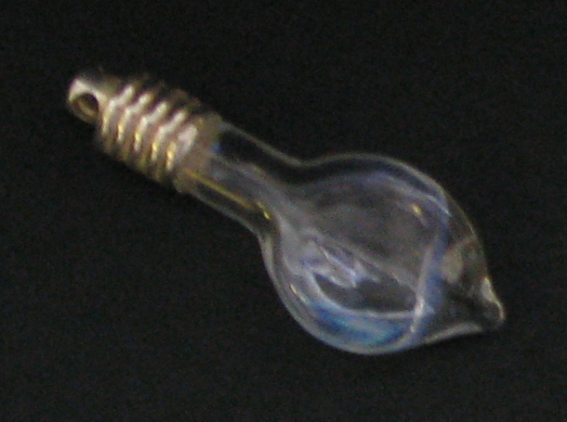
- Vials
Bio-Rad laboratories
Bio-Rad House
Maxted Road
Hemel Hempstead
HP2 7DX

Tel no 02083282000

Order code 166-2200EDU -
DNA necklace module 18 necklaces for £21.00

- Sticky-backed plastic Various stores e.g. Tesco ~£1.00/roll
- Black bin liners Various stores (or school janitor)
- Superglue Various stores
- Permanent Felt Markers Various stores
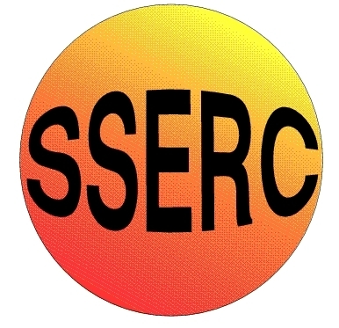
SSERC Risk Assessment (revised version November 2009)
(based on HSE ‘5 steps to risk assessment’)

2 Pitreavie Court, South Pitreavie Business Park, Dunfermline KY11 8UB
tel : 01383 626070 fax : 01383 842793
e-mail : sts@sserc.org.uk web : www.sserc.org.uk

Activity assessed | Liquid Crystals
Date of assessment
Date of review (Step 5)
School
Department

Step 1 | Step 2 | Step 3 |  | Step 4
List Significant hazards here: | Who might be harmed and how? | What are you already doing? | What further action is needed? | Action by whom? | Action by when? | Done
Cholesteryl Benzoate – Possible irritant to eyes, skin, respiratory tract. | Technician, teacher, pupils | Wear goggles, Wear gloves and avoid skin contact. Wash off skin with copious amounts of water. Avoid breathing dust. Use in well ventilated area. Wash hands after use.
Cholesteryl Oleyl Carbonate  Possible irritant to eyes, skin, respiratory tract. | Technician, teacher, pupils | Wear goggles, Wear gloves and avoid skin contact. Wash off skin with copious amounts of water. Avoid breathing dust. Use in well ventilated area. Wash hands after use.
Cholesteryl Pelargonate  Possible irritant to eyes, skin, respiratory tract. | Technician, teacher, pupils | Wear goggles, Wear gloves and avoid skin contact. Wash off skin with copious amounts of water. Avoid breathing dust. Use in well ventilated area. Wash hands after use.
Oven  Danger of burns | Teacher, pupils | Remove with care. Do not touch hot test tube or rack
Description of activity:
Different mixes of the chemicals are weighed out and fused in a hot oven. The mixtures are allowed to cool and a thin film of each painted onto sticky-backed plastic squares. These are sealed with another layer of plastic to keep the mixes water and air free. Ingress of these will destroy the properties of the liquid crystal mix.
Pupils then determine the temperature range of the liquid crystal(s) they have made by observing the colours as the temperature is increased from iced water to warm water from a kettle.
Finally they can put their squares together to produce a strip of crystals which can act as a thermometer.

Additional comments:
A “Mood Patch” can also be made by spreading a thin layer of a mix onto a square of black polythene from a bin liner and then sealing it with a top layer of sticky-backed plastic. When the patch is held on the inner wrist it starts to change colour. The degree of colour change towards the purple indicates a hotter temperature.
As an extension, a liquid crystal mix can be encapsulated in a small glass vial and used as a colour changing necklace.

