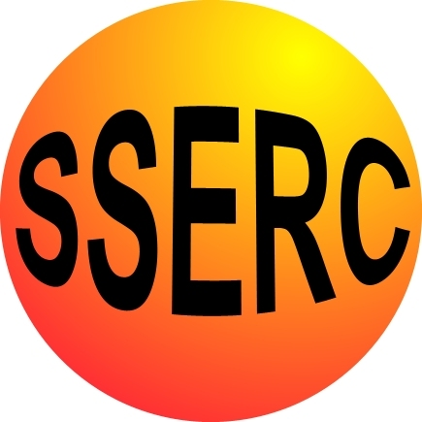

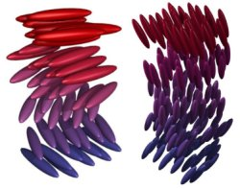
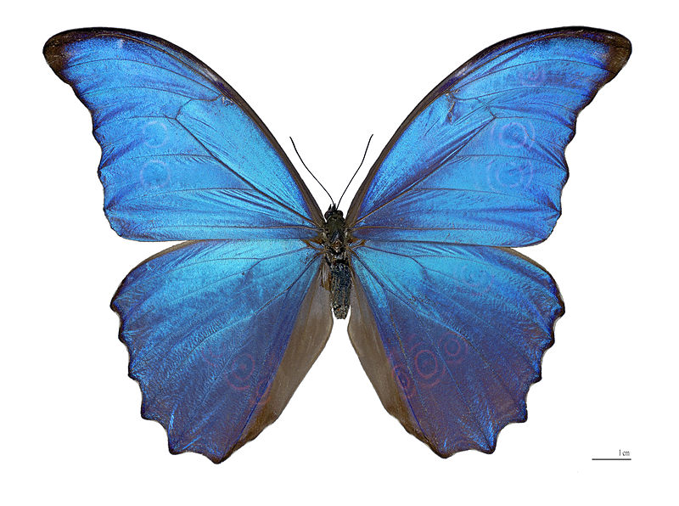
Teachers’ Guide
Liquid Crystals

Curriculum links

CfE SCN 4-16a: “I have carried out research into novel materials and can begin to explain the scientific basis of their properties and discuss the possible impacts they may have on society”.

National 4: Nature's Chemistry - plants to products
Chemistry in Society – Materials - polymers

Background:
Solid
A liquid crystal (LC) compound is an organic material composed of carbon, hydrogen, oxygen, and sometimes nitrogen and a few other elements. At room temperature, this material might look like a powder composed of small crystals, similar in appearance to salt or
sugar.

LC’s constitute a unique form of matter.
LC Phase
Figure 1 opposite shows a picture of an LC chemical as viewed between crossed polarizers.
As temperature increases, the solid powder melts into a liquid fluid that scatters light.
As the temperature continues to increase, the liquid becomes isotropic (i.e., exhibiting the same properties when examined from all
isotropic
directions), and it looks and behaves like water. It is no longer in its liquid crystal phase. Reducing the temperature returns the fluid to the LC phase.
Figure 1

Cholesteric liquid crystals are
very sensitive to the environment, and can be used to detect changes in temperature.

We can think of an LC molecule as being both long and narrow like a very small rod. The liquid crystals can arrange themselves in a layer with their neighbours: either somewhat randomly, or with higher degrees of order.
Figure 2
A rendition of cholesteric order in a stack of LC layers is given in Figure 2 opposite. Red arrows whose tips are connected by a blue line show that the direction of orientation for the rod-like molecules traces out a helical or screw-like pattern. This is the defining characteristic of the cholesteric LC phase. White light passing into a film of this liquid crystal will interact with the screw-like structure in interesting ways.

The two drawings in Figure 3 below depict the cholesteric LC fluid as a spring between two clear plates. When the LC is cool, the spring is elongated (e.g., the pitch, or distance between turns, is large). As the LC warms, the spring tightens up and the pitch becomes smaller. The red colour in white light is reflected from the cooler LC structure. As the LC warms, yellow, green, and then blue colors are reflected. This phenomenon is called “selective reflection”.
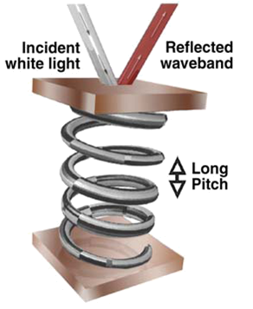
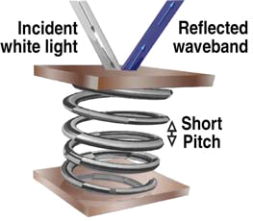

Figure 3

Some cholesteric LC chemicals are very sensitive to temperature.
The photographs in Figure 4 show a man’s hand that was coated with black paint containing a temperature sensitive cholesteric liquid crystal. His fingers were
Warm –
Blue
Figure 4
Cooler - Green
initially warm and reflected in the blue, due to good blood circulation. His circulation
was degraded by nicotine from smoking one cigarette, and his fingers cooled.

Some cholesteric LC chemicals are very sensitive to temperature and form the basis for thermometers and mood rings. They can be made by mixing together different chemicals. The range over which they change colour is determined by the composition of the mixture.

e.g. The following mixtures can be tried and used to make a thermometer.

Mixture | Cholesteryl oleyl carbonate (g) | Cholestrryl pelargonate (g) | Cholesteryl benzoate (g) | Transition range degrees C
1 | 0.65 | 0.25 | 0.10 | 17-23
2 | 0.70 | 0.10 | 0.20 | 20-25
3 | 0.45 | 0.45 | 0.10 | 26.5-30.5
4 | 0.44 | 0.46 | 0.10 | 30-33
5 | 0.42 | 0.48 | 0.10 | 31-34
6 | 0.40 | 0.50 | 0.10 | 32-35
7 | 0.38 | 0.52 | 0.10 | 33-36
8 | 0.36 | 0.54 | 0.10 | 34-37
9 | 0.32 | 0.58 | 0.10 | 36-39
10 | 0.30 | 0.60 | 0.10 | 37-40

Ideas for making mood patches and necklaces are also given.

It is envisaged that the activities will be pulled together by pupils then researching uses of these cholesteryl crystals. The results of this research, and their thermometer, would form the basis of a wall display. For these reasons, no pupil recording sheets for results were deemed necessary.

Just as some liquid crystal sensors can measure temperature, others can sense movement and pressure, chemicals (e.g., pollution, poisons), biological agents (e.g., viruses, bacteria), and electricity.
With this additional knowledge, pupils could discuss some potential inventions that would use liquid crystal sensors either as a whole class or with them divided into groups. They could use a “Lizard’s Lair” approach (see separate sheet). This relates to SCN 4-20a “I have researched new developments in science and can explain how their current or future applications might impact on modern life”.

For example, it might be good to have road signs that say “Watch out for ice” when the temperature drops below freezing and plates that say “Clean me” when bacteria or dirt are present.

Some possible URLs include:

http://www.lci.kent.edu/lc_history.html
http://video.google.com/videoplay?docid=-9025989088342897746#
http://www.lipochemicals.com/files/1113257907_010104CSTReimerOrtCosmAppLiqCryst.pdf

A game can be found at
http://nobelprize.org/educational/physics/liquid_crystals/chrystallite/

