

Science investigation

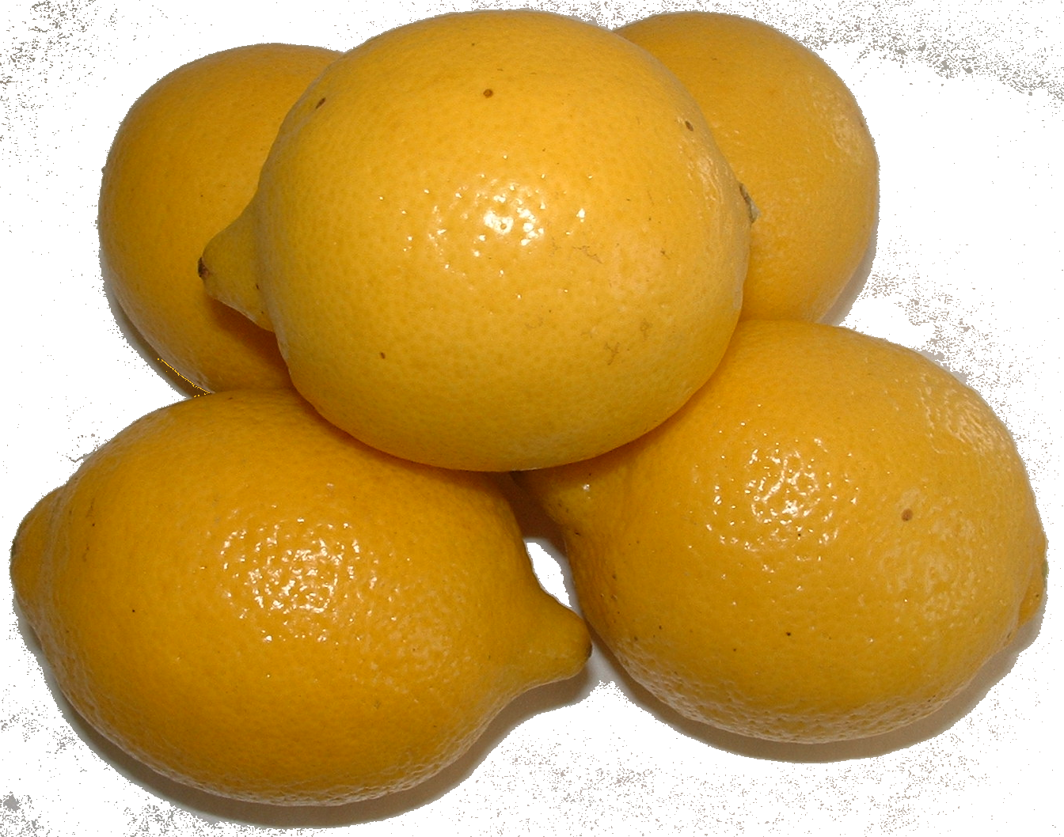

A chemical Reaction Using Lemons

Technician’s Guide

Investigating a chemical reaction using Lemons

Preparation of the permanganate solution

Pupil Apparatus needed
- A bottle of stock acidified potassium permanganate solution of concentration
0.001 mol l⁻¹
- A selection of 100 cm³ glass beakers
- Stirring rods
- Small measuring cylinders.
- Pieces of white paper or card
- Safety goggles
- A selection of stop-clocks or suitable timers
- Thermometers (to investigate effect of temperature)
- Bunsen burners and heat mats or water baths
- Knives (to investigate effect of surface area)
- A selection of 20 cm³, 10 cm³ and 5 cm³ syringes (to investigate effect
of concentration)
- Some lemons (to investigate the effect of surface area).
- Bottles of lemon juice at different concentrations.
Possibilities are 12.5%, 25%, 50%, 75% and 100%
Bottles should be labelled as such.

What you will need
- Indirect vent goggles
- Gloves
- Balance reading to at least 2 d.p.
- Spatula.
- Volumetric flask of correct volume.
- Measuring cylinders.
- Bottle(s) of concentrated lemon juice.
- Bottles to store lemon juice solutions in.
- A jar of potassium permanganate crystals (harmful, oxidising agent)
- A bottle of 2 mol l⁻¹ sulphuric acid (corrosive, irritant)
- A 1 litre beaker
- Stirring rod
- Brown bottle(s) to store permanganate solution.

What you do

Make up a batch of 0.001 mol l⁻¹ potassium permanganate solution for a number of demonstrations. Acidify at the rate of 10 cm³ of 2mol l⁻¹ sulphuric acid / litre of permanganate solution. Label bottle with name and Hazard symbols

Make up the lemon juice solutions as follows from bottles of concentrated lemon juice available from supermarkets such as Tesco.

100% concentration: Actually a 40% solution of the bottled lemon juice ( 40 cm³ of juice /100 cm³ of solution. From this prepare the other solutions as follows:

75% concentration: Dilute 40% juice at the rate of 75 cm³ of juice /100 cm³ of solution.

50% concentration: Dilute 40% juice at the rate of 50 cm³ of juice / 100 cm³ of solution.

25% concentration: Dilute 40% juice at the rate of 25 cm³ of juice / 100 cm³ of solution.

12.5% concentration: Dilute 40% juice at the rate of 12.5 cm³ of juice / 100 cm³ of solution.

Other dilutions can of course be used instead.

Store in bottles labelled with the name and concentration of the solution.


SSERC Risk Assessment (revised version November 2009)
(based on HSE ‘5 steps to risk assessment’)

2 Pitreavie Court, South Pitreavie Business Park, Dunfermline KY11 8UB
tel : 01383 626070 fax : 01383 842793
e-mail : sts@sserc.org.uk web : www.sserc.org.uk

Activity assessed
Date of assessment | 7/28/2026
Date of review (Step 5)
School
Department

Step 1 | Step 2 | Step 3 |  | Step 4
List Significant hazards here: | Who might be harmed and how? | What are you already doing? | What further action is needed? | Action by whom? | Action by when? | Done
Potassium permanganate is harmful if swallowed, a strong irritant on skin and eyes.  Dust is harmful to lungs.  It is also a powerful oxidising agent.  Danger of uncontrolled combustion.  The dilute solution used in the experiment has no significant hazard. | Teacher/technician while making up solutions | Gloves should be worn.  Indirect vent goggles (BS EN 166 3) should be worn.  If solution is splashed on skin, wash off with copious amounts of water.  Avoid raising or inhaling dust.  Keep away from from sources of combustion and combustible material
2 mol l⁻¹ sulphuric acid is corrosive and irritating to the skin | Teacher/technician while making up solutions | Gloves should be worn.  Indirect vent goggles (BS EN 166 3) should be worn.  If solution is splashed on skin, wash off with copious amounts of water.

Description of activity:

A dilute solution of acidified permanganate solution is decolourised by lemons/lemon juice. The time taken to clear allows a determination of the effect of concentration, number of pieces and temperature on the rate of reaction.

Additional comments:

