

Science investigation
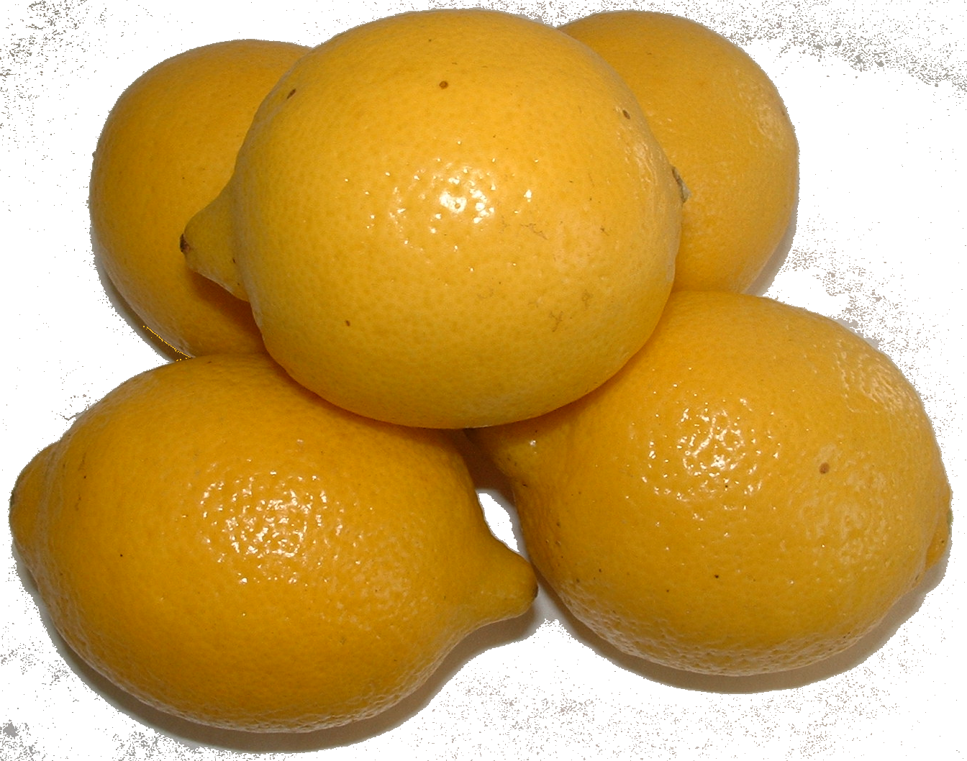

A chemical Reaction Using Lemon

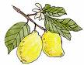

The Lemons Challenge - Concentration


There is a chemical reaction if a slice of lemon or some lemon juice is
added to a purple liquid. The purple liquid goes orange and then colourless.

Given some lemon juice and some of the purple liquid, your challenge is to investigate how changing the concentration of the lemon juice changes the speed of the reaction between them.

What’s going on here?

Lemons contain an acid called citric acid. It is this acid which makes lemons taste sour (in fact all acids have a sour taste but don’t try to taste any old acid - this could be very dangerous!). When the lemon juice is added to the purple liquid, it is this acid that turns it colourless.

Why?

The purple liquid is called potassium permanganate and it has a very
small amount of an acid called sulphuric acid added to it. This makes the permanganate solution able to react with the citric acid and the purple permanganate particles change into colourless manganese particles.

What’s so special about the name of this type of reaction?

When the purple permanganate particles change into colourless manganese particles, chemists call it a reduction reaction. At the same time, the citric acid reaction is called an oxidation reaction by chemists. Put the two together and the whole reaction is called a redox reaction!

What you must do now:

Carry out the experiment by following the instructions on the Experiment card.

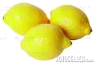
Lemons Investigation

Variable: Concentration

What you need:

- A bottle of stock acidified potassium permanganate solution.
- Some 100 cm³ glass beakers
- A stirring rod
- Some small measuring cylinders or 20 cm³, 10 cm³ and 5 cm³ syringes.
- A piece of white paper or card
- Safety goggles
- A stop-clock or suitable timer
- Bottles of lemon juice at different concentrations.
(12.5%, 25%, 50%, 75% and 100%).

What you do:

- Measure out 25 cm³ of the permanganate
solution into a 100cm³ glass beaker.

- Place the beaker on a piece of white paper.

- Measure out 5 cm³ of the most
dilute lemon solution.

- Add it to the permanganate solution
and start the stop clock.

- Stop the clock when the purple of the solution has changed to orange.
(it will go a raspberry pink first).

- Record your answers on the Results Sheet provided.

- Using clean apparatus each time, repeat with each of the other lemon juice
solutions in turn.

Record your findings on the next pages.

My investigation is to see if changing

changes

To make it a fair experiment I will need to keep these variables the same

A table of my results

Space for any rough working

A graph of my results:
A
v
e
r
a
g
e

t
i
m
e

f
o
r

s
o
l
u
t
i
o
n

t
o

d
e
c
o
l
o
u
r
i
s
e

(s)

0

Concentration of the lemon juice

Conclusion:

What happens to the speed of the chemical reaction as the concentration of the lemon juice increases?

What you must do now:

Predict from the graph how long the reaction would take if you used
a 40% solution of lemon juice.

Write this down here: ................... s

What you must do next:

Make a 40% solution of lemon juice from a solution you already have by diluting it with water. You will need enough solution to test your prediction three times as before.
Which solution will you use?

How much water will you need to add?

Test your solution and prediction by carrying out the experiment and recording your results below:
Concentration | Time 1  (s) | Time 2  (s) | Time 3  (s) | Average  time (s)
40% of lemon juice

Difference between predicted time and =
and time taken for the experiment

What things may have affected how accurate you were able to do the experiment?

If you do the experiment again, how could you improve it?

The Lemons Challenge - Surface area

There is a chemical reaction if a slice of lemon or some lemon juice is added to a purple liquid. The purple liquid goes orange and then colourless.

Given a lemon and some of the purple liquid, your challenge is to investigate how changing the surface area of the pieces of lemon changes the speed of the reaction between them.

What’s going on here?

Lemons contain an acid called citric acid. It is this acid which makes lemons taste sour (in fact all acids have a sour taste but don’t try to taste any old acid - this could be very dangerous!). When the lemon juice is added to the purple liquid, it is this acid which turns it colourless.

Why?

The purple liquid is called potassium permanganate and it has a very
small amount of an acid called sulphuric acid added to it. This makes the permanganate solution able to react with the citric acid and the purple permanganate particles change into colourless manganese particles.

What’s so special about the name of this type of reaction?

When the purple permanganate particles change into colourless manganese particles, chemists call it a reduction reaction. At the same time, the citric acid reaction is called an oxidation reaction by chemists. Put the two together and the whole reaction is called a redox reaction!

What you must do now:

Carry out the experiment by following the instructions on the Experiment card. Record your findings on the next pages.

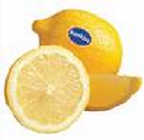
Lemons Investigation

Variable: Surface Area

What you need:

- A bottle of stock acidified potassium permanganate solution.
- Some 100 cm³ glass beakers
- Some larger beakers
- A stirring rod
- Some small measuring cylinders.
- A piece of white paper or card
- Safety goggles
- A stop-clock or suitable timer
- A knife
- Some 20 cm³, 10 cm³ and 5 cm³ syringes
- Some lemons

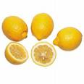
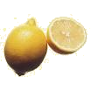
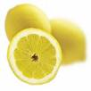

What you do:

- Measure out a large volume of the permanganate
solution into one of the large beaker.

- Cut a lemon into small equal sized wedges about 4 cm long

- Measure out 25 cm³ of the permanganate
solution into a 100 cm³ glass beaker and place
the beaker on a piece of white paper.

- Take one of the wedges and add it to the
25 cm³ of permanganate solution
Start the stop clock.

- Swirl the mixture a few times and replace the beaker on the paper.

- Observe the colour of the permanganate. Stop the clock when the purple
of the solution has changed to orange. (it will go a raspberry pink first).

- Record your answers on the Results Sheet provided.

- Do the experiment again with a fresh wedge of lemon, but this time cut it in
two before adding both bits to a fresh 25 cm³ portion of permanganate solution.

- Then repeat the whole experiment again with a wedge cut into three and finally
once more with a wedge cut into four.

My investigation is to see if changing

changes

To make it a fair experiment I will need to keep these variables the same

A table of my results

Space for any rough working

A graph of my results:
A
v
e
r
a
g
e

t
i
m
e

f
o
r

s
o
l
u
t
i
o
n

t
o

d
e
c
o
l
o
u
r
i
s
e

(s)

0

Number of pieces of lemon

Conclusion:

What happens to the speed of the chemical reaction as the number of pieces of lemon increases?

The Lemons Challenge - Temperature

There is a chemical reaction if a slice of lemon or some lemon juice is added to a purple liquid. The purple liquid goes orange and then colourless.

Given some lemon juice and some of the purple liquid, your challenge is to investigate how changing the temperature of the solutions changes the speed of the reaction between them.

What’s going on here?

Lemons contain an acid called citric acid. It is this acid which makes lemons taste sour (in fact all acids have a sour taste but don’t try to taste any old acid - this could be very dangerous!). When the lemon juice is added to the purple liquid, it is this acid which turns it colourless.

Why?

The purple liquid is called potassium permanganate and it has a very
small amount of an acid called sulphuric acid added to it. This makes the permanganate solution able to react with the citric acid and the purple permanganate particles change into colourless manganese particles.

What’s so special about the name of this type of reaction?

When the purple permanganate particles change into colourless manganese particles, chemists call it a reduction reaction. At the same time, the citric acid reaction is called an oxidation reaction by chemists. Put the two together and the whole reaction is called a redox reaction!

What you must do now:

Carry out the experiment by following the instructions on the Experiment card. Record your findings on the next pages.

Lemons Investigation

Variable: Temperature

What you need:

- A bottle of stock acidified potassium permanganate solution.
- Some 100 cm³ glass beakers
- Some larger 500 cm³ glass beakers
- A stirring rod
- Some small measuring cylinders or 20 cm³, 10 cm³ and 5 cm³ syringes.
- A piece of white paper or card
- Safety goggles
- A stop-clock or suitable timer
- A thermometer
- A Bunsen burner and heat mat or water baths
- Bottles of lemon juice at different concentrations.
(12.5%, 25%, 50%, 75% and 100%).

What you do:

- If you are using a thermostat water bath, skip straight to 5 over the page.

- If you are going to use a Bunsen to heat the water, read on from 3.

- Measure out 25 cm³ of the permanganate
solution into a 100 cm³ glass beaker and
place it on the tripod stand.

- Heat this solution on a tripod or a water bath to about 50ºC.
Check the temperature with a thermometer. Do not heat it to above 50º C

- Take the permanganate solution and place the beaker on a piece of white paper.

- Record the temperature (ideally 50º C)

- Measure out 5 cm³ of one of the dilute lemon solutions.
Add it to the permanganate solution and start
the stop clock.

- Swirl the mixture a few times and replace the beaker on the paper.

- Observe the colour of the permanganate. Stop the clock when the purple
of the solution has changed to orange. (it will go a raspberry pink first).

- Record your answers on the Results Sheet provided.

- Using clean apparatus each time, repeat the experiment at lower and lower temperatures (ideally 40ºC, 30ºC, and 20ºC or even room temperature),
recording the actual temperature and times on each occasion.
(You could even try cooling the solution down in a beaker of iced water)

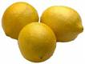
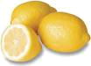

My investigation is to see if changing

changes

To make it a fair experiment I will need to keep these variables the same

A table of my results

Space for any rough working

A graph of my results:
A
v
e
r
a
g
e

t
i
m
e

f
o
r

s
o
l
u
t
i
o
n

t
o

d
e
c
o
l
o
u
r
i
s
e

(s)

0

Temperature of the solutions (ºC)

Conclusion:

What happens to the speed of the chemical reaction as the temperature increases?

What things may have affected how accurate you were able to do the experiment?

If you do the experiment again, how could you improve it?

Lemons Investigation

Variable: Concentration (Using a datalogger)

What you need:

- A bottle of stock acidified potassium permanganate solution.
- Some 100 cm³ glass beakers
- A stirring rod
- Some small measuring cylinders or 20 cm³, 10 cm³ and 5 cm³ syringes.
- A piece of white paper or card
- Safety goggles
- A stop-clock or suitable timer
- a light sensor
- Bottles of lemon juice at different concentrations.
(12.5%, 25%, 50%, 75% and 100%).
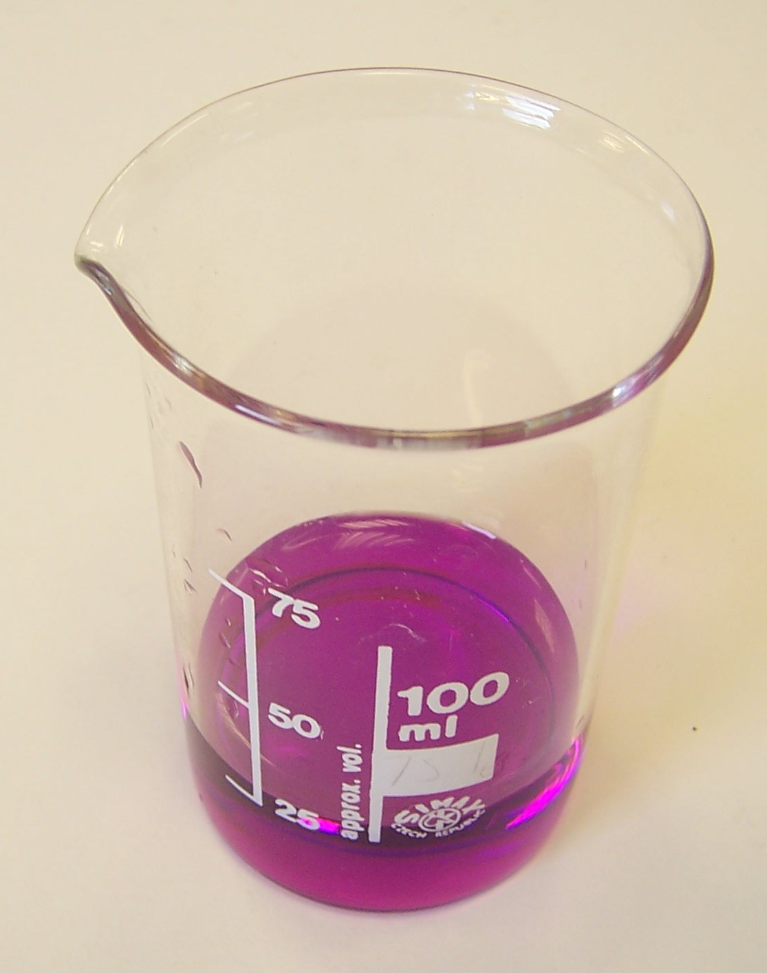

What you do:

- Measure out 25 cm³ of the permanganate
solution into a 100 cm³ glass beaker.

Place the beaker on a piece of white paper.

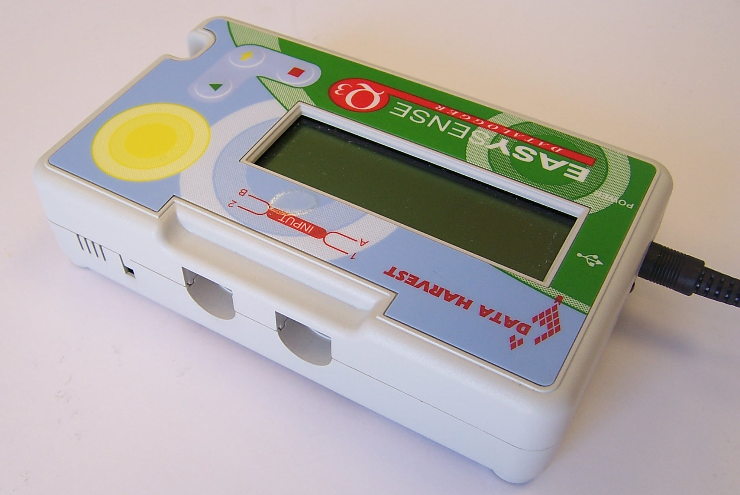

- Choose a light sensor.

Sensor

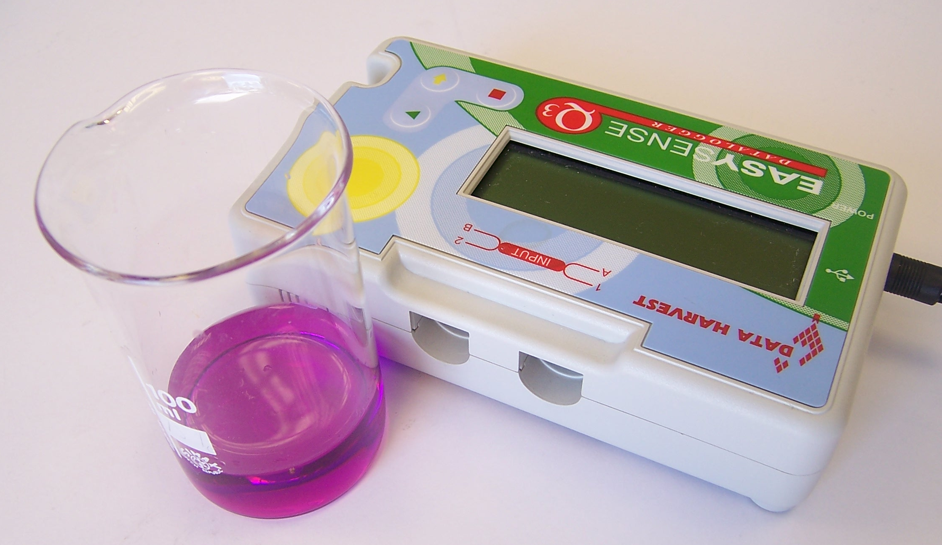

- Place the light sensor up
against the glass beaker.
Switch on and and note
the reading on the scale.

- During the experiment, the purple potassium permanganate solution will become a raspberry colour, then orange and then yellow, and the reading (in lux) on the light sensor will increase. Decide on a number you will allow the meter reading to reach. This is when you will stop the timer (e.g. 100 lux)
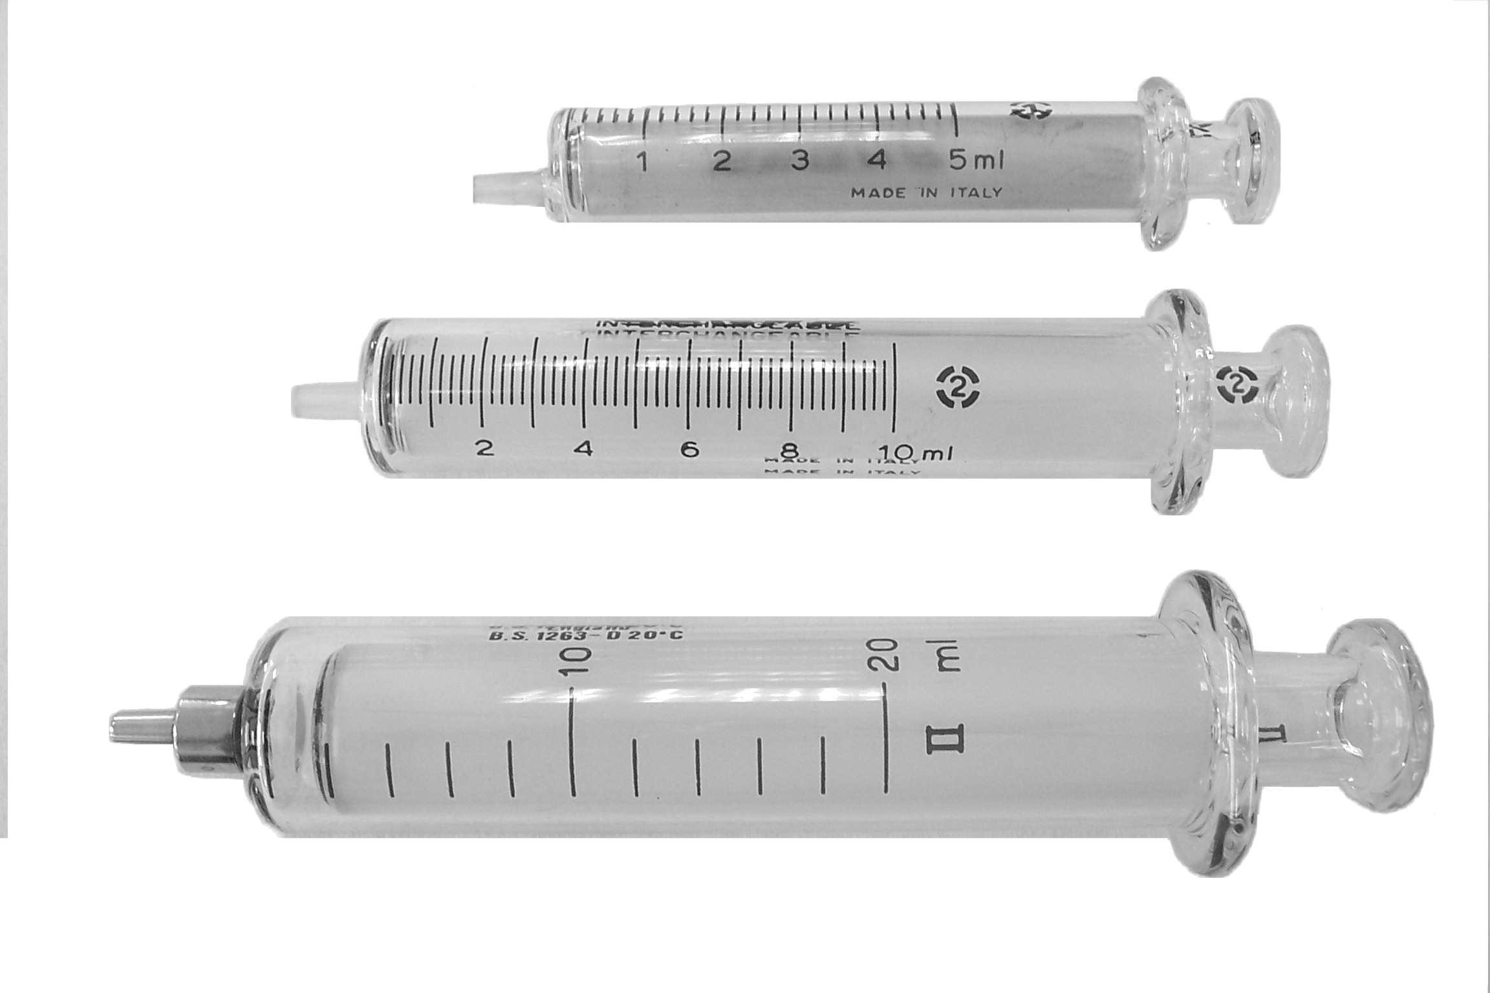
- Now measure out 5 cm³ of the most
dilute lemon solution.

- Add it to the permanganate solution and start the stop clock.

- Stop the clock when the reading on the light sensor has reached the number you agreed on in step 4.

- Record your answers on the Results Sheet provided.

For any repeat measurements, use the same beaker, carefully cleaned and dried. Make sure the reading on the light sensor is as near as possible to the original reading in step 3, (you may have to move or rotate the beaker to help you). Always stop the stop clock when the reading rises to the figure agreed on.

- Repeat the whole experiment with each of the other lemon juice solutions in turn.

