
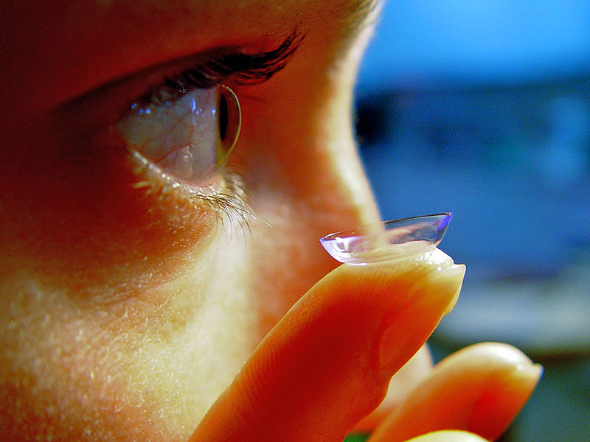
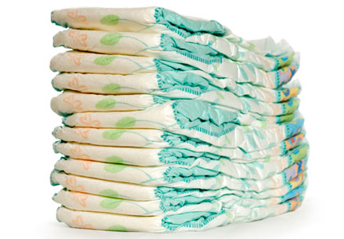
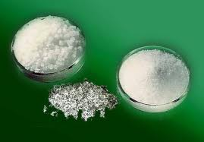
Hydrogels

A hydrogel is a solid, jelly-like material that can vary from soft and weak to hard and tough. By weight, gels are mostly liquid, yet they behave like solids.
Gels consist of a solid three-dimensional network that spans the volume of a liquid medium and ensnares it through surface tension effects. Virtually any fluid can be the basis of a gel including water (hydrogels), oil, and air (aerogel).
Both by weight and volume, gels are mostly fluid in composition and thus exhibit densities similar to those of their constituent liquids.
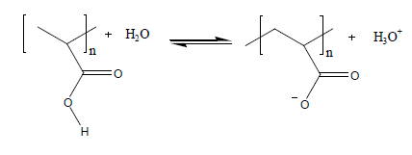
Edible jelly is a common example of a hydrogel and has approximately the density of water.
Many hydrogels are polymers of carboxylic acids. The acid groups stick off the main chain of the polymer . When these polymers are put into water, the hydrogen atoms react and come off as positive ions.
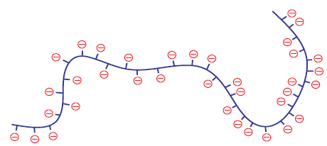
This leaves negative ions along the length of the polymer chain.
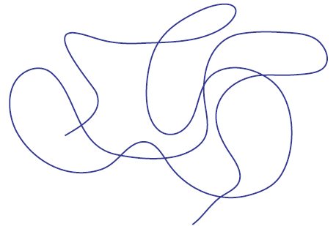

When polymer chains are in solution, they tend to coil up.

However, the hydrogel now has lots of negative charges down its length.

These negative charges do two things:
- They repel each other. This forces the polymer chain to unwind and open up.
- They attract water molecules. The water molecules stick to the hydrogel polymer and force it to open up even further.
The combination of the polymer opening up and the water molecules sticking to it make a solution of the hydrogel get thicker and more viscous.

Health & Safety
The materials involved are all of low hazard.
In experiment 2, some cross-linking solutions may contain substances that have some chemical hazards. The version described here used Iron II and Iron III chlorides which are corrosive – though the solutions are only irritants.
The only thing to watch out for is pupils being too vigorous in extracting the hydrogel particles from the nappies and raising too much dust that can be inhaled.
If this is a concern, the technician can extract the hydrogel beforehand.

Curriculum links
CfE Level 3– There are some nice, simple activities here that fit with
SCN 3-19b - Through experimentation, I can identify indicators of chemical reactions having occurred. I can describe ways of controlling the rate of reactions and can relate my findings to the world around me.
National 4 – Chemistry in Society – Materials
Many new/novel materials being developed are types of hydrogel.
Higher (CfE) – Chemical change and structure - Structure and bonding
The properties of hydrogels are determined by their bonding, either ionic cross-linking, covalent bonds or hydrogen bonding.
Experiment 1 – Make a hydrogel
Each group will need
2 x 100 cm³ beakers | 1 x magnetic stirrer
Stirring rod | 50 / 100 cm³ measuring cylinder
0.5g sodium alginate | 2g calcium chloride

It may be better if the alginate is dissolved in water and then given to the class.
Adding calcium causes cross-linking to happen with the divalent calcium ions – a similar process to that involved in making polymer slime.

Experiment 2 – hydrogel cross-linking
You will need
2 x petri dishes | 1 x 3cm³ pasteur pipette
25 cm³ 2% Iron II chloride | 25 cm3 2% Iron III chloride
5 cm³ 2% sodium alginate | Plastic spoon

Different salts can be used to investigate the differing effects on the cross-linking. This version uses Iron II and Iron III.
There is no need to stick to the 5 minute ‘setting’ time for the beads. In fact, it could be interesting to investigate the strength development over time. In this experiment at this time, the Iron III beads are much harder and more rigid than the Iron II but if left for 30 minutes this difference is significantly less marked.

Experiment 3 – ‘Drug’ Dispersal
You will need
10 cm³ 2% sodium alginate | 2 cm³ 0.1M potassium manganate VII
3 x 3cm³ pasteur pipette | 25 cm³ 2% calcium chloride
2 x plastic cups | sieve
1 universal | Wash bottle of distilled water
2x bijoux

In school, it is envisaged that the test tubes will be used in place of the Universals and bijoux.
The only reason for the choice of potassium manganate VII is that it is deeply coloured, readily available and diffuses out of the beads relatively quickly. A disadvantage is that it tends to oxidise within a few hours at most so the solution cannot be made up much in advance.
Dyes such as methylene blue could be used instead.

Experiment 4 – properties of hydrogels
Each group will need

1 x petri dish | 1 x sample of hair gel
salt | sugar
spatula

The polymer is in equilibrium with the water around it, but that equilibrium can be disturbed in a number of ways. If the the ionic concentration of the solution is increased – e.g., by adding salt – the positive ions attach themselves to the negative sites on the polymer, effectively neutralising the charges. This causes the polymer to collapse in on itself again.

Experiment 5 – hydrogels in action – disposable nappies

Each group will need
A disposable nappy | Scissors
A large ice cream tub or similar container | Distilled water
Salt | Dessert spoon or similar measure
A stirring rod or spoon | A large beaker (600 cm³)
100cm³ measuring cylinder | Gloves if you have sensitive skin.
Eye protection

If nappies are not available, water-retaining gel for plants can be used but this is slower.
If you don’t have enough ice-cream tubs, you can put the cut up nappy into a resealble freezer bag and manipulate it like that.
1 nappy makes around 500cm³ of gel – less with tap water but it still works OK.

Experiment 4 – Fighting fires with Pampers?

Each group will need
Gel from a disposable nappy | Wooden splints
water | Bunsen burner
timer

The finer the powder of the hydrogel the better this works. The material from a nappy works quite well but if you can manage to grind it up really fine – in a coffee grinder perhaps – you get a more even coating.

