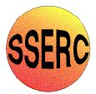
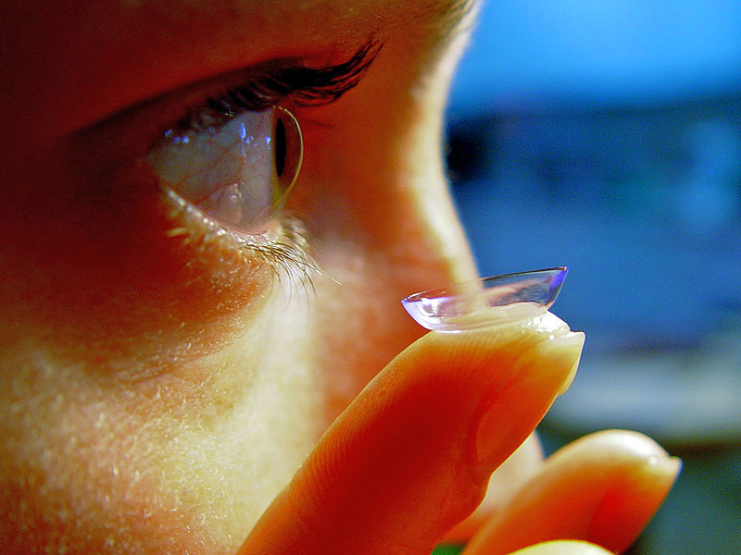
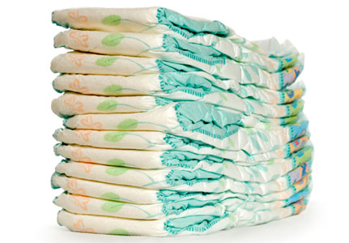
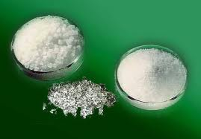
Hydrogels

A hydrogel is a solid, jelly-like material that can vary from soft and weak to hard and tough. By weight, gels are mostly liquid, yet they behave like solids.

Gels consist of a solid three-dimensional network that spans the volume of a liquid medium and ensnares it through surface tension effects. Virtually any fluid can be the basis of a gel including water (hydrogels), oil, and air (aerogel).

Both by weight and volume, gels are mostly fluid in composition and thus exhibit densities similar to those of their constituent liquids.

Edible jelly is a common example of a hydrogel and has approximately the density of water.
Experiment 1 – Make a hydrogel
You will need
2 x 100 cm³ beakers | 1 x magnetic stirrer
Stirring rod | 50 / 100 cm³ measuring cylinder
0.5g sodium alginate | 2g calcium chloride

Instructions
- Place 0.5g of sodium alginate in one beaker and 2g of calcium chloride in the other.
- Put 30 cm³ of water into each of the beakers.
- Place the beaker with the alginate in it on top of the magnetic stirrer, drop in the ‘flea’ and switch on.
- Use the stirring rod to stir the calcium chloride until it is dissolved.
- Not all the sodium alginate will have dissolved but the solution should be starting to look thickened.
- Stop the stirrer and use a spatula to remove any big lumps of undissolved solid.
- Pour the pour in the calcium chloride and stir with the stirring rod. You will see a thick gel forming round the stirring rod.
- Take out the gel, remove it from the rod and examine it.

Experiment 2 – hydrogel cross-linking
You will need
2 x petri dishes | 1 x 3cm³ pasteur pipette
25 cm³ 2% Iron II chloride | 25 cm³ 2% Iron III chloride
5 cm³ 2% sodium alginate | spatula

Instructions
- Pour the iron II chloride into one petri dish and the iron III chloride in another.
- Draw up some of the sodium alginate into the pipette.
- Holding the pipette very close to the surface of the liquid let 20 drops of alginate solution fall into the the iron II chloride.
- Repeat with the iron III chloride.
- Leave for 5 minutes.
- Use a spatula to remove some of the beads and examine them.

Experiment 3 – ‘Drug’ Dispersal
You will need
10 cm³ 2% sodium alginate | 2 cm³ 0.1M potassium manganate VII
3 x 3cm³ pasteur pipette | 25 cm³ 2% calcium chloride
Test tube | sieve
2 x plastic cups | Wash bottle of distilled water
3 test tube | Test tube rack

Instructions
- Use a Pasteur pipette to add approximately 20 drops of the potassium manganate VII into the sodium alginate and mix thoroughly (Do not shake).
- Pour the calcium chloride solution into one of the plastic cups.
- Holding the pipette very close to the surface of the liquid let 30 drops of the now purple alginate solution fall into the calcium chloride.
- Leave for 1 minute.
- Place the sieve over the other cup and pour the solution through, trapping the beads in the sieve.
- Rinse the beads in the sieve with the distilled water from the wash bottle.
- Place the beads in a test tube and add 15 cm³ of distilled water.
- Leave for 5 minutes. Invert the test tube and use a pipette to remove 1 cm³ of the liquid from the tube. Place this in a clean test tube.
- Leave for another 5 minutes. Invert the tube as above and remove a second 1 cm³ of liquid into another clean test tube.
- Compare the colours of the two test tubes

Experiment 4 – properties of hydrogels

You will need

1 x petri dish | 1 x sample of hair gel
salt | sugar
spatula
Instructions
- Use the spatula to put two blobs of the hair gel on opposite sides of a petri dish
- Sprinkle some sugar on one blob.
- Sprinkle some salt on the other blob
- Leave for a few minutes.
- Observe any changes.

Experiment 5 – hydrogels in action – disposable nappies

You will need
A disposable nappy | Scissors
A large ice cream tub or similar container | Distilled water
Salt | Dessert spoon or similar measure
A stirring rod or spoon | A large beaker (600 cm³)
100cm³ measuring cylinder | Gloves if you have sensitive skin.
Eye protection
What to do
- Cut the middle section out of the nappy. You want the thicker piece which is designed to absorb urine. Discard the other piece.
- Make sure your ice cream container is completely dry – wipe it with a paper towel if necessary. If there is any moisture in the tub the experiment will not work properly.
- Wear eye protection for the next step. Put the centre piece of the nappy into the ice cream container and gently take it apart. You should start to see small white grains coming away from the nappy and this is what you are trying to collect. Keep gently pulling the nappy apart until you have collected as many of the grains as you can. Do not do this roughly or you will lose your product and put a lot of dust and fluff into the air. Avoid breathing in any dust you do create.
- Remove and dispose of all the fluff and other parts of the nappy, keeping the white grains in the bottom of the tub. The grains are heavier than the other materials and fall to the bottom of the heap, which makes it easier to separate them out.
- Estimate the volume of the grains.
- Pour the grains into the large beaker and add about 100 cm³ distilled water (you can just use the markings on the beaker to measure the volume). Stir the mixture and keep adding distilled water until no more can be absorbed. Stir between each addition of water. Estimate the final volume of the hydrogel.
- Take a spoonful of your hydrogel and put it in a small beaker for later
- Add a dessert spoonful of salt to the large beaker and stir.
(experiment from the RSC)
Experiment 6 – Fighting fires with Pampers?

Another use for hydrogels has recently been developed by a firefighter in the USA. John Bartlett was at a fire in which an entire house was destroyed – all except a used disposable nappy. He realised that a substance inside the nappy was responsible for preventing it from being burnt and discovered that the material was the hydrogel, which had absorbed liquid. BARRICADE® fire fighting gel was developed as a result. If the gel is sprayed with water onto a house which is in the path of a fire, the house will not burn. This is a major new tool for fire fighters to use when they are battling against the vast forest fires that can burn for days in the USA.

You will need
Gel from a disposable nappy | Wooden splints
water | Bunsen burner
timer

What to do
- Take one of the splints and dip one end of it in water so it is wet.
- Take it out and hold the splint in the fire.
- Time how long it takes to burn.
- Take the other splint and coat it with the hydrogel.
- Hold this one in turn in the flame.
- Time how long it takes to burn.

