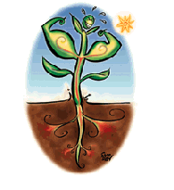

A firm of local developers has heard of the work your school
is doing about cleaning up toxic sites.
They have bought a local site that was heavily used by industry.
The developers want to know the best way to clean up the site.

Task 1: Collect a Brown Site Map, Clean up Methods sheet, and a set of Option Cards.
Each set of option cards has information about one way of cleaning up land.

Discuss these different methods of dealing with toxic waste and complete the columns on the sheet to show what you think are the ‘Good’ and ‘Bad’ points of each method.
Assess the value of each method and then decide which to
use in each area of the map.

If two or more methods could be used for an area, what
might influence which one you decide to use?

Shade the areas of the map to show the best remedy
you have chosen it clean it up.

Task 2: In your group, prepare a presentation for the class outlining your proposals, and presenting a business case for each solution.
Be prepared to justify your reason for choosing each method.

Additional research can be done at home and you could use PowerPoint to deliver your message.

Brownfield Site Map

To make the brown sites fit for building houses on, you could clean up the sites as follows:

UseGreenPhytoremediationBlueBioremediationRedLandfillBrownCapping
Colour
Site 6: Radioactive storage area for former chemical works.
Pollutants – uranium, plutonium. Area 2 acres
Depth of pollution 0.5m
Will not be developed until 15 years from now
Site 1: Former chemical works.
Pollutants – heavy metals, acids and alkalis, petrochemicals
Area 5 acres Depth of pollution 2.5m
Must be ready for development
in 2 years time at the latest

Site 5: Former industrial estate.
Pollutants – fungicides, petrochemicals, cadmium, lead, sodium, arsenic
Area 4 acres
Depth of pollution 0.1m
Must be ready for development
in 1 years time

Site 4: Former metal works.
Pollutants – zinc, copper, lead, acids
Area 2.5 acres
Depth of pollution 0.3m
Can be developed anytime up to 12 years from now
Site 2: Former farmland.
Pollutants – pesticides, fungicides, insecticides.
Area 10 acres.
Depth of pollution 1.0m
Must be ready for development in 2-3 years time at the latest
Site 3: Army test range.
Pollutants – TNT and petrol
Area 3 acres
Depth of pollution 1.5m
Must be ready for
development within 6 months.

Clean up Methods

Clean up Method | How it works | Removes | Good | Bad | Use for Area
Phytoremediation
Bioremediation

Clean up Method | How it works | Removes | Good | Bad | Use for Area
Landfill
Capping
Clean up Methods

Option Card 1

Phytoremediation:

This is the process where plants are used to clean toxic environments. The name comes from the Greek word for plant ‘phyton’, and the Latin word for remedy ‘remediare’.

Method:
Plants and soil organisms work together to transform contaminating metals into substances that the plant can absorb. These substances become stored in the plants. When the plants are harvested and removed from the site, so are the contaminants.

Which contaminants can be removed?
Heavy metals such as chromium, lead, cadmium, zinc and copper as well as petrochemicals, explosives such as TNT, preservatives, radioactive metals, acids and copper sulphate.

Problems:
- The roots can only remove substances from the top 2 m of the soil

- It takes five to ten years to clean the site fully.

Cost:
£2500 per acre

Action:
On the map, shade in green any of the areas of the site where you think phytoremediation may be suitable.

Option Card 2

Bioremediation:

This is the process of using bacteria and microbes to clean up toxic waste.

Method:
Useful bacteria are sprayed onto the affected site. They immediately start to break down the pollutants into less harmful forms. They finish breaking down the pollutants within one year.

Which contaminants can be removed?
Heavy metals such as copper, lead and zinc, as well as pesticides, fungicides, insecticides, petrol, sulphates and acids.

Problems:
- The bacteria can only survive in the top 2 m of the soil.

- The bacteria change the pollutants into less toxic forms but they are not removed completely from the site.

Cost:
£7500 per acre

Action:
On the map, shade in blue any of the areas of the site where you think bioremediation may be suitable.

Option Card 3

Landfill:

Method:
The earth that contains the pollutants is dug up and taken from the site. It is taken to another site and buried. The advantage of this method is that the toxic waste is removed from the site very quickly, usually within one month. Another advantage is that materials can be taken from any depth.

Which contaminants can be removed?
Heavy metals such as chromium, lead, cadmium, zinc and copper as well as petrochemicals, explosives such as TNT, preservatives, radioactive metals, pesticides, fungicides, insecticides, petrol, sulphates and acids.

Problems:
- It is very expensive because the government wants to discourage people from using landfill and so charges a landfill tax.

- The pollutants are just shifted from one place to another.

- During transport, some of the dust from the waste can be blown into the air and fall on nearby good land.

- Some sites are too toxic to touch.

Cost:
£50,000 per acre

Action:
On the map, shade in red any of the areas of the land you plan to remove for landfill.
Option Card 4

Capping:

Method:
The toxic chemicals are left in the soil and a trench is dug around the site. This trench is then filled with a special type of clay that does not let water through it. The top surface of the site is also covered with this clay and then fresh soil is put on the top of it. Capping is useful for very toxic sites and also for sites where it is not known what the pollutants are. The trench seals contaminants to a depth of 20 m.

Which contaminants can be capped?
Heavy metals such as chromium, lead, cadmium, zinc and copper, sodium, calcium and arsenic, as well as petrochemicals, explosives such as TNT, preservatives, radioactive metals, pesticides, fungicides, insecticides, herbicides, petrol, sulphates, acids and alkalis.

Problems:
- The pollutants are never removed.

- The site must be regularly checked to make sure that the clay wall has not allowed pollutants through it.

Cost:
£15,000 per acre

Action:
On the map, shade in brown any of the areas of the site you want to cap.

Phytoremediation

Plants are used to clean toxic environments.
Plants and soil organisms work together to transform contaminating metals into substances that the plant can absorb. These substances become stored in the plants.

Which contaminants can be removed?

Heavy metals such as chromium, lead, cadmium, zinc and copper as well as petrochemicals, explosives such as TNT, preservatives, radioactive metals, acids and copper sulphate.

Good or Bad?

The roots can only remove substances from the top 2 m of the soil.

It takes five to ten years to clean the site fully.

C Contaminants are removed from the site with the plants.

The cost is £2500 per acre.

Bioremediation
Bacteria and microbes are used to clean up toxic waste.
Useful bacteria are sprayed onto the affected site. They immediately start to break down the pollutants into less harmful forms.

Which contaminants can be removed?

Heavy metals such as copper, lead and zinc, as well as
pesticides, fungicides, insecticides, petrochemicals,
sulphates and acids.

Good or Bad?

They finish breaking down the pollutants within one year.

The bacteria can only survive in the top 2 m of the soil.

The bacteria change the pollutants into less toxic forms
but they are not removed completely from the site.

The cost is £7500 per acre.

Landfill

The earth that contains the pollutants is dug up and taken from the site. It is taken to another site and buried.

Which contaminants can be removed?

Heavy metals such as chromium, lead, cadmium, zinc and copper as well as petrochemicals, explosives such as TNT, preservatives, radioactive metals, pesticides, fungicides, insecticides, petrol, sulphates and acids.

Good or Bad?

The toxic waste is removed from the site very quickly, usually within one month.

It is very expensive because the government wants to discourage
people from using landfill and so charges a landfill tax.

The pollutants are just shifted from one place to another.

During transport, some of the dust from the waste can be blown into the air and fall on nearby good land.

Some sites are too toxic to touch.

The cost is £50,000 per acre.

Materials can be taken from any depth.

Capping

The toxic chemicals are left in the soil and a trench is dug around the site. This trench is then filled with a special type of clay that does not let water through it. The top surface of the site is also covered with this clay and then fresh soil is put on the top of it.

Which contaminants can be capped?

Heavy metals such as chromium, lead, cadmium, zinc and copper, sodium, calcium and arsenic, as well as petrochemicals, explosives such as TNT, preservatives, radioactive metals, pesticides, fungicides, insecticides, herbicides, petrol, sulphates, acids and alkalis.

Good or Bad?

The pollutants are never removed.

The site must be regularly checked to make sure that the clay wall has not allowed pollutants through it.

The cost is £15,000 per acre.

Used for very toxic sites and also for sites where it is not known what the pollutants are.

The trench seals contaminants to a depth of 20 m.

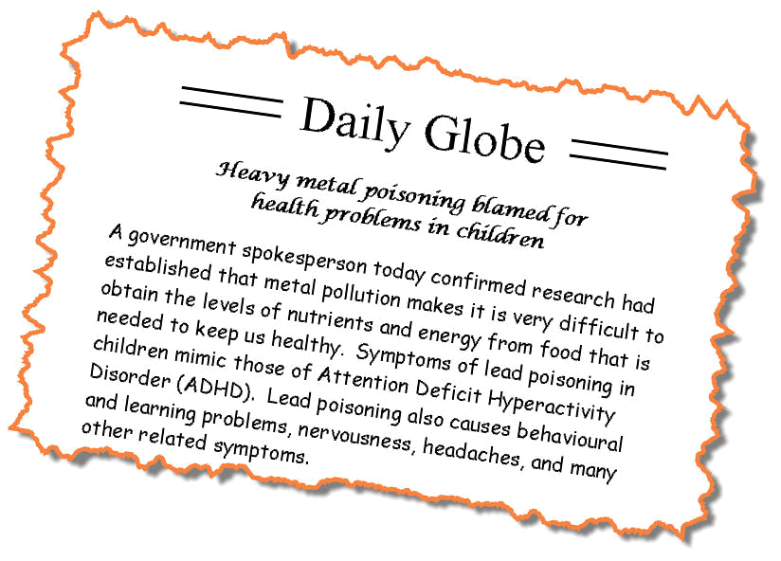
Heavy Metals and Guzzling Plants



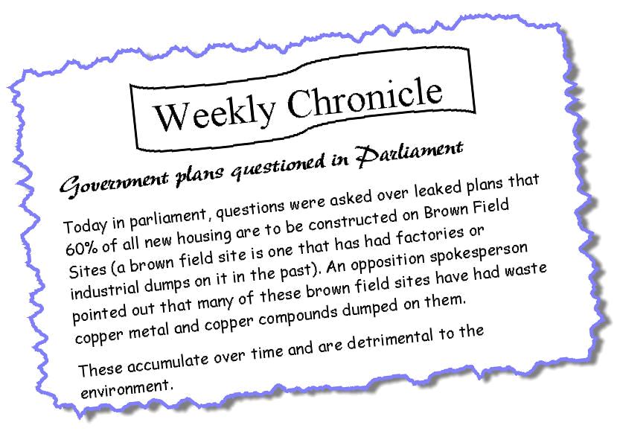

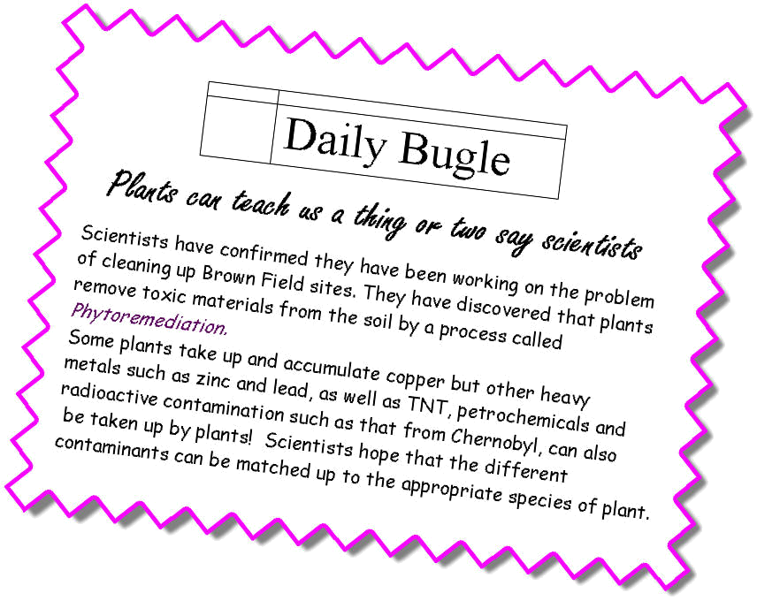

Read the following information and then use coloured pens to

Underline in red what the scientists’ aims were

Underline in blue how the scientists did their experiments

Underline in green the scientists’ findings

Underline in purple what the scientists plan to do next

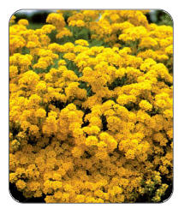
Scientists from the Universities of Manchester and Oxford discovered how the plant Alyssum lesbiacum, absorbs nickel from soils.
Their aim was to use this knowledge to develop plants that draw metals out of contaminated soil more cheaply and cleanly than other methods.
Soils on industrial land are sometimes contaminated with metals.
Alyssum lesbiacum transports nickel into its roots and then into its leaves. Most plants would die if they had high levels of metals in their tissues. Plants with the ability to absorb high levels of metals without dying are known as ‘hyperaccumulators’.
The scientists from Manchester and Oxford discovered that Alyssum lesbiacum absorbs nickel using a section of a protein, called histidine.
Working with scientists at the CCLRC Daresbury Laboratory, they used X-rays to confirm their results. The scientists are now trying to identify the genes in Alyssum lesbiacum that make hyperaccumulation possible.
The problem is that these plants grow slowly. If the researchers can find the genes, they will transfer them to fast growing plants, such as cabbages, cauliflowers and sprouts. The scientists hope to genetically engineer plants that can absorb several heavy metals at once, such as copper, zinc, lead and cobalt.
Using plants to decontaminate soil could be cheaper and more environmentally friendly than other methods, such as removing the contaminated soil.

Making the Growth Chambers

Procedure

- Make a growth chamber by cutting a plastic bottle in half as shown in Fig 1.
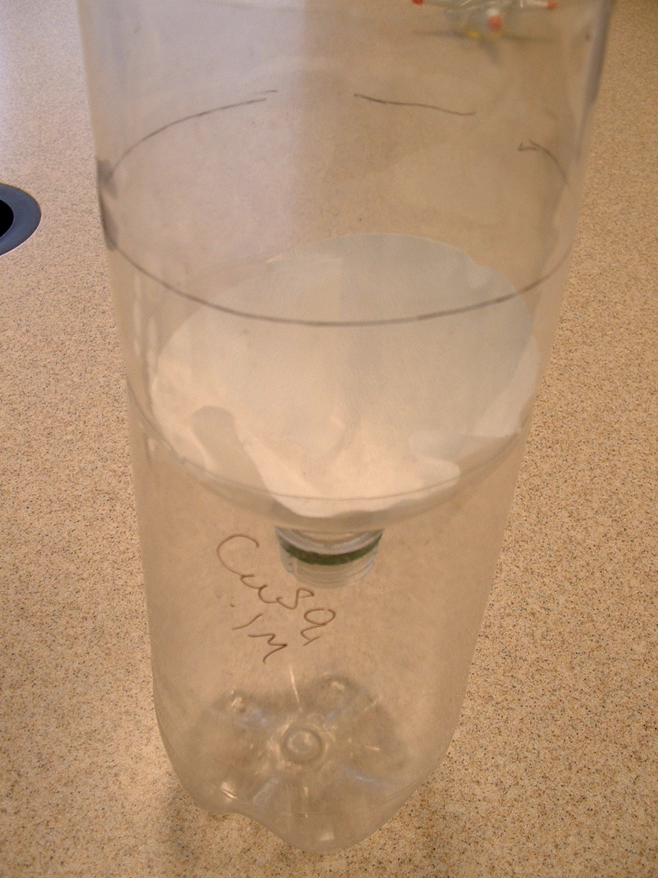
Place a piece of filter paper in the top half of the bottle and then fit the pieces of plastic bottle together to make a growth chamber as shown in Fig 2.
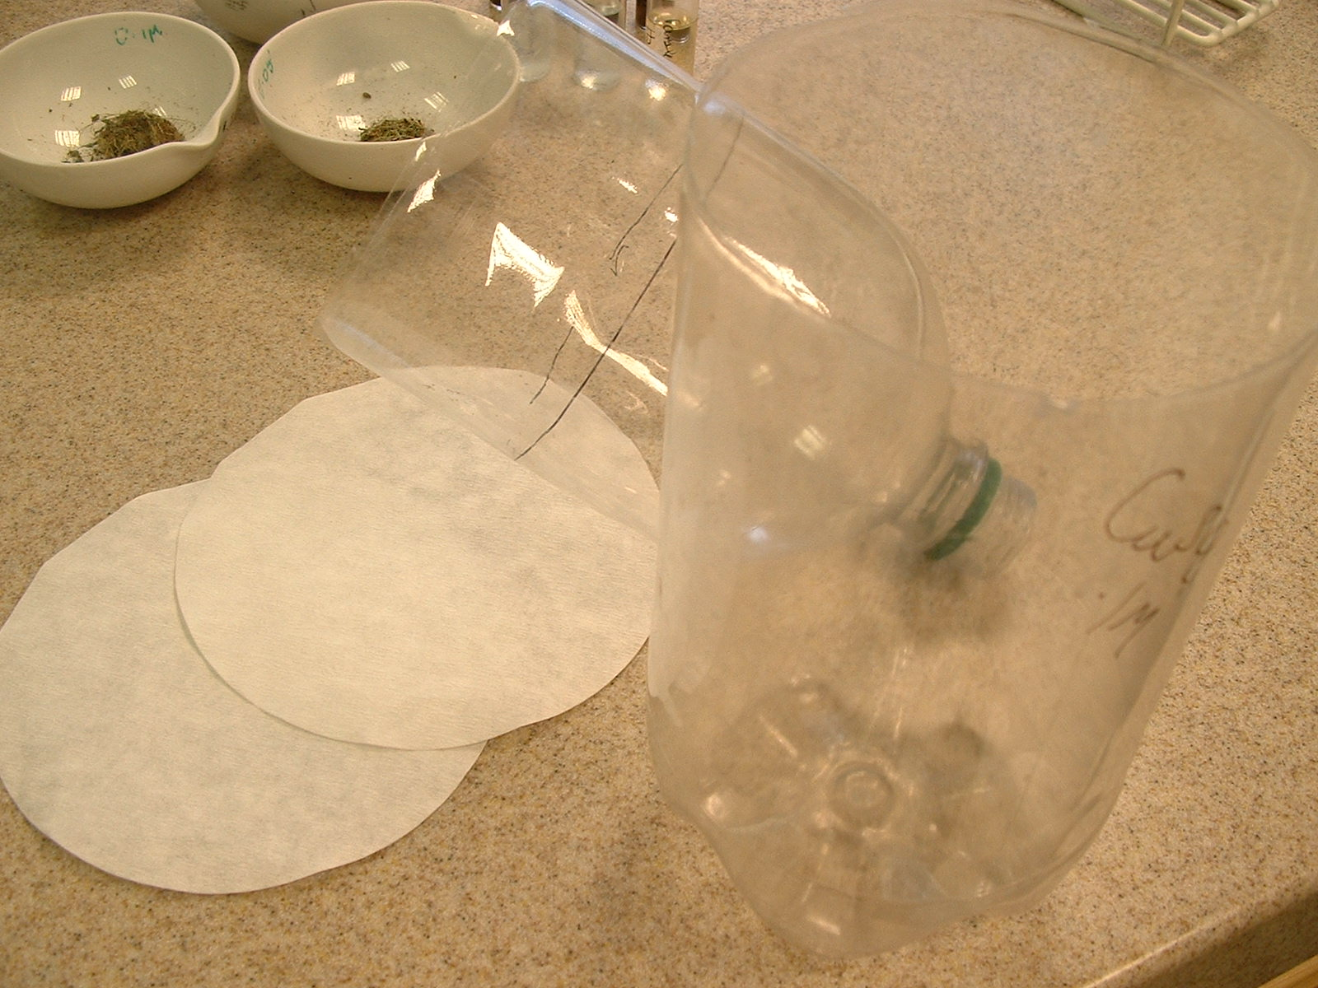

Fig 1.

Fig 2.
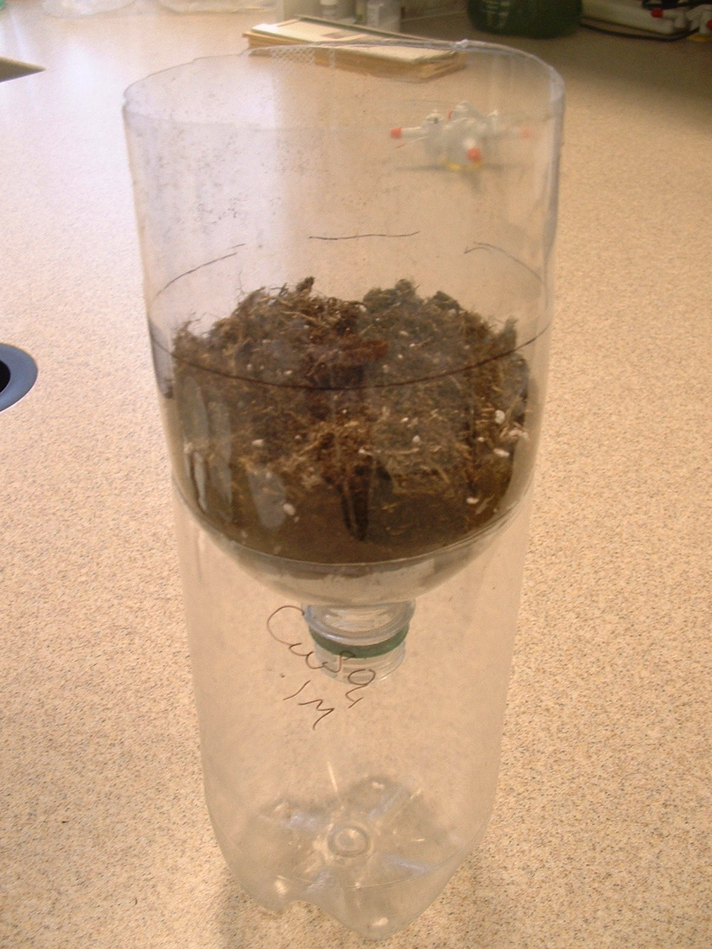

- Fill the chamber with equal amounts of soil
(Fig 3). Plant the given seeds in dishes
(Chinese take-away containers are useful
for this) to obtain strong seedlings.
This should take approx a week.
Plant enough for approximately 25 seedlings
per growth chamber.

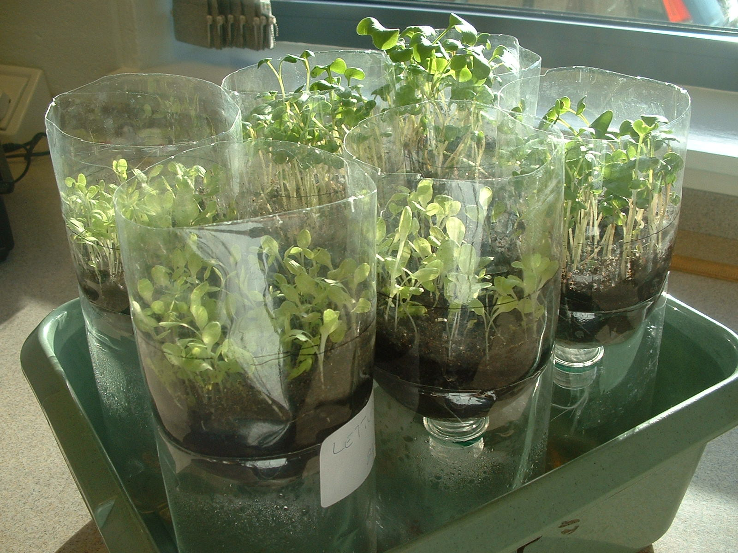
Fig 3

- Take three equal clumps of seedlings and plant them into three different growth chambers. Fig 4

Fig 4

- Allow these seedlings to settle in by watering all with 50mls water and leave overnight.

- Treat the three samples of your seedlings for a minimum of 4 days and a maximum of 7days with 50ml amounts of water or copper sulphate solutions as follows:

 | Sample 1 | Sample 2 | Sample 3
Day | Water Treatment | 0.05 M copper Sulphate Treatment | 0.1 M copper Sulphate Treatment
1 | 50mls | 50mls | 50mls
2 | 50mls | 50mls | 50mls
3 | 50mls and Recycle contents of reservoir | 50mls and Recycle contents of reservoir | 50mls and Recycle contents of reservoir
4 | Recycle contents of reservoir | Recycle contents of reservoir | Recycle contents of reservoir
5 | 50mls | 50mls | 50mls
6 | 50mls | 50mls | 50mls
7 | Recycle contents of reservoir | Recycle contents of reservoir | Recycle contents of reservoir

Guzzling plants – getting the results

- Test the liquid in the reservoir with the copper test strips.

- Harvest the plants carefully, best to wash gently under running water to remove as much soil as possible and to have root stem and leaves of the seedlings intact. Blot dry with paper towel. This is important for the next step. Place in an evaporating basin and dry in a microwave. One-minute intervals may be useful depending on the power of the microwave. Take care not to set your samples on fire.

- Weigh out 0.1g of each sample in a mortar and grind with 5 cm³ 1M hydrochloric acid.

- Place in a stoppered tube, label each tube, and leave them overnight.

- The next day remove 1cm³ of the plant liquid from each tube and test it with copper strips Figs 6 & 7.

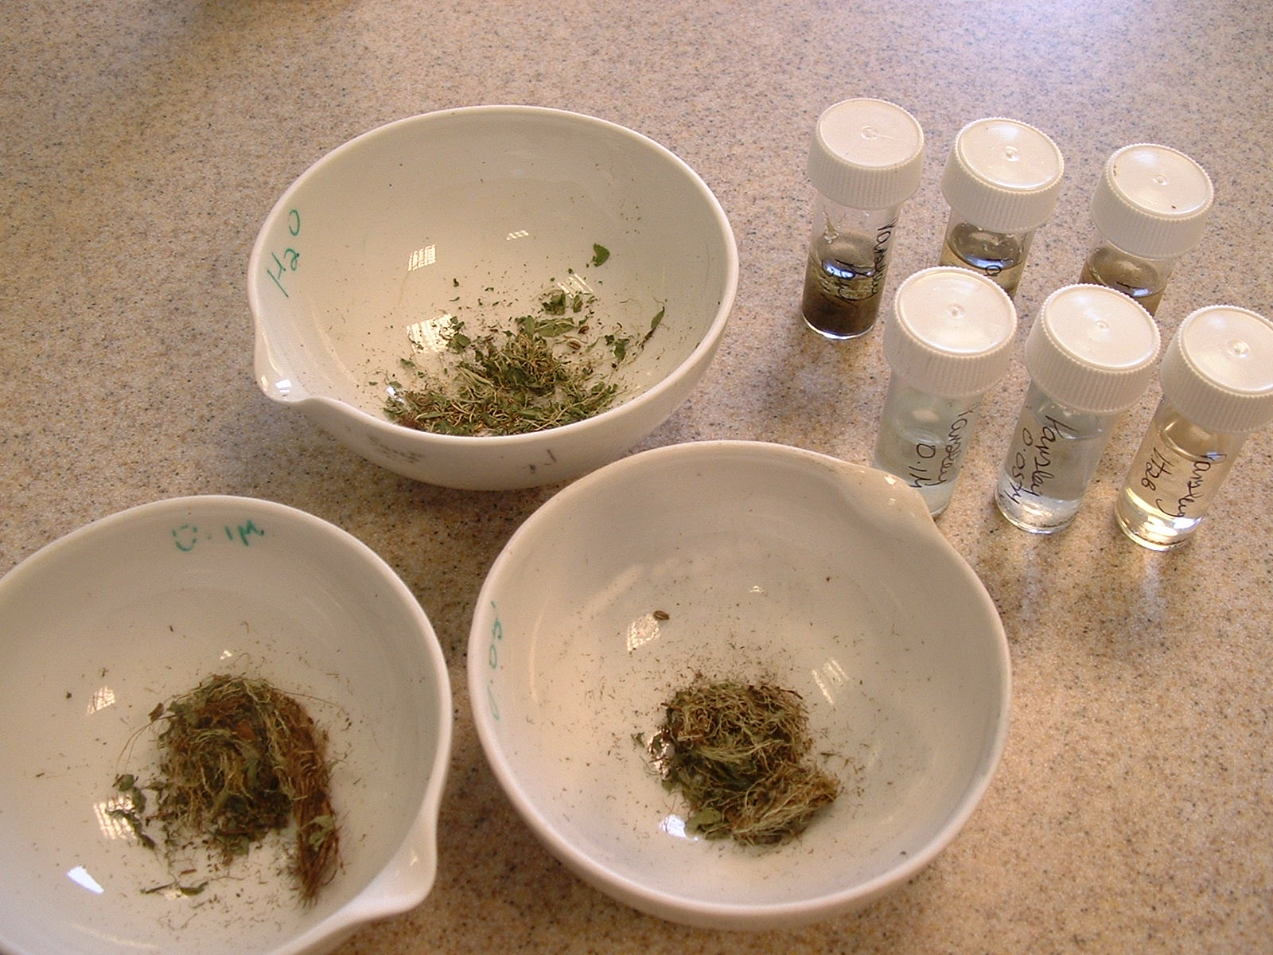
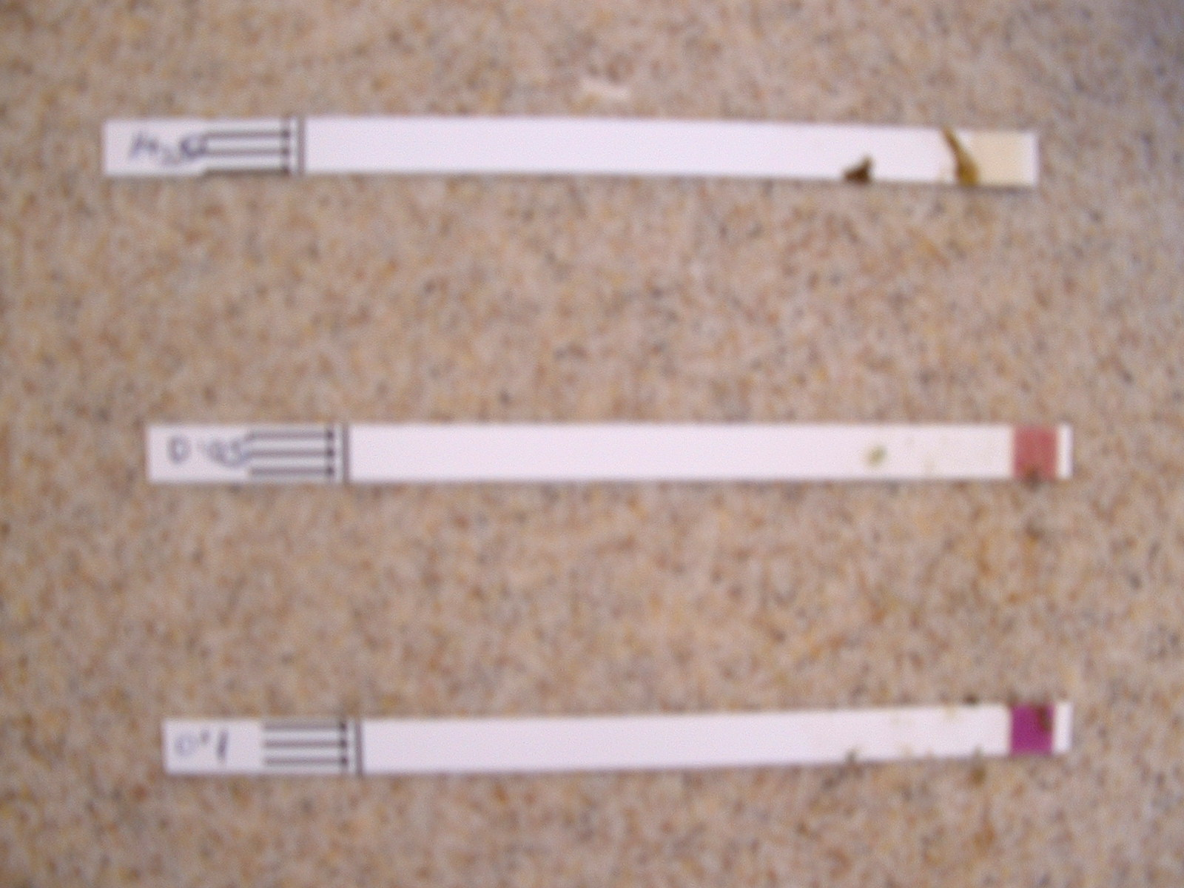

Fig. 6 Fig. 7

- Record all your answers on the sheet provided and then carry out the tasks indicated.

Guzzling plants - the results

Radish plant results
What it was watered with | Average amount of copper in the filtrate | Average amount of copper in the plant
Water | 0 mgl⁻¹ | 0 mgl⁻¹
0.05M copper sulphate solution
0.1M copper sulphate solution

Lettuce plant results
What it was watered with | Average amount of copper in the filtrate | Average amount of copper in the plant
Water | 0 mgl⁻¹ | 0 mgl⁻¹
0.05M copper sulphate solution
0.1M copper sulphate solution

Mustard plant results
What it was watered with | Average amount of copper in the filtrate | Average amount of copper in the plant
Water | 0 mgl⁻¹ | 0 mgl⁻¹
0.05M copper sulphate solution
0.1M copper sulphate solution
Mustard Seed Plant Results

Does any plant seem to be better than the others at phytoremediation?
If so, which one?

......................................................................................................................

Were there any problems in carrying out the experiment?

......................................................................................................................

......................................................................................................................

If so, how could you improve it if you had to do it again?

......................................................................................................................

......................................................................................................................

