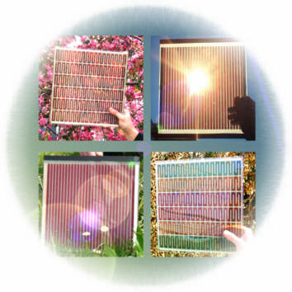



Copyright free image - Wikipedia
How dye-sensitised solar cells work

Dye-sensitised solar cells (also known as Grätzel solar cells) convert light energy into electrical energy using a process which, in some aspects, is similar to photosynthesis.

Dye-sensitised solar cells (DSSCs) are made from two transparent electrode plates, which are internally connected by an iodine/tri-iodide electrolyte. The photo-electrode is coated with titanium dioxide (TiO₂) onto which the dye has been absorbed. When the dye molecules are exposed to sunlight (photons of light) some of their electrons become excited and move through the titanium dioxide layer making the photo-electrode negative. An electrical current flows through the external circuit to the positive counter electrode which is coated in graphite. To complete the circuit, iodide ions in the electrolyte donate electrons to regenerate the dye molecules.

TiO₂
TiO₂
TiO₂
TiO₂
TiO₂
TiO₂
ē
ē
dye
reduced dye
dye
electrolyte
ē
ē
ē
2ē
ē
graphite
coated electrode
titanium dioxide coated electrode
photons
of light
I₃ –
3I –
I –
2I –
I₃ –
2ē
I₂
ē
ē
electrical device
ē
ē
ē
ē
ē
ē

Photo-electrode dyes

Most of the successful plant dyes for solar cells probably contain a mixture of flavonoids. These are based on glycosylated (i.e. sugar linked) anthocyanidins which have the following general structure:

OH
OH
OH
OH
HO
O⁺

The most important of these are: pelargonidin which gives the orange-red colour to geraniums, raspberries and strawberries; cyanidin which produces the magenta of ripe blackcurrants and red cabbage; delphinidin gives the blue colour to delphiniums and violas; and peonidin, which provides the purplish-red of peonies and cranberries.

Most of the anthocyanins are pH sensitive. For example, the pigment that gives the intense blue colour to cornflowers in basic conditions is also responsible for the red colour of poppies in acidic conditions.

It is essential that the dyes used in commercial solar cells do not degrade even after years of exposure to the extremes of sunlight, and there is considerable research taking place to develop suitable synthetic dyes.
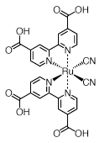
Most of the commercially, synthetic dyes which have been developed so far, contain transition metals and ligand complexes. A good example of this is Ruthenium 505.
Chemical name: cis-bis(cyanido) bis(2,2-bipyridyl-4,4-dicarboxylato) ruthenium (II)

Its manufacturers claim that Ruthenium 505 efficiently sensitizes wide band-gap oxide semiconductors, like titanium dioxide, up to a wavelength of 650 nm. As it has excellent stability properties, Ruthenium 505 is suitable for photochemical experiments and solar cell arrays,

Possible investigation projects

There are a number of topics which could make interesting projects. The most obvious question is “Which dyes, obtained from plant material, produce the most efficient dye-sensitised solar cells?” This could be extended to investigating the characteristics of the dye under various conditions of pH, ionic concentration and temperature. Alternatively a student might investigate the effects of intense sunlight or time on the rate of dye degradation. Determining the factors responsible for the absorption of a particular dye into the titanium dioxide layer, might also be a suitable challenge.

- Experimenting with different dyes

Several dyes were prepared from plant material to compare their efficiencies. These included: fresh blueberries; hibiscus flowers (supplied in the kit); red cabbage; red onion skins; red capsicum (sweet pepper); and fresh spinach leaves. Beetroot was not tested as it has been reported that the dye does not absorb onto the titanium dioxide layer. This is possibly not surprising as the purple pigment in beetroot is a betalain and not an anthocyanin.
In each case 10g of chopped material was added to 50ml of boiling water and left until cool. The cold dye solution was poured into a Petri dish and the titanium dioxide coated electrode was left to soak in the dye for 10 minutes.

Dye Source | Dye Colour | Output Current
Blueberries | Purple | 0.113mA
Hibiscus flowers | Deep red | 0.219mA
Red cabbage | Deep purple | 0.085mA
Red onion skins | Deep red | 0.050mA
Red capsicum* | Pale orange | 0.002mA
Spinach * | Pale green | 0.016mA

- The dyes from red capsicum and spinach were also extracted using ethanol. Although this resulted in a dye colour of much deeper intensity, there was no corresponding improvement in the output current.

It has been suggested that dye uptake by the titanium dioxide is improved by using a hot dye solution, but no evidence was found to support this claim when red cabbage was used as the dye. Other dyes, of course, may behave differently.

b) Changing the pH

In schools, red cabbage is commonly used as a source of pH indicator dye. In conditions where the pH is below 3, this dye turns a pinkish red, whereas above pH 11 the dye turns a deep blue-green.

When drops of 0.1M hydrochloric acid or 0.1M sodium hydroxide were added to the surface of the titanium dioxide layer which had already been impregnated with the red cabbage dye, there was an immediate colour change. After rinsing the electrodes with distilled water and assembling the solar cells, the output current was measured at each pH.

pH of Cabbage Dye | Dye Colour | Output Current
1 | Dark pink | 0.048mA
7 | Deep purple | 0.083mA
13 | Dark green | 0,015mA

Similar results were obtained when fresh titanium dioxide electrodes were soaked in the dye at the three pH values, rather than changing the pH after the cabbage dye had been absorbed into the titanium dioxide layer.

It seems likely that not only is there a decrease in the efficiency of photon capture by the cabbage dye at extremes of pH, but also that the ability of the dye to adhere to the titanium dioxide layer in impaired.

The stability of dye-sensitive solar cells

The hibiscus flower dye appears to produce a very stable solar cell. Leaving the cell set up under normal laboratory conditions for 5 days, only resulted in a 1% decrease in the output current. Even under conditions of high illumination there was still only a 1% decrease in output current after 5 days.

Electrode regeneration

Graphite coated electrodes can be reused, without any loss of efficiency, merely by rinsing off the old electrolyte and leaving them to dry. Once dried, a fresh layer of graphite can be applied if it is deemed to be necessary.

Regeneration of the titanium dioxide coated electrodes does not appear to be quite as simple. The dye can be easily removed from the titanium dioxide layer by soaking in cold water, or by pouring boiling water over the electrode.

Method used to wash TiO₂ electrode | Output Current after washing
Unwashed  (control) | 0.196mA
Overnight in water at room temperature | 0.006mA
30 minutes in water at room temperature | 0.007mA
2 minutes in  boiling water | 0.007mA

However, the electrodes show a reduced ability to reabsorb the hibiscus dye, as shown by the data obtained when a solar cell was repeatedly reassembled with the titanium dioxide electrode being washed in boiling water, and dried, between each cycle.

Age of TiO₂ electrode | Output Current | Re-use  efficiency
1st cycle | 0.223mA | 100%
2nd cycle | 0.121mA | 54%
3rd cycle | 0.082mA | 37%
4th cycle | 0.046mA | 21%

Extracting the dyes
See the experimental sheet for the apparatus and method.

Testing the dyes
See the experimental sheet for the apparatus and method, but in general:

- Students should grind plants thoroughly in mortar and pestle, then add ethanol and grind some more.
- If possible the dishes can be set aside for some time (e.g. overnight) to allow the solvent to extract maximum chlorophyll from the plants.
- The newly-coloured solvent should be poured out of the mortar into a Petri dish (or similar flat-bottomed vessel large enough to hold the filter paper), holding the remaining plant matter back using the pestle.
- Now the filter paper can be added to the dish and left until it has thoroughly soaked up the green liquid.

Measuring absorption

- Students should place the dyed slides one at a time into the light box, switch on the bulb, and note the resistance of the LDR as measured on the multimeter.
- When the amount of light shining on an LDR is increased, its resistance decreases. Therefore the dyes that show highest resistance are reflecting the lowest amount of light, and so have the best absorption properties.
- Students could produce a bar graph of their results (resistance v dye type).

Discussion points:

- Which colour of dye had the best absorbance?
- Do the results make sense with regard to the energy of light? (blue surfaces absorb red light, which is at the lower-energy scale of the spectrum, therefore blue surfaces may be expected to show poorer energy absorption altogether – but this may not be the case here).
- Make it clear that this is not the only important property that a dye-sensitized solar cell needs – the dye must also have free electrons with suitable energy bands.

Dye-sensitised Solar Cells - Preparation

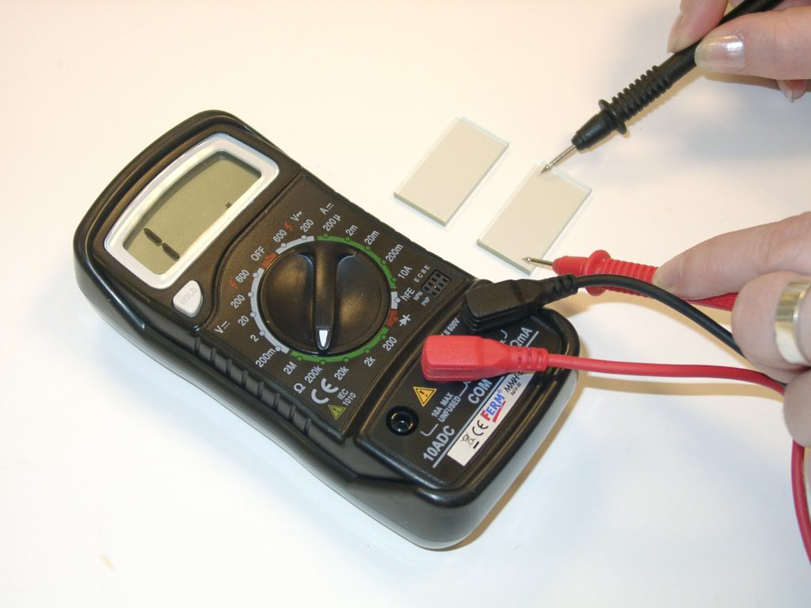
What to do:

- Identifying the conducting side
of the glass electrode

Use the multimeter to determine which
side of the glass electrode has the
conductive coating.

Turn the function switch to the 200Ω
Figure 1: Non-conducting side
resistance position. Touch the two ends
of the glass electrode plate with the
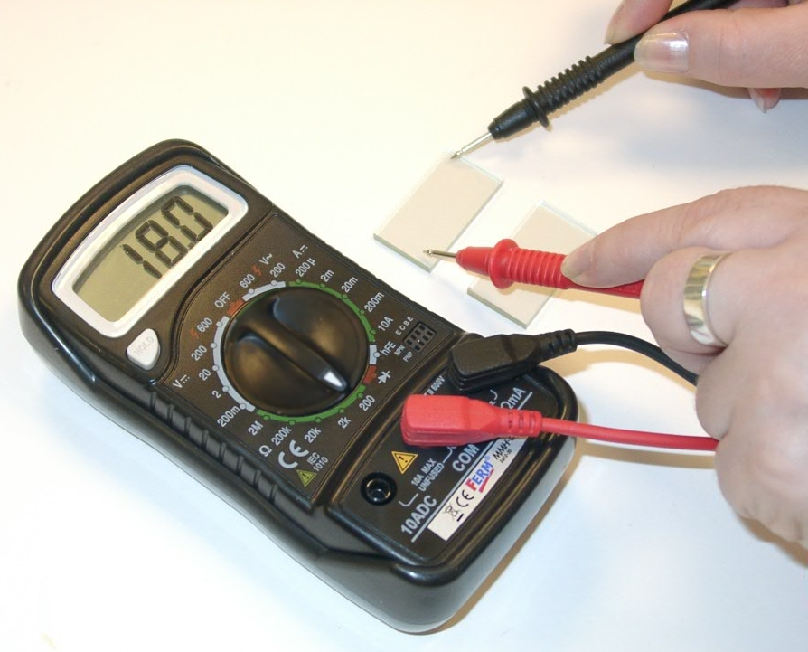
measurement probes.

If the display shows a reading of 1, then
this is the non-conducting side (Fig 1).

If the display shows any other reading
than 1, then this is the conducting side
of the glass electrode (Fig 2).

Figure 2: Conducting side

- Applying the graphite layer
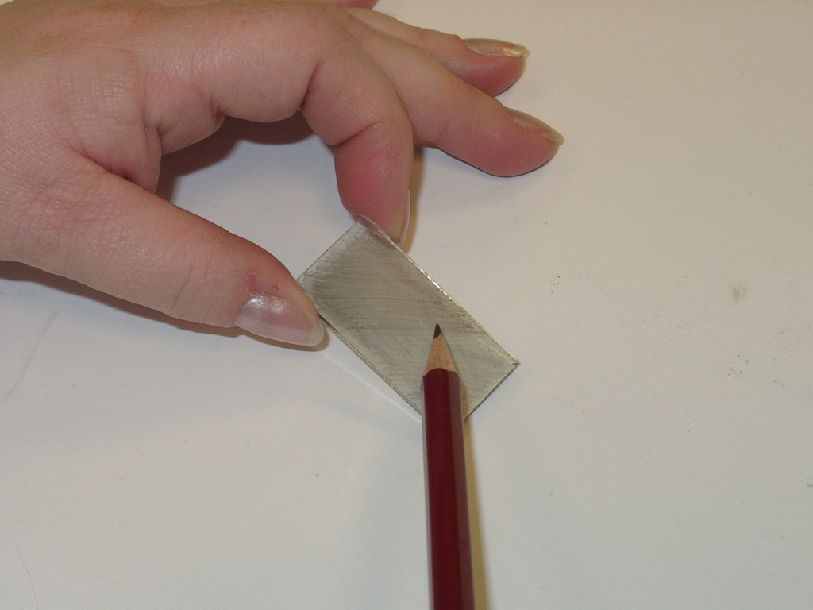
Hold the glass electrode by the sides to
keep the surface free of fingerprints,
and gently rub the pencil evenly across
the surface. A sheet of white paper will
make it easier to see the graphite layer.
Do not use the tip of the pencil which
may score the conducting surface.

To get an even layer, go over the
surface a second time, rubbing the
Figure 3: Applying the graphite layer
pencil in a different direction.

The conducting side should feel slightly rough when you are doing this. If it feels smooth, check that the conducting side is uppermost.

- Preparing the titanium dioxide suspension

Prepare the titanium dioxide suspension by incrementally adding 10ml of very dilute ethanoic acid to 5g of nanocrystalline titanium dioxide powder (e.g. Aeroxide TiO₂ P25) while grinding it for 10 minutes, using a mortar and pestle.
Finally, add one drop of dishwashing detergent and grind it again to produce a smooth paste.

It should be noted that ordinary titanium dioxide will not adhere to the glass when sintered.

- Identifying the conducting side of the glass electrode

Use the multimeter to determine which
side of the glass electrode has the
conductive coating.

Turn the function switch to the 200kΩ
Figure 1: Using the multimeter to show the non-conducting side of the glass electrode.

resistance position. Touch the two ends
of the glass electrode plate with the
measurement probes.

If the display shows a reading of 1, then
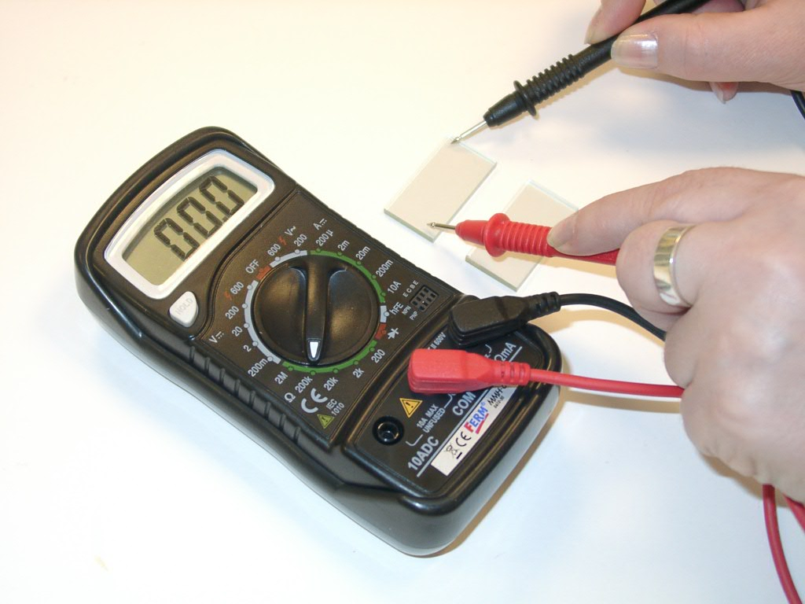
this is the non-conducting side (Figure 1).

If the display shows any other reading
than 1, then this is the conducting side
of the glass electrode (Figure 2).

Figure 2: Using the multimeter to show the conducting side of the glass electrode.

- Applying the titanium dioxide layer

Attach the glass electrode on three sides to a white tile, using adhesive tape, making sure that the conductive side is uppermost. Position the adhesive tape so that it over-laps the edge of the electrode forming a 3mm wide strip on both sides and a 5mm strip at the top end.

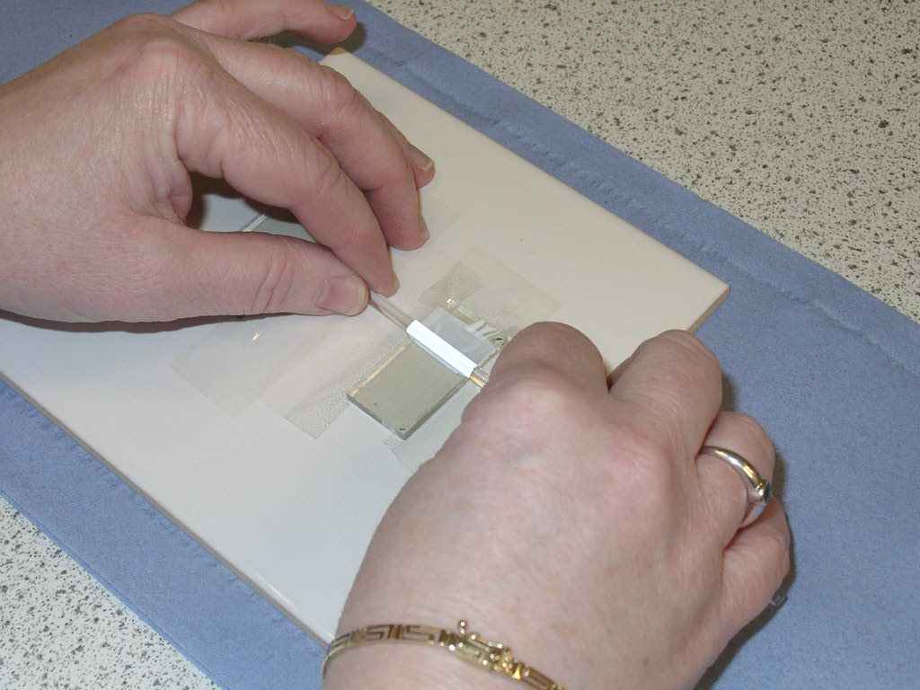
Using a Pasteur pipette, add a thin line of the titanium dioxide slurry to the top end of the electrode.

Gently draw the slurry down the glass surface using a glass rod which is resting on the two side strips of adhesive tape (Figure 3).

This should produce a uniform, thin layer.
Figure 3: Applying the titanium dioxide layer to the glass electrode.

- Sintering the electrode

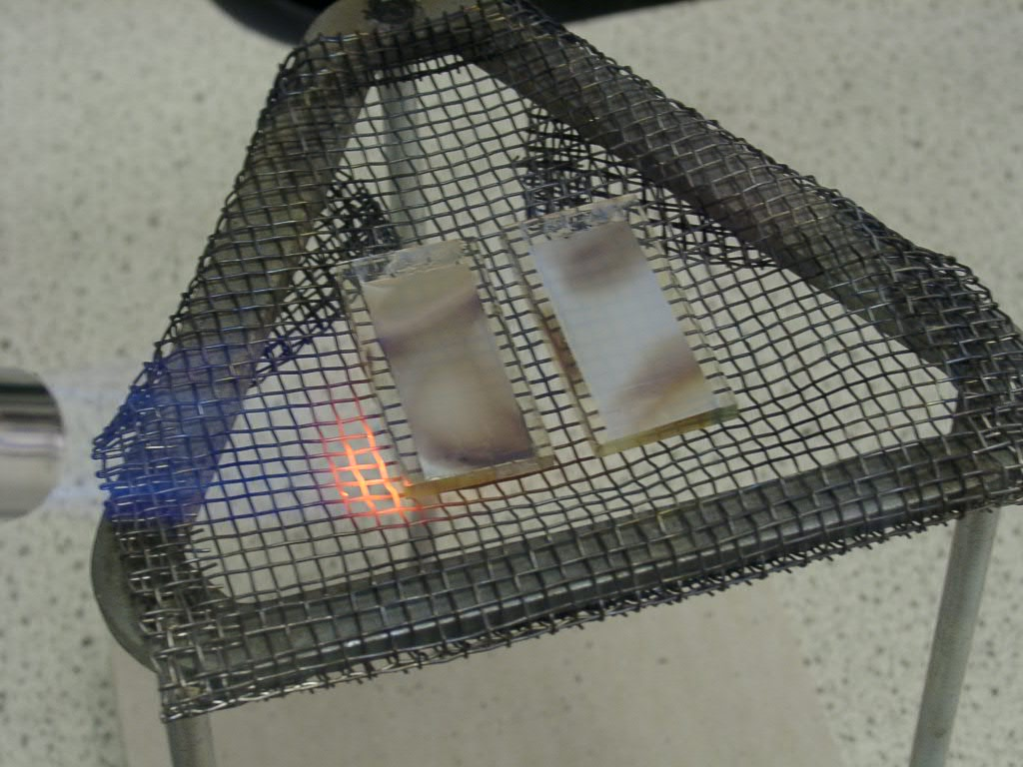
After the coating has dried (a hair-drier will speed up this process), remove the adhesive tape.
Figure 4: Sintering the titanium dioxide layer with the blue flame of a Bunsen burner.

Place the electrode on a wire gauze for sintering.

Slowly pass a blue Bunsen burner flame over the titanium dioxide surface. It will turn dark brown and then go white again. This process should only take
about 3 minutes (Figure 4).

After sintering, allow the coated
electrode to slowly cool to room temperature. Any attempt to rapidly cool the electrode will result in the glass cracking or shattering.

- Preparing the dye
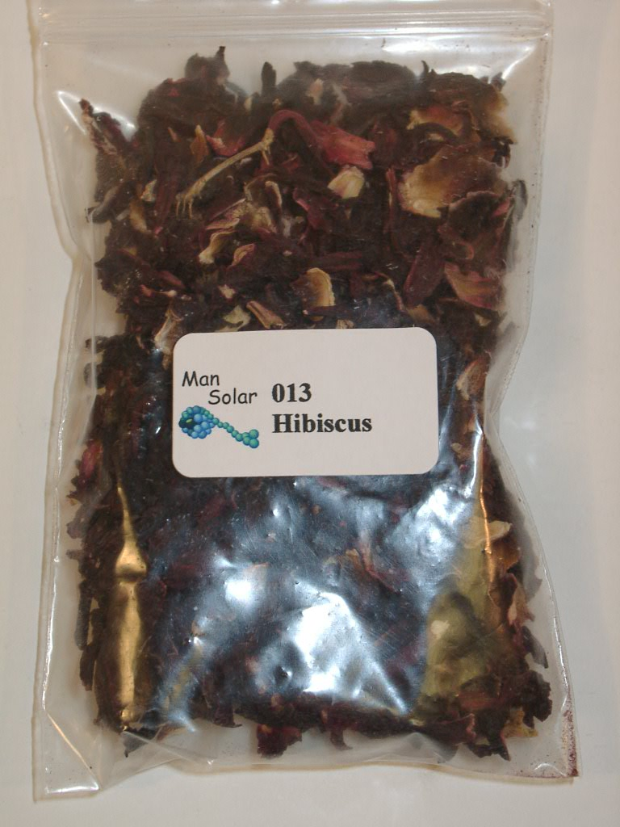
Weigh out 2g of dried hibiscus flowers
(supplied in the kit) and add to a beaker
containing 50ml of boiling water.

These are actually the dried calyces of the
Roselle plant (Hibiscus sabdariffa), which
is sold as ‘Hibiscus tea’ or ‘Flor de Jamaica’
in many health food stores. The deep red
characteristic colour comes from flavonoid
glycosides such as cyanidins and delphenidins.

Anthocyanins are separated into five groups;
cyanins, petunins, peonins, malvins and delphinins.
Figure 4: Dried Hibiscus flowers

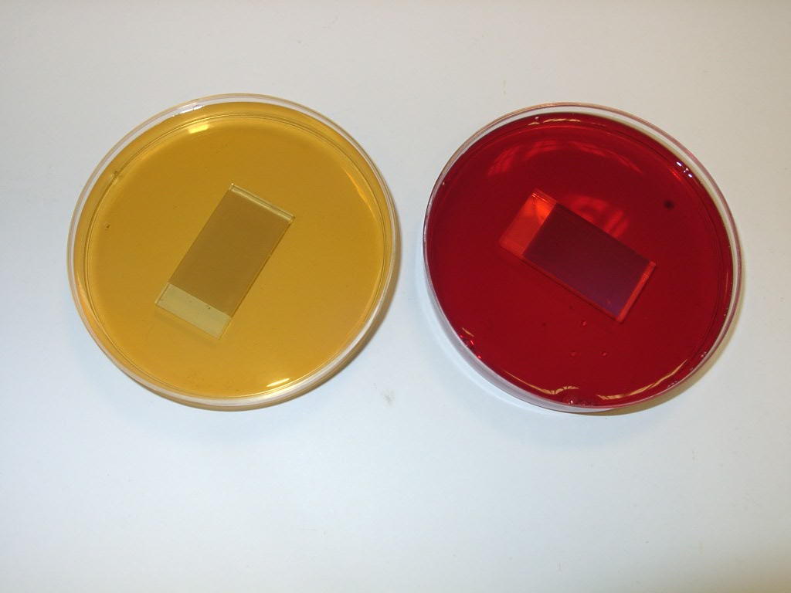
- Preparing the dye electrode

Pour the dye solution into a Petri dish and
soak the titanium dioxide coated electrode
in the dye, face up, for about 10 minutes.

Remove the dyed electrode, being careful
not to touch the titanium dioxide surface,
and gently rinse with distilled water before
drying the electrode by waving it in the air.
As the electrode dries the titanium dioxide
Figure 5: Preparing the dye layer
surface will change colour slightly. Do not
attempt to dry the surface by wiping it with
paper or tissues as this can damage the
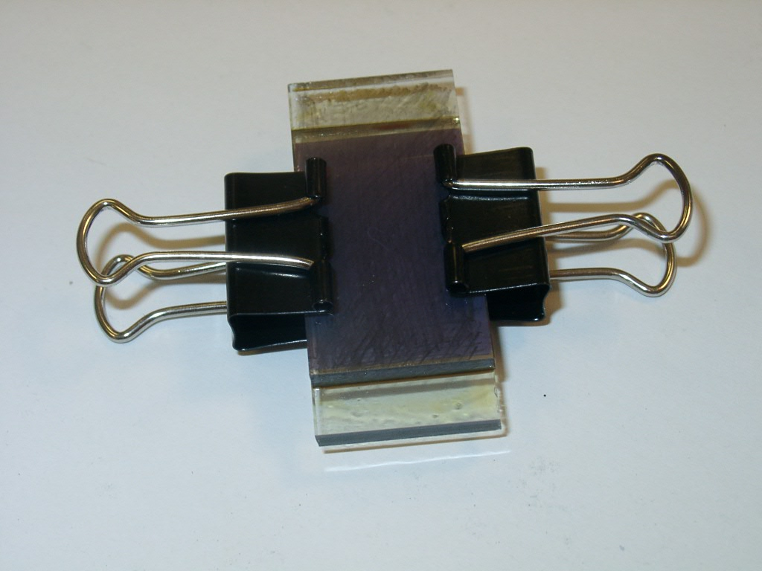
titanium dioxide layer.

- Assembling the solar cell

Place the dye coated electrode, face up, on
a flat surface and then add 2 drops of
iodine/tri-iodide electrolyte (Harmful).
Add the graphite coated electrode face down
but offset by about 5mm. Sandwich the glass
electrodes together using 19mm bulldog clips.
Figure 6: A completed solar cell
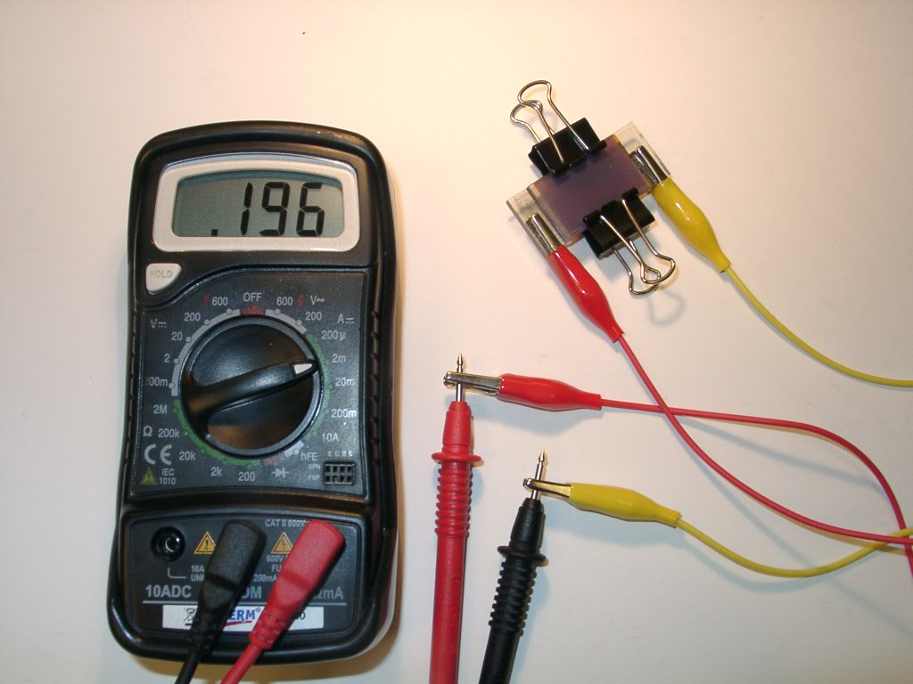
- Measuring the electrical current

Attach a crocodile clip cable to each end of
the solar cell. Turn the multimeter function
switch to 2mA, and connect the crocodile clip
cables to the two measurement probes.

If the solar cell is being illuminated by either
natural or artificial light, there should be an
output current. Passing a hand over the solar
cell will decrease the output current.
Figure 7: Measuring the output current

Turning the solar cell upside down will produce a different output current.
A higher output current is obtained by illuminating the titanium dioxide side of the solar cell (i.e. the side where the graphite pencil marks are not visible).

A constant degree of illumination can be maintained by positioning an angle-poise table lamp directly above the solar cell at a distance of approximately 20cm.

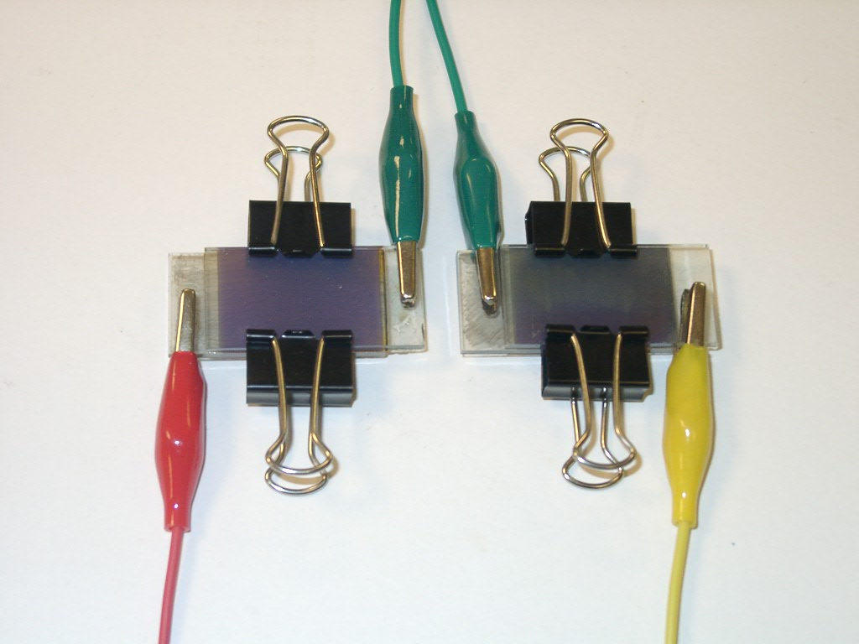
- Connecting solar cells in series
Figure 8: Solar cells in series

Several solar cells can be joined in series by
connecting the positive (graphite coated)
electrode of one solar cell to the negative
(titanium dioxide coated) electrode of the
next solar cell, using a crocodile clip cable.

When solar cells are connected in series, their
voltages are added together. In this way it is
possible to produce a voltage of 1.2V, which
will operate a melody module or a calculator.
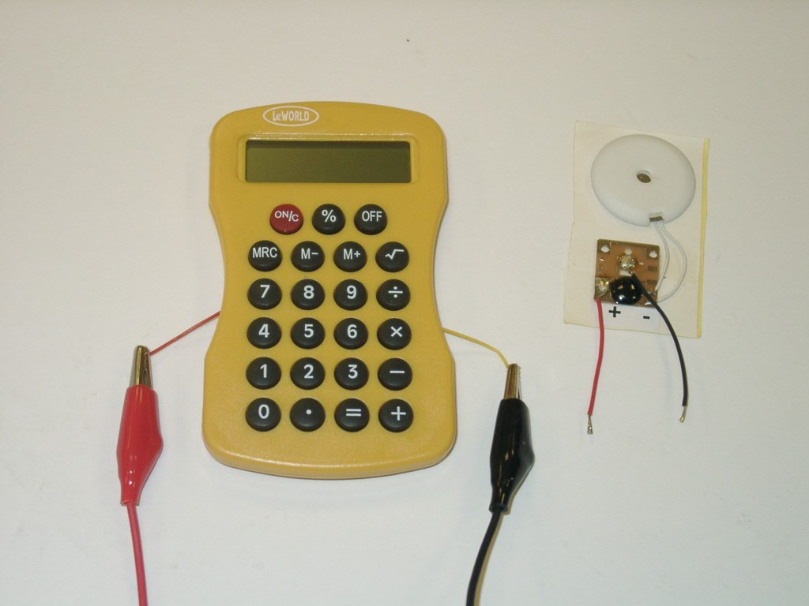
Figure 9: Devices using solar cells
Unscrew the back of a cheap pocket calculator
and detach the wires from the battery holder.
Reassemble the calculator with the two wires
exposed from either side of the calculator.

Arrange six hibiscus-dyed solar cells in series.
Connect the final graphite electrode to the
positive wire and the final titanium dioxide
electrode to the negative wire.
Once again, if the terminal graphite electrode is connected to the positive (red) wire of the calculator, and the terminal titanium dioxide electrode connected to the negative wire, the calculator will function when switched on.

Linking to Curriculum for Excellence – Experiences and Outcomes

There are a number of ways in which dye-sensitised solar cell technology could be incorporated into science learning and teaching, and some of the opportunities are illustrated below. It could also provide the focus for inter-disciplinary links with a cross curricular theme, as well as encouraging the principles and practice of “A Curriculum for Excellence”. Shorthand links to the www.science3-18.org website are also shown [].

The Sciences, Materials, Properties and uses of substances,
SCN 4-16a Researching novel materials
I have carried out research into novel materials and can begin to explain the scientific basis of their properties and discuss the possible impacts they may have on society. [http://tinyurl.com/SCN-4-16a]

Activities which could link to this outcome:
- Build a DSSC.
- Compare 3 or 4 different plant dyes, including beetroot to show that not all coloured dyes work.
- Add solar cells together in series and use a multimeter to find out the voltage required to operate a pocket calculator or melody module.
- Research the use of cheap DSSCs in developing countries where there is no National Grid.

The Sciences, Planet Earth Energy sources/sustainability,
SCN 2-04b Exploring non-renewable energy sources
Through exploring non-renewable energy sources, I can describe how they are used in Scotland today and express an informed view on the implications for their future use.[ http://tinyurl.com/SCN-2-04b]

Bottom of Form
The Sciences, Planet Earth, Energy sources/sustainability,
SCN 3-04b Issues with renewable energy
By investigating renewable energy sources and taking part in practical activities to harness them, I can discuss their benefits and potential problems. [http://tinyurl.com/SCN-3-04b]

Technologies, Tech. developments in society,
TCH 2-02b Renewable & sustainable energy
I can investigate the use and development of renewable and sustainable energy to gain an awareness of their growing importance in Scotland or beyond. [http://tinyurl.com/TCH-2-02b]
Activities which could link to this outcome:
- Build a DSSC.
- Compare 3 or 4 different plant dyes, including beetroot to show that not all coloured dyes work.
- Back the solar cell with reflective foil to see if the output current is increased.
- Plot the relationship between output current and light intensity (by measuring the distance from a light source or using a light meter).

The Sciences, Topical science,
SCN 4-20a Current and future developments
I have researched new developments in science and can explain how their current or future applications might impact on modern life. [http://tinyurl.com/SCN-4-20a]

Activities which could link to this outcome:
- Build a DSSC
- Compare the output currents of a DSSC and a silicon solar cell at different light intensities.
- Research future applications – providing energy in developing countries when there is no opportunity to recharge them through a national grid. (e.g. LED lighting, radios, refrigerators, water purification, mobile phone rechargers).

The Sciences Planet Earth Energy sources/sustainability
SCN 4-04a Risks and benefits of energy
By contributing to an investigation on different ways of meeting society’s energy needs, I can express an informed view on the risks and benefits of different energy sources, including those produced from plants. [http://tinyurl.com/SCN-4-04a]

Activities which could link to this outcome:
- Build a DSSC
- Compare the DSSC to another renewable source of energy in terms of cost, energy output, reliability and level of technology required to build it.
- Discuss attitudes towards “green energy” sources such as solar cells, wind turbines and bio-fuels.
The Sciences, Forces, electricity & waves, Electricity,
SCN 4-09a Current, voltage and resistance
Through investigation, I understand the relationship between current, voltage and resistance. I can apply this knowledge to solve practical problems. [http://tinyurl.com/SCN-4-09a]
Activities which could link to the first part of the outcome:
- Build a DSSC
- Add a variable resistance across the DSSC and plotting the relationship between voltage and current.
- Plot the relationship between power and voltage, to find the maximum power point.
- Use these graphs to examples of appliances which would / would not operate using a DSSC.

Open-ended Investigation Projects

As pupils will be unfamiliar with dye-sensitised solar cells they have tremendous potential as the basis of open-ended investigations.

Possible starter questions:

- Which flower petals produce the most effective dye for a DSSC?

- Is there a significant degradation of the dye over a period of time, as shown by a decrease in the output current? (The student would need to ensure that it is not just the electrolyte drying up)

- Is dye degradation accelerated by increasing the intensity of light?

- Does the ionic environment (concentration and type of ions) affect the photon-trapping efficiency of the dye?

- Can the mixture of anthocyanidins in a plant extract dye be separated (e.g. by chromatography) to see which is the most effective component?
Equipment and Reagents

- Preparing the titanium dioxide suspension

Prepare the titanium dioxide suspension by incrementally adding 10ml of very dilute ethanoic acid to 5g of nanocrystalline titanium dioxide powder (e.g. Aeroxide TiO₂ P25) while grinding it for 10 minutes, using a mortar and pestle.
Finally, add one drop of dishwashing detergent and grind it again to produce a smooth paste.

It should be noted that ordinary titanium dioxide will not adhere to the glass when sintered.

- Preparing the titanium dioxide suspension

The tri-iodide electrolyte can be prepared by dissolving 0.127g iodine (I₂) in 10ml of ethane 1,2-diol (ethylene glycol) and then adding 0.83g potassium iodide. The solution should be thoroughly stirred and stored in a dark container.

Hazards and control measures

Chemicals & procedures | Main Hazard | Control Measures
Iodine/tri-iodide electrolyte | Harmful | Wear nitrile gloves and indirect vent goggles.
Glass electrodes (assembling solar cell) | May have sharp edges and may break if pressed too hard. | Hold glass electrodes carefully and add bulldog clips gently.
Boiling water for dye-bath | Scalding | Don’t touch or move beaker containing the boiling hot dye-bath.
Kit lists – Per group

Extracting dyes

Safety glasses | Kettle of boiling water
Plants (dried hibiscus flowers, beetroot etc.) | Beaker, 250 cm³
Electronic balance (access to) | Weighing boat
Spatula | Stirring rod
Flat-bottomed dish | Piece of filter paper
Paper towels and hairdryer | Forceps

Extracting chlorophyll

Safety glasses | Ethanol (Flammable)
Measuring cylinder | Green plants
Mortar and pestle | Flat-bottomed dish
Piece of filter paper | Sharp sand
Spatula and Forceps | Either a filter funnel and piece of muslin, or a tea strainer
Paper towels and hairdryer

Preparing the TiO₂ electrode

If bought from ManSolar, these will be pre-coated and will last several re-uses. This technique is used for re-coating the old electrodes.

TiO₂ (nanocrystalline) | Conductive glass electrode
5% ethanoic acid (white vinegar) | Detergent (washing up liquid)
Pestle & mortar | Multimeter & leads
White tile | Electrical or masking tape
Glass rod | Dropper or Pasteur pipette
Bunsen burner | Tripod & gauze

Trying out the dyes

Filter papers with soaked in dyes | ‘light box’
 | Multimeter & leads
OR
Digital camera | computer
Paint program

Assembling the cells

The titanium dioxide electrode in the dish of hibiscus dye* | The glass electrode coated in pencil
2 small spring bulldog clips | A bottle of electrolyte solution.
Paper towels | Hairdryer
Gloves (optional)

Trying out the cells

Assembled Grätzel cell | Multimeter and leads
Lamp or other light source (eg sunlight)
Sources of materials

Most of the items in the Man Solar 2000 kit will already be in schools or can be purchased locally. However it might be considered prudent to purchase a kit which is proven to work, before attempting to substitute in alternative materials which may, or may not, work equally well.

Hibiscus ‘flowers’, Hibiscus tea or ‘Flor de Jamaica’ can be purchased in many health food stores. Alternatively dried Hibiscus flowers can be purchased on the internet for about £2 per 100g (e.g. www.Mexgrocer.co.uk) or
MexGrocer.co.uk, 1 Tennyson Rd, Stockport, SK5 6JJ. Tel : 0800 849 9042 (Information Line Only)

The tri-iodide electrolyte can be prepared by dissolving 0.127g iodine (I₂) in 10ml of ethane 1,2-diol (ethylene glycol) and then adding 0.83g potassium iodide. The solution should be thoroughly stirred and stored in a dark container.

Electrically conductive glass is produced in Britain as Pilkingtons K Glass TM (4mm). A single sheet of glass (30cm x 30cm) could be cut by a glazier to produce over 100 electrodes (2cm x 4cm). To minimise the risk of fingers being cut by sharp glass, the sides of each glass electrode should be passed through a hot Bunsen burner flame.
Pilkingtons K Glass TM appears to be the same as Pilkingtons TEC Glass TM (Transparent Electrically Conductive Glass) which is produced by Pilkingtons in the United States.

Nanocrystalline titanium dioxide powder (e.g. Aeroxide TiO₂ P25) is available from various chemical suppliers.

Man Solar also sell the following single materials but there is a minimum order charge:
Article 001: One set contains 6 titanium dioxide coated conductive glass electrodes and 6 conductive glass electrodes.
Article 002: One set contains 12 conductive glass electrodes. These are ready to be sintered with titanium dioxide or coated with graphite.
Article 004/005: Titanium dioxide solution to be deposited and sintered onto article 002
Article 013: Dried Hibiscus flowers

For up-to-date information on Man Solar kits, additional materials and prices, contact the supplier:

MAN SOLAR B.V.
Westerduinweg 3
1755 LE Petten
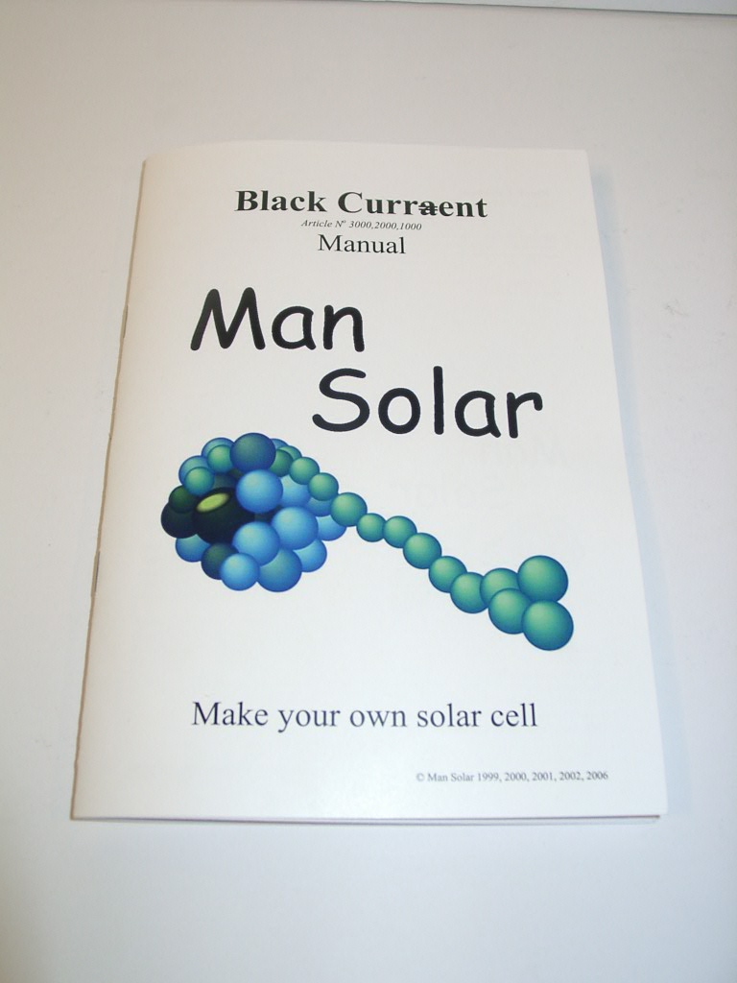
The Netherlands

E-mail: mansolar@ecn.nl
Internet: http:\\www.mansolar.com

