
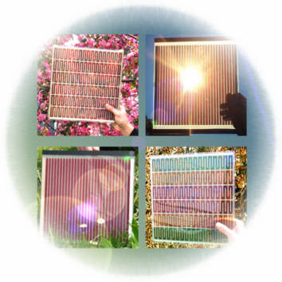


Copyright free image - Wikipedia

Name:

Dye-Sensitised Solar Cells

Solar cells are an excellent renewable source of electricity, but they are difficult to make, and need expensive materials called semiconductors.

Scientists are now developing cheaper types of solar cells called dye-sensitised solar cells that use coloured dyes instead of semiconductors. These were first devised Michael Grätzel and Brian O'Regan at the École Polytechnique Fédérale de Lausanne in 1991 and are also known as Grätzel cells. The dyes are ‘photo-sensitive’, meaning that the dye molecules lose electrons when light shines on them. We can make these electrons flow around a circuit to power electrical devices:

sunlight
dye molecules
electron flow
V

The process can be called ‘artificial photosynthesis’, because it is similar to the way that plants use light energy. For photosynthesis, plants use a natural dye called chlorophyll to absorb the light so they can grow. Dyes in solar cells work in a similar way but use the energy absorbed to produce electricity.

We can try to extract chlorophyll and other dyes from plants such as spinach, hibiscus flowers and beetroot to see how good they might be to use in a dye-sensitised cell.
Extracting Hibiscus and Beetroot Dyes

Equipment:

Safety glasses | Kettle of boiling water
Plants (dried hibiscus flowers, beetroot etc.) | Beaker, 250 cm³
Electronic balance | Weighing boat
Spatula | Stirring rod
Flat-bottomed dish | Piece of filter paper
Paper towels and hairdryer | Forceps

- Measure out 2g of the dried hibiscus flowers using the weighing boat and the balance.
- Add them to the beaker and then pour on 50 cm³ of boiling water.
- Stir the mixture to help release the dye.
- Allow to cool.
- Lay the piece of filter paper in the flat-bottomed dish.
- Pour the red dye over the filter paper. Try to leave the bits of plant behind in the beaker.
- Leave the paper in the red liquid for a few minutes.
- Carefully remove the paper and lay it on a paper towel.
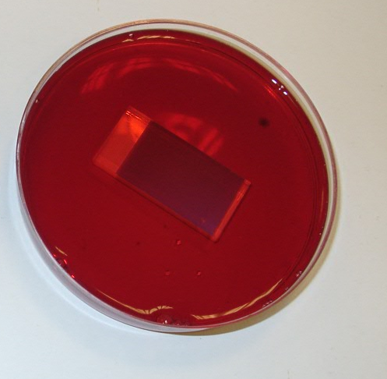
- Leave the paper to dry, or dry it gently with a hairdryer.
- Now take the white titanium dioxide coated electrode and place it in the dish of hibiscus dye. Make sure the electrode is covered. Leave it there while you carry out the preparation of the other two dyes.
- Extract the beetroot dye by adding the piece of beetroot you have been given to 50 cm³ of boiling water in a beaker.

- Then repeat instructions 3-9 above.

Extracting Chlorophyll

Equipment:

Safety glasses | Ethanol (Flammable)
Measuring cylinder | Green plants
Mortar and pestle | Flat-bottomed dish
Piece of filter paper | Sharp sand
Spatula and Forceps | Either a filter funnel and piece of muslin, or a tea strainer
Paper towels and hairdryer

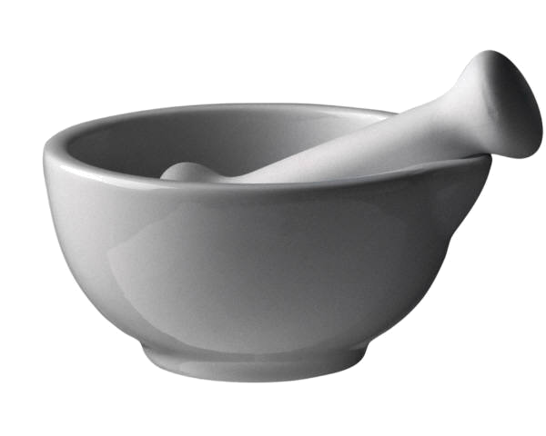

- Add a small amount of sand to the mortar (the bowl) and then add some of the green leaves.

- Now use the pestle (the stick) to grind up the green plants in the mortar.
- Add about 25 cm3 of ethanol (Care: FLAMMABLE)
- Carefully grind the plants again in the ethanol for a few minutes, until the liquid is dark green. Try not to spill any!
- Add another 25 cm3 of ethanol and mix gently.
- Lay the piece of filter paper in the flat-bottomed dish.
- Either
- place the piece of muslin in the filter funnel and pour the green liquid through it and over the filter paper OR
- pour the green liquid through the tea strainer onto the filter paper.
- Leave the paper in the green liquid for a few minutes.
- Carefully remove the paper and lay it on a paper towel.
- Leave the paper to dry, or dry it gently with a hairdryer.
Trying out the dyes

A photo-sensitive dye must be good at absorbing light. In this experiment you will test the absorbance of the dyes you prepared.
We will use a bulb to create light, and a light detector to measure the light that gets reflected from the dye. You will use the equipment shown below, and your filter papers coloured with the different dyes.
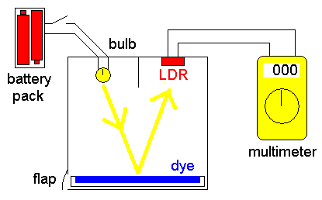

- Connect the multimeter to the light detector as shown.
- Turn the dial on the multimeter to measure resistance (Ω).
- Switch on the bulb.
- Open the flap, insert one of the dye plates, then close the flap again.
- Note down the reading on the multimeter
- Remove the dye plate.
- Repeat steps 4 to 6 for the other plates.
- Try doing the same measurement for a white piece of paper, and the empty (black) box.
- Switch the bulb off when you have finished.

Results
Type of Dye | Multimeter Reading (kΩ)

A high multimeter reading means the dye on the paper is absorbing a large amount of light. This dye might be good for using in a dye-sensitised solar cell but there are other factors to consider as well.

Draw a bar chart of your results:


Which dye might be best for using in a Grätzel cell?

_____________________________________________________________

One last question – why do you think we used a box that is black inside?

_____________________________________________________________

Finding the Luminosity
A photo-sensitive dye must be good at absorbing light.
The method given in the practical is to use an LDR attached to a multimeter to see how much light is reflected from the surface. This method is effective but needs a ‘black box’ to be made, which is a bit fiddly
Here is a way for you to test the absorbance of the dyes you prepared just using a digital camera and a computer. All you need is a digital camera (one from a phone should be fine) and a computer with a simple drawing program (these instructions refer to Paint that comes with all Windows machines).
- Take a picture of the different dyes – ideally once absorbed onto the TiO2 layer. (It is best if you can get all the samples in the same shot)
- Transfer the picture to a computer.
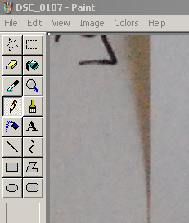
- Open your picture in Paint – right click on it, select Open With... from the menu and then select Paint.
- Select the Pick Color tool from the menu
- Move the cursor to the part of the picture with one of your dye samples in and click on it. You will see the colour in the bottom corner change to the one you have picked.
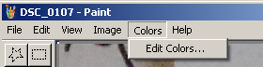
- Then Click on the Colors menu and Select edit Colors

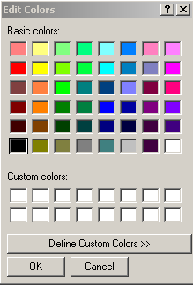
- That brings you this menu. Click on Define Custom Colors

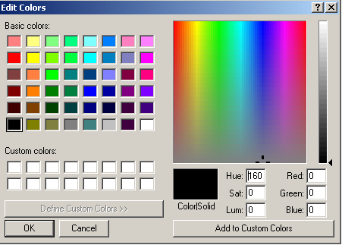
- That brings up this screen

- You will see your colour in the box here.
We are interested, however, in the numbers below. Especially the one in the box labelled Lum
Which stands for Luminosity

- Make a note of the reading and then repeat the process with the others.

If you want, you can compare them with white by placing them on a sheet of white paper and taking areading off that as well. That way you can, should you wish, get a percentage luminosity.
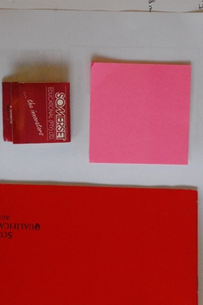
Eg Here is a photo of three different red (ish) objects.

You can clearly see from the table that, as you might expect, the pink is reflecting more light than the others.
Colour | Luminosity | % Luminosity
Pink | 135 | 79%
Scarlet | 80 | 47%
Dark Red | 64 | 38%
White | 170

Building Your Hibiscus Grätzel Cell
Note: Handle the electrodes only by their edges. The titanium dioxide coating is easily scratched.
Equipment:
The titanium dioxide electrode in the dish of hibiscus dye* | The glass electrode coated in pencil
2 small spring bulldog clips | A bottle of brown solution called “electrolyte”
Paper towels | Hairdryer
Gloves

- Handling it only by the edges, carefully remove the electrode from the dye and place it, dye face up, on a piece of paper towel
- Carefully dab off any dye from the uncoated part of the glass, being careful not to touch the titanium dioxide layer
- Use the hairdryer set at a low heat to dry the layer of dye
- Now add 2 - 3 drops of the electrolyte (Harmful) to the dyed layer
- Place the graphite coated electrode face down on the dyed electrode, but offset like this:
Graphite coated electrode offset

Titanium dioxide electrode

- Check that the electrolyte has covered the dye layer.
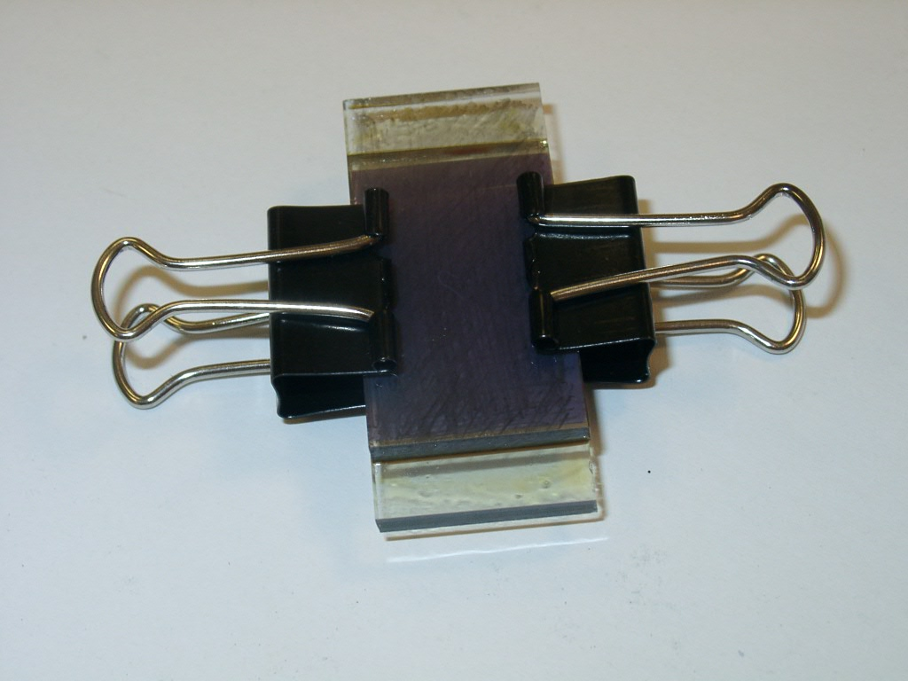
- Sandwich the glass electrodes together using 19mm bulldog clips

- It should look like this:

* You can of course use other dyes

Trying out your Grätzel cell

Once you have your cell, here is what to do:
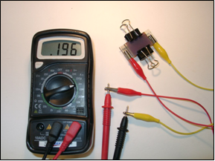
You can illuminate your cell by positioning an angle-poise table lamp directly above the solar cell and approximately 20cm from it.

Attach a crocodile clip cable to each end of the solar cell. Turn the multimeter function switch to 2mA, and connect the crocodile clip cables to the two measurement probes.

If the solar cell is being illuminated by either natural or artificial light, there should be an output current.

Try to measure the voltage of the cells.

Dye used in the cell | Current | Voltage | Comment

Are any of the dyes not very suitable for use in a cell? If so, which one?

Pass a hand over the solar cell. What happens to the readings? Suggest why.

Turn the solar cell upside down. What happens to the readings? Suggest why.

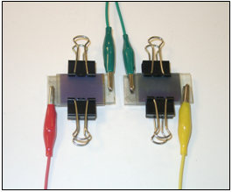
Connect your solar cells in series
Several solar cells can be joined in series by connecting the positive (graphite coated) electrode of one solar cell to the negative (titanium dioxide coated) electrode of the next solar cell, using a crocodile clip cable.

What happens to the size of the voltage produced when you connect cells in series?

Try to power a calculator with your cells.

