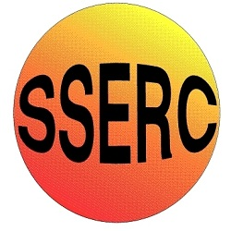
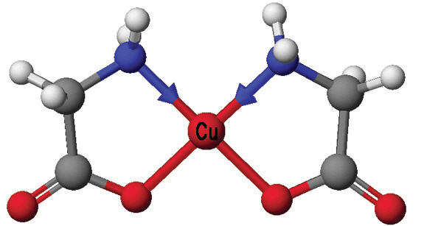
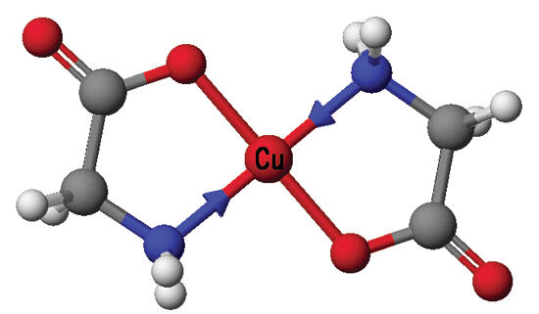
The Preparation of Amino Acid Complexes of Copper

A metabolism for copper ions is widespread among living systems. To help in the understanding of the binding of the ion in biopolymers, the prototype compounds of cupric ions with amino acids have been extensively studied.
Bis (glycinato)copper(II).hydrate was first isolated in 1841 and in 1890 a second form was discovered. It was later suggested that the two modifications were geometric (cis/trans) isomers. These compounds represent some of the first geometric isomers discovered.

cis-cic-Cu(gly)₂.H₂O

trans-Cu(gly)₂.H₂O

Their preparation is from the reaction between copper (II) acetate and glycine:

Cu(CH₃COO)₂(aq) + 2H₂NCH₂COOH(aq) Cu(H₂NCH₂COO)₂.H₂O + 2CH₃COOH

Preparation of cis-Cu(gly)2.H₂O

- Accurately weigh out approximately 4.0g of copper(II) acetate monohydrate and dissolve this in 50cm³ of hot water in a 250cm³ beaker.

- Measure out 50cm3 of warm ethanol and add this to the solution of copper(II) acetate. Mix and keep it warm.

- Accurately weigh out approximately 3.0g of glycine and dissolve this in a further 50cm3 of hot water in a separate 100cm3 beaker.

- Pour the glycine solution into the copper acetate/ethanol solution while hot (~70C). Stir to mix. Place some ice in a 400 cm3 beaker and then cool your solution on this ice.

- A needle-like precipitate should form. This is the cis-isomer.

- Filter this at the pump.

- Divide the crystals into two parts.

- Place one part on a piece of weighed filter paper in an oven at 120oC to dry it.

- Label this as ‘Sample A – cis’.

Preparation of trans-Cu(gly)₂.H₂O

Place the second part on weighed filter paper and Label this as ‘Sample B–trans’.
Now place it in an oven at 170ºC for about an hour.
This leads to the solid state conversion of the cis-isomer to the trans-isomer when it cools in air. When crystals of the cis-monohydrate are heated, they first lose water of crystallization then isomerise to the trans-isomer which is more thermodynamically stable than the cis form.

- When dry, weigh both samples and then transfer them to dry labelled sample tubes.

- Calculate the percentage yield of conversion of the copper(II) acetate to copper glycine monohydrate.

IR Help Sheet
It should be possible to distinguish between the two isomers by IR spectroscopy, by considering the immediate environment around the central metal and assuming that their vibrations are independent of the motions involving the rest of the atoms of the ligands.

It is expected that for the metal-ligand stretching vibrations, 4 bands should be observed in the IR spectrum of the cis-isomer, but only 2 bands for the trans-isomer.

Since N is the lighter atom it is also expected that the M-N modes will be at higher energy than the M-O modes.

Interpretation.

The metal-ligand stretching modes occur below 500 cm-1. From the spectra given, tabulate all peaks in that region.
For the cis-isomer, assign v asymmetric and v symmetric bands for M-N and M-O.

For the trans-isomer, assign v asymmetric for M-N and M-O.
From the spectra recorded on your samples (4000-600 cm-1), tabulate the major peaks and assign as many bands as possible. Can you make use of another region in these spectra to distinguish between the two isomers?

