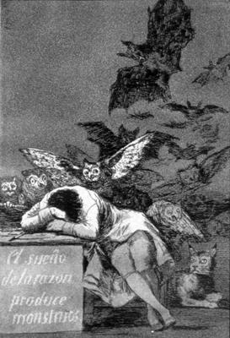
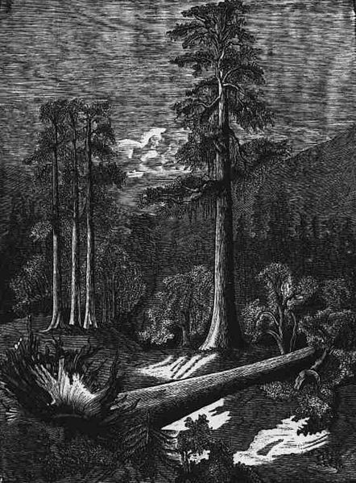
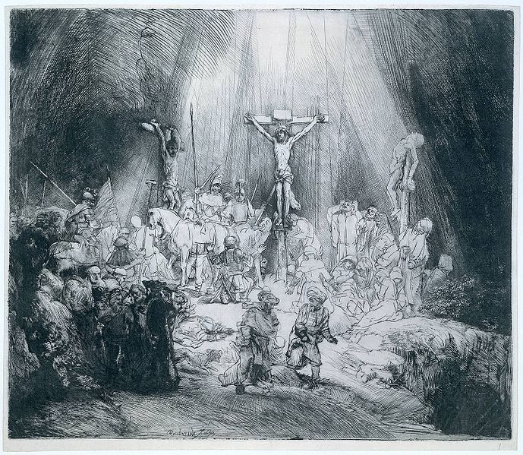
The three crosses - Rembrandt
Fallen tree – Carlos Alvarado Lang
The sleep of reason creates monsters – Francisco de Goya
Technician’s Guide
Etch a Sketch
Technician’s Guide
*Apparatus (based on 20 pupils)*

Degreasing
Scissors x 10
Insulating tape x 10
Zinc foil etch plate (5 x 5 x 0.03 cm) x 20
1 cm³ Pasteur pipette x 40
Scourer x 30
Pair of tweezers x 10
Plastic take away tub (11.5 x 17.5 x 5.5 cm) x 10
Paper towels
Tea strainer x 10
10 cm³ Soy sauce x 10
3 g calcium carbonate x 10
10 cm³ vinegar x 10
10 cm³ Washing up liquid x 10
There may be sharp edges and corners in the zinc foil. Carefully cut out twenty 5 x 5 cm² plates. Use a file to remove any burs/ sharp edges and round off any sharp corners.
Measure out 100 cm³ of any soy sauce, place into 10 bottles and label accordingly.
Weigh our 30g of calcium carbonate, place into 10 bottles and label accordingly.
Measure out 100 cm³ of white vinegar, place into 10 bottles and label accordingly.
Ground
Plastic ice cream tub (16 x 22 x 8 cm) x 10
Metal take away tub (12 x 14.5 x 4.5 cm) x 10
Access to kettle
Pair or tweezers x 10
Paper towels
Cocktail sticks x 10
Chopped tea light candles x 10
Take 2 tea light candles and chop/ dice them into smaller pieces. Place into jar and label accordingly.
The tea light candle wax can be reused. Allow the molten wax to harden in the metal tub and then pop out the solid wax and chop up ready for next use.

Etching
Plastic take-away tub (11.5 x 17.5 x 5.5 cm) x 20
Large spatula x 10
Timer x 10
Stirring rod x 10
Fine paint brush x 10
Pair of tweezers x 10
Paper towels
Scourer x 10
Access to a kettle
100 cm³ Etch solution (harmful and dangerous for the environment) x 10

Weigh our 100g of copper sulphate and 100g of sodium chloride and dry mix them thoroughly. Place mixture into a 1 litre volumetric flask and add 500 cm³ of warm water. It will turn light green. Add a further 500 cm³ of cold water and it will turn blue. Measure out 100 cm³, place into a bottle and label with harmful and dangerous for the environment pictograms. Repeat for the other 9 groups.
Note that cooking salt is a suitable alternative.
When the etch solution appears a clear greenish colour mixed in with solid copper particles it is spent and should be disposed using the guidelines given later. Until this occurs the etch solution can be filtered and reused.

Printing
Bench cover x 10
Plastic Petri dish (size) x 10
1 cm³ Pasteur pipette x 10
Stirring rod x 10
Filter paper (size) x 10
Dabber (sponge) x 10
Cotton wool buds x 20
Muslin cloth (size) x 10
Sellotape x 10
Bed (10 x 14 cm) x 10
Blanket (20 x 28 cm) x 10
Wooden rolling pin x 10
Gloves (optional)
10 cm³ Printing ink x 10
5 cm³ Ink thinner (flammable, harmful & dangerous for the environment) x 10
Cut student grade filter paper or coffee filter paper into 7 x 7 cm² squares.
The dabbers are sponge/ scourers that can be bought from local supermarkets. These can be cut into halves if required.
The beds ideally need to be of some hard wood origin. Off cuts from any timber yard or technical department can be cut into the required sizes.
The blankets ideally should be made of felt. The rectangle should be folded over. However old t-shirts are a suitable alternative.
Measure out 100 cm³ of printing ink, place into 10 bottles and label accordingly.
Measure out 50 cm³ of ink thinner, place into 10 bottles and label with flammable, harmful & dangerous for the environment pictograms.

Disposal of waste
The spent etch solution will be clear and contain solid particles. Add hot water to dissolve any solid sulphates and then add zinc or aluminium fillings. Leave overnight. Add sodium carbonate until there is no more fizzing and/ or the pH is between 7 and 8. This can then be run down the drain with copious quantities of water. The precipitate is placed in a sealed bag and stored for disposal by licensed contractor.
If any of the printing ink is split it can be removed using white spirits. The waste can be disposed of by turning off all sources of ignition, adding up to 200 cm³ at a time to 5 litres of water and then run down the drain with copious quantities of water.

