
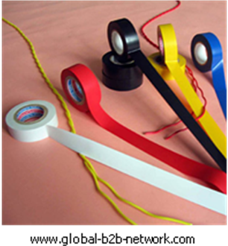
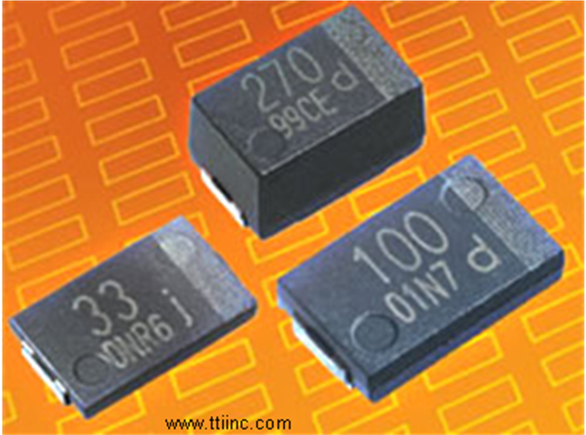

INTRODUCTION
Background

For some time now, polymers (plastics) have been used commercially as alternatives to natural materials such as wood, metals, ceramics and glass. They are used extensively because they are relatively cheap, lightweight, strong and easy to process. Most polymers are good electrical insulators, a property highlighted in science education and by their extensive use in the home.
However, over the last 30 years there has been increasing interest in a number of plastics found to be electrical conductors. Yet another case of telling students what they were taught in the past wasn’t quite the whole truth! Researchers have discovered that conjugated polymers, which have a pathway of alternating double and single bonds, exhibit metallic and semiconductor characteristics. These polymers possess a delocalised pi-electron system along their backbone that confers semiconducting properties to the polymer.
Although polymers such as polyethyne have a conjugated system of bonds, this alone does not make them conduct electricity. To make these polymers conduct, electrons must first be removed (oxidation) or added (reduction). In the case of polyethyne, oxidation to create a conducting polymer can be achieved by the addition of iodine. This particular method is called ‘doping’.
Working lifetime is a major concern when considering the commercial applications of these plastics. Considerable research has taken place over the last 50 years to improve the resistance of plastics to photo oxidation. As could be expected, similar problems exist with conjugated polymers. To be commercially viable, storage lifetimes of at least 5 years and operating lifetimes of > 20,000 hours are typically required.
Poly(pyrrole) and poly(aniline) are commonly used conducting polymers in industry because they are relatively stable. Polypyrrole is not directly processable and is deposited in film form by electrochemical means. Current commercial applications of these plastics include battery electrodes, conductive coatings for electrostatic speakers, capacitor electrolytes, transparent conductive coatings, through hole plating of double sided printed circuit boards and electrostatic discharge coatings.
In the future, conducting plastics will be used because the material and manufacturing costs are low, they can be used to cover large areas, form thin films and are flexible. As such, it seems that conducting polymers will not be a general replacement for metals but will be used where these advantages can be exploited for medium conductivity applications.
So an electricity-conducting plastic isn't necessarily a oxymoron -- conductive polymers do exist. So far, though, they are just riddled with disadvantages, or only fit for very narrow purposes.
There are specific polymer materials, like polyaniline, polythiophene and polypyrrole, which can conduct electricity, but it can be difficult or impossible to change their shape, they're often unstable conductors, they have low conductivity rates and are intolerant to oxygen exposure and difficult to process.
One of the earliest conducting polymers to be developed was polypyrrole.

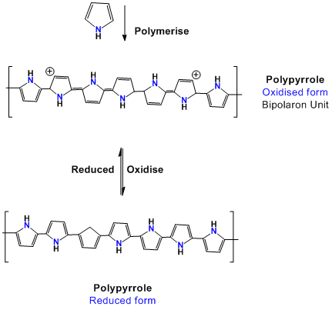

For further information, see the separate document on the uses of conductive plastics.
Syllabus Links
I have carried out research into novel materials and can begin to explain the scientific basis of their properties and discuss the possible impacts they may have on society.
SCN 4-16a
I have researched new developments in science and can explain how their current or future applications might impact on modern life.
SCN 4-20a

National 4: Chemistry in Society
The properties of Plastics - Plastics and novel materials.

National 5: Chemistry & Society
Properties of Plastics

Resources
You will need:

- For the experiment:
Sodium 4-methylbenzenesulphonate (IRRITANT)*
Pyrrole solution (FLAMMABLE, HARMFUL)
A 100 cm³ beaker
A nickel spatula cut in half. One half serves as the positive electrode.
A piece of copper wire, rod or copper sheet (if sheet it should be approximately 1 cm wide and 9 cm long. Fold the copper sheet in half lengthways so it will fit in the electrode holder). This is the negative electrode
An electrode holder (see below)
An ammeter
A variable resistor (0-5000 ohm)
Wires and crocodile clips
A low voltage power supply
A tin of Brasso
Cotton wool
Some steel wool or emery cloth
Distilled water
Propanone (FLAMMABLE)
Nitrile gloves
Goggles
*Sodium 4-methylbenzenesulphonate is known by a variety of names so you're best searching for it by CAS number (657-84-1)
Here at SSERC, we get ours from either Fisher or Sigma, though other suppliers may sell it. The sulphonate is about £45 for 100g. (2013 prices)
Sigma - http://www.sigmaaldrich.com/catalog/product/aldrich/152536?lang=en&region=GB
Fisher - https://webshop.fishersci.com/insight2_uk/getProduct.do?productCode=10669384&resultSetPosition=0

 Pyrrole is a bit easier to find Sigma sell it as a minimum 100g ( at around £45) but Fisher do 25g at £16.50 ish. (2013 prices)
https://webshop.fishersci.com/insight2_uk/getProduct.do;jsessionid=08B6DB49C6E9AF887C014388F797817F.ukhigjavappp11?productCode=10011840&resultSetPosition=0

- To make the pyrrole solution:

Use a fume cupboard.
Prepare 100 cm³ of 0.1 M sodium 4-methylbenzenesulphonate solution (dissolve 1.95g of sodium 4-methylbenzenesulphonate (Irritant) in distilled water and make up to 100 cm³ of solution). Pipette 0.68 cm³ of pyrrole (Flammable and Harmful) into a 250 cm³ conical flask and add the sodium 4-methylbenzenesulphonate solution. Carefully swirl the contents until the pyrrole has dissolved.

- To make the electrode holder:
If you do not have these, you can make them quite easily. Here are two methods:

- Take a plastic ruler and cut it into pieces about 6 cm long. If need be, glue two pieces together with Airfix cement to make it robust enough to take the electrodes. Place the ruler on the beaker and mark on the centre line, the position for two holes to take the electrodes. These should be close to the edge of the beaker to keep the electrodes as far apart as possible to avoid them touching and shorting the circuit.
Now drill two holes on the centre line just large enough to take the nickel spatula and copper electrode and to allow them to hang vertically in the solution.

- Use pieces of 10 mm square wooden dowel or similar. Cut these slightly longer than the width of the beaker. Turn the beaker upside down and mark on the dowel the two places where the lip of the beaker will rest on it. Using a saw, carefully cut two slots in the wood at these points wide enough for the lip of the beaker to rest in. Finally drill two holes just large enough to take the nickel spatula and copper electrode and to allow them to hang vertically in the solution. These should be close to the edge of the beaker to keep the electrodes as far apart as possible to avoid them touching and shorting the circuit.

- To test the poly (pyrrole) for electrical conductivity.
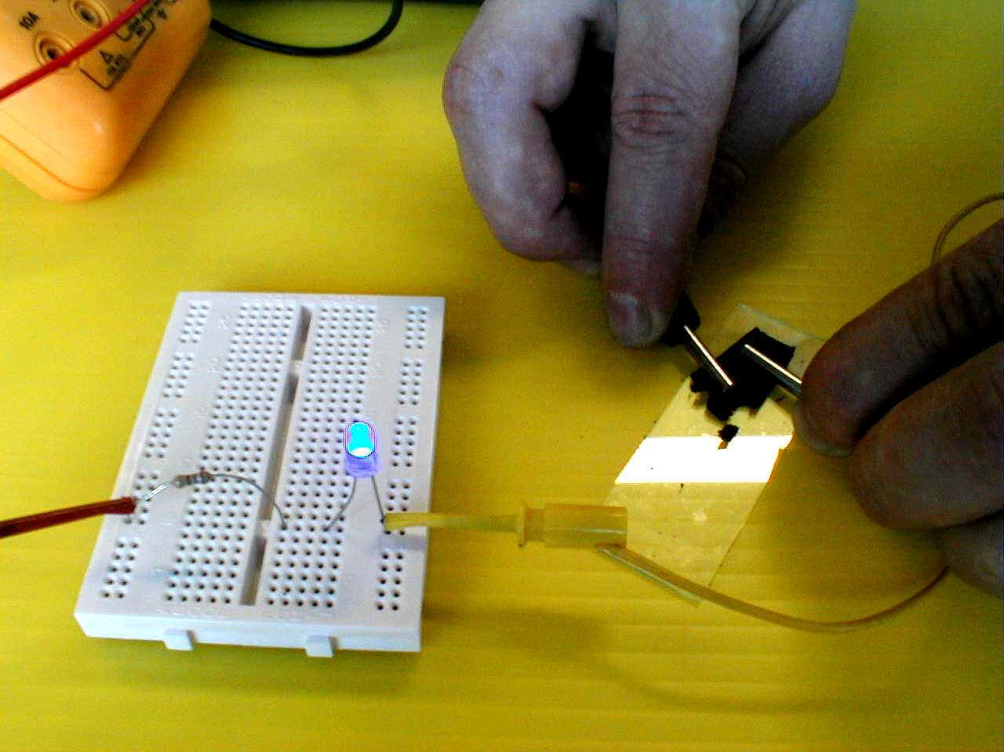
You will need:

A sample of poly(pyrrole)
Wires (with 4 mm plugs) and crocodile clips
A low voltage power supply
A board fitted with a resistor and LED
A glass microscope slide

Prepare a board with the 470 ohm resistor
and LED as in the picture opposite.

OR

You can just use a multimeter on the resistance setting.

- Safety Considerations
Wear eye protection and work in a well ventilated laboratory away from sources of ignition and hot surfaces.
Propanone is highly flammable. Its vapour is an irritant to eyes, skin and lungs and it is a narcotic in high concentrations.
Sodium 4-methylbenzenesulphonate. Avoid contact with eyes, skin and clothing. It is an irritant to eyes, skin and lungs.
Pyrrole. Avoid contact with eyes, skin and clothing. It is a flammable liquid, which is light, air and moisture sensitive (it will deteriorate slowly – buy small quantities). The vapour may travel a considerable distance to a source of ignition and flash back. It forms an explosive mixture in air, is toxic if swallowed, harmful by inhalation and skin absorption and is an irritant to eyes and lungs. Use in a fume cupboard.

This practical is adapted for use in the school laboratory from the method outlined in The Salters’ A Level Chemistry 1991 Trial material [1].

LED: Rapid Electronics. Code 55-2476

The circuit diagrams below can be used to replace the photographs of the experiments in the experimental sheets if so desired.

A
Power supply
12 V d.c.
ammeter
nickel (positive electrode)
copper (negative electrode)
pyrrole solution
0-5000 ohm
variable resistor

Apparatus set up

Testing the poly(pyrrole)
power supply
5-12 V d.c.
470 ohm resistor to protect the LED from excessive current

LED

poly(pyrrole) film
for testing

4 mm plugs

glass slide

