
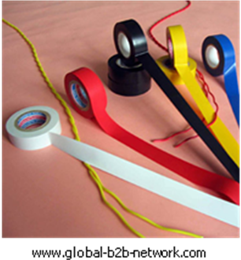
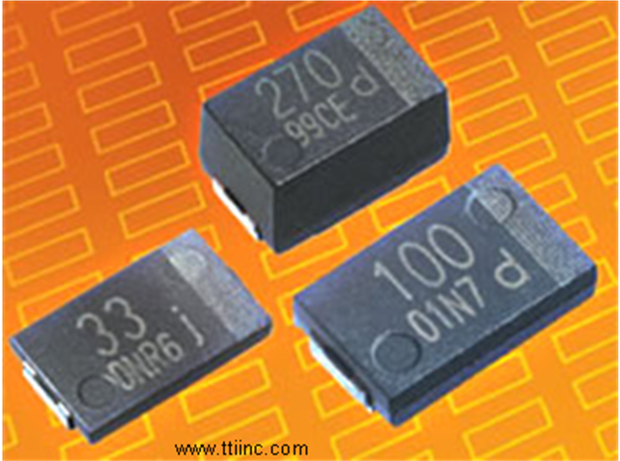

Wonder Material?
Plastic surrounds us. Our telephones, our carpets, and even the fleece we’re wearing all may contain plastic. We store our food in it, drink water from it, and even brush our teeth with it. It’s cheap, convenient, and versatile–but how much do we really know about this wonder material?
Plastic is usually made from hydrocarbons found in oil and natural gas. It’s created when small molecules, called monomers, are bonded together into chains called polymers. Different monomers, when bonded together, create different kinds of plastic; some are soft and pliable, some hard and durable, and others somewhere in between.
Plastic Fantastic
The benefits of plastics are unmatched by any other material, says the Society of the Plastics Industry (SPI). It is light, easily shaped, strong, and inexpensive. Its ability to guard against contamination makes it useful in sterile medical environments such as hospitals.
Plastic kitchenware offers a practical alternative to glass and ceramic dishes. Leak-proof and child-resistant plastic containers are useful for holding dangerous household products such as bleach, ammonia, and other caustic cleaners.
Plastic packaging is good at preventing items getting damaged while being transported and plastic containers are good for storing things in at home.
You can even make bank notes out of it! You can roll them, twist them, soak them and use the edge as an emergency toothpick. They don’t crumple or rip, and they are water-resistant, so sweaty palms don’t stain them. And, they harbour fewer germs.
It seems that the benefits of using plastic are boundless–but are they really?
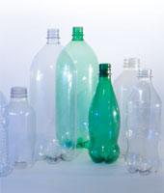
Stephanie R. Kinnon www.alive.com/6612a17a2.php?subject_bread_cramb=182 –

Instructions

Collect a set of cards. Each card has two statements. One statement on the card points out some good things about plastics, while the other statement points out some not so good things about them.

Your group must decide whether each card should go into the area “For Using Plastics” or into the area “Against Using Plastics”

To do this, each group must discuss both statements on the card and the whole group decide which of the two makes the best case. So be prepared to state your views!

Count the cards in each Area. On balance, is your group for or against using plastics?

Check what other groups have decided for each card. Are their ideas the same as for your group? Can you argue your case to make them change their minds?

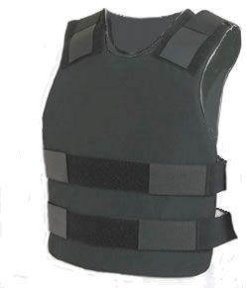
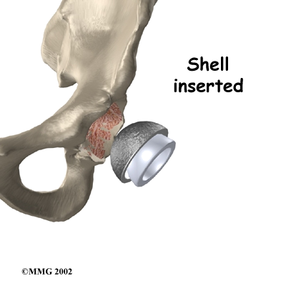
Plastic Fantastic?
www.int-int.biz
orthopedics.about.com
Plastic is light and flexible. It can be easily moulded into different shapes and can be used for lots of useful and necessary things such as Kevlar stab vests and replacement hip joints.
The chemicals used in plastic to make it flexible and colourful leach out. They can harm the environment or animals and humans.

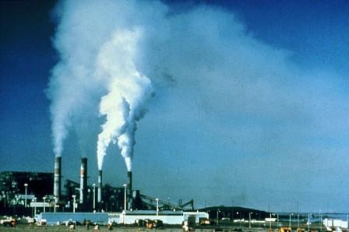
If the temperature is not high enough, incineration of some plastics with possible harmful additives (e.g. metal paints, dyes and chemicals called halogens in flame-retardants and Teflon-like coatings), can produce harmful gases which cause cancer. If the waste is deposited on the land, the chemicals can get into plants and animals and then into humans.
www.hongkonglogue.com
Plastics can be burned. Incineration would decrease the amount of plastic waste. The energy produced when they burn could be used to fuel power stations for our electricity. Some plastics are entirely hydrocarbons, which would be no better or worse for the environment than burning heating oil or gas.

A Burning Issue?

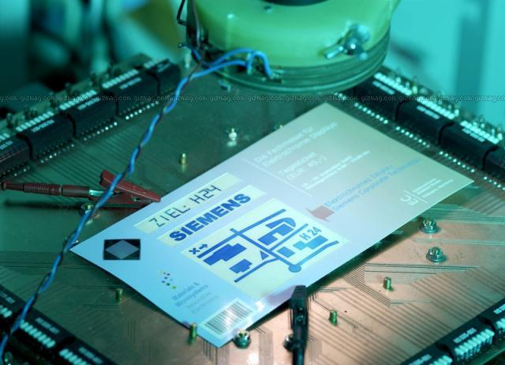
Plastic is easy to make and shape which makes it a highly desirable material of construction. Think of where we use it at home, in the electronics of iPods and Wii consoles, in our cars, in leisure wear and equipment etc and you will see we cannot do without it. In the future, advances in modern plastics will make our lives and leisure time even more exciting.
Toxic chemicals are sometimes used when some special plastics are being made so there are safety issues for the workers.

These chemicals are also bad for the environment so there are problems in disposal of any waste. Special treatment is required which is expensive.

www.dimagemaker.com
Today’s “Must Haves”?

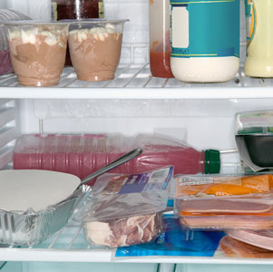
Plastic preserves flavour and freshness when used to store food and drinks.
Plastic packaging is good at preventing items getting damaged while being transported, and plastic containers are good for storing things in at home.
www.plasticsmythbuster.org
Virtually all food packaging materials contain substances that can get into the food they come into contact with, including the plasticisers used in plastic food wrap and to soften the plastic used to make the containers.

It’s a Cover Up!



Don’t Talk Rot!
www.islex.com.au
Plastic is cheap and durable. It doesn't rust or corrode or rot in any form, or melt at room temperature.

By replacing natural materials such as wood and metals they are saving natural resources.

Most plastics won’t rot so don’t not go away… ever. Poly bags blow around our streets. Beaches are littered with plastic. A "plastic soup" of 100 million tons of waste twice the size of the United States is floating in the Pacific Ocean. Animals die from choking on bags and from eating plastic waste. Sea mammals and birds get tangled in old rope and nets and die.

www.rsc.org
Plastics are light and so reduce aircraft weight. The aircraft use less fuel and fly farther and faster so we have cheap holidays in far away exotic places

With cheap flights more people fly so actually more fuel is used. More oil is needed to make the fuel so it is being used up faster.
Aircraft add to Global Warming and have a huge Carbon Footprint.
Up, Up And Away?

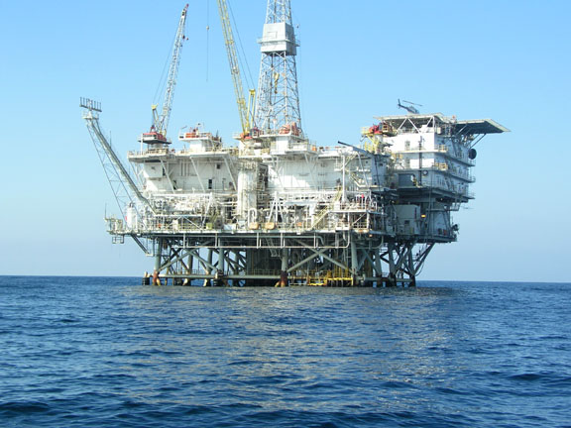
Most plastics are made from chemicals obtained from oil. Oil is a valuable fuel energy source. America uses about one trillion plastics bags each year which uses up about twelve million barrels of oil, so these can’t be used to make fuel.

Oil is running out and can’t be replaced. Paper is made from trees, and forests are a renewable source.

10 to 15% of paper bags but only 1 to 3% of plastic bags are recycled.

kechoil.com

Plastic bags are better than paper ones as it takes more than four times as much energy to make a paper bag as it does to make a plastic bag.
It takes 91% less energy to recycle 500g of plastic than it takes to recycle 500g of paper.
A Question of Energy?

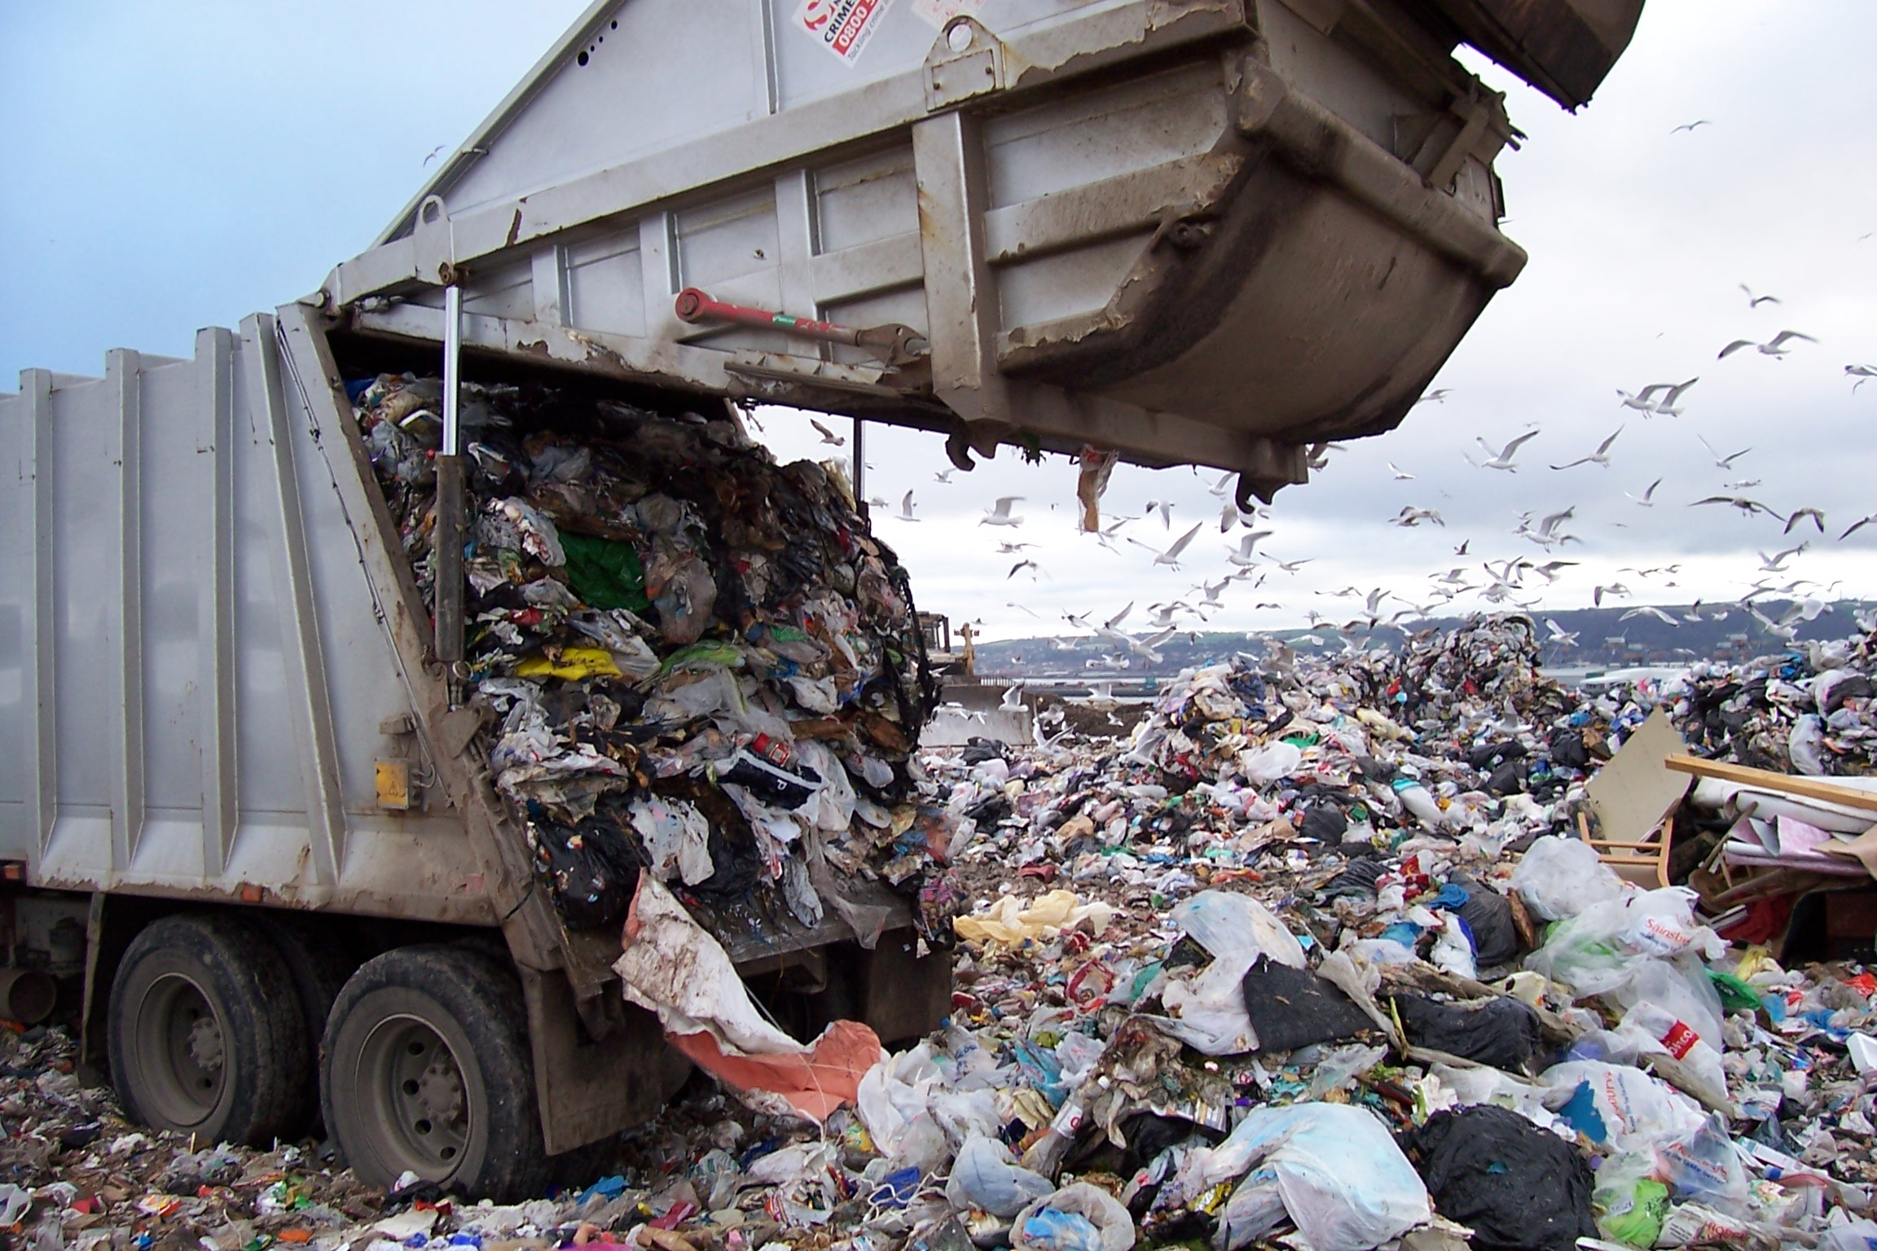
Here Today – Gone Tomorrow?
www.castlereagh.gov.uk
The fact plastics would not rot or rust was seen as being good. Now, however, for plastics which may end up in landfills, this is seen as bad. Plastics which will break down when exposed to ultraviolet light are now being developed.

In today's landfills even these modern plastics do not degrade or break down at a fast rate. In fact, nothing completely degrades in modern landfills because of the lack of water, light, oxygen and other important elements that are necessary for the degradation process to be completed.

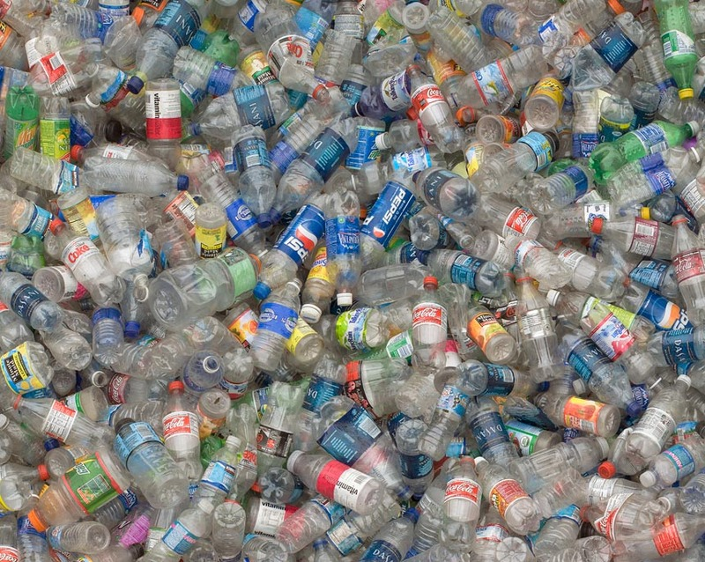
fading-hope.blog-city.com
Depending on the type of plastic, they can be recycled into CD cases, into stuffing for pillows, carpet backing, certain types of sweatshirts, and even ice scrapers.

Each time a plastic is recycled, its quality decreases.

After about five rounds
of recycling, when the lowest quality plastic is obtained, disposal becomes a big problem.

Many polymers can be recycled, but it can be difficult and expensive to separate the different polymers from each other.
Waste Not – Want Not?

Against Using Plastics

For Using Plastics

