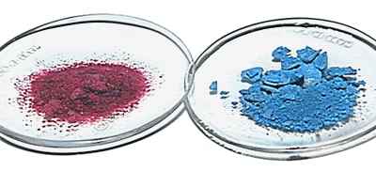

Introduction

Complex ions are composed of a central metal ion surrounded by a cluster of anions or neutral molecules. The anions and molecules bonded to the central cation are called ligands. Every ligand has at least one atom bearing a lone pair of electrons, which can be donated to the central metal ion, forming a co-ordinate bond.

Owing to the precise positions of ligands in complex ions, isomerism can occur in six co-ordinated complexes. Isomers are compounds with different arrangements of their constituent atoms, but who have the exact same molecular formula. Isomerism is an important feature of transition metal chemistry and strongly influences the properties of complex ions.

In this project a classical series of cobalt complexes is synthesised and experiments conducted to demonstrate both geometric and linkage isomerism in octahedral complexes. This project allows the illustration of several features of transition metal chemistry such as chelation, ligand exchange, relating structure to colour, and the analysis of complexes by IR-spectroscopy.

Cobalt Complex Synthesis

Theory
The hexaammino cobalt III complex ion can be easily prepared from cobaltous chloride with concentrated ammonia solution serving as a ligand source. The following reaction occurs;
The hydrogen peroxide is added as an oxidising agent, although a much slower reaction could be carried out using atmospheric oxygen instead. The percentage yield of [Co(NH₃)₆]Cl₃ is calculated and its melting point determined.

Procedure
- 9.2g of CoCl₂ and approximately 6g of NH₄Cl was added to 10 cm³ of water in a conical flask. 1g of decolourising charcoal was added and the solution was then heated until boiling.
- The solution was removed from the heat source, followed with the addition of 20cm³ of concentrated ammonia solution.
- Using an ice bath, the mixture was cooled and 20cm3 of 6% H₂O₂ was then slowly poured in.
- The mixture was heated to 60°C for 15 to 20 minutes, until the pink colour of the solution was removed, and was then cooled in an ice bath for a further 5 to 10 minutes.
- The solid produced was then filtered through a buchner funnel and collected.
- The isolated solid was added to boiling solution consisting of 3cm³ concentrated HCI and 8 cm³ of water.
- The solution was boiled until all but the charcoal had dissolved. The hot suspension was filtered through a buchner funnel, and 10 cm³ of concentrated HCI was added to the filtrate.
- The solution was allowed to cool in an ice bath.
- The crystals formed were isolated by a buchner filtration and dried by air.

Safety Measures
Goggles and gloves were worn at all times. Use of fume cupboard during preparation to avoid toxic ammonia. Precaution taken with addition of concentrated HCI, NH₃, and H₂O_{2.}

Results
The crystals formed were yellow/orange and shape was of small, hexagonal-oblong nature.

Theoretical crystals are rose red and monoclinic.
Decomposition of complex obtained at 213 ⁰C
Theoretical decomposition obtained at 215 ± 1ºC

1 mole of CoCl₂ 6H₂O YIELDS 1 mole of [Co(NH₃)₆]Cl₃

Percentage yield of [Co(NH₃)₆]Cl₃ = (actual mass/theoretical mass) x 100
= (5.909 / 10.3 ) x 100
= 57.1 %

Errors
The main error in this experiment occurs when some of the substance is lost during transfer from container to container. This was minimised as far as possible. Weighing and melting point errors minimised by weighing by difference and using accurate balancing and melting point apparatus. Other error could have occurred in the presumption that pink colour had disappeared during oxidation (presence of charcoal made it difficult to be certain).
Analysis – Calculate Percentage of Cobalt by Titration

Theory
The percentage of cobalt present in the complex [Co(NH₃)₆]Cl₃
Can be calculated through titration, using the equation below;

Procedure

- 1.02g of the compound was weighed to the nearest milligram, and then dissolved in 25cm³ of 4M NaOH.
- The solution was boiled until the evolution of ammonia had ceased. This was determined by holding damp pH paper above the boiling solution until it turned green rather than dark blue.
- 1g of potassium iodide was added to the cobalt III oxide suspension and was acidified with concentrated HCI. The acidity was checked with pH paper.
- The solution was titrated with a standard sodium thiosulphate solution until the end-point was approached. Starch was added and the titration continued drop by drop until the colour changed from bright blue to colourless.

Safety Measures
Precaution taken when dealing with all substances. Use of gloves and goggles required.

Results
Mass of [Co(NH₃)₆]Cl₃ used = 1.02 g
Titre of sodium thiosulphate solution = 32.4 cm³
Moles of sodium thiosulphate solution used = 0.00324
From equation:

Ratio is 1:1 moles of Co³⁺ = 0.00324
Thus, mass of cobalt in the complex – 0.19 g
Percentage of Cobalt in complex = (0.19 / 1.02) x 100
= 18.7 %

Theoretical percentage of cobalt in complex is 22%

Errors
Sources of error in initially weighing complex and then in titrating the solution i.e. reaching and judging the end-point. Errors minimised using an accurate balance and by using starch as an indicator.

Discussion

The crystals formed did not appear to be monoclinic as anticipated, therefore some slides of the crystals were prepared. The slides showed hexagonal, oblong shapes, indicating that the crystals were in fact monoclinic but small. Sizes of crystals are dependant on the rate of cooling, perhaps explaining the small size of crystals. The smaller size of the crystals could explain the inaccurate colour as the colour of a crystal can be dependant on its size.

At the oxidation stage of the experiment in which the pink colour of the solution should disappear, the pink colour remained. In solution cobalt (II) salts are pink, the colour being due to the presence of [Co(H₂O₂ )₆]²⁺. The remaining pink colour could indicate that the oxidising to cobalt (III) salts. This could result in the formation of a different complex than intended, thus explaining the incorrect size and colour of crystals, and the inaccurate value for the percentage of cobalt in the complex. It could also explain why the yield of the complex is low. The unreactive oxidation stage could be a result of the H₂O₂ solution, used as an oxidising agent, being out of date (H₂O₂ is thermodynamically unstable with respect to oxygen and water).

Porous decolourising charcoal is important in reactions involving Co-N bonding, and is used to ensure the correct complex is obtained. If the charcoal was not present then the complex [Co(NH₃)₅C1]C1₃ would be formed. The intended complex should absorb both green and blue from the visible spectrum to give “rose” red crystals. However the yellow colour of the crystals formed suggest that only blue is being absorbed from the visible spectrum. It can be drawn from this that not all the ligands are fully replaced i.e. the complex [Co(NH₃)₅C1]C1₃ This can again explain the inaccurate crystals produced.

Nearing the end of the experiment, after the filtration of the hot suspension, and the filtrate was collected, what appeared to be bright red/orange monoclinic crystals formed on top of the filter paper. Perhaps the suspension had cooled down too much before being filtered and the correct crystals had formed on the filter paper?
Therefore a small experiment was conducted to collect these crystals and compare them to the actual crystals obtained through IR-spectroscopy. The spectra (shown on pages 14 and 15) eliminate this possibility, as the two samples have near identical peaks, indicating the same compounds.

Geometric Isomerism

The term geometrical is generally employed when two compounds of different properties are found to have identical formulae. Cis – trans or geometrical isomerism is a type of stereoisomerism, in which the isomers have different positions of groups with respect to a central atom. The term cis entails the ligands occupying adjacent co-ordination positions, whilts the term trans means ligands occupying opposite positions.

Although most ligands are unidentate i.e. can only form one co-ordinate bond, in some cases each ligand molecule or anion can form more than one link with metal ion. These are called polydentate ligands. Complex ions formed between polydentate ligands and cations are known as chelates.

The following experiment demonstrates the conversation between geometrical isomers and also introduces chelation, both being properties characteristic of complex ions.

Synthesis

Theory
The six waters of crystallisation in CoCl₂.6H₂O can be replaced by three molecules of ethylenediamine, following a very simple ligand exchange reaction. As before the cobalt is oxidised from Co (II) to Co (III) but this time through using atmospheric oxygen as an oxidising reagent.
The trans form of dichloro-bis-(1,2-diaminoethane) cobalt (III) chloride can be converted to the thermodynamically more stable cis form by repeated evaporations of an ethanol solution.

The percentage yield of compound was calculated and IR-spectra were taken of both cis and trans products.

Procedure
- Approximately 16 g (16.008g) of cobaltous chloride (CoCl₂.6H₂O) was dissolved in 50 cm³ of water in a 250 ml buchner flask.
- Slowly , in a fume cupboard, and with stirring, 60 cm³ of a 10% solution of 1,2-diaminoethane was added.
- Air was drawn through the solution by connecting the buchner flask to a water pump and by sealing the flask with a stopper, which had a hollow piece of glass tubing through the centre of it. This was left overnight i.e. for 14 to 15 hours.
- 35 cm³ of concentrated HCI was added to the solution which was then transferred to an evaporating basin.
- Using a steam bath the solvent was evaporated until a thin green crust formed on the surface of the solution. The solution was then cooled and left overnight.
- The crystals of [CoCl₂(en)₂]Cl.HCl were washed with ethanol and petroleum ether in a buchner funnel, and were then dried in an oven heated to 110ºC, producing the trans isomer [Co Cl₂ (en)₂]Cl, where (en) = 2,3-iaminoethane.
- Converting to cis form involved taking half of the sample and dissolving it in a neutral 50% aqueous solution of ethanol.
- The solution was evaporated to dryness and repeated once more. A distinct colour change from green to blue was apparent although some green material remaining was washed off with a little cold water.

Safety Measures
Always use hand and eye protection. Extra caution taken with ethanol, petroleum ether and 1,2-diaminoethane as highly flammable. Ethylenediamine and concentrated HCI are both corrosive, so extra care taken.

Results
[CoCl₂(NH₂CH₂CH₂NH₂) _{2]}⁺Cl⁻ - trans crystals obtained were in a form of a dull green powder.
[CoCl₂(NH₂CH₂CH₂NH₂) _{2]}⁺Cl⁻ - cis crystals obtained were blue/violet.

Melting point of trans crystal obtained at 210⁰C
Theoretical melting point of trans crystal 213⁰C±1⁰C
Melting point of cis crystal obtained at 215⁰C
Theoretical melting point of cis crystal 217⁰C±1⁰C

1 mole CoCl₂.6H₂O YIELDS 1 MOLE [CoCl₂(en) ₂]Cl
237.9 g 285.5g
16.01 g 19.21 g

Percentage yield of [CoCl₂(en) ₂]Cl₃ = (actual mass/theoretical mass) x 100
= (14.48/ 19.21) x 100
= 75.38%

The IR Spectroscopy of the cis isomer is more complex than that of the trans isomer. This is interpreted more fully in the discussion. Both IR spectra are shown on pages 16 and 17.

Errors
The principal source of error was in transferring the compound from container to container. This was minimised as far as possible. Other weighing errors were minimised using an accurate balance.

Discussion
On the whole the synthesis of the complexes were a relatively straightforward procedure. Both cis and trans isomers were accurate in appearance, in melting point and had a good yield. This indicates that the experiment was carried out with a minimum amount of errors.
Infrared spectroscopy is useful in detecting the presence of functional groups from their characteristic vibrational frequencies. The IR spectra show that although the formulae of the isomers are the same, their structures are not. It can be seen that the IR of the cis isomer is more complex than the trans isomer. This is on grounds of symmetry. The trans isomer has simpler symmetry; this is due to the functional groups involved in the ligands bonding to the central atom being exactly equivalent, therefore only one signal is given, thus only one peak is given ( at and around 3433.5cm⁻¹), as opposed to the cis isomers two peaks ( cis does not have same simple symmetry). Generally, the trans isomer has a simpler IR due to its simpler symmetry i.e.

Trans form Cis form

The presence of 2,3-diaminoethane (ethylenediamine) can be correlated on both IR spectra (region shown on right of both graphs). This indicates that the same ligands are present. However, the difference shown in the N-H stretching region (shown at left of both graphs) indicates the different ligand bonding as expected in cis-trans isomerism.
Linkage isomerism

Other types of isomerism can occur among complexes. Linkage isomerism takes place when ligands can co-ordinate through one or other alternative atoms.
The case of linkage isomerism in the following experiment allows an illustration of a more detailed analysis of an IR spectroscopy, whilst also displaying another type of isomerism which occurs in cobalt complexes.

Synthesis

Theory
The complex [Co(NO₂)(NH₃)₅]Cl₂ can exist in two isomeric forms i.e. Co-No₂ and Co-ONO, referred to as nitro- and nitrito- penta- amminecobalt (III) chlorides. Both compounds are prepared from [Co(NO₂)(NH₃)₅]Cl₂

As before the products were examined by infrared spectroscopy and yields and melting points taken. As an extension the products were also examined by observation of the thermal arrangement of the isomers of the more and less stable forms simply by heating.

Procedure
- Initally the nitropenta-amminecobalt (III) chloride was prepared by dissolving. 2.96 g of chloropenta-amminecobalt (III) chloride in a warm mixture of 18 cm³ of 2M NH₃ (aq) and 18 cm³ of water.
- The solution was filtered, and allowed to cool,
- 2M of HCI was added until the solution was just acid to litmus.
- 3.5 g of sodium nitrite was added and the mixture heated until the red precipitate formed had dissolved.
- This was followed by the very slow addition of 36 cm³ of concentrated HCI, although accompanied by rapid stirring. This was cooled in an ice bath until yellow/brown crystals had formed.
- These were removed by filtration, washed with ethanol on the filter and allowed to dry by air.

Nitritopenta-amminecobalt (III) chloride was then prepared.
- 3.03 g of the chloropenta amminecobalt (III) chloride was dissolved in a warm mixture of 50 cm³ of water and 11 cm³ of concentrated aqueous ammonia.
- The solution was filtered and the solution was neutralised to litmus with 2M HCI.
- 3 g of sodium nitrite was added along with an equivolume mixture of concentrated HCI and water (3cm³).
- Over two hours, an orange precipitate slowly formed which was then collected by filtration.
- It was washed with ice cold water, then with alcohol, and dried in air.

Safety Measures
Toxic chemicals such as sodium nitrite, concentrated NH₃ and HCI, and ethanol require use of gloves and goggles. Avoid inhalation and ingestion with these chemicals. Cobalt complexes should be treated as irritants. Ethanol is flammable, therefore avoid naked flames.

Results
Deep orange [Co(NH₃)₅(ONO)]Cl₂ crystals obtained agree with theoretical crystals.
Yellow/brown [Co(NH₃)₅(ONO)]Cl₂ crystals obtained agree with theoretical crystals.

Melting point of [Co(NH₃)₅(ONO)]Cl₂ obtained at 107ºC
Theoretical melting point of [Co(NH₃)₅(ONO)]Cl₂ 110^{O}C±1^{O}C
Melting point of [Co(NH₃)₅(ONO)]Cl₂ obtained at 144ºC
Theoretical melting point of [Co(NH₃)₅(ONO)]Cl₂ 150ºC ±1ºC

1 mole [Co(NH₃)₅Cl]Cl₂ YIELDS 1 mole [Co(NH₃)₅(ONO)]Cl₂
182.4g 260.9
3.03g 4.33 g

Percentage yield of [Co(NH₃)₅(ONO)]Cl₂ = actual mass/theoretical mass) x 100
= (2.92 / 4.33) x 100
= 67.4 %

1 mole [Co(NH₃)₅Cl]Cl₂ YIELDS 1 mole [Co(NH₃)₅(NO₂)]Cl₂
182.4g 260.9
2.96g 4.23g

Percentage yield of [Co(NH₃)₅(NO₂)]Cl₂ = (actual mass/theoretical mass) x 100
= (2.61/4.23) x 100
= 61.7%

IR spectra taken of nitro- and nitro- penta- amminecobalt (III) chlorides can be seen on pages 18 and 19. The observations of the thermal arrangements concerning the stability’s of the complexes shall be discussed in the discussion section.

Errors
Margin of error accounted for in the transfer of substances from containers and minimised as much as possible. Accurate balances were used for minimising weighing errors.

Discussion

Once again the actual synthesis of the complexes caused a few problems; the products were accurate in appearance and had good yields. This indicated that the procedure was carried out correctly and with a minimal amount of errors. However, the melting points of the compounds indicated that they were slightly contaminated by being lower than the theoretical values.
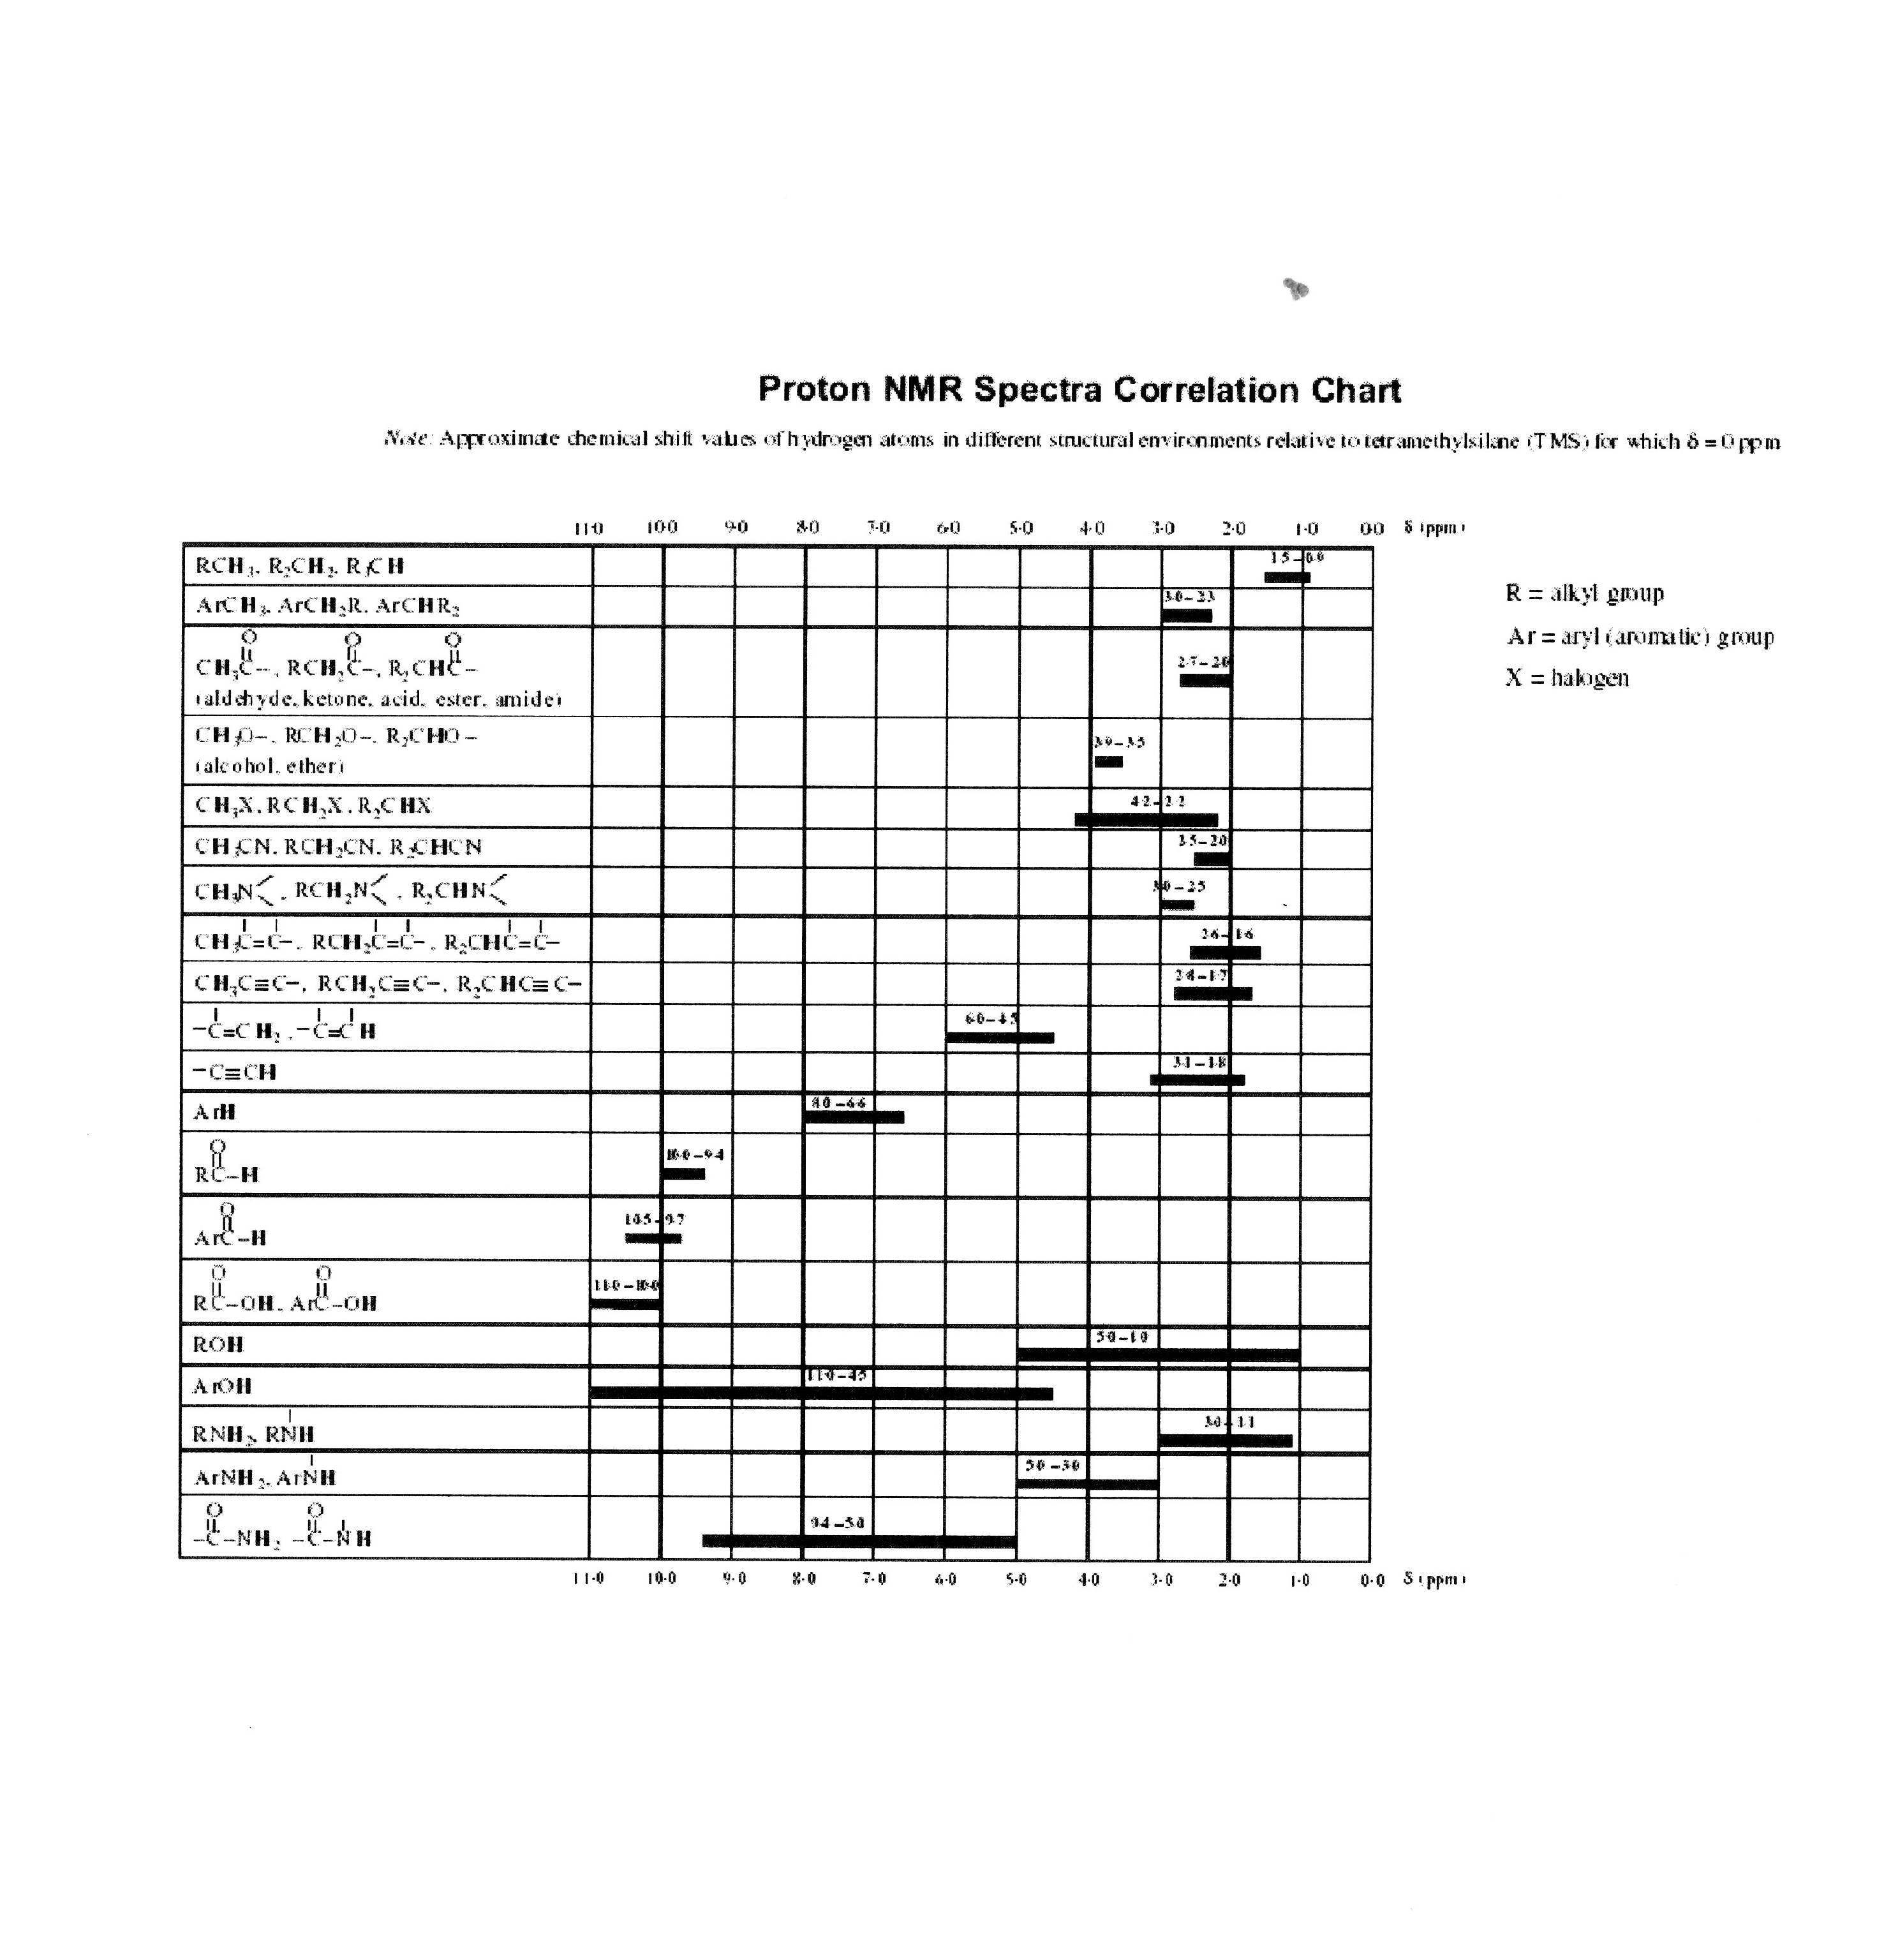
The IR spectra provide evidence of the isomeric nitrito form (Co-O-N-O), being in equilibrium with the nitro (Co-NO₂) compound, with the equilibrium lying much nearer the nitro compound than the nitrito. This can be interpreted from the IR spectroscopy, using the following correlation table.

The table shows that there is a stretching vibration for the nitrito compound between 1050 cm⁻¹ to 1070 cm⁻¹. Looking at the IR spectra we see that the nitrito, which is mainly an O-bound species, has a strong signal at 1068.6 cm⁻¹. when this nitrito compound was heated at 120 ºC for two hours, another IR spectroscopy was taken (shown on page 20). This indicated that the intensity of the nitrito peak had deceased , suggesting that some O-bound i.e. nitrito (Co-O-N-O) had gone. On heating the nitrito compound it could also be seen that the compound had changed in appearance to the colour of the nitro compound. The IR spectroscope taken also proved that the heated nitrito compound was almost exactly the same as the nitro compound (differences can be accounted for on grounds of background contaminants).

This information suggested that the O-bound nitrito, which had appeared to decrease in intensity, had converted to N-bound nitro

The nitro compound’s IR spectroscopy similarly showed an O-bound peak but only for a small signal, this indicated the nitro having some O-bound species in it. Heating this compound at 120ºC for two hours made no difference to the compound at all (IR spectroscopy shown on page 21)
Overall, all this information verifies that equilibrium exists between these compounds but that N-bound i.e the nitro compound is favoured.

Summary

The geometrical isomerism experiment allows the illustration of cis-trans isomerism, ligand exchange reactions and chelation whilst the linkage isomerism synthesis allows discussion of further features concerning cobalt complexes I.e the existence of equilibrium between isomers. All experiments permit the demonstration of how useful IR spectroscopy analysis is in establishing different types of hypothesis.

Further Work

If time allows, ideally, synthesise, illustrate and discuss optical isomerism. This would have given a greater insight into complex ion isomerism.

Deduce the structure of the complexes through the use of UV spectroscopy and through experiments fulfilling magnetic moments i.e techniques such as nuclear magnetic resonance and the Gouy method.

However due to lack of time and equipment and access to University facilities, these may prove impossible.

