
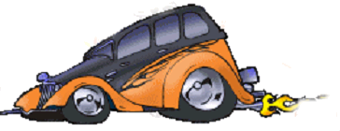
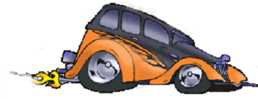
Image from http://artie.com/
Image from http://artie.com/
Car Challenge

A chemical reaction between solutions is being used here to stop a model car moving. Your challenge is to investigate what you could change when you mix the solutions that would change the distance the car moves.

What’s going on here?

You will mix two colourless solutions. They stay colourless for a while before suddenly turning dark blue.

Why?

One solution contains two chemicals called potassium iodide and sodium thiosulphate. The other solution contains potassium persulphate and starch. Potassium iodide will react with potassium persulphate to form another chemical called iodine. Normally this will react with the starch to immediately give a dark blue compound. However, the sodium thiosulphate gets there first and reacts with the newly formed iodine to turn it back into iodide. These reactions keep happening until all the sodium thiosulphate has been used up. With no more sodium thiosulphate, the iodine is free to react with the starch and we then see the solution turn a dark blue.

How can it stop the car moving?

The motor in the car is powered by a battery connected to a light sensor. When light falls on the sensor, the battery is connected to the motor and the car moves. When no light reaches the sensor then the battery is not connected and the car stops.

The chemical reaction is carried out in a beaker placed over the light sensor. When the two colourless solutions are mixed in the beaker, light can still pass through the mixture onto the sensor so the car moves. However, when the iodine and the starch react to form the dark blue chemical, the light is blocked and the car stops.

You must now think about what you could change when you mix the solutions that would change the distance the car moves.

Part 1

Planning Sheet
(Keep this to help you write your report)

Names:

What needs to be measured to show that the reaction is happening faster?

The conditions we can change are

Now discuss your answers with your teacher before you go on to Part 2 over the page.

Part 2 Now split your team into two groups. Each group will investigate one of the variables you decided on. After the experiments have been completed you will team up again to discuss both sets of results.

My team will be changing the

To make it a fair experiment we will need to keep these conditions (called variables) the same

Car Challenge
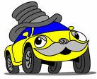
Examine me first. Check you can turn me on and off. Let me run along the race area for about half a metre. Check that covering the light sensor with your hand stops me moving. If you have any problems, please see your teacher.

Variable: Temperature

What you need:

- A bottle filled with potassium persulphate solution, labelled Solution 1.
- A bottles of potassium iodide solution (concentrations 40%)
- A bottle filled with starch solution, labelled Solution 2.
- Some 100 cm³ glass beakers and a 50 cm³ beaker
- Some small 10 cm³ syringes
- Access to water baths at various temperatures
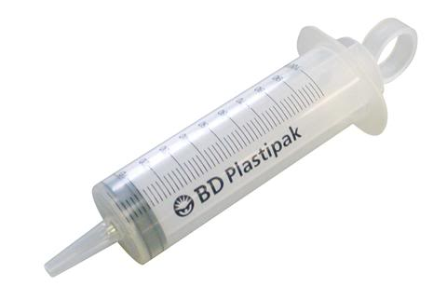
- Safety goggles

What you do:
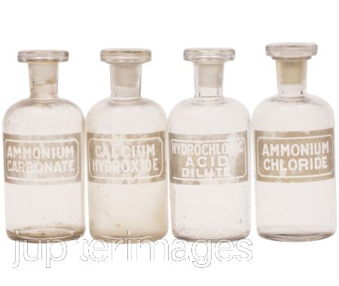
- Pour about 40ml each of Solutions 1 and 2 into separate beakers. (So you can get the syringes in!)

- Measure out 10 cm3 of the potassium persulphate solution using a syringe and place it into the 50 cm3 glass beaker.

- Measure out 10 cm3 of starch solution using a different syringe and place it in the same beaker as the potassium persulphate.

- Place the beaker in a water bath to come up to temperature

Turn Over/..........

- Now measure out 10 cm3 of the 40% potassium iodide solution using a third syringe but do not add it to the beaker yet. Put it in a test tube and place in the same water bath as the previous mixture and wait for it to come up to temperature.

- When you are satisfied that both solutions are at the right temperature

    - Place the car at the start of the race area (line up the rear of the car with the 0 cm line).
    - Remove the beaker from the water bath, dry the outside and put it into the holder on the top of the car, over the LDR. Push firmly down to make sure it is in.
    - Add the potassium iodide solution and at the same time start the car.

- Follow the car until it stops and make a note the distance it has moved (use the back of the car as your marker).

- Empty out the beaker and rinse it with distilled water. Dry the beaker.

- Repeat steps 1-7 twice more and calculate the average distance the car moved.

- Now repeat the whole experiment using the other temperatures you have decided on.

- Complete the record sheets for the experiment.

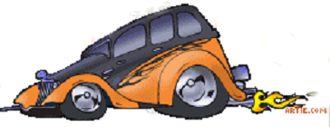

http://artie.com/

Car Challenge

Examine me first. Check you can turn me on and off. Let me run along the race area for about half a metre. Check that covering the light sensor with your hand stops me moving. If you have any problems, please see your teacher.

Variable: Concentration

What you need:

- A bottle filled with potassium persulphate solution, labelled Solution 1.
- 4 bottles of potassium iodide solution (concentrations 20%, 40%, 50% and 60%)
- A bottle filled with starch solution, labelled Solution 2.
- 3 x 100 cm3 glass beakers and a 50 cm3 beaker
- 3 x small 10 cm3 syringes
- A 50ml measuring cylinder
- Safety goggles

What you do:
- Pour about 40ml each of Solutions 1 and 2 into separate beakers. (So you can get the syringes in!)

- Measure out 10 cm3 of the potassium persulphate solution using a syringe and place it into the 50 cm3 glass beaker.

- Measure out 10 cm3 of starch solution using a different syringe and place it in the same beaker as the potassium persulphate.

Turn Over/..........

- Now measure out 10 cm3 of the 20% potassium iodide solution using a third syringe but do not add it to the beaker yet.

- Place the beaker in the holder on top of the car, over the LDR. Push firmly down to make sure it is in.

- Place the car at the start of the race area (line up the rear of the car with the 0 cm line).

- Add the potassium iodide to the beaker and at the same time start the car by pushing the car’s ‘on’ button.

- Follow the car until it stops and make a note the distance it has moved (use the back of the car as your marker).

- Empty out the beaker and rinse it with distilled water. Dry the beaker.

- Repeat steps 1-7 twice more and calculate the average distance the car moved.

- Now repeat the whole experiment using each of the other potassium iodide solutions in turn.

- Complete the record sheets for the experiment.

- When you are making up the extra solution of potassium iodide, use the 50 cm3 measuring cylinder, the wash bottle of deionised water and one of the 100 cm3 beakers

http://artie.com/

First Report Sheet

Investigating Team names

Our Tasks:

Our Results:

Now team up with the other group and pool your results. Collect the sheets called ‘Final Report Sheet’ and complete all parts. (You will need to get the results from the other group to help you do this).

Final Report Sheet
Concentration Results:

Concentration | Average distance  the car moved

A Graph of our Results

Average distance the car moved
(m)

Concentration (%)

What you must do now:

Predict from the graph the distance the car would have travelled of you had used a 30% solution of potassium iodide.

Write this down here: m

What you must do next:

Make a 30% solution of potassium iodide from a solution you already have by diluting it with water. You will need enough solution to test the car three times as before.

Which solution will you use?

How much water will you need to add?

Test your solution and prediction by carrying out the experiment and recording your results below:

Concentration | Distance 1  (m) | Distance 2  (m) | Distance 3  (m) | Average  distance (m)
30%
potassium iodide

Difference between predicted distance =
and distance actually moved

Temperature Results:

Temperature | Average distance  the car moved

A Graph of our Results

Average distance the car moved
(m)

Temperature (⁰C)
Now discuss the following questions.
You will need to look at the two graphs to help you.

Q 1. What did you find to be the ‘best’ temperature?

Q 2. What did you find to be the ‘best’ concentration?

Q 3. What reaction conditions would you therefore recommend?

Q 4. What things may have affected how accurate you were able to do the experiment?

Q 5. If you do the experiment again, how could you improve it?

