Technician’s Guide
Antioxidants

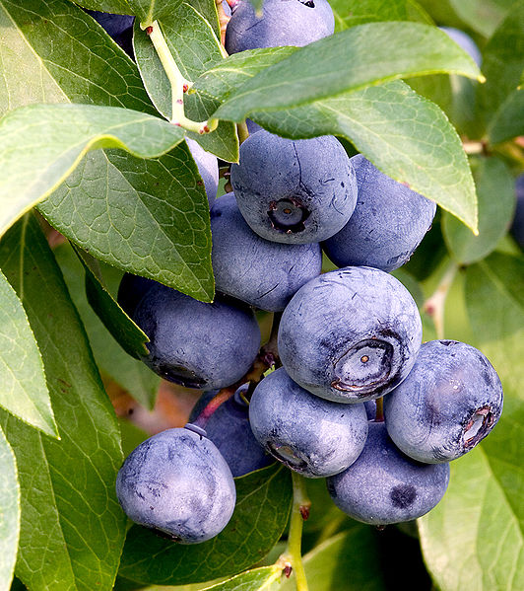
Antioxidants Technician Sheet
Apparatus (per group)
1 x Apple
Lemon juice
Samples of fruit / veg or other antioxidant sources
Eye protection – indirect vent goggles
Gloves (latex free)
Bench cover/ mat
Top pan balance
1 x Waste disposal bottle 250 cm³
Mortar & Pestle
2 x 250 cm³ beaker
1 x Stirring Rod
Filter paper
Filter Funnel
100 cm³ plastic sample bottles as required
4 x 100 cm³ glass beaker
3 cm³ Pasteur Pipettes as required
3 x 10 cm³ Syringes
Timer
Magnetic Stirrer (or stirring rod)
50 cm³ 0.2 M potassium iodate and 0.07 M sulphuric acid (solution A)
50 cm³ 0.15 M malonic acid and 0.02 M manganese sulphate (solution B)
50 cm³ 4 M hydrogen peroxide (Solution C)
Distilled water

*The following recipe assumes 5 groups per class of 20 pupils*

Preparation of potassium iodate and sulphuric acid (250 cm³)
Dissolve 10.75 g of potassium iodate (oxidizing and harmful) into 200 cm³ of distilled water and add 1.08 cm³ (1.99g) concentrated sulphuric acid (corrosive). Make up to 250 cm³ and use a magnetic stirrer on a gentle heat setting until dissolved.
Place into 5 bottles and label with harmful pictograms.

Preparation of malonic acid and manganese sulphate (250 cm³)
Take 0.25g of starch* and mix with distilled water to make a slurry. Boil distilled water and pour in the slurry until it has completely dissolved.
Dissolve 4.0 g of malonic acid (harmful) and 0.85 g of manganese sulphate (harmful) into 100 cm³ of distilled water. Add the starch solution and make up to 250 cm³ with distilled water.
Place into 5 bottles and label with harmful pictograms.

Preparation of hydrogen peroxide (250cm³)
Pipette 75 cm³ of 100 vol hydrogen peroxide (corrosive & powerful oxidizing agent) into a measuring flask and make up to 250 cm³ with distilled water.
Place into 5 bottles and label with harmful pictograms.

Disposal of waste
In a fume cupboard, slowly add solid sodium thiosulphate (irritant) to the waste. Wait until the iodine molecules (blue/ black) turn into iodide ions (colourless) and dispose of down the sink with excess water. Beware that this reaction is exothermic.

* Some previous versions of this recipe suggested 2.5g. It Turns out that starch seems to be somehow involved in the reaction rather than just an indicator. Having more starch in actually delays the appearance of the blue colour until several oscillations have taken place – up to a minute or more.

Step 1 | Step 2 | Step 3 |  | Step 4
List Significant hazards here: | Who might be harmed and how? | What are you already doing? | What further action is needed? | Action by whom? | Action by when? | Done
Potassium iodate is harmful, irritant & powerful oxidizing agent | Technician, teacher by inhalation and splashes  Antioxidants - Risk Assessment | See SSERC Hazchem  Avoid breathing in any dust  Wear indirect vent goggles  If spilt on skin, wash off with copious amounts of water  Wear gloves  Keep away from combustible materials
Concentrated sulphuric acid is very corrosive | Technician, teacher by inhalation and splashes | See SSERC Hazchem
Malonic acid | Technician, teacher by inhalation and splashes | Avoid breathing in any dust  Wear indirect vent goggles (BSN 1663)  If spilt on skin, wash off with copious amounts of water  Wear gloves
Manganese sulphate is harmful | Technician, teacher by inhalation and splashes | Avoid breathing in any dust  Wear indirect vent goggles (BSN 1663)  Wear gloves
Starch | Technician, teacher by inhalation | Avoid breathing in any dust
Foods & drinks | Teacher, pupil | Awareness of food allergies  Wear gloves and wash hands after use
Solutions A, B & C | Teacher and pupil by splashes | Wear indirect vent goggles (BNS 1663)  Wear gloves  If spilt on skin, wash off with copious amounts of water
Hydrogen peroxide 100 volume is corrosive & powerful oxidizing agent | Technician, teacher by inhalation and splashes | See SSERC Hazchem  Use indirect vent goggles (BSN 1663)  Wear gloves  If spilt on skin, wash off with copious amounts of water
Hydrogen peroxide 30 volume is irritant | Technician, teacher & pupils by splashes | See SSERC Hazchem  Use indirect vent goggles (BSN 1663)  Wear gloves  If spilt on skin, wash off with copious amounts of water
Sodium thiosulphate is irritant | Technician, teacher by inhalation and splashes | Avoid breathing in any dust  Wear indirect vent goggles (BSN 1663)  Wear gloves

Description of activity:
Preparing superfood solution samples by crushing and diluting with distilled water.
Determining levels of antioxidants by mixing solutions A, B & C, then adding sample solutions and recording the time interval between the colour cycle of colourless to amber to blue.
Waste is collected in the disposal bottle and then disposed of as described in the additional comments.
Additional comments:
Disposal of waste will be exothermic, especially in large quantities. Wear indirect vent goggles (BS EN 1663) and gloves and complete procedure in fume cupboard. Once the solution remains colourless dispose down the sink with excess water.

