Teacher’s guide
Antioxidants

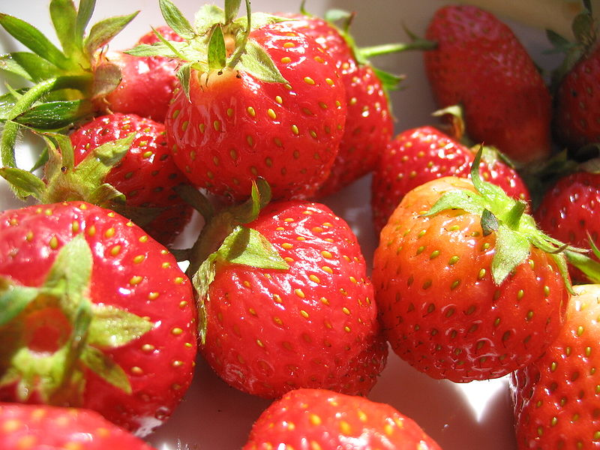
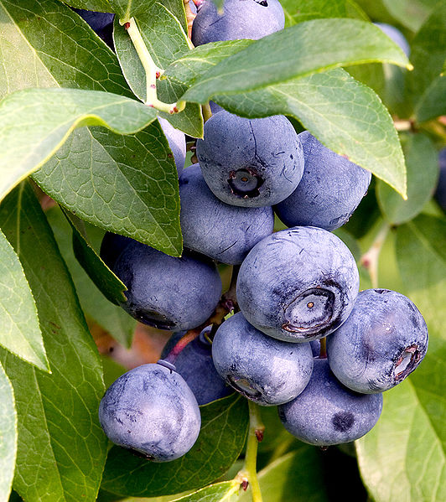
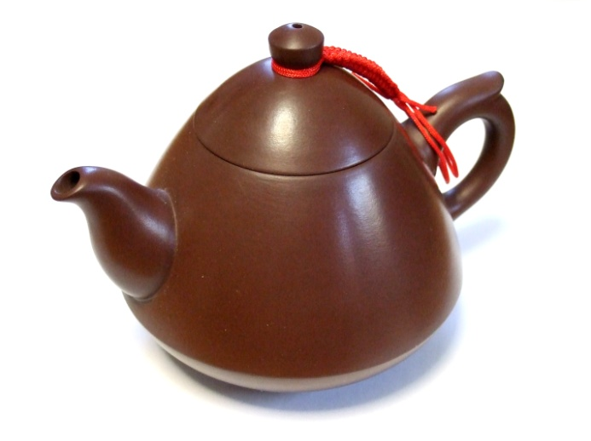
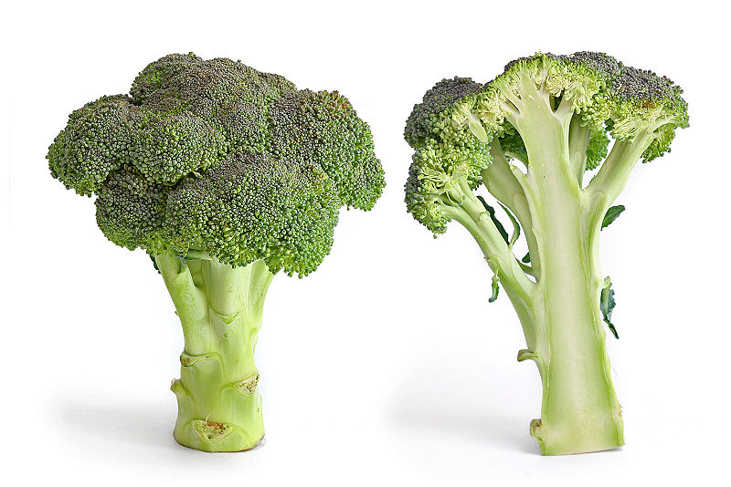
Overview
Studies involving 230.000 men and women across the UK have shown that there is no convincing proof that antioxidants have any effect on how long people can live. However 40% of women and 30% of men are reportedly taking these supplements and spending over £333 million on them per year.
By using an oscillating chemical reaction which has a vivid colour change from colourless to amber to a sudden dark blue this practical investigation can engage pupils in research and discussion of media items with regard to the so called “superfoods" in healthy diets and their subsequent impact on modern life. [1]
Curriculum links
This activity can be pitched at a variety of levels depending on how much detail is gone into about the reaction or about antioxidants. Some of the places in the curriculum that we think it fits are:

CfE
SCN 3-17b - I can participate in practical activities to extract useful substances from natural resources.
SCN 3-20a - I have collaborated with others to find and present information on how scientists from Scotland and beyond have contributed to innovative research and development.
SCN 3-20b – Through research and discussion, I have contributed to evaluations of media items with regard to scientific content and ethical implications.
SCN 4-20a - have researched new developments in science and can explain how their current or future applications might impact on modern life.
SCN 4-16a - I have carried out research into novel materials and can begin to explain the scientific basis of their properties and discuss the possible impacts they may have on society.

Higher (CfE)
Nature’s Chemistry 6) Oxidation of Food
It is also one of the Researching Chemistry units

Advanced Higher
We have come across pupils using this in their Advanced higher projects.
(It could possibly also be used in the National 5 section on rates of reaction)

Introduction
The imbalance between free radicals and antioxidants can lead to disease and ill health. The 4 main non-enzymatic antioxidants metalonin, α-tocopherol (Vitamin E), ascorbic acid (Vitamin C) and β-carotene (precursor for Vitamin A) can be found in a range of foods in our diet. However medical opinions are divided as regards the impact these antioxidants have our on general health.

Melatonin
This is a hormone which helps to regulate sleep in our bodies. This compound can be termed as a terminal or suicidal antioxidant as once it has removed the free radicals it has to be replaced.

α-tocopherol
This is a form of vitamin E and can be found in vegetable oil, nuts and seeds. It has been suggested that it is good for the skin.

Ascorbic Acid
This is also known as Vitamin C and is commonly found in fruits and vegetables. It is one of the essential vitamins and the human body is unable to synthesize it. It can be easily oxidised and acts as a hydroxyl or superoxide anion radical scavenger.

β-carotene
This is a precursor to vitamin A. It is a highly red-orange pigment found in plants and fruits. In particular it gives carrots their orange colour. It helps human cells to absorb vitamin A.

Briggs-Rauscher Reaction
This hybrid of the Bray-Liebhafski and Belousov-Zhabotinsky reactions was developed by Thomas S. Briggs and Warren C. Rauscher [2] of Galileo High School, San Francisco as an oscillating chemical reaction.
In general terms the reaction is very complex and involves iodide ions and iodine molecules. It is thought that the colourless solution arises when I₂ is low and I– is high; it is yellow when I₂ is high and I– is low; and blue when I₂ and I⁻ concentrations are high (when both are high they form pentaiodide ions which give the blue complex with starch). The changes in the relative concentrations of the I₂ and I⁻ are brought about by the species HOI. As its concentration rises and falls, it triggers oscillations in the I– and I₂ concentrations.
Thus using this reaction it is possible to determine the level of antioxidants present in everyday foods/ drinks by measuring the time difference between the oscillating colour changes of blue to amber to blue.
In basic terms the greater the time interval, the higher the level of antioxidant in the food. [1]
A more in detailed explanation of the reaction is given by B.Z. Shakhashiri [3]. The overall reaction is shown below.
IO₃⁻ + 2H₂O₂ + CH₂(COOH)₂ + H⁺ → ICH(COOH)₂ + 2O₂ + 3H₂O
It is thought that initially that the clear and colourless iodate (IO₃⁻) reacts with the hydrogen peroxide to produce small quantities of iodous acid (HIO₂). This initiates what is called the radical process (1).
IO₃⁻ +2H₂O₂ + H⁺ → HOI + 2O₂ + 2H₂O (1)
There is a rapid increase in the concentration of the iodous acid which can be seen in reactions 2 to 6.
IO₃⁻ + HIO₂ + H⁺ → 2IO₂. + H₂O (2)
Note the formation of the radical (IO₂.).
IO₂. + Mn⁺² + H₂O →HIO₂ + Mn(OH)⁺² (3)
Mn(OH)⁺² + H₂O₂ → Mn⁺² + H₂O + HOO. (4)
2HOO. → H₂O₂ + O₂ (5)
Note that these reactions provide a mechanism for the radical (IO₂.) to be reduced to iodous acid (HIO₂₎.
2HIO₂ → IO₃⁻ + HOI + H⁺ (6)
In order to balance out the overall radical process reaction 2 needs to be doubled, 3 and 4 to be quadrupled, 5 to be doubled and 6 to remain the same.
The resulting hypoiodous acid is then reduced by the hydrogen peroxide in the non radical process (12).The increased quantities of the iodide are then consumed in reactions 7 and 8.
I⁻ + HOI + H+ → I₂ + H₂O (7)
I₂ + CH₂(COOH)₂ → ICH(COOH)₂ + H⁺ + I⁻ (8)
As the radical process keeps the concentration of the hypoiodous acid greater than the concentration of the iodide, the reaction turns from clear to amber.
However the rate of the radical process (2) is faster than the rate of non radical process (9 and see later) so the concentration of the iodine, iodide and hypoiodous increases and therefore the rate of 11 in the non radical process is far greater than the autocatalysis of the radical process (2 to 6). This means that the slower non-radical process (10 to 12) is more dominant and halts the faster radical process
The overall non radical process can be seen below.
HOI + CH₂(COOH)₂ → ICH(COOH)₂ + H₂O (9)
This process starts off with the iodide and iodate slowly reacting together to produce the iodous acid (10).
IO₃⁻ + I⁻ + 2H⁺ → HIO₂ + HOI (10)

This in turn is reduced by more iodide to make hypoiodous acid (11).
HIO₂ + I⁻ + H⁺→ 2HOI (11)
This is further reduced by the hydrogen peroxide to make more iodide (12).
HOI + H₂O₂ → I⁻ + O₂ + H⁺ + H₂O (12)
The high concentration of the iodide then allows it to combine with the iodine and starch indicator to form a complex with a blue colour. As the non radical process is much slower the blue colour slowly fades and the colour cycle to begin again.
The iodide produced in 12 cannot be replaced fast enough by the iodide used in 10 and 11 and so the overall concentration of the iodide drops. This in turn slows the rate of 10 to below that of 2 to 6 and so the faster radical process becomes more dominant and the cycle starts again.
Once the concentrations of the malonic acid and iodate reach a critical low value the reaction stops and can be detected by the final deep blue colour and fumes of iodine being seen.
What to do?
Ask the pupils to compose a list of what they think are superfoods, ones rich in antioxidants. Some of the URLs given later can help to re-enforce learning or help highlight any misconceptions. It is likely that some may have seen the adverts for these types of drinks or even tried them.
A common pathway might be:
- Introduction – including apple experiment
- Preparation of fruit / veg samples – perhaps get different groups to try different ones so as to get a wider range across the class.
- Introduction to Briggs-Rauscher reaction
As blueberries will take the longest time a teacher demonstration of this sample could be completed to highlight important steps such as adding the sample after the second blue colour appearance and then left to run whilst the pupils make their own samples and determine the level of antioxidants.
- Pupils carry out tests on their samples.

To gauge level of understanding at beginning or end of the lessons the following active learning strategies could be employed.
- Divide the class into groups and issue each one with different coloured post-its. Give each group a copy of the media items sheet for discussion. Pupils can think, pair and share to generated ideas and then collate them on an A3 sheet.

- The fact or fiction cards can be sorted out accordingly and groups can be used as themes or starting points for further research presentations.

- To conclude you could use the dartboard evaluation either on an individual or group basis. Use a statement to reflect the experience and outcome and get the pupils to place their “dart” in the appropriate zone which gauges their level of understanding.
Allow the pupils to follow the instruction sheets and to complete the results sheets. To generate average times for each sample you could record each group’s time and work out the class average. These can then be plotted on the graph paper found in the pupil results sheet.
1 – Apples
The purpose of this experiment is simply to show the oxidation of fruit on exposure to air and to show that it is possible to prevent this oxidation prevent this.
Apples discolour or turned brown when peeled or bruised and exposed to air. This discolouration or browning is due to oxygen, O2, reacting with chemicals released, breaking down the cells in the fruit. The reaction is called enzymatic oxidation as it is a process catalysed by the enzymes present in the apples.
However, the enzymes are destroyed by certain chemicals (e.g. Vitamin C - Absorbic acid) or by high heat. Vitamin C, being an highly reactive anti-oxidant reacts with the O2 in the air, preventing/slowing down the enzymatic oxidation of the apples.

2 - SSERC SMOOTHIE
Squidging up the various fruit / veg samples to make a ‘smoothie’ that can be tested for antioxidant activity later.
Squashing the samples in small ziplock bags is a tidier alternative to using pestles and mortars but is not essential.
An interesting variant might be to squash the samples and test them separately and then test a mixed sample to see how, the substances interact.

3 – SMART CHEMICALS
This is a run through the Briggs-Rauscher reaction.
It refers to the food / tea samples that are prepared in 4 and 5 but the method can be used for the smoothie ingredients as well.
The reference sample needs to be run first as there can be quite a large variation in the cycling time depending on conditions. It is commonly around 15 – 30s but can be longer.
Beware that the time interval for the 1st colour cycle from colourless to amber to blue will be significantly longer than the 2nd to 3rd.
Once the cycling time has been determined, as soon as the blue colour reappears, add the sample, start the timer and wait for the reappearance of the blue colour
The antioxidant will delay the resumption of the cycling reaction and the length of the delay is related to the amount of antioxidant activity.
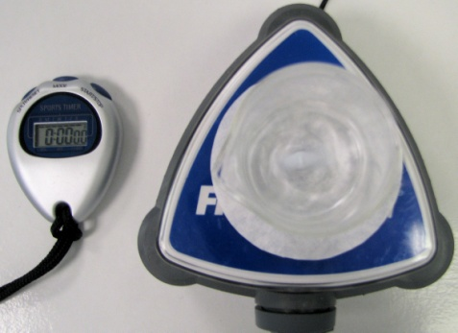
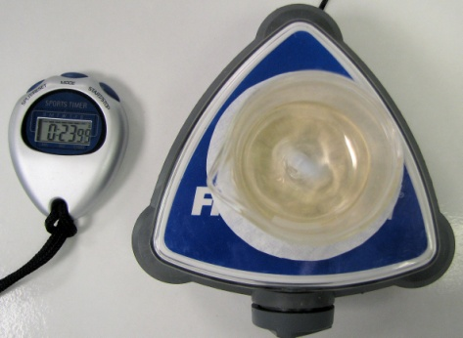
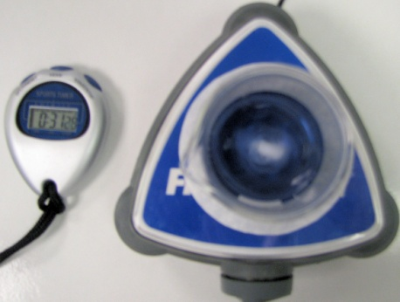
Some substances, blueberries for example, have such a lot of antioxidant activity that they effectively stop the reaction. In this case, a further dilution is needed. In one test here at SSERC the blueberries look over an hour!
Amber
Colourless
Blue

Troubleshooting
If there are insufficient mortar and pestles allow more time when stirring vigorously with distilled water in the 250 cm³ beaker.
If there are insufficient magnetic stirrers, then simply use a stirring rod inside the glass beaker. This will require some team work to co—ordinate the stirring, adding the sample and recording the time.
If pupils are finding that no colour change is occurring within 10 minutes it is most likely that they have added 2 lots of either solution A, B or C. Discard and start again.
If on repeating the test more carefully, it is still taking too long, it is possible that there is simply a very high amount of antioxidant activity. Pupils should dilute their solutions further (10x or possibly more) and try again.
4 – SUPERFOODS
As described above.

Specimen answers for superfoods

Type of Food/ Drink | Time 1 (s) | Time 2 (s) | Time 3 (s) | Ave Time (s)
Blueberries | 289 | 296 | 227 | 271
Cranberry Juice | 99 | 100 | 96 | 98
Raisins | 80 | 85 | 81 | 82
Carrots | 73 | 70 | 77 | 73
Reference Sample | 48 | 62 | 58 | 56
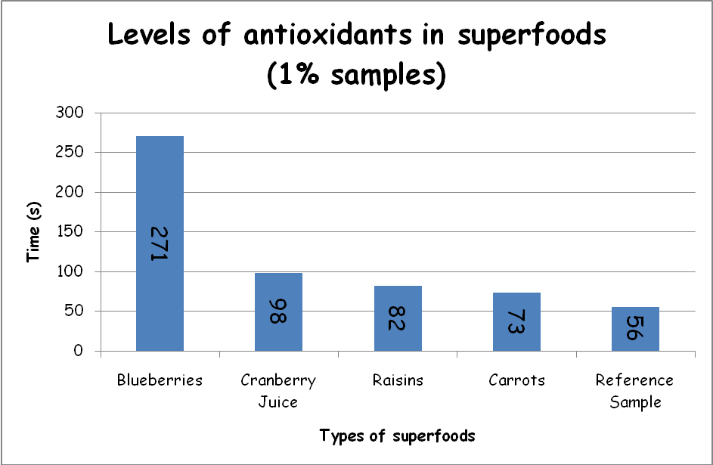
By plotting a bar graph pupils will be able to easily rank the foods in order of levels of antioxidants. Note that it is purely a qualitative not quantitative result that is obtained.
Discussions can be had as to why it has taken significantly longer to complete the colour cycle and indeed why the cycle then returns to its reference sample time interval.
4 – Tea
Determining the level of antioxidants in types of tea leaves can also be done. Note however to complete the reaction for each sample within a class period (53 minutes) you need to weigh 0.01 g of the tea leaves and stir/ brew for 2 minutes in cold distilled water. Then complete the pupil instruction sheet as per normal.
Green teas or any tea high claiming to be high in antioxidants will take considerable longer to complete the colour cycle (between 10 and 20 minutes). You can use this as a demonstration to highlight important steps such as adding the sample after the second blue colour appearance and left running whilst the pupils make their own samples and determine the level of antioxidants.

Specimen answers for tea
Type of Tea | Time 1 (s) | Time 2 (s) | Time 3 (s) | Ave Time (s)
Twinngs Pure Peppermint | 171 | 168 | 168 | 169
Twinngs Classic Traditional English | 132 | 116 | 122 | 123
Tetley Green Tea Lemon | 116 | 102 | 102 | 107
Tetley Tea | 98 | 103 | 95 | 99
Tetley Peppermint Punch | 83 | 83 | 87 | 84
Twinngs Pure Camomile | 86 | 84 | 80 | 83
Twinngs Aromatic Earl Grey | 80 | 77 | 79 | 79
Twinngs Assam | 67 | 75 | 72 | 71
Tetley Sweet Cranberry | 66 | 69 | 68 | 68
Reference Sample | 40 | 45 | 49 | 45
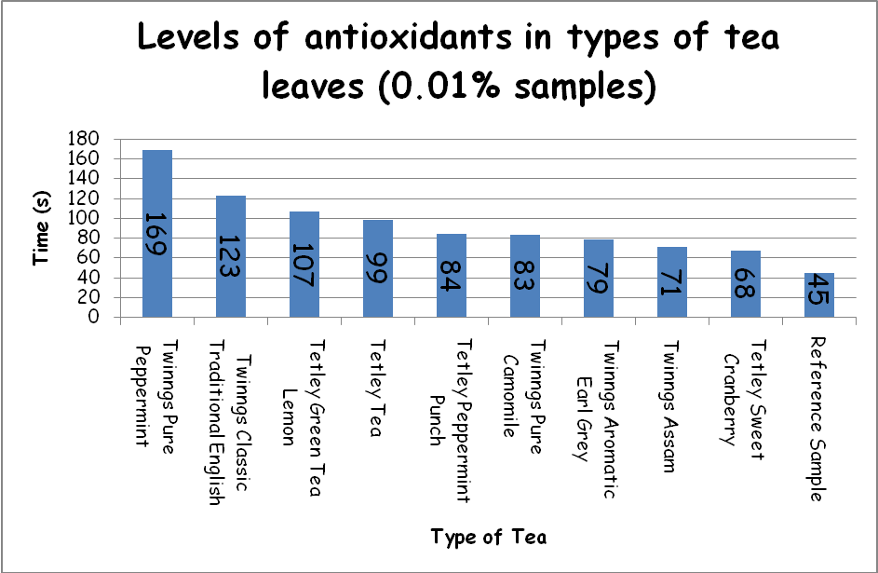
As before, discussions can be had as to why it has taken significantly longer to complete the colour cycle and indeed why the cycle then returns to its reference sample time interval.

Sample Sources
The list below will give some of idea of which samples may contain a range of the 4 antioxidants being tested. It is not exhaustive and not all have been tested for timing between the blue colour appearances.
Small red beans (dried), red kidney beans, pinto beans, cranberries, artichokes, blackberries, prunes, raspberries, strawberries, Red Delicious apples, Granny Smith apples, pecans, sweet cherries, black plums, Russet potatoes, black beans (dried), plums or Gala apples.
In the table below is a list of samples that are rich in each type of antioxidant.
Type of antioxidant | Sample
β-carotene | Carrots, sweet potatoes, pumpkin, apricots, mangoes, spinach, kale
α-tocopherol (vitamin E) | Almonds, mangoes, broccoli, wheat germ oil, soybean oil
Ascorbic acid (vitamin C) | Fruits and their juices, beef, poultry, fish and cereals
Vitamin A | Sweet potatoes, mozzarella cheese, milk, egg yolks

NOTE
Be aware of food allergies and issues with raw meats, poultry and fish.

Other Resources
http://www.youtube.com/watch?v=s3lX67swZWk
This video is 2 minutes long explaining how free radicals can damage cells and uses a cut apple as a demonstration.
http://www.youtube.com/watch?v=T_Xo5AaTH8U
This video is just over a minute long and gives a light hearted approach to explaining how free radicals are formed by using a group a people eating dessert at the dinner table as a demonstration.
http://www.youtube.com/watch?v=fTBz9ipkWhE
This video is 4 ½ minutes long which gives a more detailed explanation of how radicals are formed, lifestyles that encourage their formation and how antioxidants help to remove the free radicals. It does mention oxidative stress and oxygen radical absorbency testing (ORAC) and places examples of fruits or vegetables in order of their ORAC ranking (their ability to remove free radicals).
www.youtube.com/watch?v=yNsCU-_V0oM
This video is about 5 minutes long showing the preparation, the actual visual changes of the oscillating reaction and finally how to dispose the product mixture. Text does accompany the video.
http://www.scienceinschool.org/2009/issue13/antioxidants
This link provides further reading on how a tutor and his students were able to detect the levels of antioxidants found in food and drink samples.

Materials & Suppliers
Food and drinks can be obtained from local supermarkets.

References
- www.scienceinschool.org/2009/issue13/antioxidants
- T.S. Briggs and W.C. Rauscher, J. Chem. Educ., 1973, 50, 496.
- B.Z. Shakhashiri, Chemical Demonstrations: A Handbook for Teachers of Chemistry, Volume 2, Wisconsin, US, The University of Wisconsin Press, 1985, pp. 248-256

