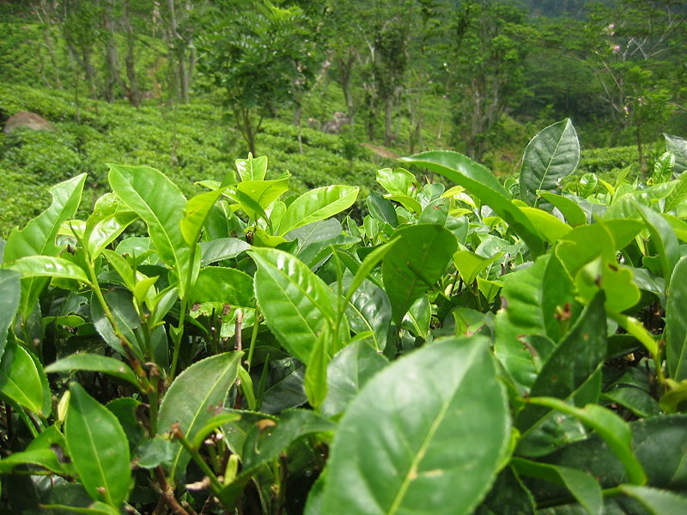
Antioxidants

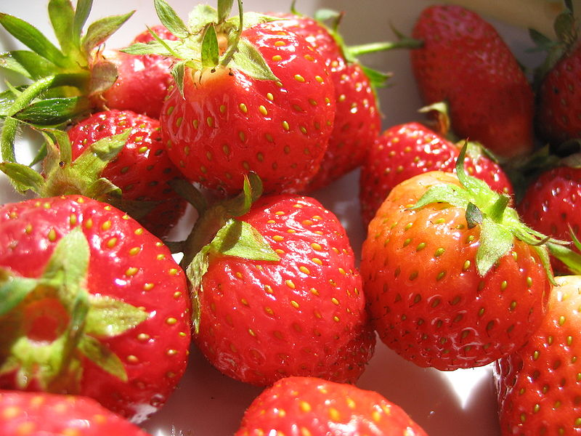
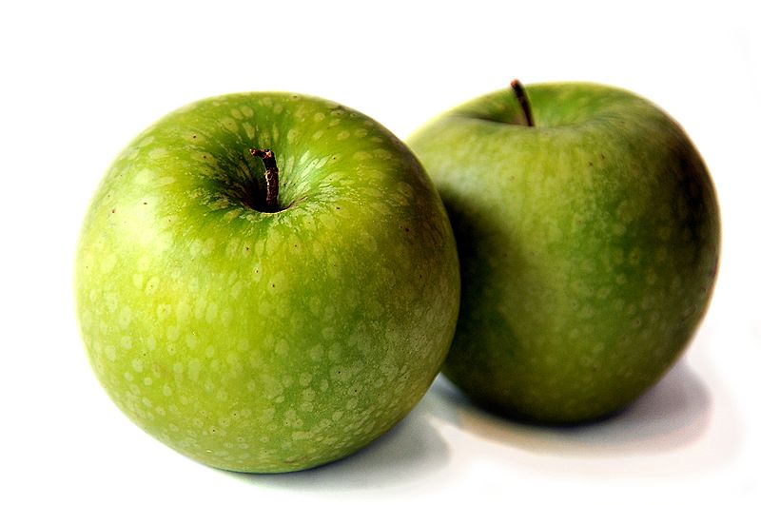
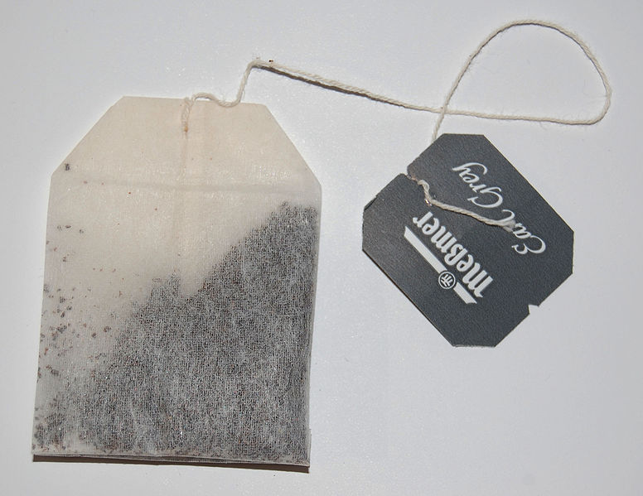
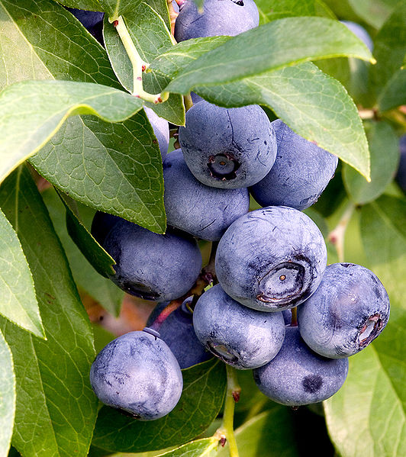
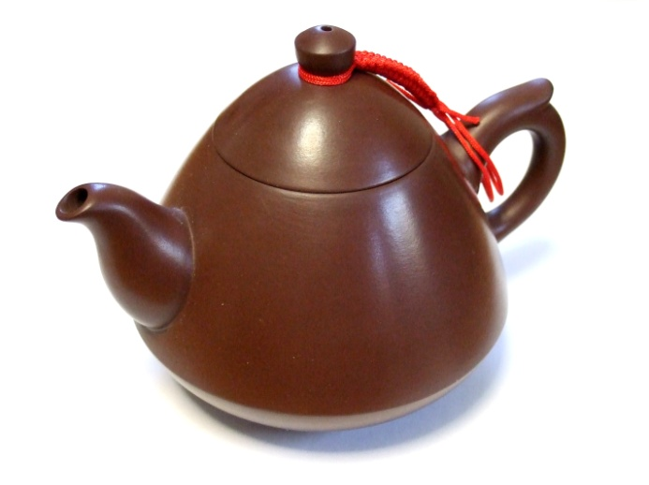

NAME :
1 - Apples

Apparatus you will need
Sharp knife | Heat proof mat | 100 cm³ glass beaker
Stirring rod | Tongs

Chemicals you will use
25 cm³ of Solution A | Red apple x 1

What you will do
- Pour 25 cm³ of Solution A into the glass beaker.
- Place the apple onto the heat proof mat and with the knife divide it into quarters.
- Carefully place 1 of the quarters into the beaker containing Solution A and another on a paper towel.
- Using the stirring rod carefully swirl the quarter around the inside of the beaker.
- Using the tongs remove the quarter from the beaker and place it onto the paper towel along side the other one.
- After approximately 5 minutes compare the quarters.
EATING the apples will break the lab rules!
2 - SSERC SMOOTHIE

Apparatus you will need
Zip lock bag x 2 | Tea strainer x 2
Stirring rod x 2 | Plastic cup x 4
Spoon x 2

Chemicals you will use
Bottled water x 2 | Berries as required

What you will do
- Carefully place all the berries into the zip lock bag making sure there is little or no air trapped inside.
- Carefully squidge the berries inside the bag with your fingers. The stirring rod may help to flatten the harder berries.
- Open the bag and pour the contents into a plastic cup.
- With a spoon, stir in 100 cm³ of bottled water to the contents of the cup.
- Using the tea strainer, filter the smoothie into the remaining cup.

The smoothie is ready for testing.

There will be a chance to drink some later.

3 - Smart Chemicals

Apparatus you will need
5 cm³ syringe x 3 | 100 cm³ glass beaker x 4
3 cm³ Pasteur pipette | Timer

Chemicals you will use
25 cm³ of Solution A | 25 cm³ of Solution B | 25 cm³ of Solution C
Distilled water (as required) | Premade food/tea samples (as required)
What you will do
- Using a syringe place 5 cm³ of solution A into a 100cm³ beaker.
- Using the 2nd syringe add 5 cm³ of solution B to the beaker and place on top of the magnetic stirrer.
- Turn on the stirrer and using the 3rd syringe, add 5 cm³ of solution C to the beaker.
- Record the time from the start of the 2nd to the start of the 3rd blue colour appearance. This is your reference sample time.
- With a clean beaker, now repeat steps 1 to 3.
- Shake the sample bottle and with a Pasteur pipette get 1.5 cm³ of sample ready for adding the beaker.
- Using a syringe add 5 cm³ of solution C to the beaker and turn on the stirrer.
- Wait for the blue colour to reappear for the 2nd time, add the food sample in the Pasteur pipette and start the timer.
- Wait for the blue colour to reappear and record the time taken.
- Empty the contents of the beaker into the waste disposal bottle.
- Now repeat steps 5 to 10 for the other samples.
4 - Superfoods

Preparation of the food/ drink sample
- Weigh 1 g of sample on a top pan balance and place into the mortar & pestle.

- Crush the sample and using 100 cm³ of distilled water transfer the sample into a 250 cm³ beaker and stir vigorously for 2 – 4 minutes.

- Filter off excess solid and pour into a plastic sample bottle.
NOTE - For any drink sample 1 cm³ = 1 g

Determining the level of antioxidant
- Place a bench mat on the bench to prevent any iodine solution staining the work surface.

- Place a blank piece of filter paper on top of the magnetic stirrer.

- Using a syringe place 5 cm³ of solution A into a 100cm³ beaker.

- Using the 2nd syringe add 5 cm³ of solution B to the beaker and place on top of the magnetic stirrer.

- Turn on the stirrer and using the 3rd syringe, add 5 cm³ of solution C to the beaker. Be aware that the time interval for the 1st colour cycle from colourless to amber to blue will be significantly longer than the 2nd to 3rd.

- Record the time from the start of the 2nd to the start of the 3rd blue colour appearance. This is your reference sample time.

- With a clean beaker, now repeat steps 3 and 4.

- Shake the sample bottle and with a Pasteur pipette get 1.5 cm³ of sample ready for adding to the beaker.

- Using a syringe add 5 cm³ of solution C to the beaker and turn on the stirrer.

- Wait for the blue colour to reappear for the 2nd time, add the food sample in the Pasteur pipette and start the timer.

- Wait for the blue colour to appear and record the time taken.

- Empty the contents of the beaker into the waste disposal bottle.

- Repeat steps 7 – 12 for the other samples.

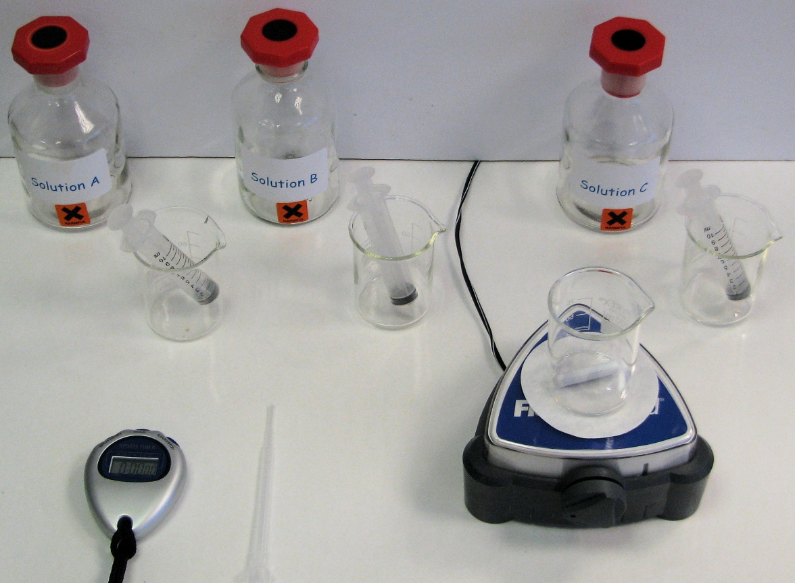
Apparatus

The colour cycle
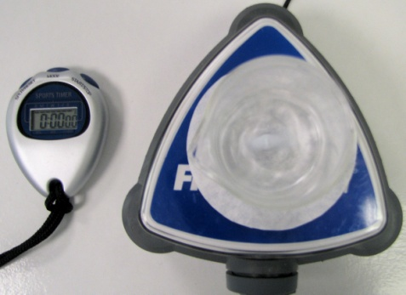
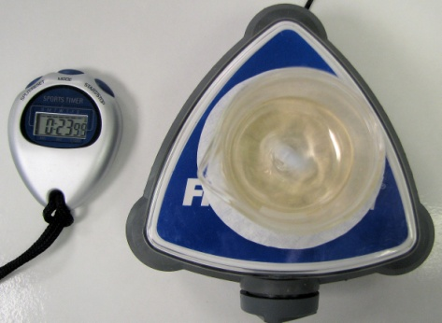
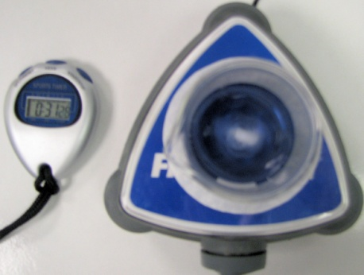
Amber
Colourless
Blue

Recording antioxidant levels
Food | Group 1 Time (s) | Group 2 Time (s) | Group 3 Time (s) | Group 4 Time (s) | Group 5 Time (s) | Ave Time (s)

Reference Sample

NOTE
Average time = time 1 + time 2 + time 3 + . . .
Number of groups
- Compare the average times and list which foods/ drinks had highest levels of antioxidants.

- Did any of the samples give surprising results? Discuss.


Now plot food types against time.
5 - TEA

Preparation of the tea leaf sample
- Weigh 0.01 g of the tea leaves on a top pan balance.
- Using 100 cm³ of distilled water transfer the sample into a 250 cm³ beaker and stir vigorously for 1 minute and allow “brewing” for another minute.
- Filter off excess solid and pour into a plastic sample bottle.

Determining the level of antioxidant
- Place a bench mat on the bench to prevent any iodine solution staining the work surface.
- Place blank piece of filter paper on top of the magnetic stirrer.
- Using a syringe place 5 cm³ of solution A into a 100cm³ beaker.
- Using the 2nd syringe add 5 cm³ of solution B to the beaker and place on top of the magnetic stirrer.
- Turn on the stirrer and using the 3rd syringe, add 5 cm³ of solution C to the beaker. Be aware that the time interval for the 1st colour cycle of colourless to amber to blue will be significantly longer than the 2nd to 2rd.
- Record the time from the start of the 2nd to start of the 3rd blue colour appearance. This is your reference sample time.
- With a clean beaker, now repeat steps 3 and 4.
- Shake the sample bottle and with a Pasteur pipette get 1.5 cm³ of sample ready for adding to the beaker.
- Using a syringe add 5 cm³ of solution C to the beaker and turn on the stirrer.
- Wait for the blue colour to appear for the 2nd time, add the tea leaf sample in the Pasteur pipette and start the timer.
- Wait for the blue colour to appear and record the time taken.
- Empty the contents of the beaker into the waste disposal bottle.
- Repeat steps 7 – 12 for the other samples.

Apparatus
The colour cycle

Amber
Colourless
Blue

Recording antioxidant levels
Food | Group 1 Time (s) | Group 2 Time (s) | Group 3 Time (s) | Group 4 Time (s) | Group 5 Time (s) | Ave Time (s)

Reference Sample

NOTE
Average time = time 1 + time 2 + time 3 + . . .
Number of groups
- Compare the average times and list which type of tea leaves had highest level of antioxidants.

- Did any of the samples give surprising results? Discuss.

Now plot types of tea leaves against time.

