

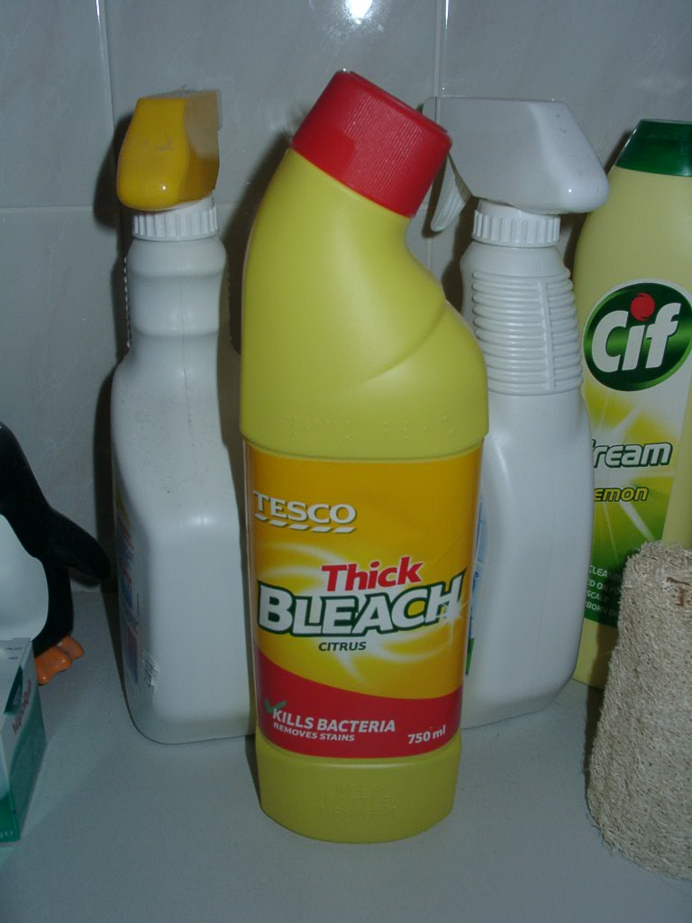

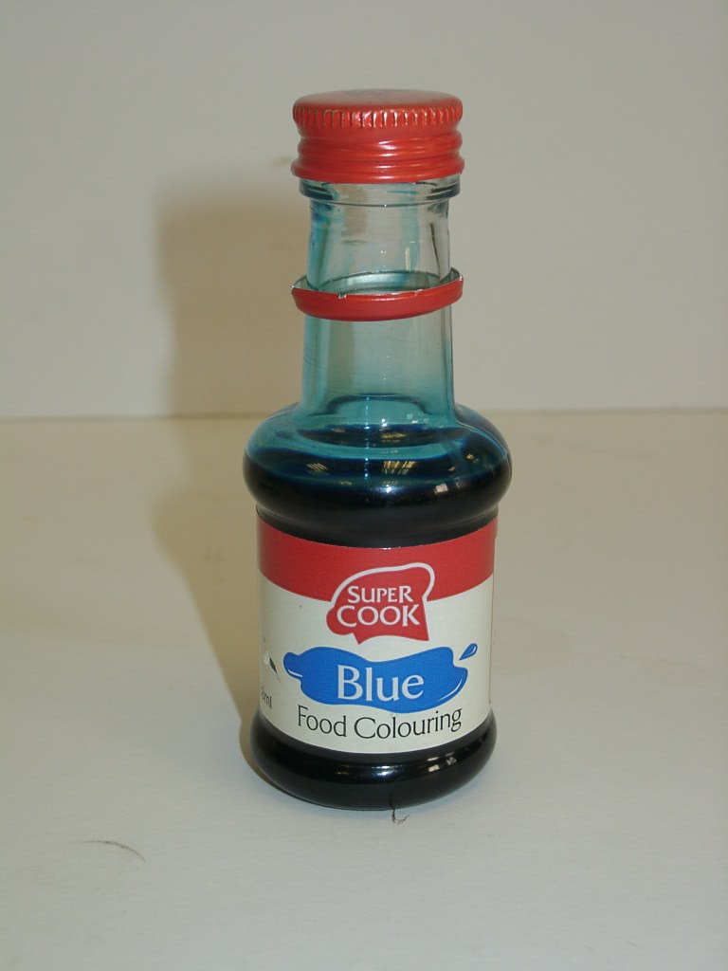

Teacher’s Guide


Advanced Higher Chemistry

The following experiment highlights an experimental method of determining the rate constant and the order of a reaction. It uses the reaction household bleach and blue food colouring.

Most blue food colourants used in cookery Household bleach is an aqueous solution of
contain the dye E133 (brilliant blue) which sodium hypochlorite, 5.25% NaOCl (m/v).
decolourises when oxidised.

In these experiments the household bleach decolourises the solution of blue food dye
within about ten minutes.

The overall rate equation is:

Rate = k [blue dye]ª [bleach]^{b}

The rate of dye decolouration can be followed using a colorimeter, and by applying the Beer-Lambert Law the concentrations of dye can be calculated.

From these results, the rate constant for the reaction (k), and the orders of reaction
(a and b) can be determined.

Exemplar Results
Time / min | Absorbance at 590nm
Time / min | 0.50ml bleach | 0.25ml bleach
0 | 0.84 | 0.84
1 | 0.68 | 0.75
2 | 0.58 | 0.67
3 | 0.46 | 0.62
4 | 0.37 | 0.56
5 | 0.30 | 0.50
6 | 0.25 | 0.45
7 | 0.20 | 0.41
8 | 0.16 | 0.36
9 | 0.13 | 0.33
10 | 0.10 | 0.30

Firstly, calculate the dye concentrations using the Beer-Lambert Law:

Absorbance = l x c x ε

where: l is the distance that the light passes through the solution (1 cm)
c is the concentration of dye
ε is the molar absorption for the blue dye (1.38 x 10⁵ cm⁻¹ mol⁻¹ litre)

Time / min | Concentration of dye ( x 10⁻⁷ moles l⁻¹ )
Time / min | 0.50ml bleach | 0.25ml bleach
0 | 60.87 | 60.87
1 | 49.28 | 54.35
2 | 42.03 | 48.55
3 | 33.33 | 44.93
4 | 26.81 | 40.58
5 | 21.74 | 36.23
6 | 18.12 | 32.61
7 | 14.49 | 29.71
8 | 11.59 | 26.09
9 | 9.42 | 23.91
10 | 7.25 | 21.74

Secondly, calculate the values of log_{n} [blue dye] and 1/[blue dye] for both bleach concentrations.

Time / min | 0.50ml bleach |  | 0.25ml bleach
Time / min | Log_{n} [dye] | 1/[dye] | Log_{n} [dye] | 1/[dye]
0 | -12.00936 | 164286 | -12.00936 | 164286
1 | -12.22067 | 202941 | -12.12269 | 184000
2 | -12.37974 | 237931 | -12.23549 | 205970
3 | -12.61154 | 300000 | -12.31304 | 222580
4 | -12.82926 | 372972 | -12.41483 | 246428
5 | -13.03898 | 460000 | -12.52816 | 276000
6 | -13.22130 | 552000 | -12.63352 | 306666
7 | -13.44445 | 690000 | -12.72661 | 336585
8 | -13.66759 | 862500 | -12.85666 | 383333
9 | -13.87523 | 1061538 | -12.94367 | 418182
10 | -14.13759 | 1380000 | -13.03898 | 460000

Finally, plot log_{n} [blue dye] versus time, and 1/[blue dye] versus time for both bleach concentrations.

Graph 1: log_{n} [dye] versus time for 0.50ml bleach.

log_{n} [dye]

Graph 2 1/[dye] versus time for 0.50ml bleach.

1/[dye]

Graph 3: log_{n} [dye] versus time for 0.25ml bleach.

log_{n} [dye]

Graph 4: 1/[dye] versus time for 0.25ml bleach.

Straight line in red to show graph is not linear

1/[dye]

If the reaction is first order with respect to the blue dye, then

rate = k_{obs} [blue dye]¹

where k_{obs} is the observed rate constant.

The integrated form of this equation is

log_{n} [blue dye] = - k_{obs}t + log_{n} [blue dye]_{o}

where t = time, and [blue dye]_{o} is the initial concentration of blue dye.

So plotting log_{n} [blue dye] versus time gives a straight line with a slope of - k_{obs}

If the reaction is second order with respect to the blue dye, then

rate = k_{obs} [blue dye]²

where k_{obs} is the observed rate constant.

The integrated form of this equation is

1/[blue dye] = k_{obs}t + 1/[blue dye]_{o}

where t = time, and [blue dye]_{o} is the initial concentration of blue dye.

So plotting 1/[blue dye] versus time gives a straight line with a slope of + k_{obs}

Calculation of Values

As the graph of log_{n} [blue dye] versus time is the linear graph with each concentration, the reaction is first order with respect to the blue dye.

The value of k_{obs} for each trial can be calculated from each linear graph.

The overall rate equation for the reaction between bleach and the blue dye is:

Rate = k [dye]ª [bleach]^{b}

In the two experiments the concentration of dye was kept constant, but the concentration of bleach was changed. Since the rate of reaction is halved when the concentration of bleach is halved, the reaction is first order with respect to the bleach.

It is assumed that the household bleach is 5.25% (m/v) sodium hypochlorite, giving a concentration of 0.705 mol l⁻¹. So 0.5ml of bleach in 10ml blue dye solution gives a concentration of 0.035(3) mol l⁻¹.

The value of k can now be calculated for each experiment and averaged to provide a final value.

