What to do if tracker.jar doesn’t work on your 64 bit computer

Tracker.jar is a fabulous piece of freeware. Unfortunately, some users who had no problems with it in the days of 32 bit computers are now experiencing difficulties. There is a work-around, though whether or not you can use it will depend on what’s already installed on your computer and whether you need administrative privileges on your system to perform certain actions.

Double click on the tracker file. If you get an error message about Java 32 being required (see below), click the Yes, relaunch now button.

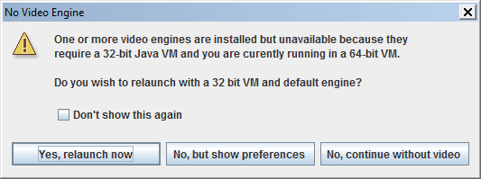

You may then get a message like this:

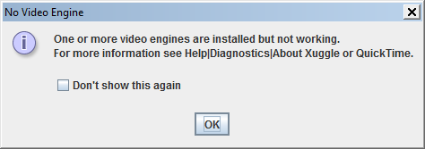

Method 1:

If you can do the following, do it:

Install the .exe version of Tracker. You can find it here: http://www.cabrillo.edu/~dbrown/tracker/

When asked if you want to install Xuggle too, say yes. You should have no problems from now on.

Method 2:

Open the Quicktime folder. It should be in the Program files (x86) folder.

Open the folder QTSystem

Look for a folder called QTJava. It should either have the file extension .zip, or have the Zip folder icon (like an ordinary folder with a zip). If you have difficulty finding it, use the Windows search facility.

Copy this folder (right-click and choose copy).

Open the folder on C: called Program Files (x86)

Open the folder Java

Open the folder jre (might be called jre6 or jre7)

Open the folder lib

Open the folder ext

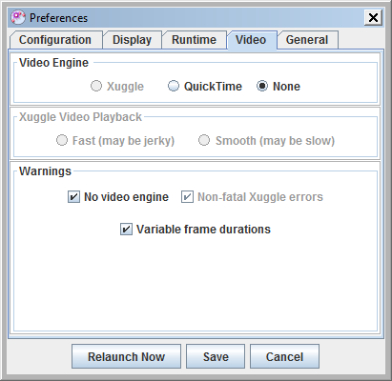
Paste QTJava.zip into this folder. (I needed Administrator privileges to do this).

Restart tracker. If you go to Preferences and click the Video tab, you should see Quicktime selected:
If that makes no difference, close down tracker.

Go to c:

Go to Users

Click on the folder corresponding to your username.

Delete any files with names like .tracker (listed on our PC as a PREFS file).

Relaunch.

If none of that works, convert your movie file to a gif using the likes of
http://image.online-convert.com/convert-to-gif and just click OK when any error messages appear.

