Burglar Alarm Challenge 2

Burglar alarm systems can be more complex if electronics are used. Electronic systems can sense the outside world (input) and act (output).
Inputs can be off or on, shown by a small light being off or on.
Outputs which are ‘on’ are said to ‘give out a 1’ (written as ‘1’) and those which are ‘off’ are said to ‘give out a 0’ (0).
Electronic systems can make decisions on how to act based on input information. These decisions are made by using three gates – NOT, AND and OR.

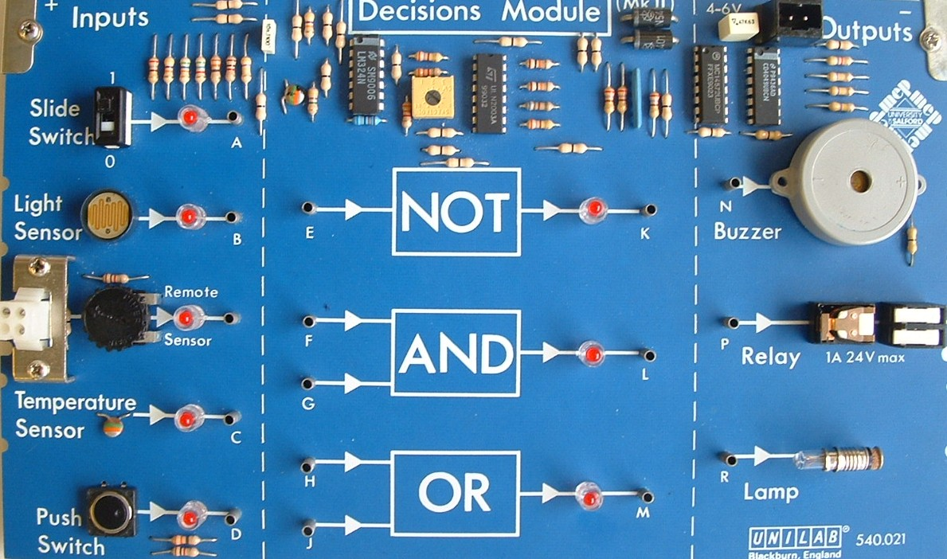
Input
Output
Decision gate

If you put a ‘0’ into the NOT gate, you will get an output (such as a light will go on) but if there is a ‘1’ input, the output will be ‘0’ and the light will be off.
You can build a circuit with two inputs to each of the AND and OR gates. For example, if the slide switch and the push switch are on, then there is an output so an action can take place. This could be the buzzer sounding.
Table: Summary of Decision gates
Input | Decision gate | Output
0  1 | NOT | 1  0
0 + 0  0 + 1  1 + 0  1 + 1 | OR | 0  1  1  1
0 . 0  0 . 1  1 . 0  1 . 1 | AND | 0  0  0  1

Your challenge
Miss Taken needs her burglar alarm to make a loud noise if either the door or the window or both are opened when she is not in her room.
How could this be done?
Design and build your circuit and test it to make sure your burglar alarm is suitable for Miss Taken.

