What other information can the bloodstain provide?

There are four possible blood types – A, B, AB and O. Blood typing can be used as a test to exclude a suspect from the investigation. If a suspect has Type O blood but the stain contains Type A blood, then he or she could not have left the bloodstain.

Blood testing kits contain chemicals called anti-A and anti-B serum.
Two different samples of the same blood are taken. Anti-A is then added to sample 1 and Anti-B to sample 2. Each blood sample is checked to see if the red blood cells in it have clumped together. Here are the results for the four blood groups:

 | Blood Sample | Serum added | Effect on blood samples | The blood type  is therefore
Test 1 | Sample 1 | Anti-A | If it clumps | Type A
 | Sample 2 | Anti-B | If it does not clump

 | Blood Sample | Serum added | Effect on blood samples | The blood type  is therefore
Test 2 | Sample 1 | Anti-A | If it does not clump | Type B
 | Sample 2 | Anti-B | If it clumps

 | Blood Sample | Serum added | Effect on blood samples | The blood type  is therefore
Test 3 | Sample 1 | Anti-A | If it clumps | Type AB
 | Sample 2 | Anti-B | If it clumps

 | Blood Sample | Serum added | Effect on blood samples | The blood type  is therefore
Test 4 | Sample 1 | Anti-A | If it does not clump | Type O
 | Sample 2 | Anti-B | If it does not clump

The following pictures shows what clumped and non-clumped blood looks like after being treated with serum.
Turn Over/.....

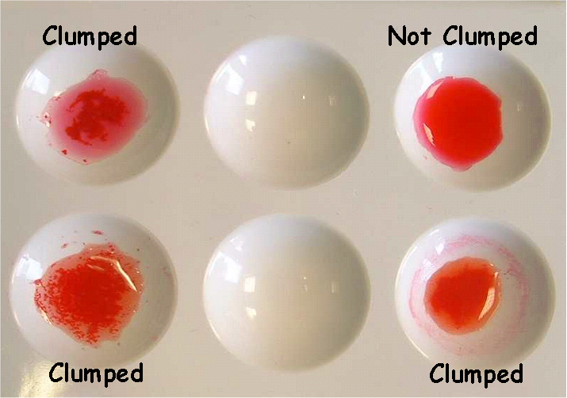

Anti-A Serum + dropper
Anti-B Serum + dropper
Dimple tiles
Sample of blood from crime scene and the suspects
2 mixing sticks colour coded

- Label two wells on the tile, one A and one B.
- Use a dropper to place one drop of a blood sample in these
two wells on the tile.
- Add one drop of anti-A (blue) to the well labelled A. Replace the stopper.
- Add one drop of anti-B to the well labelled B. Replace the stopper.
- Using a different mixing stick for each well (blue for anti-A and yellow for
anti-B), gently stir the blood and serum for 30 seconds. Discard the sticks.
- Observe – if you can see grains or lumps in the mixture then clumping has occurred. (Refer to the picture above and the table over the page).
- Record your results in the table on the ‘Whose Blood is it?’ results sheet.
- Repeat steps 1-7 for each of the blood samples you have.

