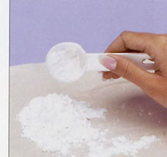

White powders -- Results

Put a tick or a cross in each box when you test your white powder

White powder | Appearance  Fine Small Larger  powder crystals crystals | Dissolves in water, clear solution | Dissolves in water, cloudy solution | Dissolves in water, with bubbles | Does not dissolve in water | Dissolves in vinegar, with bubbles

White powder | Appearance  Fine Small Larger  powder crystals crystals | Dissolves in water, clear solution | Dissolves in water, cloudy solution | Dissolves in water, with bubbles | Does not dissolve in water | Dissolves in vinegar, with bubbles
Salt

Sugar

Icing sugar
Flour

Health salts
Chalk

White powders -- Results

Put a tick or a cross in each box when you test your white powder

White powder | Appearance  Fine Small Larger  powder crystals crystals | Dissolves in water, clear solution | Dissolves in water, cloudy solution | Dissolves in water, with bubbles | Does not dissolve in water | Dissolves in vinegar, with bubbles
Salt |       |  |  |  |  | 
Sugar |      |  |  |  |  | 
Icing sugar |      |  |  |  |  | 
Flour |      |  |  |  |  | 
Health salts |      |  |  |  |  | 
Chalk |       |  |  |  |  | 
White powders -- Results

