White Powders
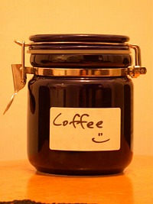
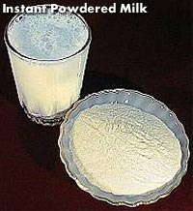
Some things have been taken from the teacher’s desk at playtime and the classroom has been left in a mess.
The teacher is very upset. She finds a note on her desk which says
“enjoy your coffee break tomorrow!”
Teacher is suspicious because she sees traces of a white powder lying on the floor near her desk. She checks her cup and her coffee jar, they both look OK. Then she has a look at her coffee-mate. It has been moved from its usual place and she thinks it looks more full than it did before.
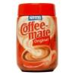
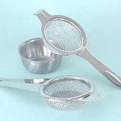
She would like to check if any extra white powder has been added to the coffee-mate and if it has, what kind of powder it is. Can you help her?

How could you separate powder from the coffee-mate?
Is there any equipment that would help?

Now you have a sample of the powder you will have to test it to find out what it is.
We have collected some white powders from the suspects and from the “scene of the crime”. You can examine each of these and then see if any of them are the same as the powder from the teacher’s coffee-mate jar.
About the white powders
We found a bag of flour children had been using to make flour bombs, one suspect had some packets of salt in her pocket, another had sachets of sugar in his bag. The teacher had health salts and icing sugar in her cupboard and some of her chalk had been crushed on the floor.

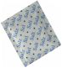
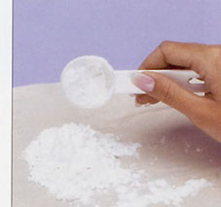
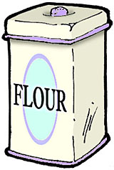
The powders are flour, icing sugar, health salts, salt, sugar, chalk
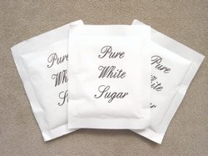
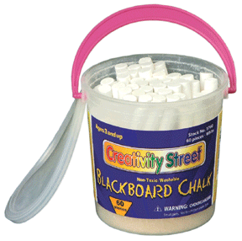
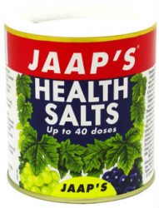

White powders

Work as a group.

You will need:
White powder sample Plastic teaspoon
Small container Hand lens
Water Vinegar

Each person in the group will study one of the samples of white powder.
You will complete all of the tests on your sample then each member of the group will fill their results into the master results sheet.

Appearance
Use the handle end of your teaspoon.
Take a very small amount of white powder and put it on a piece of black sugar paper. Look at it carefully then use a hand lens to see it more closely. Do you think it looks like a powder or can you see crystals? Have a look at someone else’s sample and compare it to your own. If you think your sample has crystals find another person in your group who has crystals and compare the size of the crystals in their sample.
To fill in your own results sheet.
Look at the sections about appearance. You have three choices. After you have studied your sample you must decide if it is a powder, has small crystals or has bigger crystals. Ask another group member to check if you are not sure. Put a tick in the correct box and a cross in the other two.

Dissolving in water.
Use the handle of your teaspoon and put a small amount of powder in your container. Put in two teaspoonfuls of water and swirl it around. Look carefully at your sample. This time you have four choices. Has your sample dissolved to give a clear solution, dissolved to give a cloudy solution, dissolved with bubbles or not dissolved? When you have decided, put a tick in the correct box and a cross in the other boxes.
Empty your container and dry it with a paper towel. While it is drying properly work with your group and fill in your own results on the group master results table.

Dissolving in Vinegar.
Vinegar is a weak acid and sometimes substances behave differently in acids from the way they behave with water.
Put two teaspoonfuls of vinegar into your container and then put a small sample of your white powder into it with the handle of the teaspoon. Give it a swirl and look at it carefully. Do you see bubbles? If you do, put a tick in the correct box on your own results sheet. Check with someone else in the group if you are not sure about seeing bubbles.
Finally, add your results to the results master sheet.

Look at the results for sample X.

Can you see if the results for sample X match the results for one of the other powders? If they do, you have identified your mystery substance.

What does your group think the mystery substance is?

Do you think it would have harmed the teacher if it got into her coffee?

